Water: Why do some things float, and other things sink?
Term three, Grade R, Life Skills Project

Playful learning to prepare teachers and learners to thrive in a changing world

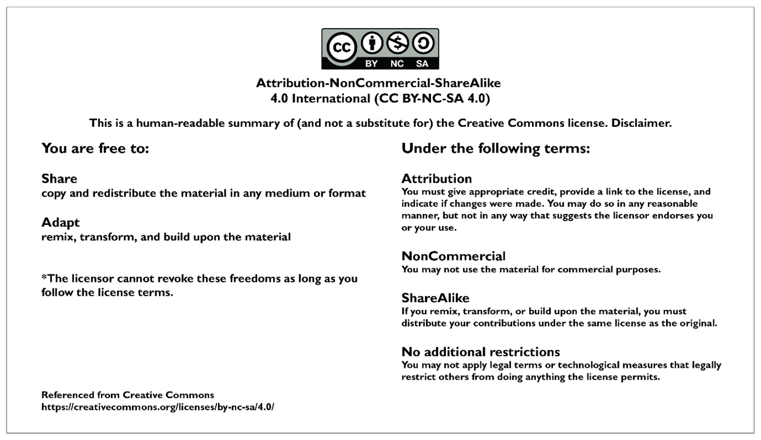

CONTENTS PAGE
PROJECT OVERVIEW 3
Preparing for the project 7
The project 8
Lesson 1: Let’s explore water? 8
Lesson 2: Water is important. 11
Lesson 3: Things that float and things that sink. 13
Lesson 4: Planning boats that can float 15
Lesson 5: Testing and iterating - It’s time to build! 17
The Public Presentation 19
Annexures - useful tools for the project 20
Annexure 1: EXEMPLAR CHECKLISTS FOR OBSERVATION 20
Annexure 2: Exemplar Competency (Skills) Observation Checklist 23
Annexure 3: Example letter to parents and caregivers about Project-based Learning 24
Annexure 4: The Project Wall 25
Annexure 5: The Project Route Map 26
Annexure 6: Roles and responsibilities 27
Annexure 7: Teachers as scaffolders of learning 30
Annexure 8: Learner Self-reflection Tool 31
Annexure 9: Teacher S.P.E.C.I.A.L. Self-reflection Tool 32

PLEASE NOTE
This is an exemplar project, but we encourage you to make it your own. Please feel free to adapt it as necessary to ensure it is suitable and relevant to your learners in your classroom. Remember, the ultimate goal of this project is to engage your learners and foster their learning, so don't be afraid to put your own spin on it! The activities and assessments in these lessons are here to guide you on your Project-based Learning journey. Feel free to adapt the activities and assessment to suit your learners needs.

PROJECT OVERVIEW
 | Name of project: Water: Why do some things float and other things sink?
Subject: Life Skills (Personal and Social Well-being and Visual Arts ) |  | Grade: R | Duration: 3 hours
Possible areas for integration with other subjects
Language development
Throughout this project learners will use language intensively and authentically as they:
- interact and communicate with one another, ask and answer questions, discuss findings from experiments, brainstorm ideas, make plans and iterate and improve plans.
Due to the communication-rich nature of the process they go through, many aspects of language are practised and developed.

Mathematics
Mathematics concepts relating to space and shape, quantity and measurement, capacity and mass are applied when learners plan and construct their boats.

CAPS content covered.  REMEMBER to always be aware of activities to promote Executive Functioning: Working memory, Inhibitory control and Self-regulation.  Learner talk, discussion, exploration, INQUIRY find-out”, problem solving, thinking and reasoning is of utmost importance. |  | Term 3  Beginning knowledge and personal and social well-being  Water  - Objects that float and sink  - Things that live in the water  - Mixing different things in water to change what it looks like  - Pouring and measuring water  - Saving water  Creative Arts (Create in 3D)  - Create freely using a range of materials: small boxes, recyclable materials like buttons, egg boxes, cardboard off-cuts, and other materials.  - Encourage development of skills through manipulation of the materials.
Driving question |  | How can we find out why some things float, and some things sink?
Project summary and objectives |  | For this project, learners experience water through their senses and describe all the ways water is used and why it is so important for life. Although water is essential for life, water can also be dangerous especially for people who cannot swim. For this reason, it is important for children to understand the concept of floating and sinking and what makes some things float and others sink. To discover this answer, learners experiment with everyday items to test what sinks and what floats. They then use their knowledge of materials that float to build boats that can carry a little load and keep floating.  Throughout this project, learners get opportunities to practise skills such as collaboration, communication, creative and conceptual thinking to:  - Make democratic decisions about how to build the boat.  - Create plans and allocate roles and responsibilities.  - Build and test prototypes.  - Review plans and solve any design problems.  - Participate in a Public Presentation.  Learners are active and have autonomy in this project making it a rich learning experience. Learners get opportunities to practise a variety of Bloom’s cognitive skills including the higher order skills such as analysis, synthesis and evaluation. Learners are constantly active as they discuss, listen, ask questions, solve problems, apply new knowledge, negotiate conflicts that may arise, plan, iterate, construct, present and most important of all – learn to love learning.
Entrepreneurial way-of- being skills developed in this project |  | Communication | Collaboration
 |  | Critical Thinking | Creative Thinking
Products |  | - A boat that floats and can carry a small load without sinking.
Public presentation |  | Projects will be presented by groups at a public presentation. Group members can explain what they have learnt about water, how they experimented to find out what things float and what things sink and how they planned, made and tested their boats. The public presentation could be, for example, held at a special event where caregivers and members of the community can join in the celebration. It is important that the projects are presented to a wider audience than just the learners and the teacher in the class.

PROJECT OVERVIEW
Activating the science of learning | This project:  Activates prior knowledge by encouraging all learners to remember (retrieve) what they already know about water and reflect on how they know what they know i.e., where did they learn this knowledge. This is an important process because linking new knowledge to what is already known improves comprehension of new knowledge and tends to lead to better storage of knowledge in long-term memory.  Focuses learner attention and engagement on the learning as it stimulates their curiosity and imagination by providing them with a purposeful question to answer and problem to solve. The project is practical and ‘hands-on’ and learners are active throughout. This tends to engage their attention and concentration. Throughout the project learners also have a lot of voice and choice and get to make some of their own decisions. When learners have this autonomy to follow their own interests or choices, they are often more engaged and attentive, both of which improve long-term retention of information and skills.  Results in ‘sticky learning’ learning that is memorable and lasting because it is learner centred and ensures they are frequently active in body and mind. The project is purposeful as it relates to learners’ personal safety. The driving questions provokes curiosity and there are opportunities to explore and discover for themselves the reasons for why some things float and others do not. For all these reasons, learning becomes sticky and hard to forget.
Lesson summary  This is a 1-week project. The following activities are intended to guide learners to use their voice and choice to come up with a creative way of answering the driving question. | Lesson one: | In this lesson, learners will:  - Get an overview of the project.  - Explore water using their senses.  - Contribute prior knowledge to a circle map.
 | Lesson two: | In this lesson learner will:  - Collaborate to discuss all the ways that water is used.  - Make their ideas visible on a bubble map.  - Conduct a gallery walk showcasing all the group’s bubble maps.
 | Lesson three: | In this lesson, learners will:  - Experiment to test what things float and what things sink.  - Use a tree map to group/categorise the items that float and the items that sink.
 | Lesson four: | In this lesson, learners will:  - Receive the guidelines for the project.  - Brainstorm ideas for how to make their boats.  - Collaborate to design a plan for the boat building.
 | Lesson five: | In this lesson, learners will:  - Test prototypes of the boats and iterate the design if the boats are not fully functional.  - Provide support, encouragement, feedback and advice to their peers.
Resources | - Resources relating to the topic that you already have in stock.  - Containers of different sizes to hold water.  - Utensils to stir water.  - Food colouring to mix into water.  - Found and recycled materials for 3D construction.
Entrepreneurship add-on possibilities | An entrepreneurial activity based on this project could be for the grade r class to create a business that sells handmade boats designed and built by the learners. The boats could be made from materials that the learners have tested for their ability to float, and they can be decorated and personalised to the customer's liking. The learners can market their products to parents and caregivers of young children who enjoy playing with boats in the bath or in a pool. The learners can also learn about the concept of pricing and working out a fair price to sell them for. This activity will not only provide a fun and creative way for learners to engage with the project's concepts but also introduce them to the fundamentals of entrepreneurship.

Preparing for the project

Preparing learners
- This is a short (but powerful) project so preparation and planning is important. It's recommended that you plan the groups before starting the project so that learners are already sitting together and are starting to get to know each other.
- It’s recommended to explain the overview of the project i.e., tell learners that they will first experiment to test what things float or sink. They will use this knowledge to design and build a boat that not only floats but can stay floating while carrying a small load.
- Effective group work is more manageable and more effective when each group member has a role and responsibility. Please see annexure 6 for more detail on the types of roles that are useful for a project.

Preparing the classroom
- Before launching the project, you can create a Project Wall. This is very similar to a theme wall where you display and show resources, pictures, posters and objects about your new theme. The Project Wall takes this a step further in that it shows the driving question, journey of the project (route map found in annexure 5). The Project Wall can begin with a display of what learners already know about the topics and as the project progresses their displays become richer and richer which makes the growth of their learning visible. Keywords can be placed on the wall as can curious questions that learners ask that you want to revisit. As far as possible, get the learners to organise the wall and take ownership of what is displayed - after all it's their project and their learning. To learn more about Project Walls please see annexure 4.

Teacher preparation
- Read the project instructions. Make any changes or updates to the project to suit your learners needs.
- Read Teaching for Learning in a Fast-Changing World. You can download it here: https://www.uj.ac.za/wp-content/uploads/2023/01/teaching-for-learning-in-a-fast-changing-world-e-version.pdf
- Do the Introduction to Project-based Learning course online https://learn.ecubed-dbe.org/courses/introduction-to-project-based-learning/
- Please see the additional notes on Collaborative Learning in Project-based Learning and Thinking Maps Resources for more information on these two topics.

Preparing parents and colleagues
- Inform parents and caregivers about your project. We have created a template that you can adapt, you can find this in annexure 3.
- Tell your colleagues about your project and what to expect e.g., for example there will be lots of group work so your lessons might be a little bit noisier, but this is good, it means learners are engaged and paying attention.

Preparing for the Public Presentation
- The project ends with a Public Presentation where learners get to show off their projects. The date needs to be booked in advance as this is not a lesson. Public Presentations can be done at assembly, as an art exhibition at break, or at an event like a parents evening.

The project
Lesson 1: Let’s explore water? | Resources needed:  Project route map  Circle maps |  | Time required:  35 mins
Summary of the Lesson
In this lesson, learners will:
- Get an overview of the project.
- Explore water using their senses.
- Contribute prior knowledge to a circle map.
Objective
The purpose of this lesson is for learners to:
- Experience water through their senses.
- Describe their experiences verbally.
- Recall ways in which they use water during the day.

The purpose of this lesson is for teachers to:
- Informally evaluate learners’ prior knowledge and vocabulary about water and how well they can demonstrate their knowledge through speaking.

Before the lesson  Draw a circle map on a big piece of paper and display it on the board.  Lesson guidelines- what will learners and teachers do?  - The project route map  - Show learners the Project Route Map so they get a sense of what they can expect. This is also an effective way to role model planning which is a useful skill for all learners to develop. (Please see annexure 5 for the Project Route Map.)  - Let's play and learn with water!  - Give each group a container with some water in it. (For hygiene reasons they could each have a plastic cup with a small amount of water in it.)  - In their groups, they need to explore this water through their senses and describe its feel, taste, smell, look and sound. They can think creatively and imagine what would change water’s feel, taste, smell, look and sound.  - We can take water for granted so take the discussion further and encourage learners to explain how they have used water during the day to show how important it is in their lives.  - Making our learning visible  - Write down what the learners share about water on the circle map so they can see their spoken words turn into written words which support sound/letter association. You can also add little drawings. Keep this circle map up on the Project Wall.  - Reflection: Looking back on our learning  - When ideas have dried up, you can ask a few comprehension questions about water. All learners can participate by simply putting a thumbs up or a thumbs down.  - As an example you can ask: “Can you think of one way you used water in the morning?”  - Pause for learners to think and then watch for the thumbs up or thumbs down. If you see a thumbs down or some confusion, you know that the learner needs help.  - To confirm understanding, ask a few learners who had their thumbs up to answer the question.  Please note, while there is no formal assessment for marks, this project offers many opportunities to observe learners’ language development (Listening and Speaking) and fine motor development as they manipulate apparatus such as scissors and crayons. Please see Annexure 1 for guidelines for your observation of these important developmental areas. |  | How learning happens.  Prior knowledge  Learners’ prior knowledge about the topic of water is brought to mind through a sensory activity. This is made visible on a circle map. This helps teachers assess informally how much the learners already know and where the gaps are. This information helps to ensure that new learning connects and builds on what learners already understand.  S.P.E.C.I.A.L.  The multisensory activity promotes active engagement and curiosity. Learners also interact socially as they explore water.  Long-term memory  Keeping the circle maps on display gives learners opportunities outside of project time to ‘read’ and remember and think about water. This can deepen engagement with the topic and can strengthen learning and long-term memory.  Reflection  ASking reflection questions encourages learners to think back over the lesson and do a mental check of what they have learnt. This promotes active processing of information which improves understanding and memory. It also activates meta-thinking (Thinking about thinking) as they consciously think about and review what they have learnt. It’s only through this process that learners can evaluate what they are sure of and where they need help.  Remember that reflection leads to learning that is ‘sticky’ learning that lasts. So, don’t miss out the reflection activity.
Extended opportunities
You could give learners the opportunity to mix food colouring or paint power into water to observe changes. They could practise pouring water in and out of different sized containers. They can also test what happens when various things like soil or flour are mixed into water. The more multisensory the activities the better the learning.
Observations and facilitation - Assessment as Learning
As a teacher you already know that you play an essential role as a facilitator of learning. You know that rather than simply giving knowledge to learners, you create an environment in which your learners can explore, discover, and construct their own understanding of the subject matter. As a facilitator you will
- create an emotionally and psychologically safe learning environment so that learners feel safe to participate in the lesson,
- provide prompts when learners get stuck,
- provide constructive and timely feedback to learners,
- and adjust your lesson based on what you observe (this is assessment as learning) so that learners can grow their understanding and grow their skills and competencies.

While learners are working on their tasks throughout this project your role as a facilitator is to observe, listen, and record the process of learning during the lesson. These observations are the foundation for the assessment of this project, so make a few notes, these will help you when you do the final assessment.
The first lesson focuses on establishing what learners already know about the topic (prior knowledge). While learners are communicating in their groups, it’s important to actively observe and listen to what they are saying and how they are interacting with their peers. As you walk around the classroom, keep an eye out for the following indicators of learning:
Learner knowledge
This is a crucial aspect to observe as learners' understanding of key concepts relating to the topic. You can assess this by observing if learners can describe or explain key words and concepts about pets. Prompting questions can be:

- “Where do we store water?”
- “What could you NOT do if you had no water?”
- “Can water change its temperature? How do you know this?
- “What animals live in water?”

These prompts work as informal, continuous assessment and can help you gauge learners’ baseline comprehension of the topic. Re-asking these questions throughout the project will help monitor their progress.

For more ideas on prompts and scaffolding questions please see Annexure 7.

Teacher self-reflections
After every lesson it is important to reflect on how the lesson went so that you can make adjustments to the lesson or project. Check out annexure 9 for a whole range of different questions you could use to reflect on for this lesson. Note you do not need to reflect on all the questions, just select 1 or 2 that resonate with you. Your own self- reflection is important for a number of reasons: it is a crucial aspect of teacher professional development and enables you to learn from experience, grow as a teacher and continually improve your instructional effectiveness so that you can better support learners’ learning.

Lesson 2: Water is important. | Resources needed:  Bubble maps |  |  | Time required:  30 mins
Summary of the Lesson
In this lesson, learners will:
- Collaborate to discuss all the ways that water is used.
- Make their ideas visible on a bubble map.
- Conduct a gallery walk showcasing all of the group’s bubble maps.
Objective
The purpose of this lesson is for learners to:
- Review and recall what they did in Lesson 1 so they can connect what they already know to new knowledge accessed in Lesson 2.
- Discuss and share on a bubble map all the ways water is used.
- Display their bubble maps in the form of a gallery wall.

The purpose of this lesson is for teachers to:
- Check how well learners recall information and activities from Lesson 1.
- Listen to the level of language used by learners to discuss their topic.
- Monitor collaboration and interaction in the group.
- Evaluate how clearly and effectively learners communicate new knowledge they learnt with the class.

Before the lesson  Prepare A3 sheets of paper – this can be scrap paper or cardboard.  Write the word ‘water’ on the board.  Lesson guidelines- what will learners and teachers do?  - Reviewing and reflecting  - Ask volunteers to explain what has been done/learnt so far in the project. They can use the Project Route Map to show progress. This will also help learners reflect on what they have learnt and what they have done which is a good strategy for shifting new knowledge into long-term memory.  - Follow the review by explaining to learners that in the last lesson they used their senses to explore water. In this lesson they will put on their thinking caps and remember all the ways water is used.  B. Talking and sharing  - Give each group a bubble map. A ‘writer’ can be selected to write the word ‘water’ into the middle bubble. In their group learners need to think of at least 8 different ways water is used by people, animals and plants. They can add more bubbles if they have more ideas.  - As learners are still emerging writers, they can represent their knowledge with sketches or drawings.  - Give a time limit for this to keep learners focussed.  C. Presenting and teaching  - Learners can then display their bubble maps like art in an art gallery and the class can do a gallery walk and have a good look at all the other groups’ maps, ask questions and interpret the drawings.  - Each group can add anything new they learn to their own bubble map.  D. Conclusion  - Conclude this lesson by counting/listing all the different ways we use water to show just how valuable it is for all life. |  | How learning happens.  Review and reflection  The review and reflection are a good way for learners to link prior knowledge to new knowledge which deepens comprehension and strengthens memory.  S.P.E.C.I.A.L.  Learners are socially interactive as they collaborate to add ideas to a bubble.  Meta-thinking (Thinking about thinking)  When participating in the gallery walk, learners get the opportunity to compare their knowledge to other people’s knowledge via the bubble maps. Learners can quickly evaluate what they may have missed out or forgotten - or may learn something new. In this way learners start to recognise and close their own knowledge gaps.  Remember that reflection leads to learning that is ‘sticky’ learning that lasts. So, don’t miss out the reflection activity.
Observations and facilitation - Assessment as learning
As they discuss and share information for their bubble maps, it's important to actively observe and listen to learners as they work together in groups. As you walk around the classroom, keep an eye out for several key indicators of learning, communication, and knowledge of the topic. These are just some examples of things to observe - you might have your own list of observations to use.

- Learner communication skills
- Observe learners' active listening skills to determine if they are fully engaging with their peers during the group discussion process. Are they focused and attentive, or are they distracted or disengaged?
- Additionally, pay attention to their articulation skills. Are they speaking clearly and confidently, or are they mumbling or speaking too fast, or speaking too loudly or softly?

If learners are struggling with any aspect of their communication skills, there are several strategies you can use to support them.
- One option is to model active listening yourself, showing the kinds of behaviours you expect from learners.
- You can also take the time to explain the guidelines for active listening or the interview process again, ensuring that all learners understand the expectations.
- It can be helpful to share and discuss the definitions of good communication. The Teacher's Guide to Competencies is an excellent resource for this purpose, providing information and guidance on the development of communication skills.

Remember, communication skills take time to develop, and learners will have many opportunities to practise and grow their abilities throughout the project. By actively observing and facilitating their progress, you can help them build important skills that will serve them well in the future.
For more ideas on prompts and scaffolding questions please see Annexure 7.
Lesson 3: Things that float and things that sink. | Resources needed:  Containers of water.  Piles of everyday items to test for floating and sinking.  A tree map. |  |  | Time required:  35 mins
Summary of the Lesson
In this lesson, learners will:
- Experiment to test what things float and what things sink.
- Use a tree map to group the items that float and the items that sink.
Objective
The purpose of this lesson is for learners to:
- Test things that sink and those that float and try to explain their properties.
- Categorise things that float and things that sink using a tree map.

The purpose of this lesson is for teachers to:
- Observe how learners manage the experiment give each other turns to test different items
- Check that they are categorising their items correctly on the tree map
- Listen to see if learners can start to work out the properties of things that float and sink yet, which starts to answer the driving question.

Before the lesson  Groups need containers of water and piles of everyday items. These can range from leaves and twigs, to stationery, to recycled and waste material. (They will all be put in water so check that nothing valuable is used that can be ruined.)  Lesson guidelines- what will learners and teachers do?  - Reviewing  - Ask volunteers to explain what has been done/learnt so far in the project. They can use the Project Route Map to show progress. They can do a quick review if the circle maps and bubble maps to refresh their memories and activate this knowledge.  - Time to experiment  - In their groups, learners will now experiment to discover things that float and things that sink. Their findings will be organised on a tree map on the floor.  - Organising our findings  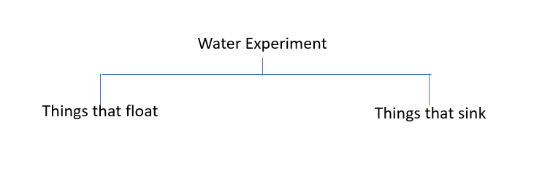  - You can create space on the floor or ground outside to create a tree map.  - As learners test each item, it can be grouped/placed under the relevant heading on the tree map.  - Conclude  - End the lesson by asking learners if there is anything the same or similar about the items that float and the items that sink. i.e., why do some things float, and other things sink?  - You might not get great answers yet, but it will pique their curiosity and get learners thinking about the properties of things that float and things that sink – which links to the driving question. |  |  | How learning happens.  S.P.E.C.I.A.L.  This lesson is highly learner centred. Learners are active both in mind and body as they conduct the experiment. This leads to a high level of attention and engagement which are necessary for deeper learning.  Experiments also pique curiosity.  Competencies  Running their own experiments offers learners the opportunity to practise communication and collaboration skills.  Concept development  Using a treemap to make visible groups of things that have something in common is an effective way of strengthening conceptual development.
Extended opportunities
You may want to bring in the concept of water safety now. Young children don’t always realise that unless they can swim, they will sink in water and possibly drown unless they are wearing water wings or vests that help them float. Knowledge about sinking and floating plays into the learner's safety in and around water. This type of discussion will bring a sense of purpose to the experiment.
Observations and facilitation - Assessment as Learning
During this experiment, it's important to actively observe and listen to learners as they work together in groups. As you walk around the classroom, keep an eye out for several key indicators of learning, including collaboration skills, communication, and critical thinking skills. Here are some suggestions of what you could observe if learners are:

- talking about the experiment while they are performing the experiment thereby and linking actions and outcomes to words.
- getting creative about what they test (within reason).
- engaging in higher order thinking such as “I think this is sinking because it’s heavy” or “This is plastic, so it won’t soak up water.” “I wonder if this will….”
- supporting each other’s learning and assisting those who need help.

For more ideas on prompts and scaffolding questions please see Annexure 7.

Lesson 4: Planning boats that can float | Resources needed:  Feedback checklists |  | Time required:  30 mins
Summary of the Lesson
In this lesson learners will:
- Receive the guidelines for the project.
- Brainstorm ideas for how to make their boats.
- Collaborate to design a plan for the boat building.
Objective
The purpose of this lesson is for learners to:
- Apply what they have learnt about objects that float to guide their choice about what materials to use to build their boats.
- Plan a design for how the boat will be built.
- Make sure they have the materials and tools for construction.

The purpose of this lesson is for teachers to:
- Observe learners critical thinking as they evaluate materials to build the boat
- Observe the level of collaboration as they plan the design
- Check in to see if the plans are well sequenced and logical.
Before the lesson  Prepare some circle maps if you are choosing to use them.  Lesson guidelines- what will learners and teachers do?  - Reviewing and introducing  - Review if learners can remember what it means to float and sink and see if they can list a few items that they saw in their experiments that could float or that sank.  - Explain to learners that now they know more about what makes things float, they will work in groups and collaborate to design and build a boat that floats. Add in an extra problem by challenging learners to make a boat that not only floats but can also carry a small load such as a few stones.  - They must build their boat from mainly found or waste materials and can use the materials that they remembered could float from their experiments.  - Brainstorming  - In their groups, learners brainstorm what materials and tools they need to build their boats. Pictures of these items can be drawn by learners on a paper circle map.  - A quick look at the maps will help you see which groups are coping and who might need help.  - Based on their circle maps, learners gather their tools and materials.  - Planning  - With the materials at hand, learners now collaborate, discuss and plan the construction of their boats and how to make sure they can carry a small load without sinking. You can scaffold this by helping learners sequence their thinking. For example, ask them what they think they should do first, and what they could do next.  - Give learners time to grapple with the planning and as far as possible let them sort out any disagreements that might bubble up in the group. |  | How learning happens.  Reviewing and prior knowledge  Encouraging learners to use what they learnt in the experiment to guide what they will use to build their boats makes for deep learning, enduring memories and makes learning purposeful.  S.P.E.C.I.A.L.  Most aspects of S.P.E.C.I.A.L are contained in this lesson as learners have full responsibility to the entire planning and production of their boats.  Remember that reflection leads to learning that is ‘sticky’ learning that lasts. So, don’t miss out the reflection activity.
Extended opportunities
- Take the learning home! Learners can share their plans with siblings, friends and parents to ‘sense-check’ the plans and get advice and help if necessary.
Observations and facilitation - Assessment as Learning
During this evaluation and feedback activity, it's important to actively observe and listen to learners as they plan their boats. As you walk around the classroom, keep an eye out for several key indicators of learning, including creative innovation, collaboration skills, communication, and critical thinking skills. Here are some suggestions of what you could observe:

Communication: Are learners listening to each other and taking turns to share ideas or are they interrupting and shouting out? Prompt by asking individual learners: “Is the group listening to you?” or “Are you listening to your friends - prove this by explaining one idea that you have heard in your group.”
Collaboration: Is everyone getting a chance to participate? Check for this by asking a few learners in each group to explain what ideas they shared and show these on the circle map.
Critical thinking: Can learners evaluate/differentiate between plans that are unrealistic and those that they can achieve? Prompt by asking: “Are you sure you can do this in class by yourself?”
Creative innovation: Are learners generating many and different types of ideas. Prompt by asking the group to count up the different ideas.

Lesson 5: Testing and iterating - It’s time to build! | Resources needed:  Found and recycled materials  Art supplies  Coloured crayons  Glue |  | Time required:  40 mins
Summary of the Lesson
In this lesson, learners will:
- Test prototypes of the boats and iterate the design if the boats are not fully functional.
- Provide support, encouragement, feedback and advice to their peers.
Objective
The purpose of this lesson is for learners to:
- Test, problem solve, iterate and test again until their boats can still float while carrying a light load.

The purpose of this lesson is for teachers to:
- Observe how learners are testing, problem solving, iterating and retesting.

Before the lesson  A container of water for testing boat designs.  Lesson guidelines- what will learners and teachers do?  - Testing and problem solving  - Based on their plans and brainstorming, learners can build and TEST their design.  - Learners can try and float their boats to observe If they float, and if they can float while carrying a small load.  - If the boat ‘fails’ the group needs to review their planning to find the problem, iterate the plan and redo the boat. This may need to happen a few times.  - If a group is struggling, they can ask peers to have a look and give feedback or advice on the problem.  - Persist until all the boats are floating and can be presented at the Public Presentation.  B. Next steps  - Depending on how close the public presentation date is, learners can take time to do final tweaks to their products.  - Once the presentation is over, it’s essential to do the last step which is the Learner's Self-reflection tool (See Annexure 8.) |  | How learning happens.  S.P.E.C.I.A.L.  This lesson incorporates all the principles of S.P.E.C.I.A.L. as learners work together to test, iterate and strengthen their boat designs.  Competencies  This lesson offers opportunities for learners to practise their collaboration, communication, creative and critical thinking.  Iteration is an important part of this lesson as learners must reflect on and solve any design problems that are interfering with their boats floating capacity.  Reflection  The self-reflection sheet is an essential part of this project and is where most of the learning – including knowledge and skills is consolidated and moves to long-term memory.  Remember that reflection leads to learning that is ‘sticky’ learning that lasts. So, don’t miss out the reflection activity.
Observations and facilitation - Assessment as Learning
During this activity, it's important to actively observe and listen to learners as they work together in groups to test and iterate their designs. As you walk around the classroom, keep an eye out for several key indicators of learning, including creative innovation, collaboration skills, communication, and critical thinking skills. Here are some suggestions of what you could observe:

  - Collaboration: Observe how the learners are fulfilling their roles and responsibilities. Are the groups functioning productively? Are they managing their own conflict and unexpected problems? Step in if it is clear they cannot solve the problem alone, but still try to scaffold their problem-solving skills with prompts such as, “Can you explain the problem here?”, “What help do you think you need?”, “What have you already done to manage the problem?”
  - Communication: Observe how clearly learners can describe any design problems and explain solutions. Prompt by asking, “Can you explain to me why your boat sank?” or “What was the problem and how did you manage to solve it”

For more ideas on prompts and scaffolding questions please see Annexure 7.

The Public Presentation | Resources needed:  - The completed projects and whatever is needed to display them effectively.
Summary of the lesson
At the end of the project, learners have the opportunity to present their work i.e., their boats to a wider public. The purpose of a public presentation is to provide learners with an authentic audience to share their learning and achievements, and to receive feedback and recognition for their hard work and to celebrate all that they have achieved. It also allows learners to practise important skills such as public speaking, communication, and presentation design.
Objective
The purpose of the public presentation is for learners to:
- Applying: Learners apply the knowledge gathered throughout the project to share their learnings and products.
communication, critical thinking, collaboration, creative innovation and meta-learning as they work collaboratively to implement their plans for the public presentation.
End of project reflections  - Once the event is over, make sure there is time to debrief the experience with the learners.  - Ask learners to complete the Learner Self-reflection Table (see annexure 8). You can decide what method to use to complete the reflection e.g., independently, in a group, in pairs. | How learning happens.  As learners work collaboratively (social interaction) to implement their ideas for their public presentation they are actively engaged in the learning process (hands-on and minds on) which increases attention and engagement, which as we know leads to better learning outcomes.  This experiential approach (designing, making and presenting pet shelters) can create more vivid and lasting memories because it engages multiple senses and emotions, e.g., learners are not only sitting and listening - they are doing.  A public presentation is a nice place to observe the E - Enjoyment in S.P.E.C.I.A.L. Throughout the project learners would have had to persevere through challenges, they would have felt frustrations, they would have had to be resilient in overcoming challenges. The E for Enjoyment speaks to the joy that you feel once you have overcome your challenges.  Learners are actively making meaningful connections between their prior knowledge and new practical learning experiences as they deal with problems and find solutions, give and receive feedback, present their ideas and so on.  All of this leads to ‘sticky’ learning, learning that is memorable, lasting, and relevant to the learners.

Annexures - useful tools for the project

Annexure 1: EXEMPLAR CHECKLISTS FOR OBSERVATION
This assessment toolkit is based only on checklists that can be used informally to observe learners’ development across a range of skills. The following development skills can be observed using checklists.

LANGUAGE DEVELOPMENT
Listening and Speaking
- Listens attentively to questions and gives answers.
- Listens without interrupting, showing respect for the speaker and takes turns to speak.
- Understands that pictures and photographs convey meaning about events, people, places and things and talks about these.
- Looks carefully at pictures and talks about common experiences.

LIFE SKILLS
Beginning knowledge and personal and social well being
- Water: Objects that float and sink.
Visual arts (Create in 3 D/Constructing)
- Can create freely using a range of materials: small boxes, recyclable materials like buttons, egg boxes, cardboard off-cuts etc.
- Fine motor strength and co-ordination is improving through the manipulation of the materials.

LANGUAGE DEVELOPMENT
Listening and Speaking
There is a lot of listening and speaking (communication) in this project and learners' listening skills can be assessed or observed continuously. In term 3 of Grade R, you can focus your observations of the following skills.
Learners should be able to:
- Pay attention and listen for at least 5 - 10 minutes.
- Respond to questions and carry out instructions.
- Understand taking turns to speak.
Learners who have not yet achieved these skills could be experiencing one or more of following difficulties/barriers:
- Hard of hearing
- Blocked ears from ear infections
- Have a different Home Language and therefore still learning the language of teaching
- Few opportunities to develop and practise these skills with friends.
- Poor role modelling from adults.
- Excessive time in front of screens (Phone, tablet, TV etc)
- Chronic health problems

CAPS Alignment | 1 Not achieved | 2 In need of support | 3 Achieved
Listens attentively to questions and gives answers.
Listens without interrupting, showing respect for the speaker and takes turns to speak.
LIFE SKILLS
Beginning Knowledge and Personal and Social well-being
- Learners experiment and test a variety of objects to see if they sink or float
Although this is a Life Skills activity, learners need to be able to understand and use concepts/vocabulary that are important to this experiment such as: Float and sink, heavy and light, under and on top, waterproof etc. Encourage learners to do the experiment and talk about what they are doing and what they can see happening.
CAPS alignment | 1 Not achieved | 2 In need of support | 3 Achieved
Can learners test, compare and group objects that float and sink.
Visual Arts Create in 3D (Constructing)
- Learners work together to build boats that can float. They use recycled and found materials and objects.
Learners should be able to hold and use tools such as wax crayons and pencil crayons, paint brushes, glue sticks, and scissors i.e., the tools of school in a way that is not too messy or clumsy.

Delays in fine motor development at this age could be due to:
- Learners being too young (approximately below age 5 .6), so the activity is developmentally inappropriate and too difficult for little fingers.
- Weak muscles in the hands so pencil grip is poor and hands get tired quickly.
- Limited practise with the tools for school.
- Too much sitting and not enough playing.

Fine motor development and muscle strengthening should happen naturally through a child’s day by:
- Dressing and undressing.
- Brushing teeth and washing and drying bodies after bathing
- Managing hair
- Using utensils such as spoons for eating.
- Helping with household chores

CAPS alignment | 1 Not achieved | 2 In need of support | 3 Achieved
Can create freely using a range of materials: small boxes, recyclable materials like buttons, egg boxes, cardboard off-cuts etc
Fine motor strength and co-ordination is improving through the manipulation of the materials

Annexure 2: Exemplar Competency (Skills) Observation Checklist
How did the project help learners to grow their skills | Yes | No
Critical Thinking: is about asking questions to understand the world, it is also about trying to make sense of information, evaluating it and connecting it to other pieces of information.
- Did the learners grow their critical thinking through the project?
- Was there a difference from the start to the end of the project in the learners’ critical thinking skills?
- Did the learners ask questions?
- Did the learners find the relevant and appropriate information, evaluate, and analyse it and apply it to solve a problem?
- Did you notice a change in learners’ critical thinking skills?
COMMENTS: What did you notice

Creative Innovation: is the ability to come up with many different ideas and apply them to find realistic solutions to problems.
- Did the learners grow their creative innovation through the project?
- Was there a difference from the start to the end of the project in the learners’ critical thinking skills?
- Did the learners generate ideas and seek solutions?
- Did you notice a change in learners’ creative innovation skills?
COMMENTS: What did you notice

Collaboration: when people work with each other to complete a task. It involves cooperation and teamwork and the sharing of ideas, knowledge, and skills to reach the same goal.
- Did the learners grow their ability to collaborate through the project?
- Was there a difference from the start to the end of the project in the learners’ collaboration?
- Did the learners show an ability to compromise, be considerate of each other, and be positive in a conflict situation?
- Did the learners leverage each other’s strengths? (Pool their collective resources in terms of strengths and knowledge)
- Were the learners willing to listen, empathise, and give and receive useful feedback to the team?
- Did you notice a change in learners' creative innovation skills?
COMMENTS: What did you notice

Annexure 3: Example letter to parents and caregivers about Project-based Learning

This is just an example. Feel free to edit and adapt it to your needs.

Dear Parents and Caregivers,

We hope this letter finds you well. We want to share with you an exciting project that your child will be working on in school called "Water: Why do some things float and other things sink? ". This is a Project-based Learning project. You may have already heard a lot about Project-based Learning, but if not, Project-based Learning is a teaching method where learners learn by actively engaging in real-world and meaningful projects. Through this method, learners are given the opportunity to collaborate with their peers, conduct research, and apply their knowledge and skills to solve real-life problems or answer real-life questions..

There are many benefits to Project-based Learning. This method encourages creativity, critical thinking, and problem-solving skills. Learners also learn to communicate effectively, both with their peers and the community, and build personal connections with the subject content (CAPS), leading to deeper and more memorable learning experiences. There are lots of ways you can support your child in their Project-based Learning journey that will not cost you anything. You can:

- Encourage your child to ask questions and take ownership of their learning. This can help them develop critical thinking skills and become more engaged in the project.
- Help your child find resources and materials related to the project topic. This can include books, articles, websites, or even just your own knowledge about the topic.
- Your child will probably want to explain the project to you. Please ask him/her many questions and listen to their ideas. Show interest and enthusiasm for what they are learning and offer positive feedback to encourage their progress.
- Help your child manage their time effectively by helping them to create a schedule or calendar with deadlines and milestones for the project.
- Attend any events or presentations related to the project and show support for your child and their classmates as they showcase their work.

Thank you for your ongoing support of our learners' education.

Sincerely,

[Your Name]

…………………………………………………………………………………………………………………………………………………………………………………………………………………………………………………………………………………………………………
This is to confirm that I __________________________________ parent/guardian of ___________________________________ have read this letter and I understand what the project is all about.

Annexure 4: The Project Wall

How to create your own Project Wall

Have you heard of a Project Wall? Or maybe you already have lots of Project Walls in your classroom. It's a physical space used in project-based learning to visually display the progress and development of a project. It's a central location where everyone can see and contribute to the organisation of ideas related to the project. If you're looking to create your own project wall, here are some ideas of what to include:

- The driving question
- The project goals
- Assessment rubrics
- Tools that learners might use, like templates of thinking maps
- The steps of the project
- Reflection tools
- Pictures
- Examples of learners' work
- Questions that learners have

The Project Wall should be an evolving space that changes and grows as the project progresses, with new insights and ideas constantly being generated.

So, how does a Project Wall support learning? Here are a few ways:

- It provides a space for learners to engage with the project material and reflect on their progress.
- It makes learning visible, so learners know what they need to learn, how to learn it, and how to evaluate their own progress.
- It's a place to practise collaborative learning, as learners can decide together what to put on the wall.

Remember, a project wall is a great tool to help you organise and visualise your ideas, keep track of your progress, and learn collaboratively with your team.

Annexure 5: The Project Route Map

This is a project route map that learners can follow to help them understand the process of the project and where they are in the project. You can recreate this for the Project Wall. At the beginning of each lesson, ask some volunteers to review the lessons that have been covered and recall what they did and what they learnt.

About this project: Water: Why do some things float and other things sink?

Part | What am I doing? | Status Tick this box after each lesson is completed.
1 | Explore water through my senses and help fill in a circle map. (Lesson 1)
2 | Use a bubble map to help us remember all the ways we use water. Do a gallery walk to learn from our friends. (Lesson 2)
3 | Do an experiment to test what things can float and what things sink – and try to work out why this happens? (Lesson 3)
4 | Use what we learnt about things that float, to plan how to build our own boat that can float. (Lesson 4)
5 | Build our boats and test if they work. If not, try again and get help if we need it. (Lesson 5)
6 | Show off our amazing boats at a public presentation.

Annexure 6: Roles and responsibilities

Here are some examples of roles and responsibilities. Print a copy for each group and place one copy on the project wall.
Instructions: Choose a role that you would like to practise. Do not worry if you do not have the skills yet for the role, this is a great opportunity to practise different skills. By the end of the project, make sure you have tried more than one role so that you can practise and grow your skills.
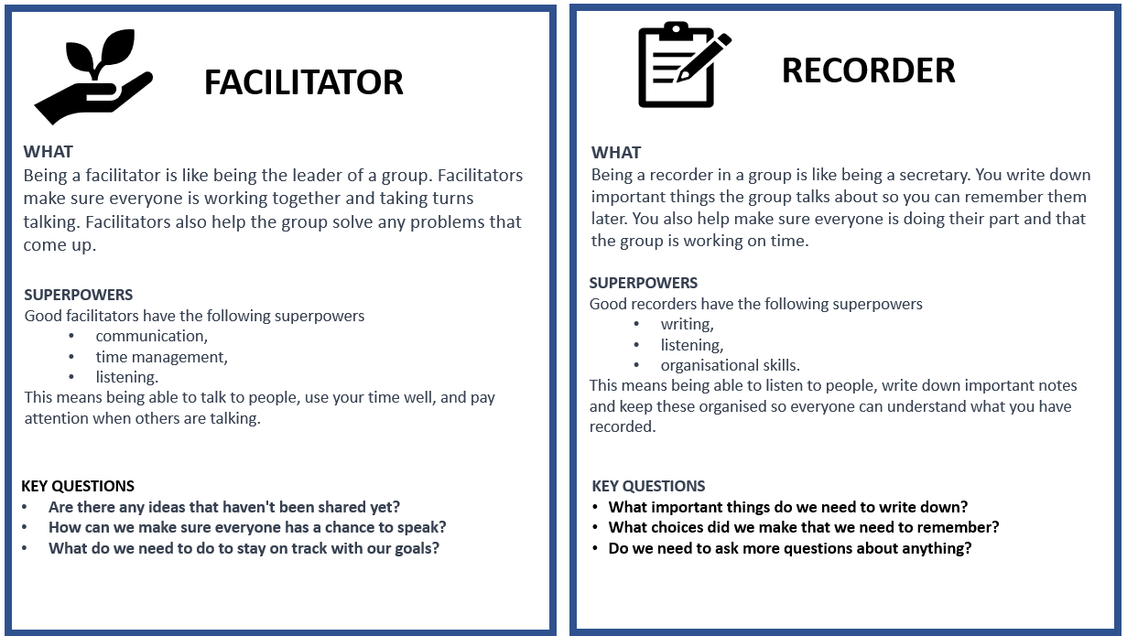
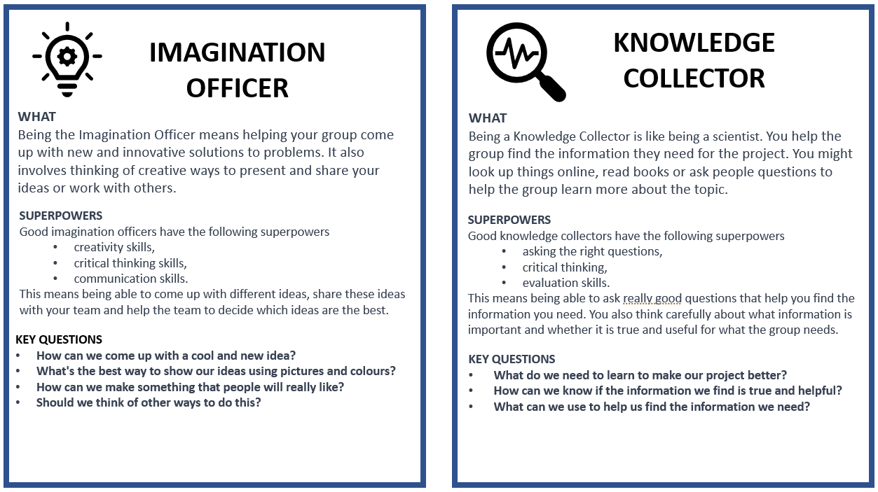

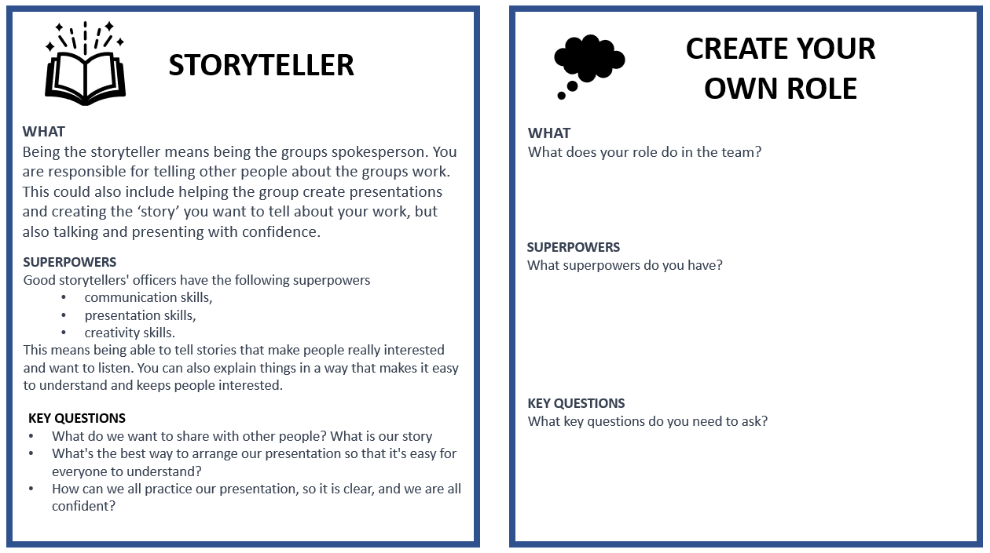

Annexure 7: Teachers as scaffolders of learning

Scaffolding learning is an instructional approach that is essential for Project-based Learning. When you scaffold learning you are providing support and guidance to learners as they engage with new or challenging material. The term "scaffolding" refers to the temporary support structures that construction workers use to help them reach high places while they build a building. In education, scaffolding means providing learners with the support they need to build their understanding of a topic or skill.
Scaffolding learning typically involves several steps.
First you assess the learners' prior knowledge and skills. What do learners already know about the topic and what gaps or misconceptions may need to be addressed.
- Provide support and guidance to help learners engage with the material and build their understanding. This support may take many forms, including modelling, feedback, prompts, and questions.
- As learners become more confident, gradually reduce the scaffolds.

Here are some examples of questions you can use in different circumstances to help scaffold your learners' learning.
Clarifying questions  Ask these types of questions to clarify learner understanding of a topic.  - Can you explain what you mean by that?  - Can you give me an example to illustrate your point? | Prompting questions  Ask these questions to help learners to think more deeply about a topic or idea.  - What other perspectives or points of view could we consider?  - How does this relate or link to what we've learned before?
Elaboration question  Ask these questions to encourage learners to expand on their ideas.  - Can you tell me more about that?  - Why do you think that is the case? | Strategy questions  Ask these questions to help learners develop problem-solving skills and strategies.  - What steps could we take to solve this problem?  - What information do we need to gather to answer this question?
Prediction questions  Ask these questions to help learners anticipate what might happen next.  - What do you think will happen if we try this?  - What do you expect to see when we conduct this experiment? | Clarification questions  Ask these clarification questions to help learners understand complex or abstract concepts.  - What do you think this term means?  - Can you give me an example of how this concept works in real life?
Reflection questions  Ask these questions to help learners to reflect on their learning  - What did you learn today?  - What was challenging about this activity, and how did you overcome those challenges? | Comparing and contrasting questions  Ask these questions to help learners understand similarities and differences between concepts or ideas.  - How is this similar to/different from what we learned before?  - What are the advantages and disadvantages of these two approaches?
Summarising questions  Ask these questions to help learners summarise key points or ideas.  - Can you tell me in your own words what we learned today?  - What are the most important takeaways from this reading? | Thinking questions  Ask these thinking questions to help learners reflect on their own learning processes and strategies.  - What strategies did you use to approach this task?  - How can you apply what you learned in this assignment to other contexts?

Annexure 8: Learner Self-reflection Tool
Each learner would benefit from thinking back on their experience of the project and answer these reflection questions. This can be done in written form or orally.

Let’s look back and learn: “We don’t learn from experience, we learn from reflecting on experience.” (John Dewey)
Knowledge of water
From your experiment, list three things that floated and three things that sank.
Explain one reason for why some things float and some things sink.
Building the boat
What did you love the most about the project?
What did you find the most difficult about the project?
What was the biggest problem you had to overcome when building the boat and how did you solve it?
What advice would you give to other learners who might do this project?
Working in a group
What was the best part of working in your group?
What do you think was the most important thing you did for your group?
What was the biggest problem you had to overcome when working in a group and how did you solve it?
Yourself
What did you do in the project that makes you feel proud of yourself?
The driving question
Can you answer the driving question which is: How can we find out why some things float, and some things sink?

Annexure 9: Teacher S.P.E.C.I.A.L. Self-reflection Tool

- Which teaching strategies were most effective in engaging the learners attention and promoting understanding? Are there other strategies that could be explored in future lessons?
- How did learners respond to the activities and tasks? Were they actively participating and demonstrating understanding? What adjustments could be made to enhance learner engagement and comprehension?
- Were there any misconceptions or misunderstandings that emerged during the lesson? How were they addressed, and how can they be prevented in future lessons?
- How effectively was feedback provided during the lesson? Were learners given opportunities to reflect on and improve their understanding?
- What opportunities were provided for learners to collaborate, problem-solve, and think critically? Can these opportunities be further developed in future lessons?
- What can be learned from this lesson to inform planning, instruction, and assessment for future lessons?

Prior Knowledge:  - How did I activate and build on the learners' prior knowledge during the lesson?  - Were there any gaps or misconceptions in learners' prior knowledge that needed to be addressed? How were they handled?  - How can I better connect new concepts to learners' existing knowledge in future lessons? | Curiosity:  - How did I encourage learners' curiosity and inquisitiveness during the lesson?  - Were there opportunities for learners to explore and investigate the subject matter on their own or with peers?  - How can I better incorporate inquiry-based learning and curiosity-driven activities in future lessons?
Social Interaction:  - How did I facilitate opportunities for social interaction and collaboration during the lesson?  - Were learners actively engaging with one another and sharing their ideas? How can I further promote this in future lessons?  - What role did peer feedback and discussion play in deepening learners' understanding of the material? | Iteration:  - Were learners provided with opportunities to practice, iterate, and refine their understanding and skills during the lesson?  - How effectively did I offer feedback and guidance to support learners' iterative learning process?  - How can I create more opportunities for practice and iteration in future lessons?
Purpose:  - Were the learning objectives clear and purposeful for the learners? Did they understand the relevance of the lesson to their lives and future learning?  - How did I connect the lesson content to real-world applications or contexts?  - What can I do to make the purpose of future lessons more explicit and meaningful for my students?  Enjoyment:  - How did I incorporate elements of enjoyment and fun into the lesson?  - Were learners actively enjoying the learning process? What can I do to further enhance their enjoyment in future lessons?  - How did the learning environment and classroom atmosphere contribute to learners' enjoyment and motivation? | Active Engagement:  - Were learners actively engaged in the learning process, both cognitively and behaviourally?  - Which activities or strategies were most successful in promoting active engagement and deep learning?  - How can I better design future lessons to foster active engagement and higher-order thinking?  Attention and Engagement:  - Which activities or strategies were most successful in capturing and maintaining learners' attention during the lesson?  - Were there any points during the lesson where learners seemed disengaged or distracted? How can I address these issues in the future?  - How can I modify the lesson to better sustain learners' attention and interest in the subject matter?
Learner Autonomy:
How did I promote learner autonomy and self-directed learning during the lesson?
Were learners given opportunities to make choices and take ownership of their learning?
How can I further support the development of learner autonomy and self-regulation in future lessons?

Find out more.
www.ecubed-dbe.org
https://learn.ecubed-dbe.org/

