I care: promoting empathy, compassion, and kindness.
Term three, Grade 6, Life Skills Project
Weeks 1 - 4

Playful learning to prepare teachers and learners to thrive in a changing world

CONTENTS PAGE
PROJECT OVERVIEW 4
Preparing for the project 6
The project 7
Lesson 1: Identifying groups for our project. 7
Lesson 2: Exploring the needs of others in our community. 11
Lesson 3: Selecting and addressing a challenge. 13
Lesson 4: Thinking of acts of kindness 15
Lesson 5: Preparing and planning our act of kindness 18
Lesson 6: Implementing our act of kindness. 20
Lesson 7: Reflecting on experience and new knowledge. 22
Lesson 8: Sharing our new knowledge. 24
Exemplar Assessment rubric 25
Annexures - useful tools for the project 28
Annexure one: Example letter to parents and caregivers about Project-based Learning 28
Annexure two: The Project Wall 29
Annexure three: Project route map 30
Annexure four: Roles and responsibilities 31
Annexure five: Hand out to assist in selecting the community group. 34
Annexure six: Teachers as scaffolders of learning 35
Annexure seven: Learner Self-Reflection Tool 36
Annexure eight: Teacher S.P.E.C.I.A.L. Self-reflection tool 37

PLEASE NOTE
This is an exemplar project, but we encourage you to make it your own. Please feel free to adapt it as necessary to ensure it is suitable and relevant to your learners in your classroom. Remember, the ultimate goal of this project is to engage your learners and foster their learning, so don't be afraid to put your own spin on it! The activities and assessments in these lessons are here to guide you on your Project-based Learning journey. Feel free to adapt the activities and assessment to suit your learners’ needs.

The definition of a project according to the SBA
(General Education and Training Phase (GET) Life Skills SBA Exemplar Booklet Grades 4 - 6, pg. 10.)
A project…
… is an assessment task that requires considerable effort. It is a form of assessment that is used to enable learners to apply their knowledge and skills. Generally, a project takes a long time to complete, as a result it is ideal that it is done in groups of about five and marked at different stages of development. The project will involve collecting, analysing and/or evaluating data and information that will result in the synthesising of the findings into a written product that may be reported, modelled or performed by the learners.

Learners will generally collect data/resources/information outside the contact time to perform the task. The topic and nature of the project will be determined by the content covered according to the annual teaching plan. Learners should be given enough time to complete the project. A project should be given before the end of the second term for submission during the third term.

PROJECT OVERVIEW
 | Name of project: I care: Promoting empathy, compassion, and kindness
Subject: Life Skills (Beginning knowledge) |  | Grade: 6 | Duration: 6 hours
Possible areas for integration with other subjects: Social Science, Languages
CAPS content covered |  | Term three, weeks 1-4 Life Skills – PSW  - Care of animals: acts of cruelty towards animals.  - Taking care of and protecting animals and places of safety for animals.  - Caring for people: Considering others’ needs and views.  - Caring for people: Communicating own views and needs without hurting others; and acts of kindness towards other people.  Click here for the 2023/2024 ATPS.
Driving question |  | Scenario: You and your friends live in a diverse community with people facing various challenges. As a team of compassionate young learners, you decide to form a group called "Community Kindness Crew." Your objective is to learn about the unique challenges faced by a specific group of people or animals within your community or school and find a way to offer assistance or perform an act of kindness.  Driving Question: How can the Community Kindness Crew identify a group in need, address their challenges with creativity and teamwork, and share our experience with peers?
Project summary and objectives |  | The project's goal is to grow learners empathy, compassion, and kindness towards others and animals among learners. By participating in activities involving caring for people or animals within their community or school, learners will enhance their social skills and establish stronger connections with others, gaining a deeper understanding of others' needs. Through reflection and discussion, learners will appreciate the importance of caring for others and be better prepared to exhibit empathy, compassion, and kindness in their interactions with people and animals in their community.  This video inspired this project, The Secret Acts of Kindess Project, watch here - https://www.youtube.com/watch?v=RVnoHV_Id9k
Entrepreneurial way-of- being skills developed in this project |  | Communication | Collaboration
 |  | Critical Thinking | Creative Thinking
Products |  | Poster, booklet, storybook, song or skit.
Public presentation |  | Sharing what the team has learnt about their chosen community group with a wide audience.

PROJECT OVERVIEW
Activating the science of learning | This project:  - Activates learner prior knowledge by asking learners to draw on their existing knowledge of the needs of their community or animals to plan an act of kindness for a particular group in their community/animals. The project also requires that they use the skills they have learnt to conduct interviews, ask appropriate questions and find methods for planning and monitoring the execution of their acts of assistance and kindness.  - Focuses learner attention and engagement on the learning throughout the project because learners work collaboratively on a real-world issue and are involved in doing, creating, and reflecting. Learners conduct research, brainstorm ideas, design solutions, implement them, and reflect on their experiences. This type of active learning is more effective in promoting knowledge retention and skill development than passive learning, where learners sit in silence to complete work on their own  - Results in ‘sticky learning’ learning that is memorable and lasting by actively engaging the learners in purposeful action that is relevant and impactful. Learners also revisit their learnings multiple times from different perspectives and with different aims, which makes the learning more memorable.
Lesson summary  This is a 4-week project. The following activities are intended to guide learners to use their voice and choice to come up with a creative way of answering the driving question | Lesson one | In this lesson, learners will be introduced to the project, they will choose a group of people or individuals or animals for whom they will create an act of kindness, and create a set of interview questions for this group of people.
 | Lesson two | In this lesson, learners will interview their chosen group/individuals/animals in their communities to find out more about their needs.
 | Lesson three | In this lesson, learners will analyse the information they collected from their interviews.
 | Lesson four | In this lesson, learners will use the information from their interviews to generate different ideas for the possible acts of kindness that they could carry out. They will then go through a process of selecting their best ideas.
 | Lesson five | In this lesson learners will have the opportunity to prepare for their act of kindness.
 | Lesson six | In this lesson, learners will implement their act of kindness.
 | Lesson seven | In this lesson, learners will reflect on their experience while performing their act of assistance or kindness. They will then document what they have learnt about the needs and struggles of their chosen community group, how we should treat others, how to employ empathy, and ways to show kindness and assistance to others.
 | Lesson eight | In this lesson, learners share what they have learnt with the class by presenting their poster, booklet, storybook, song or skit. They will also complete the learner self-reflection.
Entrepreneurship add-on possibilities | Learners could hold fundraising events to raise money for their chosen community/animal group. Learners can create business plans to help them to see how feasible their fundraising events might be, for example doing market research, feasibility study and financial planning.

Preparing for the project

Preparing learners
- This is a short (but powerful) project so preparation and planning is important. It's recommended that you plan the groups before starting the project so that learners are already sitting together and are starting to get to know each other.
- It’s recommended to explain the overview of the project - share the project overview with learners, including the scenario and the driving question with learners before the project starts. You can find this in annexure three the project routemap.
- Effective group work is more manageable and more effective when each group member has a role and responsibility. Please see annexure 4 for more detail on the types of roles that are useful for a project.

Preparing the classroom
- Before launching the project, you can create a Project Wall. This is very similar to a theme wall where you display and show resources, pictures, posters and objects about your new theme. The Project Wall takes this a step further in that it shows the driving question, journey of the project (the project route map found in annexure 3). The Project Wall can begin with a display of what learners already know about the topics and as the project progresses their displays become richer and richer which makes the growth of their learning visible. Keywords can be placed on the wall as can curious questions that learners ask that you want to revisit. As far as possible, get the learners to organise the wall and take ownership of what is displayed - after all it's their project and their learning. To learn more about Project Walls please see annexure 2.

Teacher preparation
- Read the project instructions. Make any changes or updates to the project to suit your learners needs.
- Read Teaching for Learning in a Fast-Changing World. You can download it here: https://www.uj.ac.za/wp-content/uploads/2023/01/teaching-for-learning-in-a-fast-changing-world-e-version.pdf
- Do the Introduction to Project-based Learning course online https://learn.ecubed-dbe.org/courses/introduction-to-project-based-learning/
- Read the collaborative learning guide and the Thinking Maps instructions. These are really short and will help you to make this project really effective.

Preparing parents and colleagues
- Inform parents and caregivers about your project. We have created a template that you can adapt, you can find this in annexure 1.
- Tell your colleagues about your project and what to expect e.g., for example there will be lots of group work so your lessons might be a little bit noisier, but this is good, it means learners are engaged and paying attention.

Preparing for the Public Presentation
- The project ends with a Public Presentation where learners get to show off their projects. The date needs to be booked in advance as this is not a lesson. Public Presentations can be done at assembly, as an art exhibition at break, or at an event like a parents evening.

The project
Lesson 1: Identifying groups for our project. | Resources needed:  Project Route Map for learners (Annexure 3)  Roles and responsibilities (Annexure 4)  Selecting a community group handout (Annexure 5)  Assessment Rubric |  | Time required:  1 lesson
Summary of the Lesson
In this lesson learners will be introduced to the project by reading through the project route map. Learners will be grouped into teams (you may divide them or they may choose their own team). Each team will select a group or individuals or animals in the community and will begin by creating a set of interview questions aimed at finding out the groups’ challenges.
Objective
The purpose of this activity is to develop:
- Understanding: the importance of empathy and compassion when identifying the challenges faced by a group in their community/animals.
- Applying: by creating a set of interview questions to use in the next lesson.
- To practice
  - effective collaboration as learners negotiate roles and responsibilities and engage with their roles and responsibilities.
  - critical thinking as learners identify potential gaps in their knowledge and develop a plan to seek information to fill these gaps.
  - creative innovation as learners generate a range of different ideas.
  - communication as learners articulate their thoughts and ideas.
Before the lesson  Print the Project Route Map, Assessment Rubric, and handout for selecting a community group (optional) for learners.  Lesson guidelines- what will learners and teachers do?  A. Introduce the Project: suggested time 5 minutes.  - Give the learners the Project Route Map (annexure 3) and Assessment Rubric (at the end of the project) and introduce the driving question i.e., the question that drives the project and that learners should be able to answer at the end of the project.  Scenario: You and your friends live in a diverse community with people facing various challenges. As a team of compassionate young  learners, you decide to form a group called "Community Kindness Crew." Your objective is to learn about the unique challenges faced by a specific group of people or animals within your community or school and find a way to offer assistance or perform an act of kindness.  Driving question: How can the Community Kindness Crew identify a group in need (including animals), address their challenges with creativity and teamwork, and share our experience with peers?  - Explain that in this lesson they will be working on Step 1 and Step 2 as listed in the Project Route Map which involves selecting a group in their community and exploring some of those community group’s needs and challenges.  - Ask the following types of questions to connect to learners’ prior knowledge and personal experiences:  - Can you share an example of something kind that someone did for you or something kind you have seen? How did that make you feel?  - Do you know what ‘people or animals in need’ means?  - Do you already volunteer and help a needy community?  - Does anyone know what the word ‘empathy’ means?  Empathy means trying to understand how other people feel from their point of view.  B. Choosing roles and responsibilities: suggested time 10 minutes.  - Divide the learners into teams. This may also be a good time to introduce the different roles and responsibilities that can be allocated during group work (Please see Annexure 4.) To support effective collaborative learning, explain that each learner needs to decide what role they are playing in the group. Allow learners 5 - 10 minutes to decide on their roles in the group.  - Remind learners that throughout the project they can change roles so that by the end of the project learners have experienced almost all the different roles in the team.  C. Starting the project: Suggested time allocation 25 minutes.  - Selecting our community group: Learners need to select a group or individuals or animals. They will need to find out more about the needs of this group or individual. If you have community members coming into the class, let the learners know who they are and adapt the Project Route Map in Annexure 3.  - Creating research questions: Research the chosen community or individuals’ needs, by first creating a set of interview questions. Learners will need to come up with some questions to ask their community group. There is no ‘cookie-cutter’ approach but here are some examples of questions you could share with learners if they get stuck. Remind learners they do not need a lot of questions, just good questions!  - What are some things that you find difficult in your community?  - What things do you think your community needs help with?  - How can we help make your community a better place?  - Are there any groups of people who need extra help or support?  - How can we work together to make things better in your community?  - What can we do to be kind to others in your community?  - While learners select their community group and write their interview questions, walk around the classroom, and observe how each learner is participating. If you feel it is appropriate you can prompt the learners’ discussions using some of the prompting questions in Annexure 6 (Teachers as scaffolders of learning) or any of your own.  D. Reflections and conclusions: suggested time 5 minutes.  In this lesson, remind learners that they had the opportunity to think about the needs of other people and create interview questions. Encourage some reflection using a prompt such as, “What one thing did you learn in this lesson that you didn’t know before?” |  | How learning happens.  S.P.E.C.I.A.L.  As with each of the lessons in this project, learners work and learn collaboratively, which allows social interaction. They are also given the opportunity to make decisions and develop autonomy which encourages curiosity and boosts motivation.  Social interaction can help to promote a sense of belonging and connectedness among learners, which can increase learner motivation and engagement with the learning process. This in turn promotes engagement and attention with the activities and can lead to ‘sticky learning’.  Learner autonomy is promoted as learners make their own decisions about their ideas. When learners have autonomy, they are able to take ownership of their learning and make choices aligned to their needs and interests, which leads to ‘sticky’ deeper learning and curiosity as learners can explore what interests them, and in the process learn and develop their understanding of curriculum content.  Competencies  As with all new group work experiences, the learners will need to understand how their partnerships in the group will work. During this lesson, they will be required to establish who will play what role in the project(project leader, creative director etc) and which responsibilities accompany those roles. This gives them the opportunity to develop their collaboration skills.
Extended opportunities
- Write interview scripts and practice interviewing classmates in role plays. Learners can practice giving and receiving feedback from their interviews.
- Once data from the interviews is collected you could introduce a data handling lesson and tally up and calculate the results from the interviews.
Observations and Facilitation – Assessment as Learning

As a teacher, you already know that you play an essential role as a facilitator of learning. You know that rather than simply giving knowledge to learners, you create an environment in which your learners can explore, discover, and construct their own understanding of the subject matter. As a facilitator you should
- create an emotionally and psychologically safe learning environment so that learners feel safe to participate in the lesson,
- provide prompts when learners get stuck,
- provide constructive and timely feedback to learners,
- and adjust your lesson based on what you observe (this is assessment as learning) so that learners can grow their understanding and grow their skills and competencies.

While learners are working on their tasks throughout this project your role as a facilitator is to observe, listen, and record the process of their learning during the lesson. These observations are the foundation for the assessment of this project, so make a few notes, these will help you when you do the final assessment.

While the learners are creating their interview questions, it's important to actively observe and listen to them as they work and learn together in groups. As you walk around the classroom, keep an eye out for several key indicators of learning, critical thinking, collaboration and knowledge of the topic.
- Learner participation
You can monitor learner participation by observing their level of engagement during class discussions. It's important to note whether they are actively contributing to the conversation or whether they appear disengaged. If you notice that learners are not engaged, it's crucial to identify the cause and take appropriate action. It could be that they do not understand the content or instructions provided. To re-engage learners, you can use prompts such as:
- "Can you share your thoughts on what your classmate just said?" or
- "What do you think about what we just discussed?"

Such prompts can encourage learners to participate more actively, which enhances their learning experience. It's important to keep in mind that when learners are not engaged or paying attention, they are not learning.

- Learners’ collaboration skills are also important to observe, as this plays a key role in the success of any group project. Take note of how learners are discussing and delegating roles and responsibilities within the team. Are they working together to fulfill these roles effectively, or are there issues with communication or teamwork that need to be addressed? Remember it takes time to develop these skills so it is unlikely that learners will ‘get-it’ the first time, and that is ok.

- Learners’ critical thinking
One element of critical thinking is the ability to identify possible gaps in one’s knowledge. Do the learners seem aware that they may not fully understand what life is like for their chosen community group? Are they able to use this awareness of gaps in their knowledge to seek out information to fill these gaps?

- Learners’ knowledge
Observe whether learners demonstrate a basic understanding of what life may be like for their chosen community group as well as possible challenges that may face people in this part of the community and what may have caused these challenges.

Teacher self-reflections

Reflecting on how a lesson went is essential to improve your teaching practice. By reflecting on the lesson, you can make adjustments to the project and enhance your future lessons. Annexure 8 contains a wide range of questions that you could use to reflect on this lesson. You do not need to answer all of them, just select one or two that resonate with you. Self-reflection is crucial for teacher professional development because it allows you to learn from your experiences, grow as a teacher, and improve your instructional effectiveness. By continually improving your teaching practice, you can better support your learners' learning and help them achieve their academic goals. Therefore, taking the time to reflect on each lesson is an investment in your professional development and the success of your learners.

Lesson 2: Exploring the needs of others in our community. | Resources needed:  Interview questions developed in the previous lesson |  | Time required:  1 lesson + homework
Summary of the Lesson
In this lesson learners will have the opportunity to carry out interviews with their chosen group or individuals or animals to find out more about their needs. Learners will practice their empathy, listening and articulation (how they communicate) skills.
Objective
The purpose of this activity is to develop:
- Understanding: the importance of empathy and compassion when identifying the challenges faced by a group in their community.
- Applying: by carrying out their interviews.
- To practice
  - Communication as learners articulate their thoughts and ideas and ask their interview questions.
  - Active listening as learners listen to the responses to their interview questions.
  - Empathy as learners try to understand the problems other people face and ‘put themselves into other peoples’ shoes’.
Before the lesson  If you are inviting people from the community to come to the school please make sure you let them know when and where to come. You might need to use the hall or outside space for the interviews. If learners are interviewing teachers or other learners, consider bringing learners together to do this lesson during a lunch break when teachers and learners are not in class.  Lesson guidelines - what will learners and teachers do?  A. Introduce the Project: suggested time 5 minutes.  - Explain to learners that in this lesson they have the opportunity to interview different people to find out more about their needs which will help them think of a suitable act of kindness.  B. Interviews: suggested time 25-35 minutes.  - In their group learners need to conduct their interviews. Remind the group of their roles and remind them to take some notes, they will need these in the next lesson.  C. Reflections and conclusions: suggested time 5 minutes.  In this lesson, we interviewed people from the community. In your groups think about your experience and discuss these questions  a. What did you find challenging during the interview process?  b. What did you enjoy or find interesting about interviewing community members?  c. What would you do differently if you were to conduct another interview in the future? |  | How learning happens  Learners are actively engaged and paying attention when they have opportunities to socially interact with each other through the interviews. Learners' curiosity is activated because they can ask questions and have the freedom to explore the topic. Curiosity helps to drive attention, if we are curious about something we are more likely to pay it more attention. Paying attention to what you need to learn is the first step to learning.  Remember that reflection leads to learning that is ‘sticky’ learning that lasts. So, don't miss out on the reflection activity.
Extended opportunities
- Learners could extend their interviews to more people
- Creative Writing: Learners could write a short story or poem based on their interviews with the identified group. This will provide an opportunity for them to express their empathy and creativity.
Observations and Facilitation – Assessment as Learning
During the interviews, it's important to actively observe and listen to learners as they work together in groups. As you walk around the classroom, keep an eye out for several key indicators of learning, communication, and knowledge of the topic. These are just some examples of things to observe you might have your own list of observations to use.

- Learner communication skills
  - Observe learners' active listening skills to determine if they are fully engaging with their peers during the interview process. Are they focused and attentive, or are they distracted or disengaged?
  - Additionally, pay attention to their articulation skills. Are they speaking clearly and confidently, or are they mumbling or speaking too fast, or speaking too loudly or softly?
  - Empathy is another key communication skill to observe during learner interviews. Are learners trying to understand how other people might be feeling? Are they showing empathy and consideration toward their peers?

If learners are struggling with any aspect of their communication skills, there are several strategies you can use to support them.
- One option is to model active listening yourself, demonstrating the kinds of behaviours you expect from learners.
- You can also take the time to explain the guidelines for active listening or the interview process again, ensuring that all learners understand the expectations.
- It can be helpful to share and discuss the definitions of good communication. The Teacher's Guide to Competencies is an excellent resource for this purpose, providing information and guidance on the development of communication skills.

Remember, communication skills take time to develop, and learners will have many opportunities to practice and grow their abilities throughout the project. By actively observing and facilitating their progress, you can help them build important skills that will serve them well in the future.

Teacher self-reflections

Reflecting on how a lesson went is essential to improve your teaching practice. By reflecting on the lesson, you can make adjustments to the project and enhance your future lessons. Annexure 8 contains a wide range of questions that you could use to reflect on this lesson. You do not need to answer all of them, just select one or two that resonate with you. Self-reflection is crucial for teacher professional development because it allows you to learn from your experiences, grow as a teacher, and improve your instructional effectiveness. By continually improving your teaching practice, you can better support your learners' learning and help them achieve their academic goals. Therefore, taking the time to reflect on each lesson is an investment in your professional development and the success of your learners.

Lesson 3: Selecting and addressing a challenge. | Resources needed:  Interview notes from the previous lesson  Small pieces of paper |  | Time required:  1 lesson
Summary of the Lesson
In this lesson learners will consolidate their understanding of the challenges faced by their chosen community/animal group. They will select at least one challenge that will allow them to create an act of kindness that shows their compassion and helps people or animals in need.
Objective
The purpose of this activity is to
- Analysing: the potential challenges faced by their chosen group and categorising them based on their level of impact or urgency as well as feasibility to solve.
- Evaluating: Evaluate the feasibility of their challenge that will then influence what sort of act of assistance or kindness learners can develop in the next lesson.
- Creating: Create a plan to action plan for their act of assistance or kindness.
- To practice
  - Creative innovation and critical thinking as learners assess the feasibility of implementing their designed acts of assistance and kindness.
  - Meta-learning (thinking skills) as learners plan, iterate, revise, and monitor the execution of their acts of assistance and kindness.
  - Collaboration as learners pool their resources and knowledge of the topic.
Lesson guidelines- what will learners and teachers do?  A. Explain the purpose of this lesson – suggested time 5 minutes.  - Explain to the learners that in this lesson they will analyse the information they received during their interviews. They will continue to work in the same groups as before.  B. The ‘needs snap-shot’: suggested time 15 minutes.  - Allow the groups to discuss the interviews they did in the previous lesson.  - Then give each learner a small square of paper (it doesn’t need to be big). In their groups but working individually learners need to write down ONE significant need from the community/individual they interviewed. It does not matter if learners all come up with the same idea.  - Next learners place all of these on the table. This makes the visual summary of their research.  C. Selecting and addressing the challenge: suggested time 10-15 minutes.  - Explain to the learners that they now need to select at least one challenge that they can contribute towards solving. They need to think about which challenge might be the most realistic to solve. E.g., if the elderly people are asking for a hospital to be built that might not be realistic for the learners to do.  D. Conclusions and reflections: suggested time 5 minutes  - End the lesson by asking these reflection questions:  - What did you learn from the interviews that has helped you understand your community better?  - What did you learn about your community that you didn't know before? |  | How learning happens.  S.P.E.C.I.A.L.  'Purpose' is the reason why we do things or why something exists. As soon  as learners discover real purpose or meaning in what they do and can connect what they learn and do at school to their lives outside of school, motivation improves, and much stronger learning takes place.  To be actively engaged in something means being focused and absorbed in what you are doing and being able to persist through distractions. Since the learners will have to prepare for and implement their act of assistance or kindness, they will be both physically and mentally engaged in the task and therefore will be able to learn better.
Extended opportunities
Learners could document how many community members they reached and determine a plan for how they may reach more people/animals
Observations and Facilitation – Assessment as Learning
While the learners synthesize their new knowledge about the challenges that face their community group and use this to select a challenge, it's important to actively observe and listen to learners as they work together in groups. These are just some examples of things to observe you might have your own list of observations to use.
  - Learners’ critical thinking skills - Are learners exercising critical thinking skills by evaluating and assessing the information that came out of their interviews?
  - Learners’ creative innovation skills – Are learners assessing the feasibility (how realistic, how possible) of the challenges they are selecting?
If learners are having any challenges with their critical thinking, creative innovation or communication skills, you can play some games to support them to practice these skills. You can find these in the Competency Toolkit available from the DBE-E³ programme. In addition, ask learners to reflect on what they could do differently next time.

Teacher self-reflections

Reflecting on how a lesson went is essential to improve your teaching practice. By reflecting on the lesson, you can make adjustments to the project and enhance your future lessons. Annexure 8 contains a wide range of questions that you could use to reflect on this lesson. You do not need to answer all of them, just select one or two that resonate with you. Self-reflection is crucial for teacher professional development because it allows you to learn from your experiences, grow as a teacher, and improve your instructional effectiveness. By continually improving your teaching practice, you can better support your learners' learning and help them achieve their academic goals. Therefore, taking the time to reflect on each lesson is an investment in your professional development and the success of your learners.

Lesson 4: Thinking of acts of kindness | Resources needed: |  | Time required:  2 lessons
Summary of the Lesson
In this lesson, learners will use the challenge they selected in the previous lesson to generate different ideas for their acts of kindness, they will then need to choose their best idea, so that in the next lessons they can practically implement their ideas.
Objective
The purpose of this activity is to
- Evaluating: Evaluate the feasibility of their planned act of assistance or kindness
- Creating: Create a plan to action their act of assistance or kindness
- To practice
  - creative innovation and critical thinking as learners assess the feasibility of implementing their designed acts of assistance and kindness.
  - collaboration as learners pool their resources and share different ideas for their acts of kindness.
Lesson guidelines- what will learners and teachers do?  A. Explain the purpose of this lesson – suggested time 5 minutes.  - Explain to the learners that in this lesson they take the challenge they identified in the previous lesson and come up with lots of different ideas for acts of kindness. They will then select their best idea, so that in the next lessons they can actually DO their act of kindness.  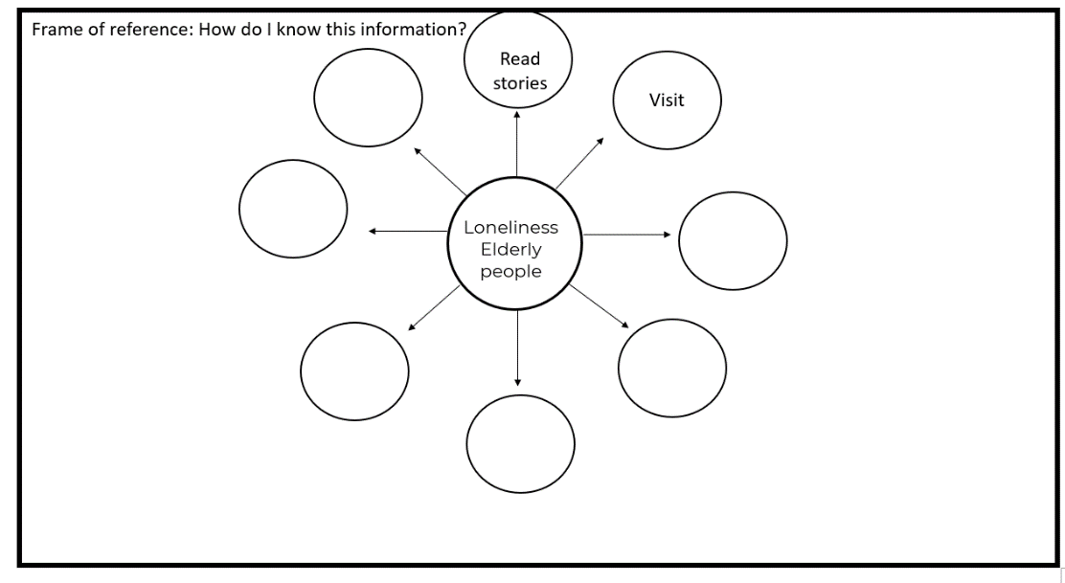  B.Brainstorming ideas: suggested time 10-15 minutes.  - Each group will use their challenge to brainstorm different ideas to solve this challenge. Remind learners that often the very best acts of kindness are actually free. Here are some examples of free acts of kindness for elderly people.  - Visit old people and chat to them.  - Write letters or cards and send them to an elderly person you know.  - Read books to elderly people.  - Play games with elderly people.  - Learners can use a bubble map to come up with ideas to solve the challenge they selected. In the middle of this bubble map learners can write the name of their challenge. In the bubble around this, write one idea.  - Remember the frame of reference. The frame of reference asks how we know this information e.g., did we read it in a book, someone told us, research it online etc…. Ask learners to share how they know this information.  A bubble map is one of 8 Thinking Maps. It is used to help us describe things, in this case, our ideas. The big bubble in the middle of the page has the question or statement in the middle, in this case, what ideas can we think of to share information about saving and protecting water? The smaller bubbles around the outside have the ideas. Bubble maps help people think creatively and come up with good ideas. They are useful when working on projects, solving problems, or making decisions.  C. Choosing our best ideas – Suggested time 10-15 minutes.  - Now in the final step learners need to choose their best idea. For this they can use the “Dot voting technique”.  - If you have any small stickers (a small round dot) give one sticker to each learner, if not learners can draw a dot.  - Still working in groups, learners will need to stick their dot on the idea that they like the most on their bubble map. Learners can draw a little circle if they don’t have stickers.  - The purpose of this is to visually see which idea is most popular.  - However, the idea with the most dots doesn’t automatically win. Learners will then need to assess this idea to see if it is realistic. They will need to ask themselves.  - Is the idea realistic? Can we do it?  - Do we need any special resources to do this idea?  - And can we get these resources if we need them?  They need to be mindful that the acts of assistance or kindness that they decide to proceed with needs to be feasible as they will in fact have to perform these actions. While the learners work together to select their challenge and find a feasible solution, walk around the class, and observe how each learner is participating.  D. Conclusions and reflections: suggested time 5 minutes.  Idea connection reflection.  This can be a group activity or a whole class activity.  - After the brainstorming session and choosing the ideas, have learners sit quietly for a moment.  - Ask them to think about the selected ideas and how these ideas connect to the problem they're trying to solve or the goal they're aiming to achieve.  - Instruct learners to focus on one aspect or feature of the chosen idea that they find particularly exciting or meaningful.  - Now, have each learner share their thoughts in a single sentence, starting with "I am excited about [aspect/feature] because…"  - As learners share their thoughts, encourage active listening, and focus on the positive aspects of the chosen ideas.  - This quick reflection activity will help learners connect the brainstorming session to the project's goals while fostering enthusiasm and motivation for the next steps.  Homework  Encourage learners to start working on their act of kindness |  | How learning happens.  S.P.E.C.I.A.L.  In this lesson, learners are actively engaged in the purposeful task of solving a problem and implementing an act of assistance or care.  Learners are drawing on their prior knowledge and the knowledge they have gained in previous lessons to understand the challenges that people in their community face.  Learners work collaboratively (social interaction) to come up with different ideas for their acts of kindness. Learners are actively engaged and paying attention in the activity because they are hands on and minds on, they are not sitting passively receiving information, they need to create the information, the ideas for the Heritage Day celebration.  Remember that reflection leads to learning that is ‘sticky’ learning that lasts. So, don't miss out the reflection activity.
Extended opportunities
- Learners can reflect on real life acts of kindness, either from their experience or what they have seen. They can analyse these to see what made them successful acts of kindness.
Observations and Facilitation – Assessment as Learning
While the learners synthesise their new knowledge about the challenges that face their community group and use this to select a challenge, it's important to actively observe and listen to learners as they work together in groups. These are just some examples of things to observe you might have your own list of observations to use.
  - Learners ’creative innovation - Are learners demonstrating creative innovation skills by generating ideas that are practical and suitable for the intended purpose?
  - Learners’ critical thinking skills - Are learners exercising critical thinking skills by evaluating and assessing the relevance of their ideas as they make their selections? Are they asking thoughtful questions and providing reasoned justifications for their suggestions?
  - Learners’ communication skills - Observe learners' active listening skills to determine if they are fully engaging with their peers during the interview process. Are they focused and attentive, or are they distracted or disengaged?

Teacher self-reflections

Reflecting on how a lesson went is essential to improve your teaching practice. By reflecting on the lesson, you can make adjustments to the project and enhance your future lessons. Annexure 8 contains a wide range of questions that you could use to reflect on this lesson. You do not need to answer all of them, just select one or two that resonate with you. Self-reflection is crucial for teacher professional development because it allows you to learn from your experiences, grow as a teacher, and improve your instructional effectiveness. By continually improving your teaching practice, you can better support your learners' learning and help them achieve their academic goals. Therefore, taking the time to reflect on each lesson is an investment in your professional development and the success of your learners.

Lesson 5: Preparing and planning our act of kindness | Resources needed:  Any resources that learners identified in the previous lesson |  | Time required:  1 lesson
Summary of the Lesson
In this lesson, learners can use this time to prepare anything they might need for their act of kindness, for example, if it is a kind letter learners could use this lesson to write their letter.
Objective
The purpose of this activity is to
- Applying and creating: using their learnings and experiences in the previous lesson to create their act of kindness.
- To practice
  - Effective communication as learners discuss and work collaborative on their act of kindness.
  - Empathy as they apply what they know to create innovative solutions to caring for others.
  - Critical thinking as learners evaluate their ideas and information to assess its relevance in creating different kind acts.
Lesson guidelines- what will learners and teachers do?  A. Explain the purpose of the lesson: suggested time 5 minutes.  - Explain to the learners that in this lesson they will have the whole lesson to work on their act of kindness.  B. Working on acts of kindness: suggested time 25-35 minutes.  - Allow time for learners to work in their groups on their acts of kindness. This is a good opportunity to walk around the room observing learners’ communication, collaboration, critical thinking, creative innovation skills.  C. Conclusions and reflections: suggested time 5 minutes  - In this reflection activity ask the groups to think about, if they could improve or change something(s) thing about their product what would it and how would they do it?  Homework  Allow homework time for learners to finish and complete their products/resources for their Water Warriors event. This is an opportunity to apply the changes they thought of during their reflection activity. |  | How learning happens.  Learners are actively engaged and paying attention in the activity because they are hands-on and minds on, they are not sitting passively receiving information. They need to apply the information that they gathered during their research to create an innovative and interesting way of showing kindness to other people in a way that solves a particular challenge or problem e.g. loneliness.
Extended opportunities
If you would like to take this a step further allow time for learners to present and share their products with other teams to give and receive feedback. Then allow time for learners to act on their feedback. This can be done quickly many times to develop a really solid piece of work. This is called Iteration and it is a very important part of the learning process.
Observations and Facilitation – Assessment as Learning
During this creative activity, it's important to actively observe and listen to learners as they work together in groups. As you walk around the classroom, keep an eye out for several key indicators of learning, including critical thinking, collaboration skills, knowledge retention, and creative innovation. Remember you might have your own list of indicators to look out for.
- Learners’ collaboration skills: these play a key role in the success of any group project. Take note of how learners are discussing and delegating roles and responsibilities within the team. Are they working together to fulfil these roles effectively, or are there issues with communication or teamwork that need to be addressed? Remember it takes time to develop these skills so it is unlikely that learners will ‘get-it’ the first time, and that is ok. Here are some prompts and scaffolds if learners are stuck.
  - Remind learners to remember and apply the guidelines to the roles or responsibilities within the group.
  - Encourage learners to share their thoughts and ideas openly and respectfully.
  - Remind learners that it's okay to disagree or make suggestions, but to do so constructively, focusing on the idea rather than the person.

- Learners’ creative innovation skills: This is a time in the process where learners will combine their content knowledge, collaboration, and critical thinking to create actual “products”. In this process learners should be beginning to analyse the information they have gathered; they should be starting to transfer this knowledge in a way that helps them solve the “problem” - in this case “How can we create an appropriate act of kindness for our chosen group ”. They will take risks as they try out things that others may not like or that may not work. All the time they will be needing to listen closely to each other in order to find solutions and generate ideas. They will need to reflect constantly on whether they are doing the right things right - and if not - try again. Here are some prompt and scaffolds if learners are stuck:
- Help them to consider modifying, rearranging, rewriting, or reframing as ways to find a new direction (use their thinking tools)
- If necessary, discuss with the learners whether their choice of either design, content, or “product” is the right one to be using (is it fit for purpose?).

Teacher self-reflections

Reflecting on how a lesson went is essential to improve your teaching practice. By reflecting on the lesson, you can make adjustments to the project and enhance your future lessons. Annexure 8 contains a wide range of questions that you could use to reflect on this lesson. You do not need to answer all of them, just select one or two that resonate with you. Self-reflection is crucial for teacher professional development because it allows you to learn from your experiences, grow as a teacher, and improve your instructional effectiveness. By continually improving your teaching practice, you can better support your learners' learning and help them achieve their academic goals. Therefore, taking the time to reflect on each lesson is an investment in your professional development and the success of your learners.

Lesson 6: Implementing our act of kindness. |  | Resources needed:  Any resources that learners identified in the previous lesson | Time required:  1 lesson
Summary of the Lesson
In this lesson, learners will create or implement their act of kindness depending on what this act of kindness is.
Objective
The purpose of this activity is to
- Applying and creating: their act of kindness
- To practice
  - Effective communication as learners implement their act of kindness.
  - Empathy as they apply what they know to implement their act of kindness.
Before the lesson  Depending on what the acts of kindness are and whether or not people from the community are coming into the school you might need to invite members of the community to this lesson. This lesson might need to take place during a lunch break or even outside of school hours.  Lesson guidelines- what will learners and teachers do?  A. Allow time for learners to implement their act of kindness. There are no guidelines here as each project will look slightly different. | How learning happens.  As learners work collaboratively (social interaction) to implement their acts of kindness they are actively engaged in the learning process (hands-on and minds on) which increases attention and engagement, which as we know leads to better learning outcomes. This experiential approach can create more vivid and lasting memories because it engages multiple senses and emotions, e.g. learners are not only sitting and listening - they are doing.  An experiential activity with real people is a nice place to observe the E - Enjoyment in S.P.E.C.I.A.L. Throughout the project learners would have had to persevere through challenges, they would have felt frustrations, they would have had to be resilient in overcoming challenges. The E for Enjoyment speak to the joy that you feel once you have overcome your challenges.  Learners are actively making meaningful connections between their prior knowledge and new practical learning experiences as they deal with problems and find solutions, give and receive feedback, present their ideas and so on.  All of this leads to ‘sticky’ learning, learning that is memorable, lasting, and relevant to the learners.
Observations and Facilitation – Assessment as Learning
While learners implement their acts of kindness you can observe their communication skills
Here are some suggestions of what you could observe:

- Learner communication skills
- Observe learners' active listening skills to determine if they are fully engaging with their chosen community group during their act of kindness. Are they focused and attentive, or are they distracted or disengaged?
- Additionally, pay attention to their articulation skills. Are they speaking clearly and confidently, or are they mumbling or speaking too fast, or speaking too loudly or softly?
- Empathy is another key communication skill to observe. Have the learners demonstrated that they understand how other people might be feeling? Are they showing empathy and consideration towards their chosen community group?

After the acts of kindness day or lesson you might want to give some feedback to learners, if there were any areas where the learners struggled you could
- model active listening yourself, demonstrating the kinds of behaviours you expect from learners.
- It can be helpful to share and discuss the definitions of good communication. The Teacher's Guide to Competencies is an excellent resource for this purpose, providing information and guidance on the development of communication skills.

Teacher self-reflections

Reflecting on how a lesson went is essential to improve your teaching practice. By reflecting on the lesson, you can make adjustments to the project and enhance your future lessons. Annexure 8 contains a wide range of questions that you could use to reflect on this lesson. You do not need to answer all of them, just select one or two that resonate with you. Self-reflection is crucial for teacher professional development because it allows you to learn from your experiences, grow as a teacher, and improve your instructional effectiveness. By continually improving your teaching practice, you can better support your learners' learning and help them achieve their academic goals. Therefore, taking the time to reflect on each lesson is an investment in your professional development and the success of your learners.

Lesson 7: Reflecting on experience and new knowledge. | Resources needed:  Chalk/board markers |  | Time required:  1 lesson
Summary of the Lesson
In this lesson, learners will reflect on their experience while performing their act of assistance or kindness. They will then document what they have learnt about the needs and struggles of their chosen community group, how we should treat others, how to employ empathy, and possible ways to show kindness and assistance to others.
Objective
The purpose of this activity is to
- Understanding: demonstrating an understanding of the importance of reflecting on experiences and sharing with others.
- Applying and creating: using their learnings to create evidence of their work in a creative way.
- To practice
  - Effective communication as learners share and receive feedback.
  - Kind communication as learners share their own views without hurting others.
  - Critical thinking as learners discriminate their ideas and information to assess its relevance.
Before the lesson  Write the following interview questions on the board.  - How did you feel when performing your act of assistance or kindness?  - How do you think the person or animal you helped felt?  - Did your act of kindness make a difference? Would you do anything differently next time?  - Do you think that you communicated with your group members well? Did you hurt anyone’s feelings? Did you express your needs to them?  Lesson guidelines- what will learners and teachers do?  A. Individual reflection: suggested time 10 - 15 minutes  - Encourage the learners to reflect on the questions that you have written on the board and to journal their answers in their life skills book.  B. Sharing our experiences: suggested time 10 minutes.  - The learners can now share their reflections with their group. Explain that each learner needs to have an equal amount of time to share their experience. So, for example, if the learners are in groups of 5 and you have allocated 10 minutes to this activity, each learner will have 2 minutes to share.  - You could suggest that each group has a timekeeper to make sure that they divide their time fairly.  - Encourage the learner’s team members to provide feedback to them during this process. During this time, you can walk around and listen to hear how the learners have self-reflected.  C. Documenting learnings: suggested time 25 minutes  Inform the learners that they will be sharing what they have learnt about their chosen community group and the act of kindness in the following lesson. Share the presentation rubric with the learners and explain how long their presentation should be. They are welcome to document their new knowledge and understanding as a booklet, poster, storybook, song, skit or chose whatever way they like to present. Their documentation needs to explain what they have learnt about:  - the needs of their chosen community group,  - the struggles that their chosen community group faces,  - how our class (grade 6s) should treat these people/animals, now and in the future,  - how they employed empathy – an ability to try and understand the other person’s feelings and views,  - possible acts of assistance or kindness that their community group would appreciate,  - what would you do differently next time?  Homework  Allow time for learners to complete their presentations/activities for homework. |  | How learning happens.  S.P.E.C.I.A.L.  During this lesson, learners receive an opportunity to reflect on their experience and reconsider the challenges and solutions that they thought about and implemented. This process introduces iteration. As learners seek feedback and reflect on their learning, they are able to identify areas for improvement. As they begin synthesising their learning, they develop a deeper understanding of it as they revisit the topic from different viewpoints or perspectives, continually strengthening connections between prior knowledge and new knowledge.  Why is reflection so important for learning:  The process of reflection allows learners to identify what they learnt from the lesson and connect it to any prior knowledge they had about the topic.  Reflection also supports deeper learning by promoting a learner’s metacognition (their thinking about thinking skills), encouraging learners to think about how they might transfer knowledge to a different context.  Reflection develops learners' self-direction, by giving learners the opportunity to monitor progress and adjust their learning strategies accordingly.  Providing regular opportunities for learners to reflect on their learning is a critical step in making learning sticky (memorable and lasting).
Observations and Facilitation – Assessment as Learning
While learners share their reflections with their peers, it is important to actively observe their communication skills and depth of reflections.
Here are some suggestions of what you could observe:

- Learner communication: how clear was the learner’s communication? Were they able to express their ideas clearly?
- Quality of reflections: did the learner engage deeply with the reflective questions? Did they uncover any meaningful insights that they could place into practice in the future?
While learners create a presentation/resource that shares their learning, it's important to actively observe and listen to learners as they work together in groups. You could make observations about the following:
- Creative innovation: Are learners demonstrating creative innovation skills by designing an entertaining and engaging presentation?
- Critical thinking: Are learners discriminating against their new knowledge to select only relevant information to share in their class presentation?
- Learner Knowledge: Observe how learners deepen their understanding of life for their chosen community group, by designing a presentation for their class.

Teacher self-reflections
Reflecting on how a lesson went is essential to improve your teaching practice. By reflecting on the lesson, you can make adjustments to the project and enhance your future lessons. Annexure 8 contains a wide range of questions that you could use to reflect on this lesson. You do not need to answer all of them, just select one or two that resonate with you. Self-reflection is crucial for teacher professional development because it allows you to learn from your experiences, grow as a teacher, and improve your instructional effectiveness. By continually improving your teaching practice, you can better support your learners' learning and help them achieve their academic goals. Therefore, taking the time to reflect on each lesson is an investment in your professional development and the success of your learners.

Lesson 8: Sharing our new knowledge. | Resources needed:  Learner Self-Reflection Tool (annexure 7) Assessment Rubric |  | Time required:  1 lesson
Summary of the Lesson
In this lesson, learners will share what they have learnt with the class by presenting their poster, booklet, storybook, song or skit. They will also complete the learner self-reflection.
Objective
The purpose of this activity is to
- Applying: the knowledge and skills learnt to improve the delivery of their presentation
- Analysing: their presentation to identify areas for improvement and make necessary adjustments
- Synthesizing: the information they have learnt about the community group and communicate it clearly and cohesively through their presentation
- Evaluating: their own learning and progress throughout the project
- To practice
  - Communication as learners articulate their experience to the class.
  - Meta-learning (thinking skills) as learners reflect on their experience.
Lesson guidelines- what will learners and teachers do?  A. Practice for their presentation: suggested time 10 minutes.  - Allow the learners some time to practice their presentation and make sure that they have everything in order.  B. Presentations: suggested time 35 minutes.  - Allow time for the learners to present what they have learnt.  - While they present the teacher will allocate their marks on the Assessment Rubric.  - The class should watch each group present.  C. Completing the Learner Self-Reflection Tool: suggested time 10 minutes.  Provide each learner with a Self-Reflection Tool and encourage them to complete it independently. |  | How learning happens.  S.P.E.C.I.A.L.  Learners are re-exposed to the same information in a new, exciting, and enjoyable manner. Since the presentations will be creatively delivered by the learner’s peers, they will be memorable. As they have all worked on similar projects, the presentations will also be relatable. This iteration of exposure leads to lasting and sticky learning.  Remember that reflection leads to learning that is ‘sticky’ and lasts. So, don't miss out the reflection activity.
Extended opportunities
- Each group could mark their peers and provide them with constructive criticism
End of Project Reflections
- Once the presentation is over, make sure there is time to debrief the experience with the learners.
- Ask learners to complete the Learner Self-reflection Table (see annexure 7). You can decide what method to use to complete the reflection e.g., independently, in a group, in pairs.

Exemplar Assessment rubric
This is an exemplar assessment rubric that reviews the whole project so please review:
- all your observations across all lessons in this project
- learner participation in the water awareness event
This collective feedback will be invaluable in completing this assessment rubric for this project. Since this is an exemplar rubric there are a number of different assessment criteria so, please use what is relevant to your situation and context, adapt, change, edit as needed. You can of course use all the criteria and use it as is.
GRADE SIX ASSESSMENT RUBRIC
I care: How can we understand the needs of others so that we can show kindness to people and animals
CRITERIA  How do we know that learners can do this? | 13-15  Mastering | 10-12  Advancing | 7-9  Developing | 4-6  Learning | 1-3  Starting | Insert your marks here
Knowledge  Exhibiting care for people and animals  (CAPS content)  To what extent did the learners show understanding by describing, explaining, and considering the needs of others. | Exhibiting empathy, compassion and kindness to others: Learners are able to consider the needs and views of others and demonstrate an understanding of these needs/views. They are able to use this insight to provide assistance or kindness to those in need. Learners are able to communicate their own views without hurting others.  Learners are aware of the possible acts of cruelty towards animals and have a good understanding of what to do if an animal is hurt or in danger. They exhibit an understanding of what animals require from human care and are able to provide this care. | Understanding the needs of others and how we can provide assistance: Learners are able to consider the needs and views of others and demonstrate an understanding of these needs/views. They are able to use this insight to provide assistance or kindness to those in need.  Learners are aware of the possible acts of cruelty towards animals and have a good understanding of what to do if an animal is hurt or in danger. They exhibit an understanding of what animals require from human care. | Understanding the needs of others: Learners are able to consider the needs and views of others and demonstrate an understanding of these needs. However, they are not yet able to use this insight to identify manners in which they can provide assistance or kindness to those in need.  Learners are aware of the possible acts of cruelty towards animals and have a good understanding of what to do if an animal is hurt or in danger. However, they are not yet able to use this insight to identify what animals require from human care. | Describing the needs of others: Learners are able to describe what people and animals may need. They are beginning to demonstrate an understanding of these needs and how another may feel as a result of these needs.  Learners can identify acts of cruelty but might not be able to suggest solutions to these challenges. | Identifying the needs of others: Learners are able to describe what people and animals may need but may not understand what these needs mean or how they make others feel.  Learners are not able to identify acts of animal cruelty.
Does the learners’ presentation show that effective research and impactful actions were conducted? Is their presentation creative and eye-catching? Was the presentation presented clearly and with confidence | Mastering  The presentation demonstrates exceptional insight and understanding of the lives of a different community group.  Learners research and planning process is comprehensive, well-organised, and shows strong teamwork.  The presentation is highly creative, visually striking, and celebrates the group’s new knowledge.  The presentation demonstrates exceptional insight and understanding of the lives of a different community group.  Learners communicated effectively with the audience by considering their needs and adapting accordingly  Learners used appropriate articulation, tone, and pitch to engage audience and convey ideas effectively | Advancing  The presentation shows that the learners were thoughtful in their project and applied the concept of kindness to their chosen group.  Learners research and planning process is thorough and demonstrates clear collaboration among members.  The presentation is creative and effectively conveys what has been learnt.  Learners’ arguments were mostly logical, thoughtful, and convincing.  Learners constructed an effective and relevant presentation.  Learners communicated effectively with the audience most of the time.  Learners used appropriate articulation, tone, and pitch to engage the audience and convey ideas effectively. | Developing  The presentation shows that the learners have learnt about the lives of a different community group.  Learners' research and planning process is organised and demonstrates understanding.  The presentation is visually appealing and appropriate for sharing what has been learnt.  Learners’ arguments were somewhat logical, thoughtful, and convincing.  Learners communicate with the audience but may not fully consider their needs. | Learning  The presentation shows a simple understanding of the lives of a different community group.  Learners’ research and planning process is present but needs more depth or organisation.  Learners demonstrated limited innovation and creativity in their presentation.  Learners' arguments were not always logical, thoughtful, or convincing.  Learners constructed a somewhat effective and relevant presentation.  Learners struggled to communicate effectively with their audience. | Starting  The presentation does not yet show a good understanding of the lives of different community groups.  Learners’ research and planning process is minimal or unclear.  Learners demonstrated minimal innovation and creativity in their presentation.  Learners’ arguments were weak and not logical, thoughtful, or convincing.  Learners constructed an ineffective or irrelevant presentation.  Learners struggled to communicate with their audience.
Comments/  feedback |  |  |  | Total marks | /30

How did the project help learners to grow their skills | Yes | No
Critical Thinking: is about asking questions to understand the world, it is also about trying to make sense of information, evaluating it and connecting it to other pieces of information.
- Did the learners grow their critical thinking through the project?
- Was there a difference from the start to the end of the project in the learners’ critical thinking skills?
- Did the learners ask questions?
- Did the learners find the relevant and appropriate information, evaluate, and analyse it and apply it to solve a problem?
- Did you notice a change in learners’ critical thinking skills?
COMMENTS: What did you notice

Creative Innovation: is the ability to come up with many different ideas and apply them to find realistic solutions to problems.
- Did the learners grow their creative innovation through the project?
- Was there a difference from the start to the end of the project in the learners’ critical thinking skills?
- Did the learners generate ideas and seek solutions?
- Did the learners transfer their knowledge of and experience about kindness to find solutions?
- Did you notice a change in learners’ creative innovation skills?
COMMENTS: What did you notice

Collaboration: when people work with each other to complete a task. It involves cooperation and teamwork and the sharing of ideas, knowledge, and skills to reach the same goal.
- Did the learners grow their ability to collaborate through the project?
- Was there a difference from the start to the end of the project in the learners’ collaboration?
- Did the learners show an ability to compromise, be considerate of each other, and be positive in a conflict situation?
- Did the learners leverage each other’s strengths? (Pool their collective resources in terms of strengths and knowledge)
- Were the learners willing to listen, empathise, and give and receive useful feedback to the team?
- Did you notice a change in learners' creative innovation skills?
COMMENTS: What did you notice

Communication: is all about sharing information, it is about what we say (verbal communication) and how we say it (non verbal communication).
- Did learners grow their ability to understand non-verbal cues such as tone of voice, body language through the project?
- Was there a different from the start to the end of the project in how learners spoke (articulation) e.g. did they stop mumbling, talked at the right speed, used the right tone etc.
- Did you notice a change in learners ability to try and understand things from other peoples perspective e.g. their empathy skills?
COMMENTS: What did you notice

Annexures - useful tools for the project

Annexure one: Example letter to parents and caregivers about Project-based Learning
This is just an example. Feel free to edit and adapt it to your needs.

Dear Parents and Caregivers,

We hope this letter finds you well. We want to share with you an exciting project that your child will be working on in school called "I care: promoting empathy, compassion and kindness". This is a Project-based Learning project. You may have already heard a lot about Project-based Learning, but if not, Project-based Learning is a teaching method where learners learn by actively engaging in real-world and meaningful projects. Through this method, learners are given the opportunity to collaborate with their peers, conduct research, and apply their knowledge and skills to solve real-life problems.

There are many benefits to Project-based Learning. This method encourages creativity, critical thinking, and problem-solving skills. Learners also learn to communicate effectively, both with their peers and the community, and build personal connections with the subject content (CAPS), leading to deeper and more memorable learning experiences.

We are excited to inform you about our current project, " I care: promoting empathy, compassion and kindness " which aims to help learners develop empathy, compassion, and kindness towards others. By engaging in activities that require them to care for people/animals in their school or community, they will develop stronger social skills and connections with others, which can help them develop a sense of community and a deeper understanding of the needs of others. Through reflection and discussion, learners will develop a greater appreciation for the importance of caring for others and will be better equipped to demonstrate empathy, compassion, and kindness in their interactions with people/animals in their community. In order for the project to be successful, learners will need to find ways to work collaboratively, communicate effectively, and share their knowledge with others. There are lots of ways you can support your child in their Project-based Learning journey that will not cost you anything. You can

- Encourage your child to ask questions and take ownership of their learning. This can help them develop critical thinking skills and become more engaged in the project.
- Help your child find resources and materials related to the project topic. This can include books, articles, websites, or even just your own knowledge about the topic.
- Ask your child about their project and listen to their ideas. Show interest and enthusiasm for what they are learning and offer positive feedback to encourage their progress.
- Help your child manage their time effectively by helping them to create a schedule or calendar with deadlines and milestones for the project.
- Attend interviews with your child if your child is speaking to people within the community.
- Attend any events or presentations related to the project and show support for your child and their classmates as they showcase their work.

We believe this project will promote attention and engagement among our learners, as they develop empathy, compassion and kindness and learn how to share these characteristics with the community. We encourage you to support your child throughout this project.

Thank you for your ongoing support of our learners' education.

Sincerely,

[Your Name]
…………………………………………………………………………………………………………………………………………………………………………………………………………………………………………………………………………………………………………
This is to confirm that I __________________________________ parent/guardian of ___________________________________ have read this letter and I understand what the project is all about.

Annexure two: The Project Wall

How to create your own Project Wall

Have you heard of a Project Wall? Or maybe you already have lots of Project Walls in your classroom. It's a physical space used in project-based learning to visually display the progress and development of a project. It's a central location where everyone can see and contribute to the organisation of ideas related to the project. If you're looking to create your own project wall, here are some ideas of what to include:
- The driving question.
- The project goals.
- Assessment rubrics
- Tools that learners might use, like templates of thinking maps.
- The steps of the project
- Reflection tools
- Pictures
- Examples of learners' work
- Questions that learners have

The Project Wall should be an evolving space that changes and grows as the project progresses, with new insights and ideas constantly being generated.

So, how does a Project Wall support learning? Here are a few ways:

- It provides a space for learners to engage with the project material and reflect on their progress.
- It makes learning visible, so learners know what they need to learn, how to learn it, and how to evaluate their own progress.
- It's a place to practice collaborative learning, as learners can decide together what to put on the wall.

Remember, a project wall is a great tool to help you organise and visualise your ideas, keep track of your progress, and learn collaboratively with your team.

Annexure three: Project route map

About this project: I Care

Hi there! This is a project where you and your friends will work together to perform an act of kindness to a certain group in your community. To make this happen, you will need to talk to your friends and interview members of your chosen community group to discover what challenges they face and what you can do to help them through one of these challenges. After performing your act of kindness, you will be able to share what you have learnt with your peers in an exciting and creative way. Perhaps you would like to make a booklet, or poster, write a storybook, create a song or a skit? During the project, you will learn lots of new things about the people around us and will be able to develop a sense of empathy toward them (this means being able to understand how others feel and think). You will also get to practice different kinds of thinking skills, like remembering information, understanding new ideas, and solving problems. But most importantly, you will work together with your friends and share what you have learnt with others. This will improve your understanding and make learning even more exciting and fun!

Scenario: You and your friends live in a diverse community with people facing various challenges. As a team of compassionate young learners, you decide to form a group called "Community Kindness Crew." Your objective is to learn about the unique challenges faced by a specific group of people or animals within your community or school and find a way to offer assistance or perform an act of kindness.

Driving Question: How can the Community Kindness Crew identify a group in need, address their challenges with creativity and teamwork, and share our experience with peers?

Lesson | What am I doing? | Status Tick this as you complete the tasks
1 | Welcome to the Kindness Crew! In this fun lesson, you'll pick a group or individuals to help and create a set of interview questions to learn more about them.
2 | Time for interviews! Chat with your chosen group, individual or animal group to discover their needs and how you can help.
3 | Let's analyse the interview info! Dive into the details you gathered to find out what matters most.
4 | Get creative with acts of kindness! Brainstorm ideas for your special act of kindness and choose the best ones to bring to life.
5 | Prep time! Get everything ready for your act of kindness, whether it's making something, researching, or planning.
6 | Kindness in action! Carry out your act of kindness and make a difference in someone's life.
7 | Time to reflect! Think about your experience and what you've learned about the needs and struggles of your chosen group, empathy, and how to show kindness to others.
8 | Share your journey! Present your poster, booklet, storybook, song, or skit to the class and complete a self-reflection to wrap up your amazing kindness adventure.

Annexure four: Roles and responsibilities

Here are some examples of roles and responsibilities. Print a copy for each group and place one copy on the project wall.
Instructions: Choose a role that you would like to practice. Do not worry if you do not have the skills yet for the role, this is a great opportunity to practice different skills. By the end of the project, make sure you have tried more than one role so that you can practice and grow your skills.

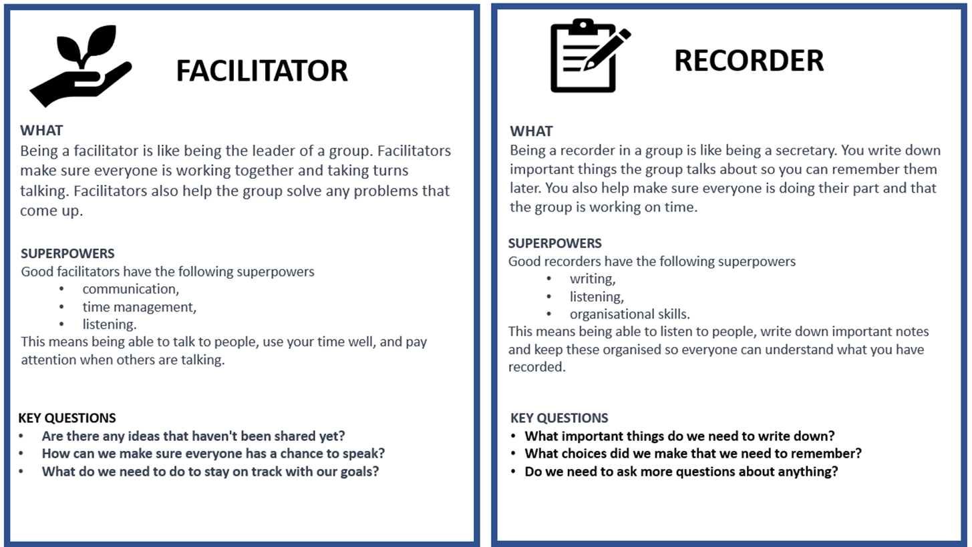

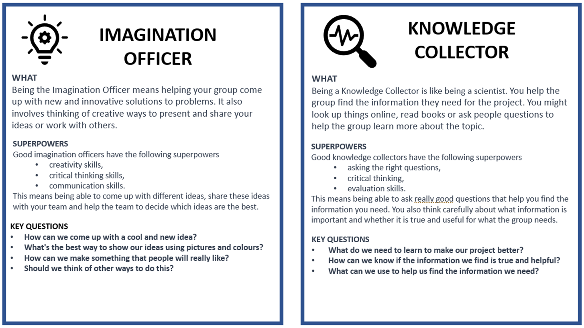

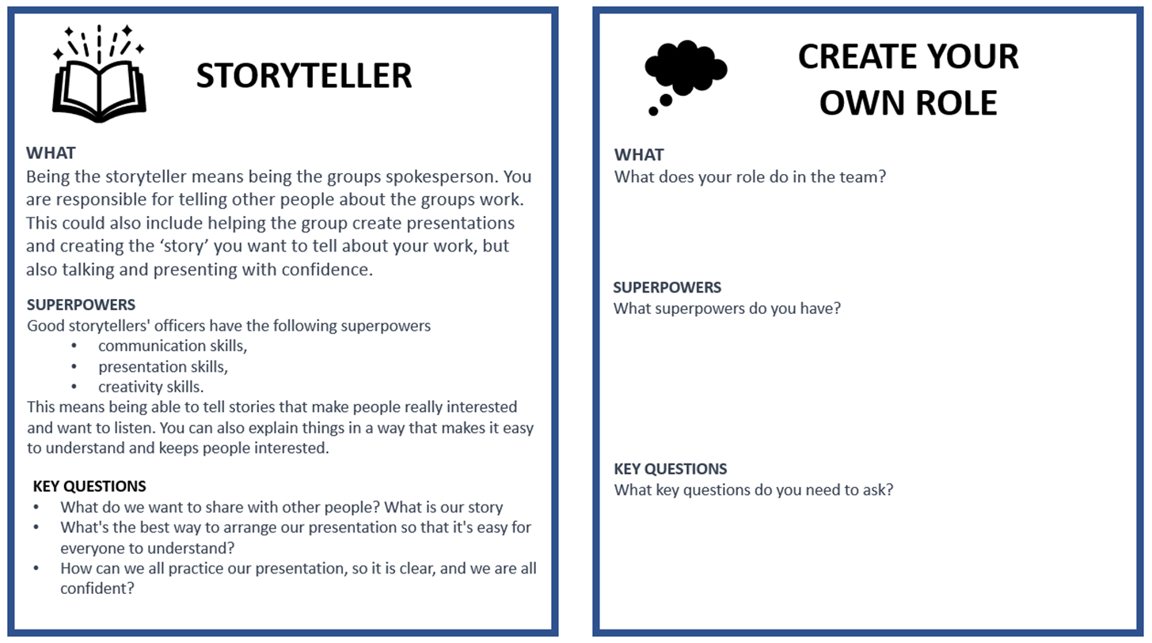

Annexure five: Hand out to assist in selecting the community group.

This is an example of a handout that you could provide your class. Complete the table with the details of relevant people in your community. You are also welcome to create your own hand out and include any information that you think your learners may find helpful.
Community Group | Representative | Contact Details | Special features of this community group
Toddlers | Perhaps an ECD teacher in your area
Stray animals | Head of an animal shelter/ SPCA in your area
The elderly | Matron at an old age facility in your area
Teachers | Your colleagues
Orphans | Person in charge of an orphanage
Homeless | Someone that works at a soup kitchen
Civil servants | Someone at a police station, fire department or social worker

Annexure six: Teachers as scaffolders of learning

Scaffolding learning is an instructional approach that is essential for Project-based Learning. When you scaffold learning you are providing support and guidance to learners as they engage with new or challenging material. The term "scaffolding" refers to the temporary support structures that construction workers use to help them reach high places while they build a building. In education, scaffolding means providing learners with the support they need to build their understanding of a topic or skill.
Scaffolding learning typically involves several steps.

- First you assess the learners' prior knowledge and skills. What do learners already know about the topic and what gaps or misconceptions may need to be addressed.
- Provide support and guidance to help learners engage with the material and build their understanding. This support may take many forms, including modelling, feedback, prompts, and questions.
- As learners become more confident, gradually reduce the scaffolds.

Here are some examples of questions you can use in different circumstances to help scaffold your learners' learning.
Clarifying questions  Ask these types of questions to clarify learner understanding of a topic.  - Can you explain what you mean by that?  - Can you give me an example to illustrate your point? | Prompting questions  Ask these questions to help learners to think more deeply about a topic or idea.  - What other perspectives or points of view could we consider?  - How does this relate or link to what we've learnt before?
Elaboration question  Ask these questions to encourage learners to expand on their ideas.  - Can you tell me more about that?  - Why do you think that is the case? | Strategy questions  Ask these questions to help learners develop problem-solving skills and strategies.  - What steps could we take to solve this problem?  - What information do we need to gather to answer this question?
Prediction questions  Ask these questions to help learners anticipate what might happen next.  - What do you think will happen if we try this?  - What do you expect to see when we conduct this experiment? | Clarification questions  Ask these clarification questions to help learners understand complex or abstract concepts.  - What do you think this term means?  - Can you give me an example of how this concept works in real life?
Reflection questions  Ask these questions to help learners to reflect on their learning.  - What did you learn today?  - What was challenging about this activity, and how did you overcome those challenges? | Comparing and contrasting questions  Ask these questions to help learners understand similarities and differences between concepts or ideas.  - How is this similar to/different from what we learnt before?  - What are the advantages and disadvantages of these two approaches?
Summarising questions  Ask these questions to help learners summarise key points or ideas.  - Can you tell me in your own words what we learnt today?  - What are the most important takeaways from this reading? | Thinking questions:  Ask these thinking questions to help learners reflect on their own learning processes and strategies.  - What strategies did you use to approach this task?  - How can you apply what you learnt in this assignment to other contexts?

Annexure seven: Learner Self-Reflection Tool

THINK ABOUT WHAT YOU DID IN THIS PROJECT, AND HOW WELL THE PROJECT WENT. WRITE YOUR COMMENTS BELOW

You Name:
Project Name:
What was the Driving Question
Your answer to the driving question

What did you learn about working with other people?

What worked/what did you enjoy?

What do you want to improve when you work with other people?

How could your teacher(s) change this project to make it better next time?

Annexure eight: Teacher S.P.E.C.I.A.L. Self-reflection tool

How to use this tool

Using the teacher self-reflection tool is a simple yet effective way to evaluate your teaching practices. After each lesson, select a few questions to reflect on. Pick 1 or 2 questions from each:
- General reflection questions.
- S.P.E.C.I.A.L reflection questions.

The purpose of this tool is to help you identify what went well and what could have been improved in your lesson. You can also consider how much your learners learnt and how they engaged with the learning process. By doing this, you can develop a better understanding of your teaching style and how it impacts your students. Through regular reflection, you can make adjustments to your approach, learn from your mistakes and build on your strengths, leading to improved teaching outcomes for your students.

Why is teacher self reflection so important

Teacher self-reflection is an essential aspect of effective teaching that involves the careful analysis of one's teaching practices to identify areas of strength and improvement. By reflecting on the lesson, you can evaluate their effectiveness in conveying the lesson's objectives, engage learners’ interest and attention, and adjust your teaching strategies to improve the learning outcomes. Moreover, self-reflection enables you to develop your teaching skills and knowledge. In summary, teacher self-reflection is crucial for continuous professional development and improvement, and it helps to ensure that learners receive high-quality and effective instruction.

General reflection questions
- Which teaching strategies were most effective in engaging the learners and promoting understanding? Are there other strategies that could be explored in future lessons?
- How did learners respond to the activities and tasks? Were they actively participating and demonstrating understanding? What adjustments could be made to enhance learner engagement and comprehension?
- Were there any misconceptions or misunderstandings that emerged during the lesson? How were they addressed, and how can they be prevented in future lessons?
- How effectively was feedback provided during the lesson? Were learners given opportunities to reflect on and improve their understanding?
- What opportunities were provided for learners to collaborate, problem-solve, and think critically? Can these opportunities be further developed in future lessons?
- What can be learned from this lesson to inform planning, instruction, and assessment for future lessons?

S.P.E.C.I.A.L. Reflection questions
Prior Knowledge:  - How did I activate and build on the learners' prior knowledge during the lesson?  - Were there any gaps or misconceptions in learners' prior knowledge that needed to be addressed? How were they handled?  - How can I better connect new concepts to learners' existing knowledge in future lessons? | Curiosity:  - How did I encourage learners' curiosity and inquisitiveness during the lesson?  - Were there opportunities for learners to explore and investigate the subject matter on their own or with peers?  - How can I better incorporate inquiry-based learning and curiosity-driven activities in future lessons?
Social Interaction:  - How did I facilitate opportunities for social interaction and collaboration during the lesson?  - Were learners actively engaging with one another and sharing their ideas? How can I further promote this in future lessons?  - What role did peer feedback and discussion play in deepening learners' understanding of the material? | Iteration:  - Were learners provided with opportunities to practice, iterate, and refine their understanding and skills during the lesson?  - How effectively did I offer feedback and guidance to support learners' iterative learning process?  - How can I create more opportunities for practice and iteration in future lessons?
Purpose:  - Were the learning objectives clear and purposeful for the learners? Did they understand the relevance of the lesson to their lives and future learning?  - How did I connect the lesson content to real-world applications or contexts?  - What can I do to make the purpose of future lessons more explicit and meaningful for my students?  Enjoyment:  - How did I incorporate elements of enjoyment and fun into the lesson?  - Were learners actively enjoying the learning process? What can I do to further enhance their enjoyment in future lessons?  - How did the learning environment and classroom atmosphere contribute to learners' enjoyment and motivation? | Active Engagement:  - Were learners actively engaged in the learning process, both cognitively and behaviourally?  - Which activities or strategies were most successful in promoting active engagement and deep learning?  - How can I better design future lessons to foster active engagement and higher-order thinking?  Attention and Engagement:  - Which activities or strategies were most successful in capturing and maintaining learners' attention during the lesson?  - Were there any points during the lesson where learners seemed disengaged or distracted? How can I address these issues in the future?  - How can I modify the lesson to better sustain learners' attention and interest in the subject matter?
Learner Autonomy:
- How did I promote learner autonomy and self-directed learning during the lesson?
- Were learners given opportunities to make choices and take ownership of their learning?
- How can I further support the development of learner autonomy and self-regulation in future lessons?

Find out more.

www.ecubed-dbe.org
https://learn.ecubed-dbe.org/

