WATER WARRIORS’ AWARENESS

Playful learning to prepare teachers and learners to thrive in a changing world

CONTENTS PAGE
PROJECT OVERVIEW 4
Preparing for the project 7
The project 8
Lesson 1: Why is water important? 8
Lesson 2: What can we learn about saving and protecting water? 12
Lesson 3: How can we share our ideas with others? 15
Lesson 4: How can we create engaging materials to share our knowledge? 19
The public presentation - being Water Warriors 21
Exemplar Assessment rubric 22
Annexures - useful tools for the project 25
Annexure one: Example letter to parents and caregivers about Project-based Learning 25
Annexure two: The Project Route Map 26
Annexure three: Creating a project wall instruction. 27
Annexure four: The Water Scarcity Game 28
Annexure five: Case study - Cape Town's Water-Saving Adventure: 32
Annexure six: Roles and responsibilities 33
Annexure seven: Resources about saving water. 36
Annexure eight: Resources for protecting water. 38
Annexure nine: Teacher self reflection tool 41
Annexure ten: Useful resources 42
Annexure eleven: Water Warrior Awareness Event ideas 43
Annexure twelve: Learner Self Reflection Tool 45

PLEASE NOTE
This is an exemplar project, but we encourage you to make it your own. Please feel free to adapt it as necessary to ensure it is suitable and relevant to your learners in your classroom. Remember, the ultimate goal of this project is to engage your learners and foster their learning, so don't be afraid to put your own spin on it! The activities and assessments in these lessons are here to guide you on your Project-based Learning journey. Feel free to adapt the activities and assessment to suit your learners needs.

The definition of a project according to the SBA
General Education and Training Phase (GET) Life Skills SBA Exemplar Booklet Grades 4 - 6, pg. 10
A project…
… is an assessment task that requires considerable effort. It is a form of assessment that is used to enable learners to apply their knowledge and skills. Generally, a project takes a long time to complete, as a result it is ideal that it is done in groups of about five and marked at different stages of development. The project will involve collecting, analysing and/or evaluating data and information that will result in the synthesising of the findings into a written product that may be reported, modelled or performed by the learners.

Learners will generally collect data/resources/information outside the contact time to perform the task. The topic and nature of the project will be determined by the content covered according to the annual teaching plan. Learners should be given enough time to complete the project. A project should be given before the end of the second term for submission during the third term.

PROJECT OVERVIEW
 | Name of project: Water Warriors Awareness
Subject: Life Skills |  | Grade: 5 |  | Duration: 2 weeks
Possible areas for integration with other subjects:  - Natural Sciences - water and air topics  - Social Sciences: - the importance of water for human survival and how water scarcity affects societies and economies. |  |  | - Life Skills - environmental awareness and care topic  - Language - researching, presenting, and communicating
CAPS content covered.  Click here for the 2023/2024 ATPS. |  | Water as an important basic need:  - Importance of water  - Different ways of saving water  - Different ways of protecting the quality of water
Driving question |  | The Water Warriors of South Africa  Scenario: You live in a small South African Town and you are facing a severe water crisis. Your town’s water supply is running low, and everyone is starting to feel the effects of water scarcity. A group of curious and determined grade five learners decide to take matters into their own hands and form a team called "The Water Warriors." Your objective, as a Water Warrior, is to learn all you need to know about the importance of water as a basic need, identify ways of saving and protecting water, and come up with creative ideas to help other people in your community save and protect water.  Driving question: How best can we share our knowledge and ideas with others at Water Warriors Awareness Day so that they become aware of the importance of water and start to use it with respect?
Project summary and objectives |  | This project requires learners to work collaboratively and draw on their knowledge and to research the importance of water, different ways of saving water, and different ways of protecting the quality of water. This will lead to participating and presenting their product at a Public Presentation that explains how we can all be more careful using water in our daily lives, that raises the awareness of the water crisis, and that motivates the audience to become active Water Warriors.  Throughout the project, learners will be expected to communicate effectively, both with their peers and their community/caregivers, to gather knowledge and understanding about water generally, its scarcity and the ease with which it can be damaged or abused (prior knowledge). They will also need to use their creative and critical thinking skills as they decide what issues they want to raise at their event, promoting opportunities for learners to be engaged and pay attention. Additionally, learners will be expected to use various thinking tools, including bubble maps, tree maps, and flow maps, to order, analyse, and evaluate information (data), as well as plan and sequence the necessary tasks to create their products.  Throughout the project, learners will have the opportunity to practice all of Bloom's cognitive levels, ranging from basic knowledge and comprehension to higher-order skills such as analysis, synthesis, and evaluation (deep learning). In order for the project to be successful, learners will need to find ways to work collaboratively, communicate effectively, and share their knowledge with others. Through this authentic real-life practice, learners will build personal connections to the subject matter, leading to deeper and more memorable learning experiences.
Entrepreneurial way-of- being skills developed in this project |  | Communication |  | Collaboration
 |  | Critical Thinking |  | Creative Thinking
Products |  | Products to share knowledge about the importance of water and saving and protecting water, that inspire people to save and protect water.
Public presentation |  | Water Warriors Awareness Day
Activating the science of learning |  | This project:  - Activates learner prior knowledge by asking learners to draw on their existing knowledge of the importance of water, its uses, and ways they know of to save and protect it, to plan the Water Warriors Awareness Day event. The project uses several retrieval practices such as the use of Thinking Maps such as the bubble map, the flow map, a rating table, and brainstorming.  - Focuses learner attention and engagement on the learning because learners work collaboratively on a real-world issue and are involved in doing, creating, and reflecting. Learners conduct research, brainstorm ideas, design solutions, implement them, and reflect on their experience. This type of active learning is more effective in promoting knowledge retention and skill development than passive learning, where learners sit in silence to complete work on their own.  - Results in ‘sticky learning’ learning that is memorable and lasting because it is relevant to learners' real lives (e.g., a topic on water) and gives learners a ‘voice and choice’ in how they create their Water Warriors Awareness Day event.
Lesson summary  This is a 2-week project. The following activities are intended to guide learners to use their voice and choice to come up with a creative way of answering the driving question |  | Lesson one: Why is water important? Learners understand the importance of water through a game and a real-life case study while being introduced to the project scenario.
Lesson two: What can we learn about saving and protecting water?
Learners research water scarcity and conservation methods to apply to their community.
Lesson three: How can we share our knowledge about water with others?
Learners brainstorm and select ideas for sharing their water knowledge at an awareness event.

Lesson four: How can we create engaging materials to share our knowledge?
Learners collaborate to create engaging materials for their Water Warriors Awareness event.
 |  | Public Presentation - Being Water Warriors - Water Awareness Day
Entrepreneurship add-on possibilities |  | The project team could take this project one step further and create entrepreneurial opportunities such as:  - Create and sell handmade water-saving reminder cards or stickers that can be placed near water sources (like taps and showers) to remind people to save water. This will teach learners basic crafting skills and the importance of marketing a product with a purpose.  - Create and sell food at their Water Warriors event.  Learners could create a business plan that includes a feasibility study, market research, budgeting etc to see how feasible and realistic their business could be. What other ideas can your learners think of?

Preparing for the project

Preparing learners
- This is a short (but powerful) project so preparation and planning is important. It's recommended that you plan the groups before starting the project so that learners are already sitting together and are starting to get to know each other.
- It’s recommended to explain the overview of the project - share the project overview with learners, including the scenario and the driving question before the project starts. You can find this in annexure two the project routemap
- Effective group work is more manageable and more effective when each group member has a role and responsibility. Please see annexure 6 for more detail on the types of roles that are useful for a project.

Preparing the classroom
- Before launching the project, you can create a Project Wall. This is very similar to a theme wall where you display and show resources, pictures, posters and objects about your new theme. The Project Wall takes this a step further in that it shows the driving question, journey of the project (route map found in annexure 2). The Project Wall can begin with a display of what learners already know about the topics and as the project progresses their displays become richer and richer which makes the growth of their learning visible. Keywords can be placed on the wall as can curious questions that learners ask that you want to revisit. As far as possible, get the learners to organise the wall and take ownership of what is displayed - after all it's their project and their learning. To learn more about Project Walls please see annexure 3

Teacher preparation
- Read the project instructions. Make any changes or updates to the project to suit your learners needs.
- Read Teaching for Learning in a Fast-Changing World. You can download it here: https://www.uj.ac.za/wp-content/uploads/2023/01/teaching-for-learning-in-a-fast-changing-world-e-version.pdf
- Do the Introduction to Project-based Learning course online https://learn.ecubed-dbe.org/courses/introduction-to-project-based-learning/
- Read the collaborative learning guide and the Thinking Maps instructions. These are really short and will help you to make this project really effective.

Preparing parents and colleagues
- Inform parents and caregivers about your project. We have created a template that you can adapt, you can find this in annexure 1.
- Tell your colleagues about your project and what to expect e.g., for example there will be lots of group work so your lessons might be a little bit noisier, but this is good, it means learners are engaged and paying attention.

Preparing for the Public Presentation
- The project ends with a Public Presentation where learners get to show off their projects. The date needs to be booked in advance as this is not a lesson. Public Presentations can be done at assembly, as an art exhibition at break, or at an event like a parents evening.

The project
Lesson 1: Why is water important? | Resources needed: Water droplet tokens, Life Cards  (Annexure 4 and Annexure 5) |  | Time required: 1 lesson
Summary of the Lesson
In this lesson, learners will engage with the topic of water scarcity by participating in a simulation game. The game aims to demonstrate the precious and scarce nature of water, emphasising the importance of its conservation. Following the game, learners will read a brief case study about the Cape Town drought (you can of course use any case studies on this topic), which will lead to a short discussion and introduction to the driving question. Throughout the lesson, learners will exercise their communication, collaboration, and critical thinking skills as they work together to analyse the scenarios presented in the water scarcity simulation game and apply this experience to the case study.
Objective
The purpose of this activity is for learners to:
- Knowledge: List the primary uses of water in daily life and describe why water is a valuable resource.
- Understanding: Explain the concept of water scarcity and its impact on communities.
- Application: Demonstrate responsible water usage by making choices in the water scarcity simulation game based on real-life situations.
- Critical thinking as learners evaluate information during the simulation game, communicate and listen to each other, and work together in a team.
Before the lesson  - Prepare the water droplet tokens and the Life Cards found in annexure 4.  Lesson guidelines- what will learners and teachers do?  A. Introduction to the lesson - Suggested time 5 minutes  - Gather your learners together and explain: Over the next 2 weeks, we will be doing a project on water. In this project you will work together in groups to solve real-life and relevant challenges about water. Before we start, let's see what you already know about water.  - Why is water important? Ask the class - how have you used water today? Write these ideas on the board. This is one way to establish learners' prior knowledge of the topic. You are welcome to use whatever method you like.  B. Water Scarcity Simulation - Suggested time 15 minutes  - Explain to the class that we are now going to play a quick game called the Water Scarcity Game. This game will help us to answer the question of Why is Water Important? Explain the rules of the game to the class:  How to play the Water Scarcity Game  - Divide the class into groups of 5 people each.  - Give each learner 8 water tokens (you can find them in annexure 4). These tokens represent the amount of water that you have available to you in this game.  - Provide each group with a set of Life Cards (you can find these in annexure 4), which include various scenarios that include water usage (e.g., drinking water, washing, agriculture, personal use, etc.).  - Learner 1 from each group picks up their first Life Card, reads it aloud, and follows the instructions on the card. They must place the specified number of tokens into a cup or vessel to represent the water being used.  - Each learner will take one turn to select and read a Life Card, follow the instructions, and place the appropriate number of tokens into the cup or vessel.  - Once each learner has selected one Life Card, the teacher makes an announcement: There has been a drought in the community, so everyone in the group must contribute HALF of their remaining tokens into the cup or vessel.  - Learners proceed with one more round, taking turns selecting and reading Life Cards, and following the instructions on the cards.  At the end of the game, some learners may have no water (tokens) left, or they may need to make choices about how they will be using their remaining water. This illustrates that the water we have available to us is limited, it is scarce. Because water is limited, we need to use water wisely, and find ways to save and protect the quality of water.  Let us now look at a real example here in South Africa:  C. Cape Town's Water-Saving Adventure: How Everyone Worked Together to Stop Day Zero - suggested time 15 minutes  - Give each group a copy of the Case Study (or you could read it as a class activity, use whatever reading strategy you like for this activity). Please feel free to use any case study that shows water scarcity. Give learners some time to read the case study.  - Allow time for a short discussion. Here are some example questions that you could use, but feel free to add your own. You don't need to use all these questions.  - How did playing the water scarcity game make you feel about the importance of water?  - Why is water important?  - Can you think of other ways to save water in your daily life, like the people in Cape Town did during the drought?  - In the Cape Town case study, residents, businesses, and the government worked together to avoid Day Zero. What are some things that you think our community could do together to save water and help prevent water scarcity?  - Imagine if you were in a situation similar to Cape Town's Day Zero. You might even have been in Cape Town and remember this yourself. How would you decide how to use water? What activities would you choose to use water for, and which ones would you have to give up?  D. Introduce the project and the driving question - suggested time 5 minutes  - Introduce the driving question and the scenario for this project  Scenario: Imagine that you live in a small South African Town, you are facing a severe water crisis. Your town’s water supply is running low, and everyone is starting to feel the effects of water scarcity. You are part of a group of curious and determined grade five learners who decide to take matters into their own hands and form a team called "The Water Warriors." Your objective is to learn all you need to know about the importance of water as a basic need, identify ways of saving and protecting water, and thinking up creative ideas to help other people in your community save and protect water.  How best can we share our knowledge and ideas with others at Water Warriors Awareness Day so that they are aware of the importance of water and start to use it with respect?  E. Conclusions and reflections - suggested time 5-10 minutes  - The exit card reflection activity  - Give each learner a small piece of paper.  - Ask learners to write down one thing they learned during the lesson or one question they still have about the topic. You could remind them of the question - Why is Water Important?  - Collect the exit cards as learners leave the class.  - Review the exit cards to get feedback on what learners learned and any questions they may still have.  - Use this information to adjust future lessons or to provide additional support to learners who may need it.  - Remember to keep the instructions clear and concise so that learners can understand and complete the activity easily. |  | How learning happens.  S.P.E.C.I.A.L. - Prior knowledge  In this lesson learners are drawing on their prior knowledge about the topic of water by looking at how they use water in their everyday lives. Determining prior knowledge is important, especially at the start of a new project. It allows us to understand what a learner already knows and spot any gaps in knowledge. As teachers we can use this information to adapt and tailor our lessons to their needs.  Games and active engagement: Learners are actively engaged and paying attention during the activity because they are hands on and minds on while playing a game. Learners are not sitting passively receiving information about the topic of water, but actively thinking about different scenarios and uses for water as they play the game.  Reflection  Reflection allows learners to identify what they learnt from the lesson and connect it to any prior knowledge they had about the topic.  Reflection also supports deeper learning by promoting learners’ ability to think about their thinking (metacognition)  and encourages them to transfer knowledge (understand what they have learnt) to a different context. For example, understanding cultural differences at school, in a family or in a wider community.  Reflection develops learners' self-direction and autonomy as they think back on and monitor their own progress.  Providing regular opportunities for learners to reflect on their learning is a critical step in making learning sticky (memorable and lasting).
Extended opportunities
- The Water Scarcity Game - learners could create their own scenarios and grow the game.
- The Case Study could be used as a language comprehension activity.
Observations and Facilitation – Assessment as Learning

As a teacher you already know that you play an essential role as a facilitator of learning. You know that rather than simply giving knowledge to learners, you create an environment in which your learners can explore, discover, and construct their own understanding of the subject matter. As a facilitator you should
- create an emotionally and psychologically safe learning environment so that learners feel safe to participate in the lesson,
- provide prompts when learners get stuck,
- provide constructive and timely feedback to learners,
- and make adjustments to your lesson based on what you observe (this is assessment as learning) so that learners can grow their understanding and grow their skills and competencies.

While learners are working on their tasks throughout this project your role as a facilitator is to observe, listen, and record the process of their learning during the lesson. These observations are the foundation for the assessment of this project, so make a few notes, these will help you when you do the final assessment.

This lesson is quite an emotional lesson, some learners may feel anxious or worried about this topic, after all, water is essential for life.

- Emotion - Observe the learner’s reactions and feelings during the simulation game. See if they become upset or worried about the idea of not having enough water.
  - Prompt - If you notice learners getting worried or upset, pause the game, and ask, "How does this game make you feel about not having enough water? What can we learn from our feelings to help us understand why it's important to save water?"

- Critical thinking - As the learners discuss the question, why is water important, observe their ability to think critically about the bigger problems that happen when there isn't enough water for everyone and everything. If learners get stuck with this, you could:
  - Encourage deeper thinking by asking, "What do you think might happen to people, animals, and plants if there isn't enough water? How can what we learned in the game and the real-life situation help us understand why it's important to save water?"

Teacher self-reflections

Reflecting on how a lesson went is essential to improve your teaching practice. By reflecting on the lesson, you can make adjustments to the project and enhance your future lessons. Annexure 9 contains a wide range of questions that you could use to reflect on this lesson. You do not need to answer all of them, just select one or two that resonate with you. Self-reflection is crucial for teacher professional development because it allows you to learn from your experiences, grow as a teacher, and improve your instructional effectiveness. By continually improving your teaching practice, you can better support your learners' learning and help them achieve their academic goals. Therefore, taking the time to reflect on each lesson is an investment in your professional development and the success of your learners.

Lesson 2: What can we learn about saving and protecting water? | Resources needed: Circle Map, Paper, Pens |  | Time required:  1 lesson
Summary of the Lesson
In this lesson, learners will delve deeper into the topic of water by exploring two key aspects: saving water and protecting water sources. If possible, allow learners time to conduct their own research on these topics. Alternatively, provide them with a resource pack containing selected readings, utilise the textbook, or find appropriate resources yourself. Learners will continue working in groups for this activity. Throughout this process, learners will practice their creative innovation and critical thinking skills as they collaborate to research and develop their products.
Objective
The purpose of this lesson is for learners to:
- Knowledge: identify the key aspects of water conservation, including saving water and protecting water sources.
- Practice: Learners will collaborate and apply critical and creative thinking to research information that could be used to create a product (e.g., posters or advertisements) that communicates the importance of saving and protecting water
Before the lesson  You might want to draw a template of a circle map on the board.  Lesson guidelines- what will learners and teachers do?  A. Introduction to the lesson - suggested time 1-5 minutes  - Explain to learners that they will continue to work in the same groups to answer the question: What can we learn about saving and protecting water?  - Learners will conduct their own research. They can find their own research materials or use the ones in annexure 7 and annexure 8 and their textbook.  - Before they begin their research, they will need to choose a role to play in the group.  B.Choosing our roles and responsibilities in the group - suggested time 10 minutes.  - To support effective collaborative learning, explain that each learner needs to decide what role they are playing in the group. Allow learners 5 - 10 minutes to decide their roles in the group. You can find the suggested group role descriptions in annexure 6. Here are some examples of what different roles could be included:  - Facilitator - helps the group work together and makes sure everyone can contribute.  - Recorder - helps the group by recording all the group ideas and actions.  - Imagination officer- helps the group by thinking about how the project could look, supports group members to come up with ideas.  - Knowledge collector- helps the group find the information it needs.  - Storyteller- helps the group by speaking and presenting their ideas.  C. Group research circle map - suggested time 20-30 minutes.  - Learners will continue to work in the same groups that they have been working in since the beginning of the project.  - Assign the groups a topic, for example if you have 6 groups, 3 groups will answer question a. and 3 groups will answer question b.  - How can we save water?  - How can we protect water?  - Explain that in this lesson each group will do some research to help them to answer their question.  - Learners can use a circle map to help them with their research.  Circle Map  A Circle Map is one of 8 thinking tools that help to make learning visible. A circle map is a useful way to document information. A circle map is used to define things.  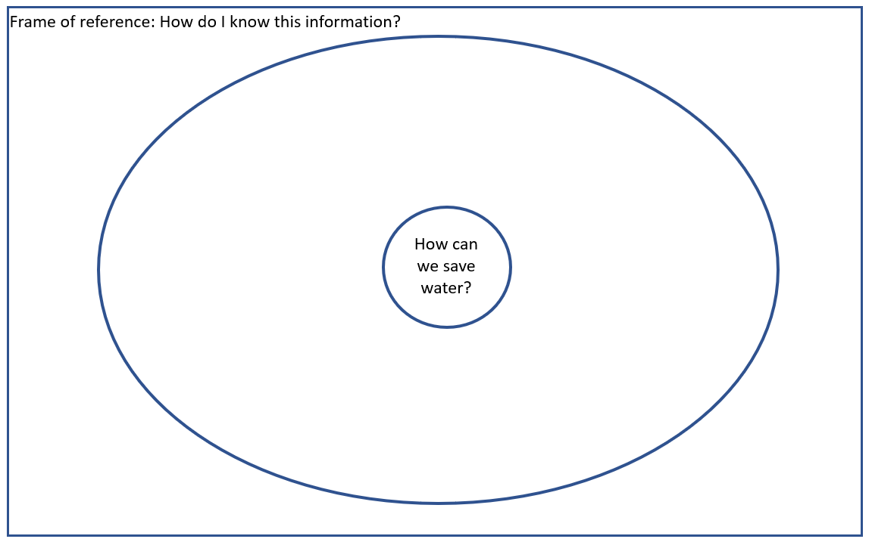  - In the innermost circle write the question. (Note that this will be done for both questions).  - In the large circle around the smaller circle write key words that help answer the question.  - In the square around the circles explain how you know this information - this is the frame of reference, and it is a very important reflection tool.  - There are some resources learners could use in Annexure 7 and Annexure 8. Ideally allow learners time to do their own research in books, or the internet, or you could even get some water conservationists in to share their knowledge with learners.  - Remind learners that the purpose of this activity is for learners to gather information that they could use to create their product for their Public Presentation.  D. Reflections and conclusions - Suggested time allocation - 5 minutes  - Ask learners to reflect on what they have learned in the lessons by answering the following questions:  - What is the most interesting thing you learnt in this lesson and why?  - What would you like to know more about?  - In what ways did the circle map process enable you to “see” your thinking - and was this helpful? |  | How learning happens.  S.P.E.C.I.A.L.  Learners are actively engaged and paying attention when they have opportunities to socially interact with each other while working together to carry out their research.  By conducting research or exploring resources, learners are encouraged to be curious, to ask questions and discover new information on their own, of course if they get stuck jump in with a scaffold. Curiosity helps to drive attention, if we are curious about something we are more likely to pay it more attention. Paying attention to what you need to learn is the first step to learning.  Learners also have a voice and choice in this activity. Learners choose how and where they want to do research which helps build their voice and autonomy (independence). When learners have autonomy, they are able to take ownership of their learning and make choices in line with their needs and interests, which leads to ‘sticky’ deeper learning.  Remember that reflection leads to learning that is ‘sticky’ learning that lasts. So don't miss out the reflection activity
Extended opportunities
- If you would like to take this a step further, you could conduct a science experiment, by creating a water filter. There are some simple instructions on how to create a water filter in annexure 8. Learners could use different materials to create their water filters and compare and contrast what works the best. Learners could also research different water filter methods.
Observations and Facilitations – Assessment as Learning
During the researching activity, it's important to actively observe and listen to learners as they work together in groups. As you walk around the classroom, keep an eye out for several key indicators of learning, including critical thinking, collaboration skills, and knowledge retention. Remember you might have your own list of indicators to look out for.

- Learners’ collaboration skills: Are learners discussing and delegating roles and responsibilities within the team? Are they working together to fulfil these roles effectively, or are there issues with communication or teamwork that need to be addressed? Remember it takes time to develop these skills so it is unlikely that learners will ‘get-it’ the first time, and that is ok. Here are some prompts and scaffolds if learners are stuck.
  - Remind learners to discuss and decide on roles or responsibilities within the group.
  - Encourage learners to share their thoughts and ideas openly and respectfully.
  - Remind learners that it's okay to disagree but to do so constructively, focusing on the idea rather than the person.

- Learners critical thinking skills: Are learners exercising critical thinking skills by evaluating and assessing the relevance of their information that they are researching? Are they asking thoughtful questions that are helping them to find out more information or question the information that they have researched? Here are some prompts and scaffolds if learners are stuck.
  - If learners are doing their own research, remind them to check if their sources are trustworthy and accurate.
  - Remind learners to think about different opinions or ideas before choosing one.
  - Encourage learners to look for any hidden beliefs or opinions in the information they find.

- Learners' knowledge: ask learners to identify and describe ways of saving water or ways of protecting water. Ask learners why it is important to save and protect water. This can help gauge their understanding and retention of the CAPS material and highlight any gaps that may need additional focus or support. Here are some prompts and scaffolds if learners are stuck.
  - Use open-ended questions to help learners recall information, such as "What are some ways we can save water?" or "Why is it important to protect our water sources?"
  - Encourage learners to make connections between the information they've learned and real-world examples.
  - Provide opportunities for learners to share and discuss their findings with the class, allowing them to learn from one another.
Remember to complete your own teacher reflection on this lesson. Use Annexure 9 to help you

Lesson 3: How can we share our ideas with others? | Resources needed: Exercise book and a pen. |  | Time required:  1 lesson
Summary of the Lesson
In this lesson, learners will brainstorm ideas on how to share the information that they learned in the previous lesson about saving and protecting water with their school or community. They will work in groups to think creatively to generate different realistic ideas on how to approach this topic, and then use a tool called the idea elimination tool to select their best idea. Through this activity learners will grow their collaboration skills and practice their communication skills as they listen and work together to brainstorm ideas, and by ensuring they articulate (speak clearly) their ideas.
Objective
The purpose of this activity is for learners to:
- Understand: use their knowledge from lesson 1-2 to identify several possible ways to best communicate this information at the Water Warriors Awareness Day.
- Apply: demonstrate their ability to discuss and discover various ideas for sharing information on water conservation with their school or community.
- Practice: collaboration and communication as they articulate and share their ideas with their group and the wider class, and critical thinking as they evaluate their ideas and choose their best idea.
Before the lesson  - Be familiar with:  - the steps in this lesson and your role in guiding the flow.  - the use of a Bubble Map so that you can explain it and also assist and guide throughout the process (See B below).  - Ensure that learners have paper and pens.  Lesson guidelines- what will learners and teachers do?  A. Introduction to the lesson - Suggested time 5 minutes.  Explain to the class that in this lesson they will be working in groups to come up with different ideas for how they can share information about what they are learning in this project around saving and protecting water with other people either in their school or community. They will then have the opportunity to select their best ideas.  B. Coming up with ideas - the Creative stage through brainstorming (using a Bubble Map) - suggested time 5-10 minutes.  - In their group’s learners can create a bubble map that will capture as many ideas as possible. Remember to remind them that at this stage no idea is silly. It’s the creative stage where anything goes!  - Give learners a short amount of time 5 minutes (maximum 10 minutes) to do this. The idea is to generate ideas and not to think about whether these ideas would work or not.  A bubble map is one of 8 Thinking Maps. It is used to help us describe things, in this case, our ideas. The big bubble in the middle of the page has the question or statement in the middle, in this case, what ideas can we think of to share information about saving and protecting water? The smaller bubbles around the outside have the ideas. Bubble maps help people think creatively and come up with good ideas. They are useful when working on projects, solving problems, or making decisions.  Here is an example of a bubble map with a few ideas. Learners can have as many or as few bubbles as they like, this is just an example. Learners place a different idea in each of the outer bubbles. Remember the frame of reference – how do I know this or where have I seen this type of idea before?  This is a quick activity, learners do not have to come up with the perfect idea, the purpose of this is just to be free to generate ideas. Allow learners around 5-10 minutes to think of different ideas.  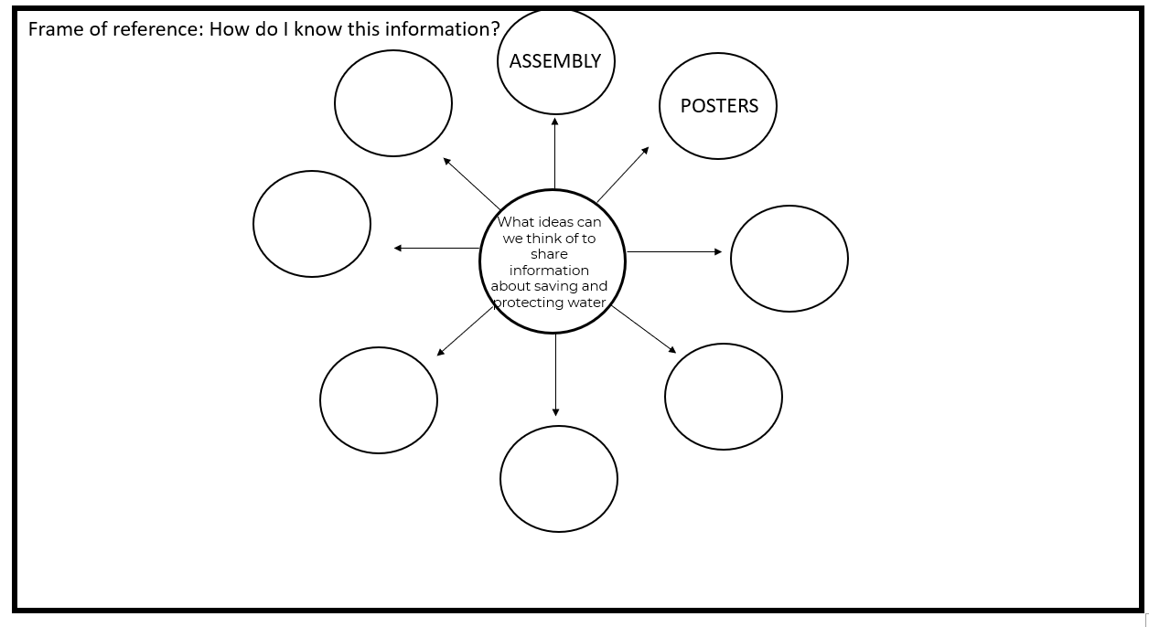  C. Choosing our best ideas: the Idea Elimination technique - suggested time allocation 15 minutes.  - Still in the same groups, ask learners to quickly write one idea on one small piece of paper. If they have 5 ideas they will need five scraps of paper each with a different idea.  - Next discuss what criteria learners can use to evaluate and eliminate different ideas. Here are some suggestions, we recommend having less than 3 criteria.  - Realistic (can we do it),  - Possible (do we have the resources),  - Interesting (is this an interesting idea)  - Next, each learner within the group will need to take a moment to review all the ideas according to these criteria. Then invite learners to choose one idea that should be eliminated based on the criteria. It is ok if learners select the same idea.  - Learners can then have a quick discussion to share their reasons for elimination. They will need to agree before the idea is eliminated.  - Repeat this process until 1 idea is left. This idea is considered the best idea according to their criteria.  D. Conclusions and reflections - suggested time allocation 5 minutes.  - After completing the brainstorming and idea elimination activities, ask learners to engage in a quick "Plus, Minus, Interesting" (PMI) reflection.  Instructions:  - Give each learner a small piece of paper or an index card.  - Ask them to divide the paper into three sections and label them as follows:  - Plus (+): What went well during the brainstorming and idea elimination activities?  - Minus (-): What challenges or difficulties did they face?  - Interesting (I): What did they find interesting or surprising about the process?  - Give learners one minute to silently reflect and jot down their thoughts in each section.  - Once the minute is up, invite volunteers to briefly share their reflections with the class, or within their group. This can help learners gain insights from their peers and identify areas for improvement in future brainstorming and decision-making activities. |  | How learning happens.  S.P.E.C.I.A.L.  Caring and psychologically safe learning environments are essential to enable learners to speak, share ideas and be confident in their ideas and previous knowledge.  The principles of S.P.E.C.I.A.L. (above) apply to this lesson too as the learners work together to evaluate their ideas and select those they want to use for the Water Warriors Awareness Event.  Learners are actively engaged and paying attention in the activity because they are hands on and minds on, they are not sitting passively receiving information.  They need to apply the information that they gathered during their research to create an innovative and interesting product to encourage people to save and protect water, which they will present at their Water Warriors event or campaign.  In the process of brainstorming and rating - the competencies of creative thinking and critical thinking are activated.  This process builds their confidence in believing in the strength of their choice and builds their agency, autonomy and ownership of the learning, because they are deciding on what they want to create for the Water Warriors event.  The need to listen, be empathetic and inclusive in the brainstorming phase leads to better collaboration.  The acceptance of the outcome also builds their social and emotional ability to self-regulate their emotions if the “winner choice” is not theirs.  Having been through the thinking process, they will be able to more readily accept opposing views or outcomes which builds resilience and good citizenship.
Extended opportunities
- You could use a Gallery walk for generating ideas, and for grouping ideas. Gallery Walk - The Teacher Toolkit
Observations and Facilitation – Assessment as Learning
During the brainstorming and idea selection activity, it's important to actively observe and listen to learners as they work together in groups. As you walk around the classroom, keep an eye out for several key indicators of learning, including critical thinking, creative innovation, collaboration skills, and knowledge retention. Remember you might have your own list of indicators to look out for.

- Learners’ collaboration skills: Are learners working together effectively, or are there issues with communication or teamwork that need to be addressed? Remember it takes time to develop these skills so it is unlikely that learners will ‘get-it’ the first time, and that is ok. Can they come to compromise, and be positive in conflict resolution situations? Are the learners showing high levels of consideration? Are they beginning to see the value of sharing ideas?
  - Prompts and facilitation guidance: At this stage your role is to encourage cooperation and to ensure that they are growing their compromise, listening, consideration, and seeing others’ strengths and skills. Look out for opportunities to guide and support where you see these skills need attention.
- Learners’ critical thinking skills: Are learners exercising critical thinking skills by evaluating and assessing the relevance of their ideas as they make their selections? Are they asking thoughtful questions and providing reasoned justifications for their suggestions?
  - Prompts and facilitation guidance: It is also an opportunity to ensure “safety” and “caring” because there may be learners who will think their ideas are not worth sharing. It is a great opportunity to “see” these learners’ and help them to feel a sense of belong (identity-safety)

Teacher self-reflections

Reflecting on how a lesson went is essential to improve your teaching practice. By reflecting on the lesson, you can make adjustments to the project and enhance your future lessons. Annexure 9 contains a wide range of questions that you could use to reflect on this lesson. You do not need to answer all of them, just select one or two that resonate with you. Self-reflection is crucial for teacher professional development because it allows you to learn from your experiences, grow as a teacher, and improve your instructional effectiveness. By continually improving your teaching practice, you can better support your learners' learning and help them achieve their academic goals. Therefore, taking the time to reflect on each lesson is an investment in your professional development and the success of your learners.

Lesson 4: How can we create engaging materials to share our knowledge? | Resources needed: Paper, pens, materials to create the products for the Water Warriors Event/Campaign |  | Time required:  1 lesson
Summary of the Lesson
In this lesson, learners will have the opportunity to create the resources they identified in lessons 3 for their Water Warriors event. Drawing from the research they gathered in the previous lesson and as homework, learners will apply their critical and creative thinking skills to develop innovative and relevant materials that effectively explain the importance of saving and protecting water.
Objective
The purpose of this activity is to grow:
- Knowledge: Learners will recall key facts about the importance of saving and protecting water.
- Comprehension: Learners will summarise their research findings on water conservation and protection.
- Application: Learners will use their research to create informative and engaging materials for their Water Warriors event or campaign.
- Practice: learners will practice their creative innovation skills as they create innovative and interesting products for their Water Warriors event. They will continue to collaborate and engage with their roles and responsibilities, and they will think about their work and adapt as necessary as they develop their products.
Before the lesson  No planning needed.  Lesson guidelines- what will learners and teachers do?  A. Create products for the Water Warriors campaign or event - suggested time 20-30 minutes + homework time.  - Explain to learners that they will still be continuing to work in the same groups. In this lesson they have the chance to actually create some of the items they came up with in lessons 2 and 3 that they would like to use for their event (using the research gathered in the circle map from the previous lesson). If possible, plan ahead so that the learners have the materials and equipment they need to work on their items. e.g., posters, role plays, skits, info-graphic/diagrams, etc.  - Remind learners that if they would like to change roles in the group they can do so.  - Allow time for learners to work on their products.  B. Conclusions and reflections - suggested time 5-10 minutes  - In this reflection activity ask the groups to think about, if they could improve or change something(s) thing about their product what would it and how would they do it?  Homework  Allow homework time for learners to finish and complete their products/resources for their Water Warriors event. This is an opportunity to apply the changes they thought of during their reflection activity. |  | How learning happens.  Learners are actively engaged and paying attention in the activity because they are hands-on and minds on, they are not sitting passively receiving information. They need to apply the information that they gathered during their research to create an innovative and interesting product to encourage people to save and protect water, which they will present at their Water Warriors event or campaign.
Extended opportunities
- If you would like to take this a step further allow time for learners to present and share their products with other teams to give and receive feedback. Then allow time for learners to act on their feedback. This can be done quickly many times to develop a really solid piece of work. We really recommend finding the time to do this as it is an extremely valuable exercise.
Observations and Facilitations – Assessment as Learning
During this creative activity, it's important to actively observe and listen to learners as they work together in groups. As you walk around the classroom, keep an eye out for several key indicators of learning, including critical thinking, collaboration skills, knowledge retention, and creative innovation. Remember you might have your own list of indicators to look out for.

- Learners’ collaboration skills: these play a key role in the success of any group project. Take note of how learners are discussing and delegating roles and responsibilities within the team. Are they working together to fulfill these roles effectively, or are there issues with communication or teamwork that need to be addressed? Remember it takes time to develop these skills so it is unlikely that learners will ‘get-it’ the first time, and that is ok. Here are some prompts and scaffolds if learners are stuck.
  - Remind learners to remember and apply the guidelines to the roles or responsibilities within the group.
  - Encourage learners to share their thoughts and ideas openly and respectfully.
  - Remind learners that it's okay to disagree or make suggestions, but to do so constructively, focusing on the idea rather than the person.

- Learners’ critical thinking skills: Are learners exercising critical thinking skills by evaluating and assessing how to apply the information that they found during the research stage? Are they asking thoughtful questions that are helping them to apply, design and create the products? Here are some prompts and scaffolds if learners are stuck.
  - Remind learners that the tools (bubble maps etc.) are there to help them to analyse, prioritise, select, explain, and connect information they have researched to that they can order it in a way that can be understood by the people coming to the event.
  - Remind learners to think about different opinions or ideas before choosing one and to ask many questions.
  - Encourage learners to look for any hidden beliefs or opinions in the information they find and to evaluate information for relevance to their products.

- Learners’ creative innovation skills: This is a time in the process where learners will combine their content knowledge, collaboration, and critical thinking to create actual “products”. In this process learners should be beginning to analyse the information they have gathered; they should be starting to transfer this knowledge in a way that helps them solve the “problem” - in this case “How to raise awareness of water at the Water Warriors Awareness Day”. They will take risks as they try out things that others may not like or that may not work. All the time they will be needing to listen closely to each other in order to find solutions and generate ideas. They will need to reflect constantly on whether they are doing the right things right - and if not - try again. Here are some prompt and scaffolds if learners are stuck:
- Help them to consider modifying, rearranging, rewriting, or reframing as ways to find a new direction (use their thinking tools)
- Encourage learners to generate a number of creative ideas in the design of their product to make it interesting and engaging.
- Remind learners to include a range of ideas in their information and awareness-raising products so that the audience is well informed with accurate data
- If necessary, discuss with the learners whether their choice of either design, content, or “product” is the right one to be using (is it fit for purpose?).
Remember to complete your own teacher reflection on this lesson. Use annexure 9 to help you.

The public presentation - being Water Warriors |  | Resources needed: Anything identified in lessons 2-6 to run this public presentation | Time required:  1 lesson
Summary of the Lesson
At the end of the project learners have the opportunity to present their work e.g., the products they created to encourage people to save and protect water. The purpose of a public presentation is to provide learners with an authentic audience to share their learning and achievements, and to receive feedback and recognition for their hard work. It also allows learners to practice important skills such as public speaking, communication, and presentation design.
Objective
The purpose of the public presentation is for learners to:
- Apply: Learners apply the knowledge gathered throughout the project to share their learnings and awareness-raising products during the Water Warriors Awareness Day.
- Create: Learners actively create items to display at the Water Warriors Awareness Day.
- Practice: communication, critical thinking, collaboration, creative innovation, and meta-learning as they work collaboratively to implement their plans for the Water Warriors Awareness Day.
Lesson guidelines- what will learners and teachers do?  Every class or school will do something and so there are no specific guidelines here.  End of project reflections  - Once the event is over, make sure there is time to debrief the experience with learners.  - Ask learners to complete the Learner Self-reflection Table (see annexure 12). You can decide what method to use to complete the reflection e.g. independently, in a group, in pairs. | How learning happens.  As learners work collaboratively (social interaction) to implement their ideas for their Water Warriors Awareness Day they are actively engaged in the learning process (hands-on and minds on) which increases attention and engagement, which as we know leads to better learning outcomes.  This experiential approach (planning and presenting an awareness event that informs and includes a call to action for the audience so that they improve the water scarcity problem) can create more vivid and lasting memories because it engages multiple senses and emotions, e.g., learners are not only sitting and listening - but they are also doing. Not only does it do this but having to continually think about why and what (the learning content) they are learning in order to transform and create something new, makes for deep learning. Remember - learners remember what they think deeply about.  A public presentation is a nice place to observe the E - Enjoyment in S.P.E.C.I.A.L. Throughout the project learners would have had to persevere through challenges, they would have felt frustrations, they would have had to be resilient in overcoming challenges. The E for Enjoyment speaks to the joy that you feel once you have overcome your challenges.  Learners are actively making meaningful connections between their prior knowledge and new practical learning experiences as they deal with problems and find solutions, give and receive feedback, present their ideas and so on. All of this leads to ‘sticky’ learning, learning that is memorable, lasting, and relevant to the learners.

Exemplar Assessment rubric
This is an exemplar assessment rubric that reviews the whole project so please review:
- all your observations across all lessons in this project
- learner participation in the water awareness event
This collective feedback will be invaluable in completing this assessment rubric for this project. Since this is an exemplar rubric there are a number of different assessment criteria so please use what is relevant to your situation and context, adapt, change, edit as needed. You can of course use all the criteria and use it as is.
Creating awareness about Water: how best can we share our knowledge and ideas with others at the Water Warriors Awareness Day so that they are aware of the importance of water and start to use it with respect? |  |  |  |  |  | Write your mark here
CRITERIA  How do we know that learners can do this? | 10-9  Mastering | 8-7  Advancing | 6-5  Developing | 4-3  Learning | 2-1  Starting | 1 - 10
Knowledge of Water as an important basic need; the need to save water; the need to protect water. (CAPS content)  To what extent did the learners show understanding by identifying and recalling, describing and explaining, applying and analysing. | - Learners can analyse their water knowledge by comparing different strategies and solutions to conserve water and protect water quality.  - Learners can now identify, rate, and choose innovative ideas to design convincing, accurate, and informative items to effectively communicate the need to conserve water and protect water quality. | - Learners can apply and evaluate knowledge and information of water as an important basic need.  - Learners are able to back up (defend) these recommendations with facts that will assist them with choosing how to communicate these to others. | - Learners can explain to other people why water is important and identify 4+ simple strategies to save water and 4+ simple strategies to protect water quality at home and in their community.  - Learners are able to explain why these strategies are important and relevant based on their new knowledge. | - Learners can describe the importance of water as a basic need.  - Learners are able to explain how they know this information and why water is an important resource. | - Learners can recall 1-3 facts on the importance of water as a basic need for all living things. They can list 1- 3 reasons that water must be conserved and protected.  - Learners may not yet be able to identify simple strategies to save water or explain why water is important.
Research: To what extent did learners:  These are possible points of observation, you can use all of them or select the ones that are relevant to your classroom.  - show curiosity to be inquiring  - ask probing questions  - use a variety of sources  - evaluate the sources for  - integrity  - usefulness  - become confident to defend their research | - Learners demonstrated exceptional curiosity and inquiry skills  - Learners asked highly probing and insightful questions  - Learners used a wide variety of sources effectively  - Learners critically evaluated the sources for both integrity and usefulness  - Learners confidently defended their research with compelling evidence and arguments | - Learners showed a good level of curiosity and inquiry skills  - Learners asked probing questions that were mostly insightful  - Learners used a variety of sources effectively  - Learners generally evaluated sources for integrity and usefulness  - Learners mostly were confident when defending their research with evidence and arguments | - Learners demonstrated some curiosity and inquiry skills  - Learners asked some probing questions, but may need guidance  - Learners used some sources effectively  - Learners attempted to evaluate sources for integrity and usefulness  - Learners may lack confidence when defending their research with evidence and arguments | - Learners showed limited curiosity and inquiry skills  - Learners asked basic questions with little probing  - Learners used limited sources effectively  - Learners struggled to evaluate sources for integrity and usefulness  - Learners were not confident when defending their research with evidence and arguments | - Learners demonstrated minimal curiosity and inquiry skills  - Learners asked few or no probing questions  - Learners used very limited sources effectively  - Learners did not evaluate sources for integrity or usefulness  - Learners were unable to defend their research with evidence and arguments
Public Presentation: to observe how learners apply their knowledge and skills  These are possible points of observation, you can use all of them or select the ones that are relevant to your classroom.  To what extent did the learners demonstrate their ability to:  - innovate and be creative  - be thoughtful and logical in their arguments  - construct an effective, convincing, and relevant presentation  - communicate effectively  - by considering their audience  - articulating appropriately  - using the right tone/pitch | - Learners demonstrated exceptional innovation and creativity in presentation  - Learners arguments were highly logical, thoughtful, and convincing  - Learners constructed a highly effective, convincing, and relevant presentation  - Learners communicated effectively with the audience by considering their needs and adapting accordingly  - Learners used appropriate articulation, tone, and pitch to engage audience and convey ideas effectively  - Learners’ presentation resulted in a compelling and convincing call to action. | - Learners demonstrated innovation and creativity in presentation  - Learners’ arguments were mostly logical, thoughtful, and convincing  - Learners constructed an effective and relevant presentation  - Learners communicated effectively with the audience most of the time  - Learners used appropriate articulation, tone, and pitch to engage audience and convey ideas effectively  - Learners’ presentation resulted in a convincing call to action. | - Learners demonstrated some innovation and creativity in presentation  - Learners’ arguments were somewhat logical, thoughtful, and convincing  - Learners constructed a mostly effective and relevant presentation  - Learners communicated with the audience but may not fully consider their needs  - Learners may need improvement in articulation, tone, and pitch to engage audience and convey ideas effectively  - Learners may need to work on how to be more convincing, compelling in their call to action. | - Learners demonstrated limited innovation and creativity in presentation  - Learners’ arguments were not always logical, thoughtful, or convincing  - Learners constructed a somewhat effective and relevant presentation  - Learners struggled to communicate effectively with audience  - Learners may need significant improvement in articulation, tone, and pitch to engage an audience and convey ideas effectively  - Learners may need significant input if they intend to convince and compel their audience to take action. | - Learners demonstrated minimal innovation and creativity in presentation  - Learners’ arguments were weak and not logical, thoughtful, or convincing  - Learners constructed an ineffective or irrelevant presentation  - Learners struggled to communicate with audience  - Learners need significant improvement in articulation, tone, and pitch to engage audience and convey ideas effectively  - Learners need significant guidance, support and scaffolding before they will effectively be able to be compelling and convincing in their call to action.
Comments |  |  |  |  |  | /30

How did the project help learners to grow their skills | Yes | No
Critical Thinking: is about asking questions to understand the world, it is also about trying to make sense of information, evaluating it and connecting it to other pieces of information.
- Did the learners grow their critical thinking through the project?
- Was there a difference from the start to the end of the project in the learners’ critical thinking skills?
- Did the learners ask questions?
- Did the learners find the relevant and appropriate information, evaluate, and analyse it and apply it to solve a problem?
- Did you notice a change in learners' critical thinking skills?
COMMENTS: What did you notice

Creative Innovation: is the ability to come up with many different ideas and apply them to find realistic solutions to problems.
- Did the learners grow their creative innovation through the project?
- Was there a difference from the start to the end of the project in the learners’ critical thinking skills?
- Did the learners generate ideas and seek solutions?
- Did the learners transfer their knowledge of and experience about water to find solutions?
- Did you notice a change in learners' creative innovation skills?’
COMMENTS: What did you notice

Collaboration: when people work with each other to complete a task. It involves co-operation and teamwork and the sharing of ideas, knowledge, and skills to reach the same goal.
- Did the learners grow their ability to collaborate through the project?
- Was there a difference from the start to the end of the project in the learners’ collaboration?
- Did the learners show an ability to compromise, be considerate of each other, and be positive in a conflict situation?
- Did the learners leverage each other’s strengths? (Pool their collective resources in terms of strengths and knowledge)
- Were the learners willing to listen, empathise, and give and receive useful feedback to the team?
- Did you notice a change in learners' creative innovation skills?
COMMENTS: What did you notice

Communication: is all about sharing information, it is about what we say (verbal communication) and how we say it (non verbal communication).
- Did learners grow their ability to understand non-verbal cues such as tone of voice, body language through the project?
- Was there a different from the start to the end of the project in how learners spoke (articulation) e.g. did they stop mumbling, talked at the right speed, used the right tone etc.
- Did you notice a change in learners ability to try and understand things from other peoples perspective e.g. their empathy skills?

COMMENTS: What did you notice

Annexures - useful tools for the project

Annexure one: Example letter to parents and caregivers about Project-based Learning

This is just an example. Feel free to edit and adapt it to your needs.

Dear Parents and Caregivers,

We hope this letter finds you well. We want to share with you an exciting project that your child will be working on in school called "Water Warriors Awareness". This is a Project-based Learning project. You may have already heard a lot about Project-based Learning, but if not, Project-based Learning is a teaching method where learners learn by actively engaging in real-world and meaningful projects. Through this method, learners are given the opportunity to collaborate with their peers, conduct research, and apply their knowledge and skills to solve real-life problems.

There are many benefits to Project-based Learning. This method encourages creativity, critical thinking, and problem-solving skills. Learners also learn to communicate effectively, both with their peers and the community, and build personal connections with the subject content (CAPS), leading to deeper and more memorable learning experiences.

We are excited to inform you about our current project, "Water Warriors Awareness". This project is all about teaching children about the importance of water, and how we can save it and keep it clean. The learners will work together to plan a special event (public presentation) that shows everyone how to use water more carefully in their daily lives. During the project, the learners will talk to each other and to their families and community to learn more about water, why it's so important, and how we can hurt it if we're not careful. The learners will also use different tools to help them organise their thoughts and ideas, like bubble maps, tree maps, and flow maps. This will help them figure out what they need to do and when they need to do it, so that everything goes smoothly. We are really excited about this project, and we hope that the kids will learn a lot and have fun at the same time!

There are lots of ways you can support your child in their Project-based Learning journey that will not cost you anything. You can
- Encourage your child to ask questions and take ownership of their learning. This can help them develop critical thinking skills and become more engaged in the project.
- Help your child find resources and materials related to the project topic. This can include books, articles, websites, or even just your own knowledge about the topic.
- Ask your child about their project and listen to their ideas. Show interest and enthusiasm for what they are learning and offer positive feedback to encourage their progress.
- Help your child manage their time effectively by helping them to create a schedule or calendar with deadlines and milestones for the project.
- Attend any events or presentations related to the project, and show support for your child and their classmates as they showcase their work.

We believe this project will promote attention and engagement among our learners, as they learn more about saving and protecting water, and how they might share this in a public presentation. We encourage you to support your child throughout this project and attend their public presentation.

Thank you for your ongoing support of our learners' education.

Sincerely,

[Your Name]

…………………………………………………………………………………………………………………………………………………………………………………………………………………………………………………………………………………………………………
This is to confirm that I __________________________________ parent/guardian of ___________________________________ have read this letter and I understand what the project is all about.

Annexure two: The Project Route Map

About this project: Water Warriors Awareness

Hi there! Are you ready for an amazing project all about water? You and your friends will team up to learn about how we use water, how we can save it, and how we can keep it clean. You'll even come up with fun and creative ideas to show others how to protect our precious water! But that's not all - you'll also learn why water is important and how to be responsible with it. You'll use cool thinking tools like bubble maps and tree maps, to help you plan and organise your event. You'll practice all kinds of thinking skills, like communication, collaboration, critical thinking, and creativity. The best part? You'll work together with your friends to make a real difference in the world! By sharing what you learn with others, you'll help everyone be more careful with water, which is good for the planet and all its creatures. So, get ready to have fun, learn a lot, and make a big splash with your water project!

Your scenario to solve
You live in a small South African Town, you are facing a severe water crisis. Your town’s water supply is running low, and everyone is starting to feel the effects of water scarcity. A group of curious and determined grade five learners decide to take matters into their own hands and form a team called "The Water Warriors." Your objective is to learn all you need to know about the importance of water as a basic need, identify ways of saving and protecting water, and creative ideas to help other people in your community to save and protect water.

Driving question: How best can we share our knowledge and ideas with others at Water Warriors Awareness Day so that they are aware of the importance of water and start to use it with respect?

Part | What am I doing? | Status Tick this as you complete the tasks
1 | Lesson One: The Water Adventure Begins! Why is water important? Get ready to dive into the amazing world of water! In this exciting lesson, you'll play an exciting game that helps you understand why water is so important. You'll also explore a real-life story about water in South Africa, and discover the fantastic mission you'll embark on as a "Water Warrior"!
2 | Lesson Two: Water Detectives on a Mission What can we learn about saving and protecting water? Put on your detective hats and start investigating! In this lesson, you'll become a water-saving expert by researching water scarcity and protecting water methods. Your detective work will help your community use water more wisely!
3 | Lesson Three: Water Knowledge Superheroes How can we share our knowledge about water with others? It's time to share your water wisdom with the world! In this lesson, you'll brainstorm awesome ideas for teaching others about water at a special Water Warriors Awareness event. Get ready to spread the word and make a splash!
4 | Lesson Four: Crafting Creative Water Masterpieces How can we create engaging materials to share our knowledge? Let your creativity flow in this lesson, as you work together with your friends to create amazing materials for your Water Warriors Awareness event! Whether it's posters, models, or presentations, your engaging creations will help everyone learn more about the importance of water.
5 | Public Presentation: Water Warriors to the Rescue – Awareness Day! On this special day, you'll shine as true Water Warriors! Present your fantastic findings and share your water-saving ideas with your peers, teachers, and community members. Together, you'll inspire everyone to appreciate the importance of water and use it responsibly!

Annexure three: Creating a project wall instruction.

How to create your own Project Wall

Have you heard of a Project Wall? Or maybe you already have lots of Project Walls in your classroom. It's a physical space used in project-based learning to visually display the progress and development of a project. It's a central location where everyone can see and contribute to the organisation of ideas related to the project. If you're looking to create your own project wall, here are some ideas of what to include:

- The driving questions.
- The project goals.
- Assessment rubrics
- Tools that learners might use, like templates of thinking maps
- The steps of the project
- Reflection tools
- Pictures
- Examples of learners' work
- Questions that learners have

The Project Wall should be an evolving space that changes and grows as the project progresses, with new insights and ideas constantly being generated.

So, how does a Project Wall support learning? Here are a few ways:

- It provides a space for learners to engage with the project material and reflect on their progress.
- It makes learning visible, so learners know what they need to learn, how to learn it, and how to evaluate their own progress.
- It's a place to practice collaborative learning, as learners can decide together what to put on the wall.

Remember, a project wall is a great tool to help you organise and visualise your ideas, keep track of your progress, and learn collaboratively with your team.

Annexure four: The Water Scarcity Game
Objective: To educate learners about the importance of water conservation and to promote awareness of the water scarcity issue.
How to play the Water Scarcity Game

- Divide the class into groups of 5 people each.
- Give each learner 8 tokens (you can find them in annexure 4). These tokens represent the amount of water they have available to them.
- Provide each group with a set of Life Cards (you can find these in annexure 4), which include various scenarios that impact water usage (e.g., drinking water, washing, agriculture, personal use, etc.).
- Learner one from each group picks up their first Life Card, reads it aloud, and follows the instructions on the card. They must place the specified number of tokens (or water cups) into a cup or vessel to represent the water being used.
- Each learner will take one turn in selecting and reading a Life Card, following the instructions and placing the appropriate number of tokens into the cup or vessel.
- Once each learner has selected one Life Card, the teacher makes an announcement: There has been a drought in the community, so everyone in the group must contribute HALF of their remaining tokens into the cup or bin.
- Learners proceed with one more round, taking turns selecting and reading Life Cards, and following the instructions on the cards.

At the end of the game, some learners may have no water (tokens) left, which illustrates the impact of water scarcity and the importance of water conservation.
After playing the game, encourage a discussion about the importance of water conservation, the various factors that contribute to water scarcity, and potential solutions for reducing water consumption in daily life.

The Water Tokens for the Water Scarcity Game
Print and cut out as many of these as you need so that each learner in your class has 8 water droplets each.

Scenarios for the Water Scarcity Game
Life Cards
Please print and cut out these scenarios for your groups. Each group will need one set of the scenarios (Life Cards), so if you have 5 groups, you will need 5 copies. Ensure that you print and cut out the scenarios before the lesson begins.
It is bedtime and you need to use…  - 1 water token to brush your teeth.  - 1 water token for your shower  If you have enough water, put 2 drops of water into the cup. If not, decide which is more important. |  | You are going to visit your grandparents and you need to use…  - 1 water token to wash your clothes.  - 1 water token to take a shower.  If you have enough water, put 2 drops of water into the cup. If not, decide which is more important.
You are a busy parent; you need water to prepare food and maintain a healthy garden at home.  You need water for:  - 1 water token for cooking dinner.  - 1 water token for watering the garden.  If you have enough water, put 2 drops of water into the cup. If not, decide which is more important. |  | Taking care of pets and keeping the toilet clean are some important household tasks that need water.  You need water for:  - 1 water token to clean your pet.  - 1 water token to flush the toilet.  If you have enough water, put 2 drops of water into the cup. If not, choose which one to prioritise.
As a businessperson, you have to balance the water needs of factories and cleaning polluted rivers.  You need water for:  - 2 water tokens for factories.  - 2 water tokens to clean a polluted river.  If you have enough water, put 4 drops of water into the cup. If not, make a choice. |  | As a farmer, you need water to grow crops and support the increasing water demands of the growing population.  You need water for:  - 2 water tokens for farming.  - 2 water tokens to support the growing population.  If you have enough water, put 4 drops of water into the cup. If not, decide which one to prioritise.

As a teacher, you need water for educational activities like maintaining the school garden and working on art projects.  You need water for:  - 1 water token for the school garden.  - 1 water token for an art project.  If you have enough water, put 2 drops of water into the cup. If not, choose which activity to prioritise. |  | As a teacher ensuring learners have access to clean drinking water and a clean learning environment are essential tasks that require water.  You need water for:  - 1 water token for the drinking fountain.  - 1 water token for cleaning the classrooms.  If you have enough water, put 2 drops of water into the cup. If not, decide which one is more important.
As a farmer planting new trees and fixing leaking pipes on your farm are essential tasks to maintain water resources and infrastructure.  You need water for:  - 2 water tokens to plant new trees.  - 2 water tokens to fix a leaking pipe.  If you have enough water, put 4 drops of water into the cup. If not, choose what to do. |  | As an environmentalist, you aim to protect the rainforest and to keep rivers clean.  You need water for:  - 2 water tokens to save the rainforest.  - 2 water tokens for animals that have been injured.  If you have enough water, put 4 drops of water into the cup. If not, make a choice.
As a local government official, you must allocate water for public park maintenance and firefighting.  You need water for:  - 2 water tokens for public park maintenance.  - 2 water tokens for firefighting.  If you have enough water, put 4 drops of water into the cup. If not, make a choice. |  | As a parent, you want to keep your home clean and comfortable for your family while being careful about water usage.  You need water for:  - 1 water token to wash the dishes after dinner.  - 1 water token to clear the floors and keep your home tidy.  If you have enough water, put 2 drops of water into the cup. If not, decide which cleaning task you should do first.

Annexure five: Case study - Cape Town's Water-Saving Adventure:
How Everyone Worked Together to Stop Day Zero
In 2018, Cape Town, South Africa, faced a serious drought, which meant there was not enough water for everyone in the city. They called the day when there would be no more water in the taps “Day Zero”. But the people of Cape Town didn't want Day Zero to happen. They knew life would be tough without enough water, so everyone, including businesses and other groups, came up with ways to save water and use it more efficiently.
Some of the things they did include:

- Encouraging people to take shorter showers and not fill bathtubs.
- Asking people not to water their gardens as much.
- Encouraging people to collect rainwater to use for watering plants and flushing toilets.
- Businesses used water-saving technologies, reused water, and educated employees about water conservation.
- Restaurants served water only upon request and used disposable plates and cutlery to reduce dishwashing.
- The city also installed special devices on water pipes that could find leaks and send alerts to the people who could fix them. This meant that leaks were fixed quickly, and water wasn't wasted.

All these efforts helped Cape Town avoid Day Zero. The people of Cape Town, including businesses and other groups, worked together to save water and use it efficiently. This meant everyone had enough water to drink, wash, cook, and live their daily lives. It's essential to remember that we all need to save water, not just during droughts. Water is a precious resource, and we should use it wisely so there's enough for everyone, now and in the future.

Annexure six: Roles and responsibilities
Here are some examples of roles and responsibilities. Print a copy for each group and place one copy on the project wall.

Instructions: Choose a role that you would like to practice. Do not worry if you do not have the skills yet for the role, this is a great opportunity to practice different skills. By the end of the project, make sure you have tried more than one role so that you can practice and grow your skills.
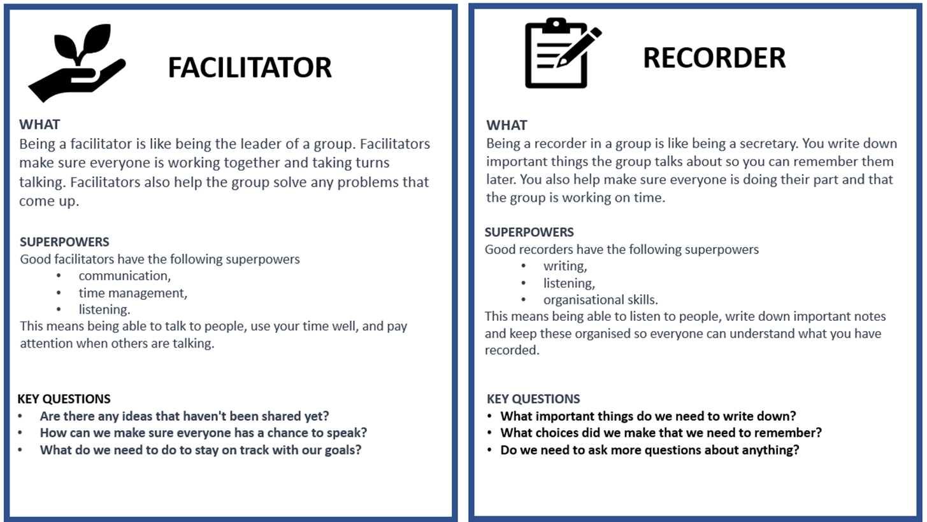

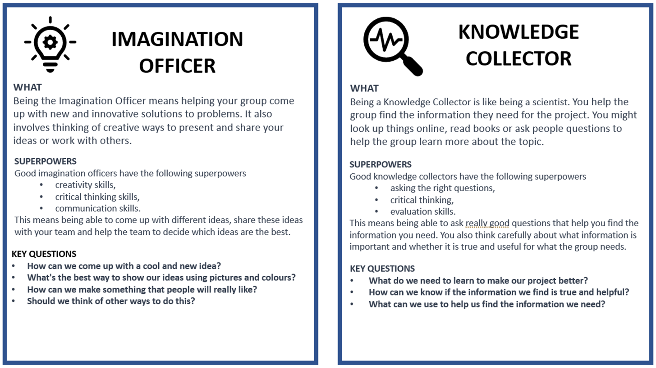

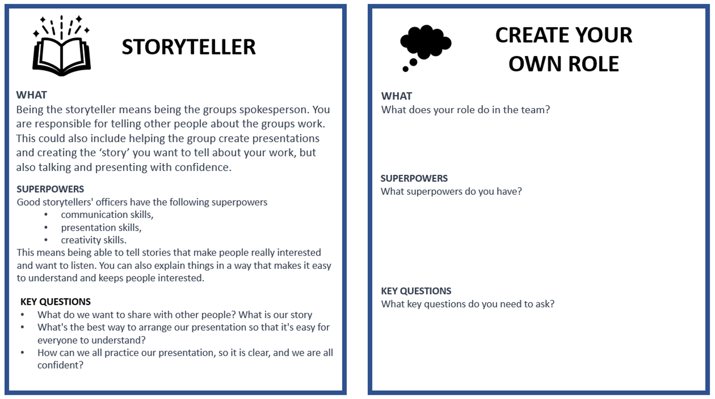

Annexure seven: Resources about saving water.

Why is water important?
Water is essential for life on earth. Here are some ways that water is important to us:
- Water is very important because it helps us to stay alive! We need water to drink, to keep our bodies clean, and to help our plants and animals grow. In fact, water is so important that without it, we couldn't survive.
- Water helps plants and animals grow. Just like how we need water to survive, plants and animals also need water to grow and stay healthy. Without water, plants can't make food, and animals can't find water to drink.
- Water helps us stay clean. We use water to take baths or showers, brush our teeth, and wash our hands. This helps us stay clean and healthy!
- Water helps us stay cool. On a hot day, we can splash around in a pool or run through a sprinkler to cool off. This is because water absorbs heat, which helps us feel cooler.
- Water can also be used to create energy. Water can be used to generate electricity by moving turbines in power plants. This helps power our homes and businesses.
- Water is also important for transportation. Ships and boats travel on water, and we can also use waterways to move goods from one place to another.

Remember, water is a precious resource that we all need to live, so let's work together to protect it! So, you see, water is important for many things in our daily lives!

Water is a problem!
There's a big problem in South Africa because there's not enough clean water for everyone. Lots of people are using up the water, and there's not enough left. This is making it hard for people to drink, cook, and clean. Even industries and businesses need water, which is making the problem worse.

It's really important to save water in South Africa because the country doesn't have enough of it. In fact, the government thinks that by the year 2030, there won't be enough water for everyone. This is really bad for the economy and for nature. Also, the water that is left is often dirty and polluted. This can make people sick and harm plants and animals.

To fix this problem, people need to work together to save water and keep it clean. Some ways to do this are by fixing leaks, taking shorter showers, and turning off taps when you're not using them. The government can also help by making policies to protect water and by investing in infrastructure to make sure there's enough clean water for everyone.

What solutions can we think of to save water?
In South Africa, it's really important to save water and protect it so that people, animals, and plants can all survive and be healthy.

Water is very important to us, and we need to make sure that we use it wisely. In South Africa, we have a limited supply of water, and we need to take care of it. Here are some tips to help you save water:

- Turn off the tap when you brush your teeth or wash your hands: This can save about 6-10 litres of water per minute.
- Take shorter showers: Taking a shorter shower can save about 30-60 litres of water per shower.
- Fix leaky taps: A leaky tap can waste up to 5,000 litres of water per year. Fixing it can save this amount of water.
- Use a bucket to catch water: You can save about 10-15 litres of water each time you use a bucket to catch water.
- Don't overfill the bath: Taking a shallow bath instead of a full bath can save about 80-100 litres of water per bath.

Water your garden in the early morning or late afternoon: Watering your garden during the cooler parts of the day can save up to 25 litres of water per day.

Remember, every drop counts! By using water wisely, we can help to make sure that we have enough water for everyone.

Annexure eight: Resources for protecting water.

Why is water important?
Water is essential for life on earth. Here are some ways that water is important to us:
- Water is very important because it helps us to stay alive! We need water to drink, to keep our bodies clean, and to help our plants and animals grow. In fact, water is so important that without it, we couldn't survive.
- Water helps plants and animals grow. Just like how we need water to survive, plants and animals also need water to grow and stay healthy. Without water, plants can't make food, and animals can't find water to drink.
- Water helps us stay clean. We use water to take baths or showers, brush our teeth, and wash our hands. This helps us stay clean and healthy!
- Water helps us stay cool. On a hot day, we can splash around in a pool or run through a sprinkler to cool off. This is because water absorbs heat, which helps us feel cooler.
- Water can also be used to create energy. Water can be used to generate electricity by moving turbines in power plants. This helps power our homes and businesses.
- Water is also important for transportation. Ships and boats travel on water, and we can also use waterways to move goods from one place to another.

Remember, water is a precious resource that we all need to live, so let's work together to protect it! So, you see, water is important for many things in our daily lives!

Water scarcity is a problem!
There's a big problem in South Africa because there's not enough clean water for everyone. Lots of people are using up the water, and there's not enough left. This is making it hard for people to drink, cook, and clean. Even industries and businesses need water, which is making the problem worse.

It's really important to save water in South Africa because the country doesn't have enough of it. In fact, the government thinks that by the year 2030, there won't be enough water for everyone. This is really bad for the economy and for nature. Also, the water that is left is often dirty and polluted. This can make people sick and harm plants and animals.

To fix this problem, people need to work together to save water and keep it clean. Some ways to do this are by fixing leaks, taking shorter showers, and turning off taps when you're not using them. The government can also help by making policies to protect water and by investing in infrastructure to make sure there's enough clean water for everyone.

What solutions can we think of to protect water?
We all need to help protect our precious water, but what does it mean to protect water? To protect water means to take care of it and make sure it stays clean and safe for people, animals, and plants to use. It also means using water wisely and not wasting it, so that there's enough water for everyone, both now and in the future.
Protecting water involves actions like not polluting it with chemicals or rubbish, conserving it by using it wisely and carefully, and keeping it clean by not flushing things down the toilet that don't belong there. It can also involve supporting protections that conserve and protect water resources, like river clean-up projects or campaigns to reduce water usage. Protecting water is important because it is a limited resource that we all depend on to survive. By taking care of it, we can help ensure that there is enough clean water for everyone, both now and in the future. Here are some ways to protect water.
- Don't throw rubbish or litter into water sources. Instead, put it in the rubbish bins.
- Pick up rubbish, when it rains rubbish can often find its way into rivers and cause harm to fish and wildlife.
- Use water wisely. Don't let water run when you're not using it, like when you're brushing your teeth or washing your hands. And try to take shorter showers to conserve water.
- Don't pour chemicals or medicines down the drain, always ask an adult to help you find the proper place for chemicals or medicines.
- Spread the word. Tell your family and friends about the importance of protecting water and encourage them to help, too!
What other ideas can you think of for protecting water?
Create your own water filter!
Materials Needed | Instructions
- A plastic bottle  - Scissors  - Cotton balls or cloth  - Sand  - Gravel or small rocks | - Cut the bottom of the plastic bottle off with scissors. Make sure to ask an adult for help with this step.  - Place a layer of cotton balls or cloth at the bottom of the bottle. This will help filter out large particles.  - Add a layer of sand on top of the cotton balls or cloth.  - Add a layer of gravel or small rocks on top of the sand.  - Continue layering cotton balls or cloth, sand, and gravel until the bottle is almost full.  - Pour dirty water into the top of the filter and let it slowly drip through the layers of cotton balls or cloth, sand, and gravel.  - Collect the filtered water in a clean container at the bottom of the filter.

Annexure nine: Teacher S.P.E.C.I.A.L. Self-reflection tool

How to use this tool

Using the teacher self-reflection tool is a simple yet effective way to evaluate your teaching practices. After each lesson, select a few questions to reflect on. Pick 1 or 2 questions from each:
- General reflection questions.
- S.P.E.C.I.A.L reflection questions.

The purpose of this tool is to help you identify what went well and what could have been improved in your lesson. You can also consider how much your learners learnt and how they engaged with the learning process. By doing this, you can develop a better understanding of your teaching style and how it impacts your students. Through regular reflection, you can make adjustments to your approach, learn from your mistakes and build on your strengths, leading to improved teaching outcomes for your students.

Why is teacher self reflection so important

Teacher self-reflection is an essential aspect of effective teaching that involves the careful analysis of one's teaching practices to identify areas of strength and improvement. By reflecting on the lesson, you can evaluate their effectiveness in conveying the lesson's objectives, engage learners’ interest and attention, and adjust your teaching strategies to improve the learning outcomes. Moreover, self-reflection enables you to develop your teaching skills and knowledge. In summary, teacher self-reflection is crucial for continuous professional development and improvement, and it helps to ensure that learners receive high-quality and effective instruction.

General reflection questions
- Which teaching strategies were most effective in engaging the learners and promoting understanding? Are there other strategies that could be explored in future lessons?
- How did learners respond to the activities and tasks? Were they actively participating and demonstrating understanding? What adjustments could be made to enhance learner engagement and comprehension?
- Were there any misconceptions or misunderstandings that emerged during the lesson? How were they addressed, and how can they be prevented in future lessons?
- How effectively was feedback provided during the lesson? Were learners given opportunities to reflect on and improve their understanding?
- What opportunities were provided for learners to collaborate, problem-solve, and think critically? Can these opportunities be further developed in future lessons?
- What can be learned from this lesson to inform planning, instruction, and assessment for future lessons?

S.P.E.C.I.A.L. Reflection questions

Prior Knowledge:  - How did I activate and build on the learners' prior knowledge during the lesson?  - Were there any gaps or misconceptions in learners' prior knowledge that needed to be addressed? How were they handled?  - How can I better connect new concepts to learners' existing knowledge in future lessons? | Curiosity:  - How did I encourage learners' curiosity and inquisitiveness during the lesson?  - Were there opportunities for learners to explore and investigate the subject matter on their own or with peers?  - How can I better incorporate inquiry-based learning and curiosity-driven activities in future lessons?
Social Interaction:  - How did I facilitate opportunities for social interaction and collaboration during the lesson?  - Were learners actively engaging with one another and sharing their ideas? How can I further promote this in future lessons?  - What role did peer feedback and discussion play in deepening learners' understanding of the material? | Iteration:  - Were learners provided with opportunities to practice, iterate, and refine their understanding and skills during the lesson?  - How effectively did I offer feedback and guidance to support learners' iterative learning process?  - How can I create more opportunities for practice and iteration in future lessons?
Purpose:  - Were the learning objectives clear and purposeful for the learners? Did they understand the relevance of the lesson to their lives and future learning?  - How did I connect the lesson content to real-world applications or contexts?  - What can I do to make the purpose of future lessons more explicit and meaningful for my students?  Enjoyment:  - How did I incorporate elements of enjoyment and fun into the lesson?  - Were learners actively enjoying the learning process? What can I do to further enhance their enjoyment in future lessons?  - How did the learning environment and classroom atmosphere contribute to learners' enjoyment and motivation? | Active Engagement:  - Were learners actively engaged in the learning process, both cognitively and behaviourally?  - Which activities or strategies were most successful in promoting active engagement and deep learning?  - How can I better design future lessons to foster active engagement and higher-order thinking?  Attention and Engagement:  - Which activities or strategies were most successful in capturing and maintaining learners' attention during the lesson?  - Were there any points during the lesson where learners seemed disengaged or distracted? How can I address these issues in the future?  - How can I modify the lesson to better sustain learners' attention and interest in the subject matter?
Learner Autonomy:
- How did I promote learner autonomy and self-directed learning during the lesson?
- Were learners given opportunities to make choices and take ownership of their learning?
- How can I further support the development of learner autonomy and self-regulation in future lessons?

Annexure ten: Useful resources

Information on water: https://store.projectwet.org/water-and-sanitation-in-cities.html?options=cart
How to evaluate brainstorming ideas: How to evaluate brainstorm ideas like a professional - HatRabbits
Gallery Walk: Gallery Walk - The Teacher Toolkit
A thinking map resource: 8 Types of Thinking Maps and Free Editable Templates
Other examples of Project-based Learning water projects can be found here, this is a 5-week project - https://www.projectwater.info/index.html

Annexure eleven: Water Warrior Awareness Product ideas

Event ideas:
Creative ideas for ways which learners could raise awareness at school about water importance, saving, and protection. Here are some examples, don’t share these with learners, these are a resource for teachers. Only share 1 or 2 ideas IF learners struggle to come up with ideas, this might help kickstart their thinking:
- Posters: Learners could create posters with messages about the importance of water conservation and protection, using pictures and graphics to make the messages more impactful.
- Infographics: Learners could create infographics that visually represent data and statistics about water usage, scarcity, and pollution. These could be displayed on school bulletin boards or presented during an assembly.
- Skits or plays: Learners could write and perform skits or plays that illustrate the importance of water conservation and protection. These could be performed in front of the entire school community.
- Songs: Learners could write and perform songs that highlight the importance of water conservation and protection. These songs could be sung during an assembly or performed at an outdoor event.
- Podcasts: Learners could create podcasts that explore different aspects of water usage, scarcity, and pollution. These could be shared with the school community through the school website or social media channels.
- Art installations: Learners could create art installations that highlight the importance of water conservation and protection. These could be displayed in the school courtyard or other public areas.
- Public service announcements: Learners could create public service announcements (PSAs) that encourage their peers and families to conserve and protect water. These PSAs could be shared on the school website or social media channels.
- Brochures or pamphlets: Learners could create brochures or pamphlets that provide tips and information about water conservation and protection. These could be distributed to the school community or at a community event.
- Debates: Learners could participate in debates about different approaches to water conservation and protection. These debates could be held in class or as part of an assembly.
- Documentaries: Learners could create short documentaries that explore different aspects of water usage, scarcity, and pollution. These documentaries could be shared with the school community or at a community event.
Other ideas
- Water Walk: Organise a walk around the school, neighbourhood or local area to raise awareness about the importance of water conservation. Participants can carry signs and distribute flyers with water conservation tips and facts.
- Art Exhibition: Host an art exhibition featuring water-themed artwork created by the Grade 5 learners. The exhibition can be open to the public and can also include a presentation on the importance of water conservation.
- Water Challenge: Challenge learners to take part in a water conservation challenge, such as using a water metre to track their daily water usage, taking shorter showers, or turning off the tap while brushing their teeth. Learners can compete in teams or individually and prizes can be awarded to the winners.
- Community Clean-up: Learners can work together to collect litter and debris from local parks, beaches, or waterways.
- Water Day Celebration: Plan a Water Day Celebration to celebrate the end of the project. Activities can include water-themed games, water conservation presentations, and a water-saving pledge signing. Learners can also create and display posters promoting water conservation and pollution prevention.

Annexure twelve: Learner Self Reflection Tool

THINK ABOUT WHAT YOU DID IN THIS PROJECT, AND HOW WELL THE PROJECT WENT. WRITE YOUR COMMENTS BELOW

You Name:
Project Name:
What was the Driving Question
Your answer to the driving question

What did you learn about working with other people?

What worked/what did you enjoy?

What do you want to improve when you work with other people?

How could your teacher(s) change this project to make it better next time?

Find out more.
www.ecubed-dbe.org
https://learn.ecubed-dbe.org/

