Celebrating our Rainbow Nation - planning an event to celebrate our cultures on Heritage Day
Term three, Grade 4, Life Skills Project
Weeks 1-3

Playful learning to prepare teachers and learners to thrive in a changing world

CONTENTS PAGE

PROJECT OVERVIEW 4
Preparing for the project 6
The project 7
Lesson 1: What is a rainbow nation? 7
Lesson 2: Let’s learn about each other and discover our cultures. 11
Lesson 3: Getting ready to plan our event - coming up with ideas 15
Lesson 4: Choosing our best ideas. 19
Lesson 5: Sharing our best ideas. 22
Lesson 6: Iterating and Improving our ideas. 25
Lesson 7: Creating an action plan. 28
The Public Presentation – Heritage Day 31
Exemplar Assessment rubric 32
Annexures 35
Annexure one: Example letter to parents and caregivers about Project-based Learning 35
Annexure two: The Go Away Girl Story 36
Annexure three: The Project Wall 38
Annexure four: The Project Route Map 39
Annexure five: Roles and responsibilities 41
Annexure six: The Decision Matrix 44
Annexure seven: Teachers as scaffolders of learning 45
Annexure eight: End of project Learner Self-Reflection Tool 46
Annexure nine: Teacher S.P.E.C.I.A.L. Self-reflection tool 47

PLEASE NOTE
This is an exemplar project, but we encourage you to make it your own. Please feel free to adapt it as necessary to ensure it is suitable and relevant to your learners in your classroom. Remember, the ultimate goal of this project is to engage your learners and foster their learning, so don't be afraid to put your own spin on it! The activities and assessments in these lessons are here to guide you on your Project-based Learning journey. Feel free to adapt the activities and assessment to suit your learners needs.

The definition of a project according to the SBA
General Education and Training Phase (GET) Life Skills SBA Exemplar Booklet Grades 4 - 6, pg. 10
A project…
… is an assessment task that requires considerable effort. It is a form of assessment that is used to enable learners to apply their knowledge and skills. Generally, a project takes a long time to complete, as a result it is ideal that it is done in groups of about five and marked at different stages of development. The project will involve collecting, analysing and/or evaluating data and information that will result in the synthesising of the findings into a written product that may be reported, modelled or performed by the learners.

Learners will generally collect data/resources/information outside the contact time to perform the task. The topic and nature of the project will be determined by the content covered according to the annual teaching plan. Learners should be given enough time to complete the project. A project should be given before the end of the second term for submission during the third term.

PROJECT OVERVIEW
 | Name of project: Celebrating our Rainbow Nation - planning an event to celebrate our cultures on Heritage Day
Subject: Life Skills |  | Grade: 4 | Duration: 3 Weeks
Possible areas for integration with other subjects: Languages, Mathematics, Social Science History (the ways we get food).
CAPS content covered |  | Term three, weeks 1-3 Life Skills – PSW  - Cultures and moral lessons: Cultural groups in South Africa  - Menus from different cultures in South Africa  - Moral lessons selected from the narratives of cultural groups in South Africa  Click here for the 2023/2024 ATPS.
Driving question |  | Scenario for learners: You and your friends are on a fantastic mission to bring your community together by celebrating the rich cultural diversity of South Africa on Heritage Day. You need to organize a spectacular event that showcases the unique customs, foods, music, and dances from various cultures found across the Rainbow Nation.  Driving Question: How can we create a memorable Heritage Day celebration that embraces and showcases the diverse cultures of South Africa, inspiring our community to appreciate and learn from one another?
Project summary and objectives |  | This project requires learners to work collaboratively and draw on their knowledge of different South African cultures and cuisines to plan and organize a special event that celebrates the country's cultural heritage on Heritage Day. Throughout the project, learners will be expected to communicate effectively, both with their peers and their community/caregivers, in order to gather knowledge and understanding about the diverse cultures represented in South Africa (prior knowledge). They will also need to utilize their creative and critical thinking skills as they decide which foods, clothing, songs, and dances they wish to showcase at their event, thus promoting attention and engagement. Additionally, learners will be expected to use various thinking tools, including bubble maps, tree maps, and flow maps, to order, analyse, and evaluate information (data), as well as plan and sequence the necessary tasks to organize their event. Throughout the project, learners will have the opportunity to practice all of Bloom's cognitive levels, ranging from basic knowledge and comprehension to higher-order skills such as analysis, synthesis, and evaluation (deep learning). In order for the project to be successful, learners will need to find ways to work collaboratively, communicate effectively, and share their knowledge with others. Through this authentic real-life practice, learners will build personal connections to the subject matter, leading to deeper and more memorable learning experiences.
Entrepreneurial way-of- being skills developed in this project |  | Communication Critical Thinking Collaboration Creative Innovation
Products |  | 1.Cultural food menu for Heritage Day  2.Programme of cultural entertainment for Heritage Day  3. Heritage day celebration
Public presentation |  | Heritage Day Celebration
Activating the science of learning |  | This project:  - Activates learner prior knowledge by asking learners to draw on their existing knowledge of South African cultures to plan a Heritage Day event. The project uses several retrieval practices such the use of Thinking Maps such as the circle map, interviews and questioning,  - Focuses learner attention and engagement on the learning throughout the project because learners work collaboratively on a real-world issue and are involved in doing, creating, and reflecting. Learners conduct research, brainstorm ideas, design solutions, implement them, and reflect on their experiences. This type of active learning is more effective in promoting knowledge retention and skill development than passive learning, where learners sit in silence to complete work on their own.  - Results in ‘sticky learning’ learning that is memorable and lasting because it is relevant to learners' real lives (e.g. a topic on culture) and where learners have a voice and choice in how they create their Heritage Day celebration.
Lesson summary  This is a 3-week project. The following activities are intended to guide learners to use their voice and choice to come up with a creative way of answering the driving question |  | Lesson one | Lesson one: In this lesson, learners share their understanding of a rainbow nation and read and discuss a story that contains moral lessons.
 |  | Lesson two | Lesson two: In this lesson, learners discover differences and similarities among all learners in the class in relation to their cultures when they interview each other.
 |  | Lesson three | Lesson three: In this lesson, learners work collaboratively to come up with different ideas for their Heritage Day celebrations.
 |  | Lesson four | Lesson four: In this lesson, learners work collaboratively to choose their best celebration ideas.
 |  | Lesson five | Lesson five: In this lesson learners share their best ideas and get feedback from other groups.
 |  | Lesson six | Lesson six: In this lesson, learners reflect on their feedback and make appropriate changes to their ideas.
 |  | Lesson seven | Lesson seven: in this lesson learners create an action plan for their Heritage Day celebration.
Resources |  | No special resources are needed for this project, except those identified by learners throughout the project that they need to implement their Heritage Day celebrations. Encourage learners to think creatively about how they can gather these items; this links well to the possible entrepreneurship add-ons mentioned below.
Entrepreneurship add-on possibilities |  | Option 1: Discover the world of entrepreneurship by designing and selling unique, culturally-inspired crafts or merchandise at the Heritage Day event, promoting local talent and supporting community artists.  Option 2: Explore the exciting possibilities of starting a small food stand or pop-up shop at the Heritage Day celebration, offering traditional delicacies from different cultures while learning essential entrepreneurial skills.

Preparing for the project

Preparing learners
- This is a short (but powerful) project so preparation and planning is important. It's recommended that you plan the groups before starting the project so that learners are already sitting together and are starting to get to know each other.
- It’s recommended to explain the overview of the project - share the projetc overview with learners, including the scenario and the driving question with learners before the project starts. You can find this in annexure 4
- Effective group work is more manageable and more effective when each group member has a role and responsibility. Please see annexure 5 for more detail on the types of roles that are useful for a project.

Preparing the classroom
- Before launching the project, you can create a Project Wall. This is very similar to a theme wall where you display and show resources, pictures, posters and objects about your new theme. The Project Wall takes this a step further in that it shows the driving question, journey of the project (route map found in annexure 4). The Project Wall can begin with a display of what learners already know about the topics and as the project progresses their displays become richer and richer which makes the growth of their learning visible. Keywords can be placed on the wall as can curious questions that learners ask that you want to revisit. As far as possible, get the learners to organise the wall and take ownership of what is displayed - after all it's their project and their learning. To learn more about Project Walls please see annexure 3.

Teacher preparation
- Read the project instructions. Make any changes or updates to the project to suit your learners needs.
- Read Teaching for Learning in a Fast-Changing World. You can download it here: https://www.uj.ac.za/wp-content/uploads/2023/01/teaching-for-learning-in-a-fast-changing-world-e-version.pdf
- Do the Introduction to Project-based Learning course online https://learn.ecubed-dbe.org/courses/introduction-to-project-based-learning/
- Read the collaborative learning guide and the Thinking Maps instructions. These are really short and will help you to make this project really effective.

Preparing parents and colleagues
- Inform parents and caregivers about your project. We have created a template that you can adapt, you can find this in annexure 1.
- Tell your colleagues about your project and what to expect e.g., for example there will be lots of group work so your lessons might be a little bit noisier, but this is good, it means learners are engaged and paying attention.

Preparing for the Public Presentation
- The project ends with a Public Presentation where learners get to show off their projects. The date needs to be booked in advance as this is not a lesson. Public Presentations can be done at assembly, as an art exhibition at break, or at an event like a parents evening.

The project

Lesson 1: What is a rainbow nation? | Resources needed:  - The Go-Away Girl story in Annexure 2.  - Annexure 4 The project routemap |  | Time required:  1 lesson
Summary of the Lesson
In this lesson, learners will develop an understanding of the concept of a rainbow nation in South Africa by reading a story that explores how much we can learn from the different cultures and traditions in our country. Through this lesson, learners will practice their critical thinking and communication skills as they engage with the story, while also promoting cultural awareness, empathy and respect.
Objective
The purpose of this lesson is for learners to:
- Remembering: To recall and identify the diverse cultures and traditions that make up the concept of a rainbow nation in South Africa.
- Understanding: To explain the meaning and significance of the term "rainbow nation" in South Africa and how it relates to cultural diversity and tolerance.
- Analysing: To analyse and interpret the story's characters, plot, and themes in relation to the cultural context of South Africa.
- Evaluating: To evaluate the story's relevance and importance in promoting cultural awareness, empathy, and respect in South African society.
- To practice critical thinking as learners analyse and interpret the story.
Before the lesson  This lesson involves reading a story. A story has been provided but you are welcome to choose your own suitable story. You are welcome to use any reading strategy that is suitable to help learners enjoy the story and understand what moral lessons we can learn from the story.  Lesson guidelines- what will learners and teachers do?  A. Introduce the driving question – the suggested time 5 minutes.  - Start this lesson by introducing the driving question: How can we create a memorable Heritage Day celebration that embraces and showcases the diverse cultures of South Africa, inspiring our community to appreciate and learn from one another? This can be displayed on the project wall and be kept up for the whole project to keep the learners focussed on the project’s objective.  - Share the project routemap (annexure 4) with the learners, they can use this to track their progress through the project.  B. Class discussion - suggested time 5 minutes.  - Explain to the class that we will be reading a story. In this story, there are some important moral lessons for them to listen to. Start by asking the class the following questions to help establish what learners already know about the topic (prior knowledge).  - “Why do you think South Africa is called a rainbow nation?” (Keywords to listen for are: different cultures, races, languages, traditions, ceremonies, food, attire, etc living together in one country.)  - “There are many differences between cultures, but do you think there is anything the same between different cultures?”  C. Read the Go-Away girl story - suggested time 15 minutes.  - Keep this discussion short and then refer learners to the story called “The Go-Away girl” in annexure two. This story is about people from different cultures who learn to value and celebrate how much we all have in common and how much we can learn from each other.  - If you have time here are some suggestions for a guided discussion to help learners think critically and analyse the story in more detail:  - Why do you think the grade 4s were scared or suspicious of Aamiina?  - Is Aamiina different from you? Give a reason for your answer.  - How do you think Aamiina felt at the new school?  - Do you think this type of situation happens a lot?  - Do you think this type of situation has even happened in your school?  - How do you think Aamiina was made to feel about her culture?  - What did you learn from this story?  D. Conclusion - suggested time 5 - 10 minutes for these discussion  - After the story, learners can focus their thinking using the question, “What moral lessons can we learn from the story that we use in our daily lives that can help us behave with friendliness, kindness, and respect? You can put this question on the project wall and learners can write in some of their answers.  E. Reflections – suggested time 5 minutes  Here is an example of a reflection strategy you could use but you are welcome to use any reflection strategy of your choice. Please don’t skip the reflection activities (see the How learning happens box for more information). If you do not have time in class, encourage learners to reflect on the lessons for homework.  Ask learners to summarise what they learnt from the lesson in one word. You can record the answers on the board (or project wall). This will help you identify the most important concepts or ideas learnt which you can quickly share with the class. You can also gauge the type of learning in the lesson by the answers you receive. Remember the objective is for learners to learn to respect and celebrate cultural and traditional differences so their answers should reflect this |  | How learning happens.  S.P.E.C.I.A.L.  Storytelling is a great tool to help learners connect with the content being covered. This links to P in S.P.E.C.I.A.L. i.e., Purpose. Because learners can relate to the story they start to bridge classroom learning to real life which improves the sense of Purpose.  Questions and curiosity  Encourage learners to ask their own questions about the story. This stimulates curiosity and encourages learners to share what they already know (prior knowledge).  Reflection  Reflection allows learners to identify what they learnt from the lesson and connect it to any prior knowledge they had about the topic.  Reflection also supports deeper learning by promoting learners’ ability to think about their thinking (metacognition)  and encourages them to transfer knowledge (understand what they have learnt) to a different context. For example, understanding cultural differences at school, in a family, or in a wider community.  Reflection develops learners' self-direction and autonomy as they think back on and monitor their own progress.  Providing regular opportunities for learners to reflect on their learning is a critical step in making learning sticky (memorable and lasting).
Extended opportunities
If you would like to take this lesson further here are some ideas you could use. Remember you can also create your own extended opportunities. Learners could:
- use a double-bubble map to compare and contrast what is the same and different between the different characters in the story,
- role-play the story,
- create their own ending to the story.
Teachers can use a variety of reading strategies to help improve learners' reading skills, comprehension, and confidence in the language.
Observations and Facilitations – Assessment as Learning

As a teacher you already know that you play an essential role as a facilitator of learning. You know that rather than simply giving knowledge to learners, you create an environment in which your learners can explore, discover, and construct their own understanding of the subject matter. As a facilitator you should
- create an emotionally and psychologically safe learning environment so that learners feel safe to participate in the lesson,
- provide prompts when learners get stuck,
- provide constructive and timely feedback to learners,
- and make adjustments to your lesson based on what you observe (this is assessment as learning) so that learners can grow their understanding and grow their skills and competencies.

While learners are working on their tasks throughout this project your role as a facilitator is to observe, listen, and record the process of their learning during the lesson. These observations are the foundation for the assessment of this project, so make a few notes, these will help you when you do the final assessment.

During the story and discussion activity, it's important to actively observe and listen to learners as they work together in groups. As you walk around the classroom, keep an eye out for several key indicators of learning, critical thinking, comprehension, and knowledge of the topic.

- Learner participation
You can monitor learner participation by observing their level of engagement during class discussions. It's important to note whether they are actively contributing to the conversation or whether they appear disengaged. If you notice that learners are not engaged, it's crucial to identify the cause and take appropriate action. It could be that they do not understand the content or instructions provided. To re-engage learners, you can use prompts such as”.
- "Can you share your thoughts on what your classmate just said?" or
- "What do you think about what we just discussed?"

Such prompts can encourage learners to participate more actively, which enhances their learning experience. It's important to keep in mind that when learners are not engaged or paying attention, they are not learning.

- Learner comprehension
Another crucial aspect to observe is learners' comprehension of the story's characters, plot, and themes in relation to the cultural context of South Africa. You can assess this by observing if learners can apply (transfer) the story's lessons to their daily lives. You can use prompts such as:
- “Can you tell me how the story connects to the way people live and what they believe in, in South Africa?” or
- "What lesson from the story do you think is the most important, and why?"

Such prompts can help learners to relate the story to their personal experiences and cultural background, which enhances their understanding.

- Learners’ critical thinking
One element of critical thinking is the ability to analyse and interpret. You can assess learners while they analyse and interpret the story's characters, plot, and themes by listening to the questions they ask about the story and if they can make connections between the story and their lives. If learners get stuck, you can use prompts such as:
- "Why do you think the author chose to tell this particular story?" or
- "What are some other ways we can promote cultural awareness, empathy, and respect in our community?"
Such prompts can encourage learners to think critically and develop their analytical skills.

- Learners’ knowledge
Ask a selection of learners (especially those who may need more support) to identify and explain what a rainbow nation means and describe and cultural traditions.

Teacher self-reflections

Reflecting on how a lesson went is essential to improve your teaching practice. By reflecting on the lesson, you can make adjustments to the project and enhance your future lessons. Annexure 9 contains a wide range of questions that you could use to reflect on this lesson. You do not need to answer all of them, just select one or two that resonate with you. Self-reflection is crucial for teacher professional development because it allows you to learn from your experiences, grow as a teacher, and improve your instructional effectiveness. By continually improving your teaching practice, you can better support your learners' learning and help them achieve their academic goals. Therefore, taking the time to reflect on each lesson is an investment in your professional development and the success of your learners.

Lesson 2: Let’s learn about each other and discover our cultures. | Resources needed:  - Chalk/whiteboard  - Timer (On a cell phone/stopwatch) |  | Time required:  1 lesson
Summary of the Lesson
In this lesson, learners will conduct interviews with each other to learn more about the different cultures and traditions represented in their class. Learners will practice their communication and collaboration skills, while also developing empathy and respect for others. This lesson can help promote a positive and inclusive classroom environment, where diversity is valued and celebrated.
Objective
The purpose of this lesson is for learners to:
- Remembering: To identify, recognise, and build knowledge about the different cultures represented within the class through conducting interviews.
- Evaluating: To reflect on what they have learned from the interviews and how it has helped them better understand their peers.
- To practice effective communication skills including listening, ‘reading’ non-verbal communication, articulating, empathising and showing respect for cultural differences in the class.
Before the lesson  Plan how you want to group learners into diverse groups of up to 3 people. The more diverse the groups the better the outcomes from the interviews will be.  Write the following interview questions on the board:  - I interviewed: ______________________  - Cultural group: ____________________  - Please explain the traditional clothing(attire) of your culture? _______________  - What is your favourite traditional food? ___________________  - What are your favourite songs or dances in your culture? _______________  Lesson guidelines- what will learners and teachers do?  A. Introduce the lesson - suggested time allocation 5-minutes.  - Explain the purpose of this lesson and arrange learners into pairs/small groups for the interviews.  B. Learner interviews- suggested time allocation 10 minutes  - In pairs or small groups learners ask each other the interview questions. Remind learners to record their answers in their exercise books. Single word answers are enough as this is more of a listening and learning than a writing activity. Learners can discuss the questions and give answers in their home language.  - Encourage learners to create their own questions about culture to add to the list.  - Walk around the classroom, observing learners' interactions and listening to some of their answers. This is a good time to offer scaffolding (extra support) to learners who need it. Listening to what they are saying and seeing what they are writing down will give you useful formative information and help you evaluate their understanding.  - To facilitate good listening skills you could use the Active Listening Tool which you can find here: https://www.schoolreforminitiative.org/download/pair-communication-active-listening-exercise/?wpdmdl=12559&refresh=6401da8ae109b1677843082  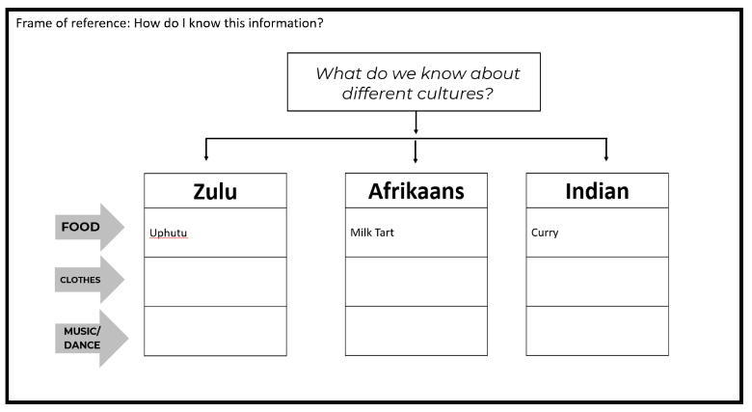  C. Analysing the interviews - suggested time allocation 15 minutes.  - Once the interviews are done, create a Tree Thinking Map on your project wall or the board. Your Tree Map could look something like this example. that represents three cultural groups. If you have more than three cultures, create extra branches for your Tree Map.  - As learners call out answers, ask them where their answers should be placed on the Tree Map. You can write in one-word answers e.g., Uphutu, Melktert, Samosa etc.  - Remember the frame of reference. The frame of reference asks how we know this information e.g., did we read it in a book, someone told us, research it online etc…. Ask learners to share how they know this information.  D. Conclusion and reflection - suggested time allocation 10 minutes  - End the lesson by asking these reflection questions:  - What did you learn from the interviews that has helped you understand your classmates better?  - What did you learn about your classmates that you didn't know before?  - What culture of tradition would you like to know more about? |  | How learning happens.  S.P.E.C.I.A.L.  Learners are actively engaged and paying attention when they have opportunities to socially interact with each other through the interviews. Learners' curiosity is activated because they can ask questions and have the freedom to explore the topic. Curiosity helps to drive attention, if we are curious about something we are more likely to pay it more attention. Paying attention to what you need to learn is the first step to learning.  Remember that reflection leads to learning that is ‘sticky’ learning that lasts. So, don't miss out the reflection activity.
Remember to explain the homework task outlined below.

Homework: Preparing for lesson three.
- At the end of lesson 2, reorganise the class into groups of 4-5 learners and assign each group a theme. The themes are:
- Theme 1: Celebrating culture through food.
- Theme 2: Celebrating culture through music/dance/art/drama.
- You could allow learners to choose their theme first and then divide them into groups. If your class has 40 learners in it, you might have 4 groups with 5 learners that have theme 1 and 4 groups of 5 learners that have theme 2.
Homework task
- Theme 1: Celebrating Culture through Food. Your homework is to research your own culture by finding out more about the traditional foods of your culture. Speak to your family to learn about the traditional foods that are part of your culture. You can also look for recipes of your favourite dishes. Remember to bring your research to school so that you can share it with your group in the next lesson.
- Theme 2: Celebrating culture through music/dance/art/drama: Your homework is to research your own culture by finding out more about either traditional music, or dance, or art or drama (or all of them if you are very interested). Make sure that you bring your research to school to share with your group in the next lesson.
Extended opportunities
- Double-Bubble Map: A double-bubble map is one of eight different thinking maps. It is used to compare and contrast. Learners could create their own double-bubble maps looking for similarities and differences between the cultures represented in their classroom.
- Extend interviews outside of the classroom: This is a great opportunity for learners to either interview other people outside of the classroom (friends, family, community members) or to invite cultural leaders from the community to come and talk to the learners.
Observations and Facilitations – Assessment as Learning
During the learner interviews, it's important to actively observe and listen to learners as they work together in groups. As you walk around the classroom, keep an eye out for several key indicators of learning, communication, and knowledge of the topic. These are just some examples of things to observe you might have your own list of observations to use.

- Learner communication skills
  - Observe learners' active listening skills to determine if they are fully engaging with their peers during the interview process. Are they focused and attentive, or are they distracted or disengaged?
  - Additionally, pay attention to their articulation skills. Are they speaking clearly and confidently, or are they mumbling or speaking too fast, or speaking too loudly or softly?
  - Empathy is another key communication skill to observe during learner interviews. Are learners trying to understand how other people might be feeling? Are they showing empathy and consideration towards their peers?

If learners are struggling with any aspect of their communication skills, there are several strategies you can use to support them.
- One option is to model active listening yourself, demonstrating the kinds of behaviours you expect from learners.
- You can also take the time to explain the guidelines for active listening or the interview process again, ensuring that all learners understand the expectations.
- It can be helpful to share and discuss the definitions of good communication. The Teacher's Guide to Competencies is an excellent resource for this purpose, providing information and guidance on the development of communication skills.

Remember, communication skills take time to develop, and learners will have many opportunities to practice and grow their abilities throughout the project. By actively observing and facilitating their progress, you can help them build important skills that will serve them well in the future.

Teacher self-reflections

Reflecting on how a lesson went is essential to improve your teaching practice. By reflecting on the lesson, you can make adjustments to the project and enhance your future lessons. Annexure 9 contains a wide range of questions that you could use to reflect on this lesson. You do not need to answer all of them, just select one or two that resonate with you. Self-reflection is crucial for teacher professional development because it allows you to learn from your experiences, grow as a teacher, and improve your instructional effectiveness. By continually improving your teaching practice, you can better support your learners' learning and help them achieve their academic goals. Therefore, taking the time to reflect on each lesson is an investment in your professional development and the success of your learners.

Lesson 3: Getting ready to plan our event - coming up with ideas | Resources needed:  No resources are needed for this lesson. |  | Time required:  1 lesson
Summary of the Lesson
In this lesson, learners will work collaboratively in groups to explore and share their knowledge and research on cultural practices and traditions in South Africa. Using their research, learners will develop creative ideas and plans to celebrate Heritage Day that reflect the unique aspects of different cultures. This lesson will provide learners with an opportunity to practice their critical thinking and problem-solving skills, while also promoting cultural awareness, pride, respect, and sensitivity.
Objective
The purpose of this lesson is for learners to:
- Remembering: To identify and recognise the diverse cultural practices and traditions in South Africa.
- Applying: To use critical and creative thinking skills to develop creative ideas and plans for a Heritage Day celebration that reflects the unique aspects of different cultures.
- Analysing: To compare and contrast different cultural practices and traditions in South Africa.
- To practice:
effective collaboration as learners negotiates roles and responsibilities, pool their resources (knowledge) and engage in their roles and responsibilities.
creative innovation as learners generates a range of different ideas.
communication as learners articulates their thoughts and ideas logically so others can understand.
Before the lesson  - Write the group work role descriptions on the board or place them on the Project Wall.  - Write the two group work questions on the board or place them on the Project Wall.  Lesson guidelines- what will learners and teachers do?  A. Introduce the lesson - suggested time allocation 5 minutes.  - Explain to learners that in this lesson they will share and use their research to complete the task outlined below.  - Group one - cultural food: Create a menu that celebrates cultural diversity. You will need to research and think about:  - What food items will be on our menu for our Heritage Day celebrations?  - How do we make these items, who can help us to make these items, or who might make them for us?  - How can we design this menu to present at the Heritage Day celebration?  - Group two - cultural music/dance: Create a programme of events that showcase either music/art/dance/drama that celebrates cultural diversity at our Heritage Day celebration. You will need to research and think about:  - What songs/dances/dramas etc will be performed  - Who will perform these, will we perform, or will we find other people to perform?  - How will we design our programme of cultural events for our Heritage Day celebration?  By the end of the project learners will have created with a menu OR a programme of cultural events that they will showcase at their Heritage Day celebration. If learners want to they can also make food and practice and showcase their cultural performances at this event as well.  B. Selecting roles in the group- suggested time allocation 10-15 minutes.  - Encourage learners to make sure that they represent different cultures at the event.  - To support effective collaborative learning, explain that each learner needs to decide what role they are playing in the group. Allow learners 5 - 10 minutes to decide their roles in the group. You can find the suggested group role descriptions in annexure 4. Here are some examples of what different roles could be included:  - Facilitator - helps the group work together and makes sure everyone can contribute.  - Recorder - helps the group by recording all the group ideas and actions.  - Creative - helps the group by thinking about how the project could look, supports group members to come up with ideas.  - Researcher - helps the group find the information it needs.  - Presenter - helps the group by speaking and presenting their ideas.  C. Brainstorming ideas bubble map - suggested time allocation 15 minutes  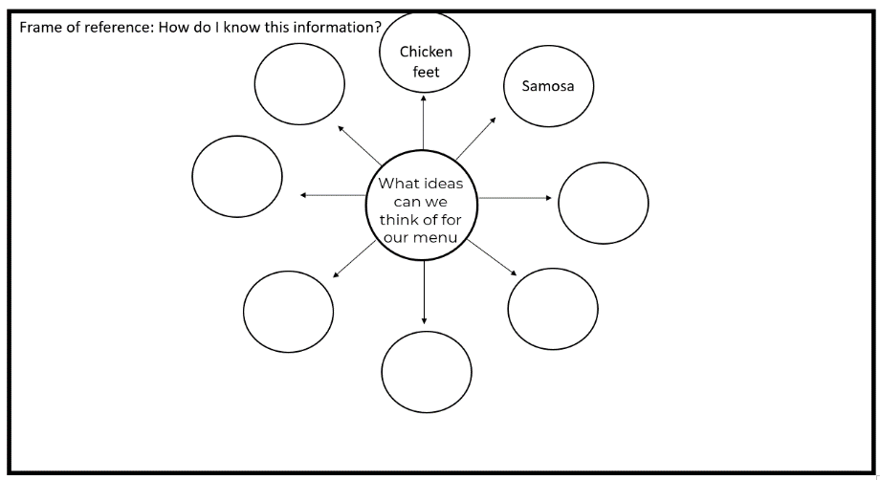  - Learners can use a bubble map to document their ideas. Learners place a different idea in each of the outer bubbles. Learners can add as many bubbles as they like, this is just an example of a bubble map for group 1.  - Remember the frame of reference, remind learners to think about how they know this information.  A bubble map is one of 8 Thinking Maps. It is used to help us describe things, in this case, our ideas. The big bubble in the middle of the page has the question or statement in the middle, in this case, what ideas can we think of to share information about saving and protecting water? The smaller bubbles around the outside have the ideas. Bubble maps help people think creatively and come up with good ideas. They are useful when working on projects, solving problems, or making decisions.  D. Conclude the lesson - suggested time allocation 2 minutes.  4. Explain that in the next lesson, learners will need to decide which of their ideas they would like to choose to do in their Heritage Day celebrations. They will share these ideas with other groups to gain feedback.  E. Reflections - suggested time allocation 5 minutes  5. For this reflection activity you can try out the 5-minute group work check-in. In their groups discuss  - How successfully they worked as a group.  - What areas of the group work didn't work as well?  - What would they like to do differently in the next group work activity? |  | How learning happens.  S.P.E.C.I.A.L.  In this lesson learners are drawing on their prior knowledge and the knowledge they have gained in previous lessons to generate ideas for a Heritage Day celebration. Learners work collaboratively (social interaction) to come up with different ideas for their Heritage Day celebrations. Learners are actively engaged and paying attention in the activity because they are hands on and minds on, they are not sitting passively receiving information, they need to create the information, the ideas for the Heritage Day celebration.  Remember that reflection leads to learning that is ‘sticky’ learning that lasts. So, don't miss out the reflection activity.
Extended opportunities
- Pre-brainstorming warmups! Our brains are just like muscles, they also need to be warmed up before exercise. Here are a couple of suggestions of creativity games to play BEFORE brainstorming, to help improve the brainstorming process, because creativity can be learnt and improved. Feel free to use your own creativity for warm up games.
  - Alternate uses game: The alternate uses game is a creative thinking exercise in which participants generate unconventional uses for common objects or concepts. In this game, participants are given a common object, for example a pencil, and they have a limited time frame, typically 30 seconds, to brainstorm and call out different ideas for how that object could be used in unconventional ways.
Observations and Facilitations – Assessment as Learning

During the brainstorming activity, it's important to actively observe and listen to learners as they work together in groups. As you walk around the classroom, keep an eye out for several key indicators of learning, including creative innovation, collaboration skills, and knowledge retention. Remember you might have your own list of indicators to look out for.
- Learners’ creative innovation: take note of the kinds of ideas that learners are coming up with as they work on their menus or programmes. Are they all the same, or are there different, unique ideas being shared? Encouraging learners to think ‘outside the box’ and approach tasks in their own unique way can help promote creative thinking and problem-solving skills.
- Learners’ collaboration skills are also important to observe, as this plays a key role in the success of any group project. Take note of how learners are discussing and delegating roles and responsibilities within the team. Are they working together to fulfil these roles effectively, or are there issues with communication or teamwork that need to be addressed? Remember it takes time to develop these skills so it is unlikely that learners will ‘get-it’ the first time, and that is ok.
- Learners' knowledge: ask learners to identify and describe different cultural foods, forms of art, dance, music, and other aspects of culture. This can help gauge their understanding and retention of the CAPS material and highlight any gaps that may need additional focus or support.

Teacher self-reflections

Reflecting on how a lesson went is essential to improve your teaching practice. By reflecting on the lesson, you can make adjustments to the project and enhance your future lessons. Annexure 9 contains a wide range of questions that you could use to reflect on this lesson. You do not need to answer all of them, just select one or two that resonate with you. Self-reflection is crucial for teacher professional development because it allows you to learn from your experiences, grow as a teacher, and improve your instructional effectiveness. By continually improving your teaching practice, you can better support your learners' learning and help them achieve their academic goals. Therefore, taking the time to reflect on each lesson is an investment in your professional development and the success of your learners.

Lesson 4: Choosing our best ideas. | Resources needed:  - The Decision Matrix template in Appendix 6  - Learners’ bubble maps from lesson 3. |  | Time required:  1 lesson
Summary of the Lesson
To kick off this lesson, learners will collaborate in groups to choose their top ideas and then design a menu or entertainment programme for their Heritage Day celebration. During this process, groups are encouraged to use a range of tools to assess and refine their concepts.
Objective
The purpose of this lesson is for learners to:
- Applying: Learners will evaluate their ideas to select the best ideas to create either their menu or programme of entertainment and apply critical thinking skills to refine their ideas.
- Analysing: Learners will be able to analyse and then give and receive constructive feedback on their ideas and evaluate which ideas are the best.
- Learners get the opportunity to practice:
  - critical thinking skills such as evaluating information to assess relevance.
  - creative innovation by assessing the fitness for purpose of ideas.
  - collaboration by engaging with roles and responsibilities.
  - communication as learners articulate logically and clearly their thoughts and ideas.
Before the lesson  If you are not printing out the decision matrix, draw the decision matrix template on the board. You could also print one out and have it on the Project Wall.  Lesson guidelines- what will learners and teachers do?  A. Introduce the lesson - suggested time allocation 5 minutes.  - Explain to learners that in this lesson they will continue to work in the same groups. Their task in this lesson is to select the best ideas for their menu or programme, and share these with other group members .  - Before learners start the activity, remind them of their roles and responsibilities. You might want to allow learners the opportunity to change roles in their group so that by the end of the project everyone has had a chance to play all roles in the group.  B. Decision Matrix, selecting our best ideas - suggested time allocation 15 minutes  - Decision Matrix - here is a decision matrix template. You are welcome to use whatever decision-making tool you like, this is just an example.  - Share this template with the learners and explain that they need to write their ideas in the first column.  - Each idea needs its own row.  - Then they need to score each idea from 1-5 for each of the criteria below.  - Finally ask the learners to add up their scores. The ideas with the highest marks are their best ideas.  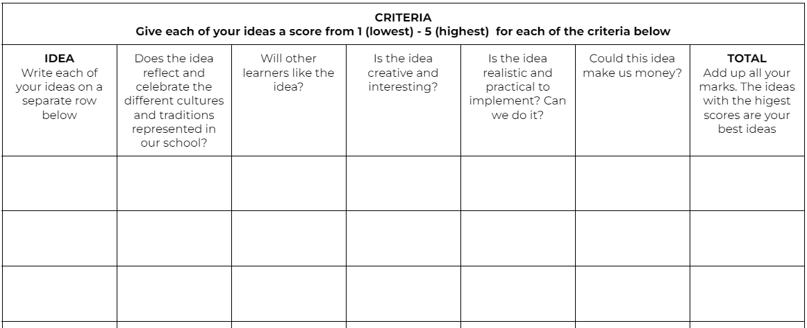  C.Create a menu or programme - suggested time allocation 10 minutes.  - Groups then need to select their best ideas and create their menu or entertainment programme. This can be finished off for homework.  D.Conclude the lesson - suggested time 5 minutes.  - Conclude the lesson with a reflection activity which could be as simple as asking the question: “What is one thing you group achieved in this lesson that makes you feel really proud.” Encourage learners to add some of their proudest achievements to the Project Wall. Of |  | How learning happens.  S.P.E.C.I.A.L.  As with each of the lessons in this project, learners are working collaboratively i.e. the S of S.P.E.C.I.A.L. Social interaction can help to promote a sense of belonging and connectedness among learners, which can increase learner motivation and participation in the learning process. This in turn promotes engagement and attention to the tasks and can lead to ‘sticky learning’.  Learner autonomy is promoted as learners are making their own decisions about their ideas. When learners have autonomy they are able to take ownership of their learning and make choices in line with their needs and interests, which leads to ‘sticky’ deeper learning. This also promotes curiosity as learners can explore what interests them, and in the process learn and develop their understanding of curriculum content.  Remember that reflection leads to ‘sticky’ learning that lasts. So, don't miss out on the reflection activity.
Extended opportunities
To take this activity further, learners could conduct a survey with other learners in the school to find out what items on their menus or programmes they are most interested in. This would be a great activity to do in maths covering data handling. If learners are looking at how they could make money from this event, one of their questions in their survey could be - how much money would you be willing to spend on X…

Observations and Facilitations – Assessment as Learning
During this activity, it's important to actively observe and listen to learners as they work together in groups. As you walk around the classroom, keep an eye out for several key indicators of learning, including creative innovation, collaboration skills, communication, and critical thinking skills.
Here are some suggestions of what you could observe:
- Learners’ critical thinking skills: Are learners exercising critical thinking skills by evaluating and assessing the relevance of their ideas as they make their selections? Are they asking thoughtful questions and providing reasoned justifications for their suggestions?
- Learners’ creative innovation skills: Are learners demonstrating creative innovation skills by generating ideas that are practical and suitable for the intended purpose?
- Learners’ collaboration skills: Are learners effectively collaborating by assuming different roles within the team? Are they continuing to engage with their assigned responsibilities, or is everyone working independently without regard for the group's goals?

If learners are having any challenges with their critical thinking, creative innovation or collaboration skills, you can play some games to support them to practice these skills. You can find these in the Competency Toolkit available from the DBE-E³ programme. In addition, ask learners to reflect on what they could do differently next time.

Teacher self-reflections

Reflecting on how a lesson went is essential to improve your teaching practice. By reflecting on the lesson, you can make adjustments to the project and enhance your future lessons. Annexure 9 contains a wide range of questions that you could use to reflect on this lesson. You do not need to answer all of them, just select one or two that resonate with you. Self-reflection is crucial for teacher professional development because it allows you to learn from your experiences, grow as a teacher, and improve your instructional effectiveness. By continually improving your teaching practice, you can better support your learners' learning and help them achieve their academic goals. Therefore, taking the time to reflect on each lesson is an investment in your professional development and the success of your learners.

Lesson 5: Sharing our best ideas. | Resources needed:  - Menus and programmes created in the previous lesson. |  | Time required:  1 lesson
Summary of the Lesson
In this lesson learners will continue to work in their groups, but this time they will be sharing their ideas and giving and receiving feedback with one other group. The aim of this lesson and the next lesson is to encourage learners to critically assess and refine their ideas while also developing their ability to provide constructive feedback. This lesson is designed to promote collaboration, creativity, and communication skills among learners.
Objective
The purpose of this lesson is for learners to:
- Understanding: Learners understand why it's important to give helpful feedback in group work, including how it can make their ideas better and improve their relationships with their peers.
- Applying: Learners will use the principles of helpful feedback in their own group work, giving specific and useful suggestions to their peers to help improve their ideas.
- Learners get the opportunity to practice:
  - communication as learners articulate their thoughts and ideas.
  - critical thinking as learners evaluate information and ask questions.
Before the lesson  Write the feedback guidelines on the board OR make them visible on your Project Wall.  Lesson guidelines- what will learners and teachers do?  A. Introduce the lesson - suggested time allocation 5 minutes.  - Explain to the class that in this lesson each group will have the opportunity to share their programme or menu with one other group who has a different theme. E.g., place a group that is doing a menu with a group that is doing an entertainment programme.  B. Give and receive feedback – suggested time allocation 20 minutes.  - Allow group one 5 minutes to share their menu with their peers.  - Allow group two 5 minutes to share their feedback on group 1’s menu.  - Swap roles and repeat.  - Encourage both groups to write down feedback.  Feedback protocol  Please feel free to use your favourite feedback tools. This is just a suggestion of what learners could do.  Remember the three rules. Make sure your feedback is:  - Kind - think about how you give your feedback.  - Helpful - think about what you are sharing that is useful to the team.  - Specific - think about giving feedback that is very clear, simple and focuses on one thing.  Suggested feedback starter starters:  - I really liked__________________ because….  - How could you _____________________________________  - Another way to do this is____________________________________  - Have you considered________________________________________  - I agree with_________________________________________________  C.Conclusions and reflections - suggested time allocation 5 mins  6. "Exit Ticket" - Give each learner a small piece of paper or an index card. Ask learners to write down one thing they learned during the lesson or one question they have about the lesson. Collect the exit tickets as students leave the classroom.  This exit reflection activity provides a quick and easy way to check for understanding and gather feedback from learners about the lesson. It also allows them to reflect on their learning and express any remaining questions or concerns they may have about the topic. As the teacher, you can use this feedback to guide future lessons and address any areas of confusion or misunderstanding. |  | How learning happens.  In this lesson learners start the process of Iteration as they get feedback on their project plans and reflect on their learning. This can help learners identify areas that need improvement and they can adjust their approach accordingly.  Iteration can also lead to deeper understanding and learning of a topic or concept because learners can revisit the topic from different viewpoints or perspectives, continually strengthening connections between prior knowledge and new knowledge.  Seeking feedback is the first step in the process of iteration.  Remember that reflection leads to learning that is ‘sticky’ learning that lasts. So don't miss out the reflection activity
Extended opportunities
There are many different approaches to giving and receiving feedback such as role playing or giving a presentation to the whole class for comment. Please feel free to use whatever technique works best in your classroom.
Observations and Facilitation – Assessment as Learning
During this activity, it's important to actively observe and listen to learners as they work together in groups. As you walk around the classroom, keep an eye out for several key indicators of learning, including creative innovation, collaboration skills, communication, and critical thinking skills.

Here are some suggestions of what you could observe:

- Giving Feedback: Observe learners as they give feedback to their peers. Take note of the quality of their feedback, including whether it is specific, actionable, and relevant and shows respect and kindness.
If learners get stuck, you could prompt them by saying “Can you give your peer a specific suggestion on how to improve their idea?"

- Receiving feedback: Observe learners as they receive feedback from their peers. Take note of their reactions and whether they are open to receiving feedback.
Prompt: "How did you feel when your peer gave you feedback on your idea? Was it helpful?"

- Learner communication: how clear was the learner communication? Were they able to express their ideas clearly?

- Learner Knowledge: Are the learners demonstrating an understanding of different cultural traditions and practices? Are learners respectful of different cultures?

Teacher self-reflections

Reflecting on how a lesson went is essential to improve your teaching practice. By reflecting on the lesson, you can make adjustments to the project and enhance your future lessons. Annexure 9 contains a wide range of questions that you could use to reflect on this lesson. You do not need to answer all of them, just select one or two that resonate with you. Self-reflection is crucial for teacher professional development because it allows you to learn from your experiences, grow as a teacher, and improve your instructional effectiveness. By continually improving your teaching practice, you can better support your learners' learning and help them achieve their academic goals. Therefore, taking the time to reflect on each lesson is an investment in your professional development and the success of your learners.

Lesson 6: Iterating and Improving our ideas. | Resources needed:  Menus or entertainment programmes |  | Time required:  1 lesson
Summary of the Lesson
In this lesson, learners will have the chance to use the feedback they received in the previous lesson relating to their programmes or menus. This provides an excellent opportunity to introduce the concept of iteration. By making changes to their menus or programmes, learners can improve on their initial ideas and create better, more effective products.
Objective
The purpose of this lesson is for learners to:
- Understanding: Explain what the concept of iteration means.
- Analysing: Learners will analyse the feedback they receive from their peers, identifying strengths and weaknesses in their ideas and using that feedback to refine and improve their work.
- Creating: Learners will create an updated version of their original idea using the feedback and suggestions provided by other groups, demonstrating creativity and innovation.
- Learners get the opportunity to practice:
  - critical thinking as learners evaluate information and ask questions.
  - collaboration as learners engage with their roles and responsibilities.
  - meta-learning (thinking skills) as learners adapt and iterate their work based on feedback they received.
Before the lesson  You do not need to do anything to prepare for this lesson.  Lesson guidelines- what will learners and teachers do?  A. Introduce the lesson – suggested time allocation 5 minutes.  - Start the class by explaining that in this lesson learners will have the opportunity to update and improve their menus or programmes, to include any feedback they received in the previous lesson.  - Explain that this process is called Iteration. Ask the class if anyone knows what iteration means. By asking this question you are determining learners' Prior Knowledge of the topic.  Iteration: Iteration is the process of trying something, making changes based on feedback, and then trying again to make it even better. Think of it like a chef who tries a recipe, adjusts the ingredients, and then tries again until the dish tastes just right. The more times you go through this process, the better your product will become.  B. Iteration – suggested time allocation 20 minutes.  - Ask the learners to review the feedback that they received and think about what changes they would like to make to their menu or programme. Walk around the room and scaffold learning when necessary. If learners quickly finish, a good question to ask them is to: Are you sure your work is finished? What do you think about what you have done?  C. Conclusions and reflections - suggested time allocation 5 minutes  - In this reflection activity (feel free to choose your own) ask the whole class, “Were your projects better before or after you iterated?”  - Next, ask learners to reflect on their own using the questions: How or where can you use iteration in your own life to make improvements? |  | How learning happens.  S.P.E.C.I.A.L.  We've already explored why iteration is important for learning, but let's delve deeper. Iteration plays a critical role in developing our meta-learning (thinking) skills, such as our ability to reflect on our thinking and enhance our awareness of our learning process. It allows us to develop mastery of a skill, not by mindlessly repeating the same thing over and over again, but by continuously improving each time until we achieve mastery. Imagine the possibilities if we could incorporate iteration into all assessment tasks. Learners would work on a project, essay presentation, or whatever the task is, receive feedback, and apply it repeatedly until all learners produce an exceptional piece of work. Iteration enables learners to identify and correct errors, enhances memory retention as learning becomes embedded, and builds confidence by demonstrating that it is okay to make mistakes and learn from them. After all, the real world doesn't always allow us to get everything right the first time.
Extended opportunities
Learners can repeat the process of iteration as many times as necessary to improve their product. Each time learners iterate; they make their product stronger and better. So, if you have enough time, it's a good idea to have another round of feedback and iteration. You can have short rounds of feedback, followed by quick iteration. For example, you can take 5 minutes for feedback and 5 minutes for iteration until you finish your lesson. This way, learners can keep improving their work until it's the best it can be.
Observations and Facilitation – Assessment as Learning

During this activity, it's important to actively observe and listen to learners as they work together in groups. As you walk around the classroom, keep an eye out for several key indicators of learning, including creative innovation, collaboration skills, communication, and critical thinking skills.

Here are some suggestions of what you could observe:

- Learner critical thinking skills: As learners work on creating an updated version of their original idea, observe their level of critical thinking. Are they able to evaluate their feedback and use this to assess and update their current menus or programmes. You can use prompts such as:
- "How did the feedback you received help you improve your original idea?" or
- "What are some possible consequences of implementing this updated version of your idea?"
- “Remember to explain the reasoning behind your changes so that others can understand your thought process”.

- Learner Meta-learning: Observe how learners adapt their work based on the feedback they received. Did learners show a willingness to adapt? Did learners reflect on the feedback they received? How did learners react to the feedback? You could use prompts such as:
  - "You did a great job adapting your menu/programme based on the feedback you received. Your willingness to change shows a strong willingness to adapt and change your thinking."
  - "Next time, try to reflect more deeply on what you learned from the feedback process and how you can apply it in other areas of your work."
  - "Remember to take both positive and negative feedback as opportunities for growth and improvement."
- Learner knowledge: While learners are discussing their feedback, they will be learning more about the different food, dance/song etc. of different cultures. You can ask learners questions about what they know and how they know it, or reflect on what they know now that they did not know before.
Teacher self-reflections

Reflecting on how a lesson went is essential to improve your teaching practice. By reflecting on the lesson, you can make adjustments to the project and enhance your future lessons. Annexure 9 contains a wide range of questions that you could use to reflect on this lesson. You do not need to answer all of them, just select one or two that resonate with you. Self-reflection is crucial for teacher professional development because it allows you to learn from your experiences, grow as a teacher, and improve your instructional effectiveness. By continually improving your teaching practice, you can better support your learners' learning and help them achieve their academic goals. Therefore, taking the time to reflect on each lesson is an investment in your professional development and the success of your learners.

Lesson 7: Creating an action plan. | Resources needed:  Menus and programmes created in the previous lesson. |  | Time required:  1 lesson
Summary of the Lesson
In this lesson, learners will create an action plan using a flow map to help them plan the steps they need to take to turn their ideas into reality. They will work in the same groups as in previous lessons. By the end of the lesson, learners will have a clear understanding of the steps needed to bring their ideas to life and will be equipped with an actionable plan to move forward.
Objective
The purpose of this lesson is for learners to:
- Applying: Use a flow map to create an action plan for bringing an idea to life.
- Creating: Create an actionable plan to move forward and turn their ideas into reality.
- To practice meta-learning (thinking skills) as learners set goals and create a plan of action.
Before the lesson  You might want to draw a flow map template on the board or put one on the Project Wall.  Lesson guidelines- what will learners and teachers do?  A. Introduce the lesson - suggested time allocation 5 minutes.  - Start the class by explaining that the Heritage Day celebration will start to become more real, because learners can now move from their ideas to thinking about the steps they need to take to actually put into action.  - Ask the class if anyone knows what a Flow Map is? By asking this question you are determining learners' Prior Knowledge of the topic. Depending on the answers, show the flow map of the board or Project Wall and explain a bit more about the value and use of such a map.  A Flow Map is a type of thinking map that is used to represent the steps in a process (sequence of events). A typical Flow Map consists of a series of boxes or shapes connected by arrows or lines, with each box representing a step or event in the process. The arrows or lines indicate the direction of the flow of the process, from the initial step to the final outcome.  Flow Maps can be used to help learners understand the order and relationship of events in a process, and can help them identify the key components of the process. By using a visual representation of the process, learners can better understand and remember the steps involved, and can more easily identify areas where they may need additional support or guidance.  Overall, Flow Maps are a useful tool for promoting critical thinking, problem-solving, and understanding of complex processes. They are flexible and adaptable to a wide range of educational contexts and can be used to support learning across many subject areas.  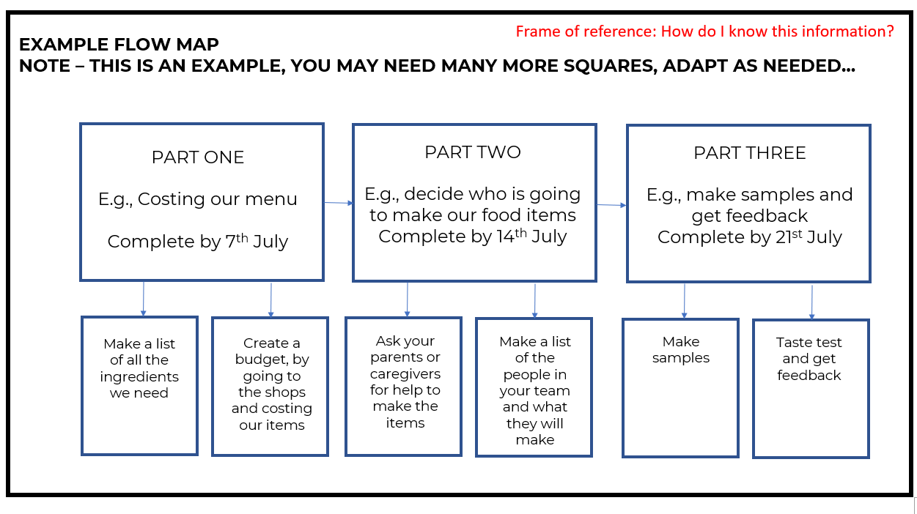  B.Creating a flow map – suggested time allocation 20 minutes.  - In the same groups, ask learners to create a flow map of the steps/activities they need to do to turn their menus or programmes into a reality.  - Remember the frame of reference, remind learners to think about how they know this information.  - Here are some questions to get them started.  What tasks might you need to do first?  What are the smaller tasks for each big task?  Who will do these?  When will they do them?  Who will make sure they are done?  C. Conclusions and reflection – suggested time allocation 5 minutes.  - For some learners this might be the first time that they have done a flow map. In their groups ask learners to discuss, “What part of the flow map makes you most excited and why?” and “How can you use a flow map in your day-to-day life?” |  | How learning happens.  In this lesson, learners will have the opportunity to plan how they might implement their ideas for the Heritage Day celebration. They will use their thinking skills. This involves reflecting on and analysing their learning process, an important aspect of Iteration. By doing so, learners can identify what strategies work best for them and adjust our approach accordingly. Meta-learning also involves identifying strengths and weaknesses, which can help learners to take ownership of their learning and become autonomous self-directed learners.  Remember that reflection leads to learning that is ‘sticky’ learning that lasts. So don't miss out the reflection activity
Extended opportunities
There are lots of extended opportunities for this lesson, here are some ideas, but as always feel free to add your own ideas.
- Create posters to advertise your event. This could be connected to languages.
- Over the rest of the term learners can start implementing actions they identified in their flow maps.
- Learners could consider finding people in the community or school to support the event.
- Learners can practice making food or performing cultural dances, and songs before their Heritage Day event.
Observations and Facilitation – Assessment as Learning
During this activity, it's important to actively observe and listen to learners as they work together in groups. As you walk around the classroom, keep an eye out for several key indicators of learning, including creative innovation, collaboration skills, communication, and critical thinking skills.

Here are some suggestions of what you could observe:
- Meta-learning (Thinking skills) skills: Observe how the learners set goals and break down their plan of action into smaller tasks and activities. Were learners able to set realistic goals? Did learners set clear tasks with achievable deadlines? If learners struggle with this, you can prompt them by asking
  - “What is the next small thing that you need to do to achieve this. Keep thinking about the small tasks that make up this whole.”
  - “Remember to adjust your plan as challenges come up. You can always change your plan.”
- Knowledge: Observe how learners deepen their knowledge of cultures, menus, and food, as well as music and dance, by breaking down the steps needed to create either food items or a cultural performance for Heritage Day. You could ask learners:
  - “What challenges have you encountered as you've worked on your food menus /entertainment programmes?

Teacher self-reflections

Reflecting on how a lesson went is essential to improve your teaching practice. By reflecting on the lesson, you can make adjustments to the project and enhance your future lessons. Annexure 9 contains a wide range of questions that you could use to reflect on this lesson. You do not need to answer all of them, just select one or two that resonate with you. Self-reflection is crucial for teacher professional development because it allows you to learn from your experiences, grow as a teacher, and improve your instructional effectiveness. By continually improving your teaching practice, you can better support your learners' learning and help them achieve their academic goals. Therefore, taking the time to reflect on each lesson is an investment in your professional development and the success of your learners.

The Public Presentation – Heritage Day |  | Resources needed:  This will depend on what sort of food, events, and dress learners have planned for their event. | Time required:  1 lesson
Summary of the Lesson
At the end of the project, learners have the opportunity to present their work e.g., their menus and food items and their programmes and entertainment at the public presentation - a celebration for Heritage Day. The purpose of a public presentation is to provide learners with an authentic audience to share their learning and achievements, and to receive feedback and recognition for their hard work. It also allows learners to practice important skills such as public speaking, communication, and presentation design.
Objective
The purpose of the public presentation is for learners to:
- Applying: Learners apply the knowledge gathered throughout the project to share their learnings and products during the Heritage Day celebration.
- Creating: Learners actively create items to display at their Heritage Day Celebrations e.g., food items, music, dance etc.
- Learners get the opportunity to practice:
- communication, critical thinking, collaboration, creative innovation, and meta-learning as they work collaboratively to implement their plans for the Heritage Day Celebration
The flow maps created in lesson 7 will guide learners and teachers in planning the Heritage Day Celebrations. Every class or school will do something and so there are no specific guidelines here.  End of project reflections  - Once the event is over, make sure you have time to debrief the experience with the learners.  - Ask learners to complete the Learner Self-reflection Table (see annexure 8). You can decide what method to use to complete the reflection e.g. independently, in a group, in pairs. | How learning happens.  As learners work collaboratively (social interaction) to implement their ideas for their Heritage Day celebrations they are actively engaged in the learning process (hands-on and minds on) which increases attention and engagement, which as we know leads to better learning outcomes. This experiential approach (planning and organising a menu or entertainment programmes for Heritage Day) can create more vivid and lasting memories because it engages multiple senses and emotions, e.g. learners are not only sitting and listening - they are doing.  A public presentation is a nice place to observe the E - Enjoyment in S.P.E.C.I.A.L. Throughout the project learners would have had to persevere through challenges, they would have felt frustrations, they would have had to be resilient in overcoming challenges. The E for Enjoyment speak to the joy that you feel once you have overcome your challenges.  Learners are actively making meaningful connections between their prior knowledge and new practical learning experiences as they deal with problems and find solutions, give and receive feedback, present their ideas and so on.  All of this leads to ‘sticky’ learning, learning that is memorable, lasting, and relevant to the learners.

Exemplar Assessment rubric

This is an exemplar assessment rubric that reviews the whole project so please review:

- all your observations across all lessons in this project
- learner participation in the water awareness event

This collective feedback will be invaluable in completing this assessment rubric for this project. Since this is an exemplar rubric there are a number of different assessment criteria so, please use what is relevant to your situation and context, adapt, change, edit as needed. You can of course use all the criteria and use it as is.

GRADE FOUR ASSESSMENT RUBRIC
Celebrating our rainbow nation: what can we learn from different cultures to create a very special celebration for Heritage Day?
CRITERIA  How do we know that learners can do this? | 9-10  Mastering | 7-8  Advancing | 5-6  Developing | 3-4  Learning | 1-2  Starting
Knowledge  Cultures in South Africa  (CAPS content)  To what extent did the learners show understanding by identifying, describing, explaining, and evaluating different cultures. | Learners can evaluate the importance of cultural diversity and inclusivity in South Africa and identify ways in which a rainbow nation can be celebrated and respected to promote unity and tolerance among diverse groups.  Learners can also suggest practical and realistic ways to make everyone feel included. | Learners can compare and contrast different aspects of cultural practices, such as music or dance, from different South African cultures, and identify both their similarities and differences.  Learners can also identify the benefits or strengths of a rainbow nation. | Learners can explain why cultural items, such as traditional clothing or food items, are important to different South African cultures.  Learners can explain to other people what the concept of rainbow nation means. | Learners can describe basic cultural items, such as traditional clothing or food items, from different South African cultures, including their colours, shapes, textures, and tastes.  Learners show an understanding of the term "rainbow nation". | Learners can identify basic cultural items, such as traditional clothing or food items, from different South African cultures, and recognise them as belonging to a particular culture.  Learners recognise the term "rainbow nation" but might not yet be able to explain the concept to other people.
Research: To what extent did learners:  These are possible points of observation; you can use all of them or select the ones that are relevant to your classroom.  - show curiosity to be inquiring.  - ask probing questions.  - use a variety of sources.  - evaluate the sources for  - integrity  - usefulness  become confident to defend their research | - Learners demonstrated exceptional curiosity and inquiry skills.  - Learners asked highly probing and insightful questions.  - Learners used a wide variety of sources effectively.  - Learners critically evaluated the sources for both integrity and usefulness.  Learners confidently defended their research with compelling evidence and arguments | - Learners showed a good level of curiosity and inquiry skills.  - Learners asked probing questions that were mostly insightful.  - Learners used a variety of sources effectively.  - Learners generally evaluated sources for integrity and usefulness.  - Learners mostly were confident when defending their research with evidence and arguments. | - Learners demonstrated some curiosity and inquiry skills.  - Learners asked some probing questions but may need guidance.  - Learners used some sources effectively.  - Learners attempted to evaluate sources for integrity and usefulness.  Learners may lack confidence when defending their research with evidence and arguments | - Learners showed limited curiosity and inquiry skills.  - Learners asked basic questions with little probing.  - Learners used limited sources effectively.  - Learners struggled to evaluate sources for integrity and usefulness.  - Learners were not confident when defending their research with evidence and arguments. | - Learners demonstrated minimal curiosity and inquiry skills.  - Learners asked few or no probing questions.  - Learners used very limited sources effectively.  - Learners did not evaluate sources for integrity or usefulness.  - Learners were unable to defend their research with evidence and arguments.
Do learners’ cultural food menus or programmes of performance celebrate cultural diversity due to effective research and eye-catching presentation? | Mastering  The menu/performance programme demonstrates exceptional cultural diversity, reflecting extensive research and understanding.  The group's research and planning process is comprehensive, well-organised, and shows strong teamwork.  The presentation of the menu/performance programme is highly creative, visually striking, and celebrates cultural diversity in a memorable way. | Advancing  The menu/performance programme showcases a thoughtful and well-researched variety of food items/ music/dance performances, from various cultures.  The group's research and planning process is thorough and demonstrates clear collaboration among members.  The presentation of the menu/performance programme is creative and effectively conveys the cultural diversity of the Heritage Day celebration. | Developing  The menu/performance programme includes a diverse selection of food items/ music/dance performances, representing different cultures.  The group's research and planning process is organised and demonstrates understanding.  The presentation of the menu/performance programme is visually appealing and appropriate for the Heritage Day celebration. | Learning  The menu/performance programme includes some food items/ music/dance performances, from different cultures but could benefit from more variety.  The group's research and planning process is present but needs more depth or organisation.  The presentation of the menu/performance programme shows some effort but could be improved. | Starting  The menu/performance programme includes only a few food items or music/dance performances, and cultural diversity is not evident.  The group's research and planning process is minimal or unclear.  The presentation of the menu/performance programme lacks creativity and effort.
Comments/  feedback |  |  |  | Total marks | /30

How did the project help learners to grow their skills | Yes | No
Critical Thinking: is about asking questions to understand the world, it is also about trying to make sense of information, evaluating it and connecting it to other pieces of information.
- Did the learners grow their critical thinking through the project?
- Was there a difference from the start to the end of the project in the learners’ critical thinking skills?
- Did the learners ask questions?
- Did the learners find the relevant and appropriate information, evaluate, and analyse it and apply it to solve a problem?
- Did you notice a change in learners critical thinking skills?
COMMENTS: What did you notice
Creative Innovation: is the ability to come up with many different ideas and apply them to find realistic solutions to problems.
- Did the learners grow their creative innovation through the project?
- Was there a difference from the start to the end of the project in the learners’ critical thinking skills?
- Did the learners generate ideas and seek solutions?
- Did the learners transfer their knowledge of and experience about culture to find solutions?
- Did you notice a change in learners creative innovation skills?
COMMENTS: What did you notice

Collaboration: when people work with each other to complete a task. It involves co-operation and teamwork and the sharing of ideas, knowledge, and skills to reach the same goal.
- Did the learners grow their ability to collaboration through the project?
- Was there a difference from the start to the end of the project in the learners’ collaboration?
- Did the learners show an ability to compromise, be considerate of each other, and be positive in a conflict situation?
- Did the learners leverage on each other’s strengths? (Pool their collective resources in terms of strengths and knowledge)
- Were the learners willing to listen, empathise, and give and receive useful feedback to the team?
- Did you notice a change in learners creative innovation skills?
COMMENTS: What did you notice
Communication: is all about sharing information, it is about what we say (verbal communication) and how we say it (non verbal communication).
- Did learners grow their ability to understand non-verbal cues such as tone of voice, body language through the project?
- Was there a different from the start to the end of the project in how learners spoke (articulation) e.g. did they stop mumbling, talked at the right speed, used the right tone etc.
- Did you notice a change in learners ability to try and understand things from other peoples perspective e.g. their empathy skills?
COMMENTS: What did you notice

Annexures

Annexure one: Example letter to parents and caregivers about Project-based Learning
This is just an example. Feel free to edit and adapt it to your needs.

Dear Parents and Caregivers,

We hope this letter finds you well. We want to share with you an exciting project that your child will be working on in school called "Celebrating our Rainbow Nation". This is a Project-based Learning project. You may have already heard a lot about Project-based Learning, but if not, Project-based Learning is a teaching method where learners learn by actively engaging in real-world and meaningful projects. Through this method, learners are given the opportunity to collaborate with their peers, conduct research, and apply their knowledge and skills to solve real-life problems.

There are many benefits to Project-based Learning. This method encourages creativity, critical thinking, and problem-solving skills. Learners also learn to communicate effectively, both with their peers and the community, and build personal connections with the subject content (CAPS), leading to deeper and more memorable learning experiences.

We are excited to inform you about our current project, "Celebrating our Rainbow Nation" where learners will be working collaboratively to plan and organise a special event that celebrates the diverse cultures and cuisines in South Africa on Heritage Day. Throughout the project, learners will be expected to communicate effectively and draw on their knowledge of different South African cultures and cuisines. Learners will be encouraged to use various thinking tools, to order, analyse, and evaluate information (data), as well as plan and sequence the necessary tasks to organise their event. In order for the project to be successful, learners will need to find ways to work collaboratively, communicate effectively, and share their knowledge with others. There are lots of ways you can support your child in their Project-based Learning journey that will not cost you anything. You can

- Encourage your child to ask questions and take ownership of their learning. This can help them develop critical thinking skills and become more engaged in the project.
- Help your child find resources and materials related to the project topic. This can include books, articles, websites, or even just your own knowledge about the topic.
- Ask your child about their project and listen to their ideas. Show interest and enthusiasm for what they are learning, and offer positive feedback to encourage their progress.
- Help your child manage their time effectively by helping them to create a schedule or calendar with deadlines and milestones for the project.
- Attend any events or presentations related to the project, and show support for your child and their classmates as they showcase their work.

We believe this project will promote attention and engagement among our learners, as they decide which foods, clothing, songs, and dances they wish to showcase at their event. We encourage you to support your child throughout this project and attend the event on Heritage Day to celebrate the country's cultural heritage.

Thank you for your ongoing support of our learners' education.

Sincerely,

[Your Name]
…………………………………………………………………………………………………………………………………………………………………………………………………………………………………………………………………………………………………………
This is to confirm that I __________________________________ parent/guardian of ___________________________________ have read this letter and I understand what the project is all about.

Annexure two: The Go Away Girl Story
It was the first day of term 3. All the grade 4s were excited to be back at school. We lined up outside our class and although our teacher, Ms Mbete, asked us to, “Shush”, there was lots of whispering and giggling as we shared our holiday stories. As the first bell of the day rang, we walked into class and sat at our desks.
Ms Mbete started by calling the register to see who was there, “Sindiswa, Enzo, Kgatliso, Xolale, Andile, Kgopotso, Zanele, Aamiina, Aamiina …”. Ms Mbete called out the name, but no one answered. We didn’t even know anyone called Aamiina – what a funny name! As we looked around for this Aamiina person the principal walked in followed by a new learner. “Grade 4s, she said, this is Aamiina, she is new to the area and new to school. Please make her feel welcome.” We were shocked into silence as we stared at the new girl because she looked so different. First, she was only carrying a lunchbox– no school case. Where were her books? Second were her funny clothes. She was wearing a school skirt, but it was so long it touched the ground. Her school shirt was long-sleeved and buttoned at her wrists even though it was warm. Also, her head and shoulders were wrapped in a scarf so that it was hard to see her hair and face.
Ms Mbete smiled at her, “Please sit at that desk,” she said pointing to an empty desk. Aamiina walked over and sat quietly. She looked down at the desk while we all stared at her. “Take out your pencil cases and Life Skills books and let’s get started,” said our teacher. We all started preparing for the lesson except for Aamiina. “She doesn’t have a school case, or books or EVEN a pencil case,” we whispered to each other in amazement. Who was this girl and where did she come from?
The bell rang for break and Ms Mbete asked if Aamiina could sit with me and Sindiswa. “Yes teacher,” we said, but immediately ran out because we did not want to sit with her. From our shady place under the tree, Sindiswa and I watched the new girl carefully. We saw her open her lunchbox and take out … a sort of a pancake? With rice? Where were her sandwiches?
After break we washed our hands and went back to class. It was my favourite part of the day: story time when Ms Mbete read us wonderful stories. We all sat comfortably, and the story started. After a few minutes Sindiswa shot her hand up saying urgently, “Teacher, teacher, the new girl isn’t listening to you!” Ms Mbete stopped reading and we all turned our eyes towards the new girl. Not listening was one rule you didn’t break in this class! “What are you doing?” asked Ms Mbete. “You –new girl, what are you doing?” Aamiina didn’t even look up. Sjoe but there was going to be trouble now. Ms Mbete walked over to Aamiina and saw she was looking at a small card. The teacher took it away, gave the new girl a fierce and angry look and put the card on her desk.
As one, our eyes followed that card. What was it? At second break we got our chance to find out. Ms Mbete stepped out and left the classroom door open. Andile and Zanele snuck into the class and grabbed the card. There was some kind of writing and drawing but like nothing we had ever seen before. Was this a spell? Was the new girl a witch? Now we were scared. “She must go, this girl,” we said. “She must just go – go away girl – we don’t want her here. She might be dangerous!” For the rest of the day, we avoided the Go-Away girl and stayed as far away from her as we could.
Later that day when I was busy with homework, my mother came home with the news that there was a new family running the spaza and the big news was they were Somali. That got my attention. “Is there a daughter?” I asked. “Yes,” said my mother.” It’s a father with his daughter. I don’t know if there is a mother or any other family.” “So that’s who the new girl must be,” I thought to myself, pleased to have solved some of the problem at least.
The next morning, I was burning with the news. “Guess what?” I told everyone I saw, “That new girl is Somali. She lives with her father at the spaza shop.” The news flew around the school, “She’s Somali, she’s Somali she’s Somali.”
Over the next few weeks, we lost interest in the Go Away girl and ignored her. We didn’t like her food or her clothes, and we couldn’t understand her, and we didn’t even try. The Go Away girl became like a shadow until one unbelievable day when everything changed.
It was late afternoon and my mother had forgotten to buy salt. The shops were far away so she asked me to run quickly to the Somali spaza shop to buy a packet. When I got there, no one was at the counter, the spaza looked empty. I waited for a few minutes and then peeped over the counter to the back of the store. The first thing I saw was Go-Away girl sitting on her father’s lap. She was crying softly with tears pouring down her cheeks. Her father was hugging her and rocking her gently from side to side. He looked so sad. On the wall above them was a photo of a young woman who looked so much like Go Away girls that it must have been her mother. Before I disturbed them, I tip-toed out of the shop and ran home. Before my mother could even shout at me for not buying the salt, I burst into tears and told her the whole story: about the girl who was not like us, and who we ignored, but now I knew she didn’t have a mother and she was so sad, and we had done nothing.
Just like Aamiira’s father had sat his daughter on his lap and hugged and rocked her, so my mother took me on her lap and hugged and rocked me until I stopped crying.
Something had to be done! I couldn’t sleep that night thinking and thinking of a plan to help Aamiira.
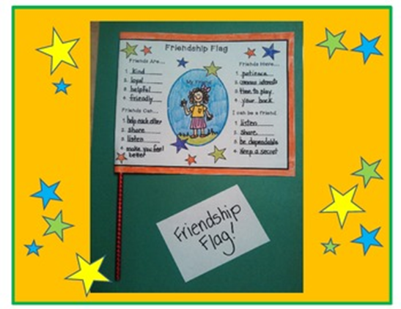
The next day I told my teacher the story and she realised we had a problem to solve. A few days later she came up with a plan. We were going to organise a ‘Fly a friend’s flag day.’ When Ms Mbete explained the plan, we were all so excited. We had to work in pairs and learn all about our friend. Aamiira’s father explained the plan to her, and she and I worked together. We asked so many questions. We asked what languages were spoken at home and were amazed to find out how many different languages there were just from our class. We found out about food and drinks that were important to our cultures. We asked what religions were followed and where we went to worship. We also asked what our favourite holidays and festivals were and how we celebrated these days. We brought in our traditional clothes and explained when we wore the clothes and why they were important to us. We brought different types of music to school and learnt to sing each other’s songs. We had the best week ever.
After finding out all these amazing cultural facts, we had to make a beautiful flag about our friend that she or he could hold up and show off with pride.
On the big celebration day, some parents had kindly made some traditional cultural foods. At assembly we stood in our pairs at the front, all socially distanced. First, we swapped flags and then held our unique flags up high to show off our culture with pride. Different colours, different words, different foods, clothes and religions – so much difference, but all equally beautiful.
The principal was nearly in tears. “Grade 4s,” she said, “You are so young, but you have taught us a very important lesson: to be proud of your culture and celebrate others’ cultures. A great man, Kofi Annan had some wise words which I’m going to end with now, ‘We may have different religions, different languages, different-coloured skin, but we all belong to one human race.’

Annexure three: The Project Wall

How to create your own Project Wall

Have you heard of a Project Wall? Or maybe you already have lots of Project Walls in your classroom. It's a physical space used in project-based learning to visually display the progress and development of a project. It's a central location where everyone can see and contribute to the organisation of ideas related to the project. If you're looking to create your own project wall, here are some ideas of what to include:

- The driving question.
- The project goals.
- Assessment rubrics
- Tools that learners might use, like templates of thinking maps.
- The steps of the project
- Reflection tools
- Pictures
- Examples of learners' work
- Questions that learners have

The Project Wall should be an evolving space that changes and grows as the project progresses, with new insights and ideas constantly being generated.

So, how does a Project Wall support learning? Here are a few ways:

- It provides a space for learners to engage with the project material and reflect on their progress.
- It makes learning visible, so learners know what they need to learn, how to learn it, and how to evaluate their own progress.
- It's a place to practice collaborative learning, as learners can decide together what to put on the wall.

Remember, a project wall is a great tool to help you organise and visualise your ideas, keep track of your progress, and learn collaboratively with your team.

Annexure four: The Project Route Map

About this project: Celebrating our Rainbow Nation - planning an event to celebrate our cultures on Heritage Day
Hi there! This is a project where you and your friends will work together to plan a special event. The event will celebrate the different cultures and foods from South Africa on a special day called Heritage Day.

To make this happen, you will need to talk to your friends and your family to learn more about the different cultures in South Africa. You will need to be creative and think carefully about what kinds of foods, clothes, songs, and dances you want to show at the event. You will also use some special tools to help you organise all of your ideas and plan the different parts of the event. These tools will help you think about what needs to happen first, second, and so on, to make everything run smoothly. During the project, you will learn lots of new things about South African cultures and cuisines, and you will get to practice different kinds of thinking skills, like remembering information, understanding new ideas, and solving problems. But most importantly, you will work together with your friends and share what you have learned with others. This will help you build a stronger connection to the subject and make the learning experience even more exciting and fun!

Scenario: You and your friends are on a fantastic mission to bring your community together by celebrating the rich cultural diversity of South Africa on Heritage Day. You need to organize a spectacular event that showcases the unique customs, foods, music, and dances from various cultures found across the Rainbow Nation.

Driving Question: How can we create a memorable Heritage Day celebration that embraces and showcases the diverse cultures of South Africa, inspiring our community to appreciate and learn from one another?

Part | What am I doing? | Status Tick this box when you have completed this task
1 | Lesson One: The Rainbow Nation Adventure. Get ready to explore the world of the Rainbow Nation! In this lesson, you'll share your thoughts about what makes a rainbow nation so special, and read a captivating story filled with important life lessons.
2 | Lesson Two: Cultural Explorers Unite! Embark on a fantastic journey to discover the unique cultures of your classmates! In this lesson, you'll interview each other to uncover fascinating similarities and differences among your friends. Let the cultural exploration begin!
3 | Lesson Three: Heritage Day Party Planners. Put on your party-planning hats and work together to brainstorm amazing ideas for your Heritage Day celebration! In this lesson, you'll join forces with your friends to come up with creative and exciting ways to honor your diverse cultural backgrounds.
4 | Lesson Four: Picking the Perfect Party Ideas. Work together in this lesson to choose the very best ideas for your Heritage Day celebration! Collaborate with your friends to select the most fun and meaningful ways to celebrate your unique cultures.
5 | Lesson Five: Idea Sharing and Super Feedback. In this lesson, share your incredible ideas with other groups and receive valuable feedback to make your Heritage Day celebration even better! Learn from your peers and gain new insights to improve your plans.
6 | Lesson Six: Refining Our Heritage Day Masterpieces. Take the feedback from your friends and fine-tune your ideas in this lesson! Reflect on the suggestions you received, make changes where needed, and get ready to create an unforgettable Heritage Day event.
7 | Lesson Seven: Action Plans for a Spectacular Heritage Day. In this final lesson, put your plans into action! Create a detailed action plan to bring your Heritage Day celebration to life, and get ready to enjoy a fantastic day filled with joy, learning, and cultural appreciation.
8 | The public presentation: Get ready to celebrate Heritage day, have some fun and reflect on your whole experience.

Annexure five: Roles and responsibilities
Here are some examples of roles and responsibilities.
Print a copy for each group and place one copy on the project wall. You can print this project in black and white it will still come out nicely. Instructions: Choose a role that you would like to practice. Do not worry if you do not have the skills yet for the role, this is a great opportunity to practice different skills. By the end of the project, make sure you have tried more than one role so that you can practice and grow your skills. 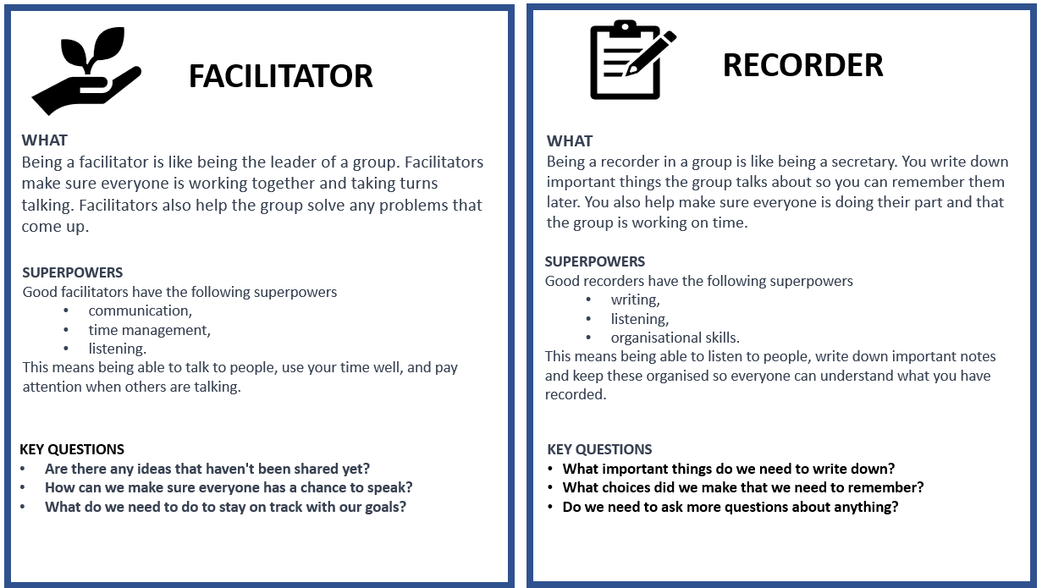

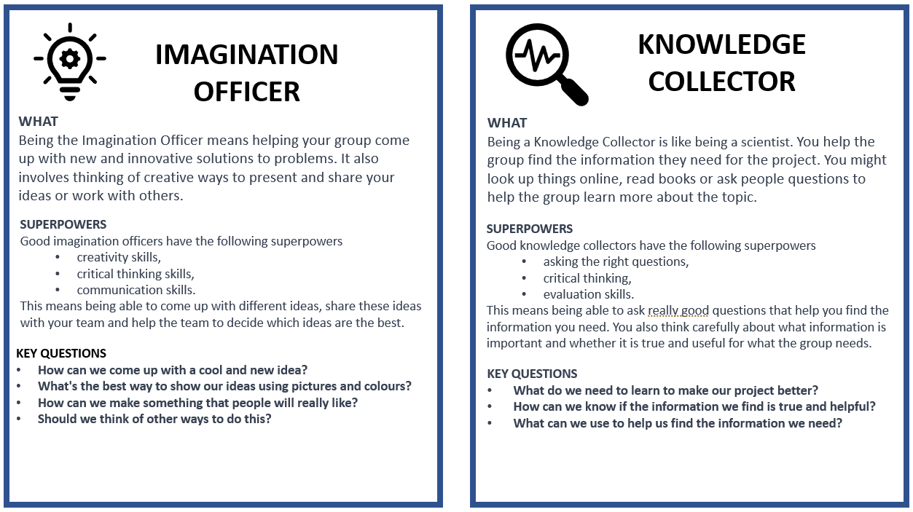

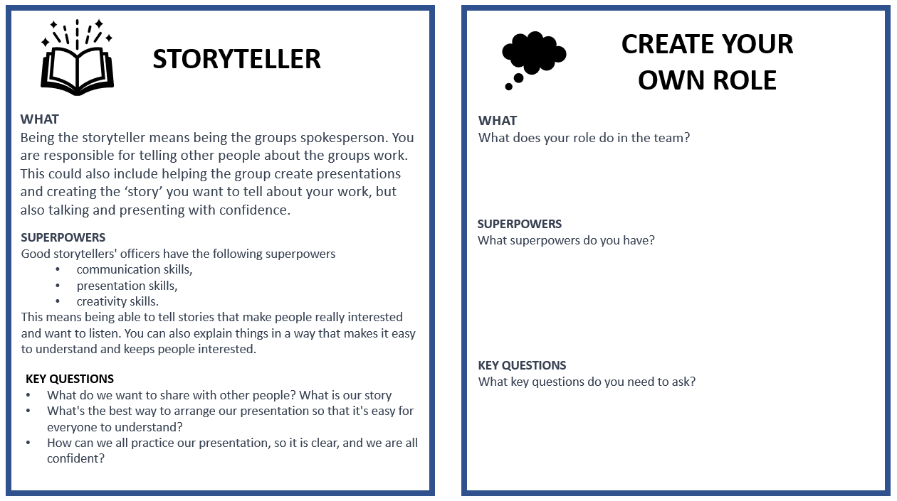

Annexure six: The Decision Matrix

CRITERIA
Give each of your ideas a score from 1 (lowest) - 5 (highest) for each of the criteria below
IDEA  Write each of your ideas on a separate row below | Does the idea reflect and celebrate the different cultures and traditions represented in our school? | Will other learners like the idea? | Is the idea creative and interesting? | Is the idea realistic and practical to implement? Can we do it? | Could this idea make us money? | TOTAL  Add up all your marks. The ideas with the highest scores are your best ideas

Annexure seven: Teachers as scaffolders of learning
Scaffolding learning is an instructional approach that is essential for Project-based Learning. When you scaffold learning you are providing support and guidance to learners as they engage with new or challenging material. The term "scaffolding" refers to the temporary support structures that construction workers use to help them reach high places while they build a building. In education, scaffolding means providing learners with the support they need to build their understanding of a topic or skill.
Scaffolding learning typically involves several steps.
- First you assess the learners' prior knowledge and skills. What do learners already know about the topic and what gaps or misconceptions may need to be addressed.
- Provide support and guidance to help learners engage with the material and build their understanding. This support may take many forms, including modelling, feedback, prompts, and questions.
- As learners become more confident, gradually reduce the scaffolds.

Here are some examples of questions you can use in different circumstances to help scaffold your learners' learning.
Clarifying questions  Ask these types of questions to clarify learner understanding of a topic.  - Can you explain what you mean by that?  - Can you give me an example to illustrate your point? | Prompting questions  Ask these questions to help learners to think more deeply about a topic or idea.  - What other perspectives or points of view could we consider?  - How does this relate or link to what we've learned before?
Elaboration question  Ask these questions to encourage learners to expand on their ideas.  - Can you tell me more about that?  - Why do you think that is the case? | Strategy questions  Ask these questions to help learners develop problem-solving skills and strategies.  - What steps could we take to solve this problem?  - What information do we need to gather to answer this question?
Prediction questions  Ask these questions to help learners anticipate what might happen next.  - What do you think will happen if we try this?  - What do you expect to see when we conduct this experiment? | Clarification questions  Ask these clarification questions to help learners understand complex or abstract concepts.  - What do you think this term means?  - Can you give me an example of how this concept works in real life?
Reflection questions  Ask these questions to help learners to reflect on their learning.  - What did you learn today?  - What was challenging about this activity, and how did you overcome those challenges? | Comparing and contrasting questions  Ask these questions to help learners understand similarities and differences between concepts or ideas.  - How is this similar to/different from what we learned before?  - What are the advantages and disadvantages of these two approaches?
Summarising questions  Ask these questions to help learners summarise key points or ideas.  - Can you tell me in your own words what we learned today?  - What are the most important takeaways from this reading? | Thinking questions:  Ask these thinking questions to help learners reflect on their own learning processes and strategies.  - What strategies did you use to approach this task?  - How can you apply what you learned in this assignment to other contexts?

Annexure eight: End of project Learner Self-Reflection Tool

THINK ABOUT WHAT YOU DID IN THIS PROJECT, AND HOW WELL THE PROJECT WENT. WRITE YOUR COMMENTS BELOW

You Name:
Project Name:
What was the Driving Question
Your answer to the driving question

What did you learn about working with other people?

What worked/what did you enjoy?

What do you want to improve when you work with other people?

How could your teacher(s) change this project to make it better next time?

Annexure nine: Teacher S.P.E.C.I.A.L. Self-reflection tool

How to use this tool

Using the teacher self-reflection tool is a simple yet effective way to evaluate your teaching practices. After each lesson, select a few questions to reflect on. Pick 1 or 2 questions from each:
- General reflection questions.
- S.P.E.C.I.A.L reflection questions.

The purpose of this tool is to help you identify what went well and what could have been improved in your lesson. You can also consider how much your learners learnt and how they engaged with the learning process. By doing this, you can develop a better understanding of your teaching style and how it impacts your students. Through regular reflection, you can make adjustments to your approach, learn from your mistakes and build on your strengths, leading to improved teaching outcomes for your students.

Why is teacher self reflection so important

Teacher self-reflection is an essential aspect of effective teaching that involves the careful analysis of one's teaching practices to identify areas of strength and improvement. By reflecting on the lesson, you can evaluate their effectiveness in conveying the lesson's objectives, engage learners’ interest and attention, and adjust your teaching strategies to improve the learning outcomes. Moreover, self-reflection enables you to develop your teaching skills and knowledge. In summary, teacher self-reflection is crucial for continuous professional development and improvement, and it helps to ensure that learners receive high-quality and effective instruction.

General reflection questions
- Which teaching strategies were most effective in engaging the learners and promoting understanding? Are there other strategies that could be explored in future lessons?
- How did learners respond to the activities and tasks? Were they actively participating and demonstrating understanding? What adjustments could be made to enhance learner engagement and comprehension?
- Were there any misconceptions or misunderstandings that emerged during the lesson? How were they addressed, and how can they be prevented in future lessons?
- How effectively was feedback provided during the lesson? Were learners given opportunities to reflect on and improve their understanding?
- What opportunities were provided for learners to collaborate, problem-solve, and think critically? Can these opportunities be further developed in future lessons?
- What can be learned from this lesson to inform planning, instruction, and assessment for future lessons?

S.P.E.C.I.A.L. Reflection questions

Prior Knowledge:  - How did I activate and build on the learners' prior knowledge during the lesson?  - Were there any gaps or misconceptions in learners' prior knowledge that needed to be addressed? How were they handled?  - How can I better connect new concepts to learners' existing knowledge in future lessons? | Curiosity:  - How did I encourage learners' curiosity and inquisitiveness during the lesson?  - Were there opportunities for learners to explore and investigate the subject matter on their own or with peers?  - How can I better incorporate inquiry-based learning and curiosity-driven activities in future lessons?
Social Interaction:  - How did I facilitate opportunities for social interaction and collaboration during the lesson?  - Were learners actively engaging with one another and sharing their ideas? How can I further promote this in future lessons?  - What role did peer feedback and discussion play in deepening learners' understanding of the material? | Iteration:  - Were learners provided with opportunities to practice, iterate, and refine their understanding and skills during the lesson?  - How effectively did I offer feedback and guidance to support learners' iterative learning process?  - How can I create more opportunities for practice and iteration in future lessons?
Purpose:  - Were the learning objectives clear and purposeful for the learners? Did they understand the relevance of the lesson to their lives and future learning?  - How did I connect the lesson content to real-world applications or contexts?  - What can I do to make the purpose of future lessons more explicit and meaningful for my students?  Enjoyment:  - How did I incorporate elements of enjoyment and fun into the lesson?  - Were learners actively enjoying the learning process? What can I do to further enhance their enjoyment in future lessons?  - How did the learning environment and classroom atmosphere contribute to learners' enjoyment and motivation? | Active Engagement:  - Were learners actively engaged in the learning process, both cognitively and behaviourally?  - Which activities or strategies were most successful in promoting active engagement and deep learning?  - How can I better design future lessons to foster active engagement and higher-order thinking?  Attention and Engagement:  - Which activities or strategies were most successful in capturing and maintaining learners' attention during the lesson?  - Were there any points during the lesson where learners seemed disengaged or distracted? How can I address these issues in the future?  - How can I modify the lesson to better sustain learners' attention and interest in the subject matter?
Learner Autonomy:
- How did I promote learner autonomy and self-directed learning during the lesson?
- Were learners given opportunities to make choices and take ownership of their learning?
- How can I further support the development of learner autonomy and self-regulation in future lessons?

Find out more.
www.ecubed-dbe.org
https://learn.ecubed-dbe.org/

