SPACE EXPLORERS: Planning our first journey into space.
Term three, Grade 3, Life Skills Project
Weeks 9 - 10

Playful learning to prepare teachers and learners to thrive in a changing world

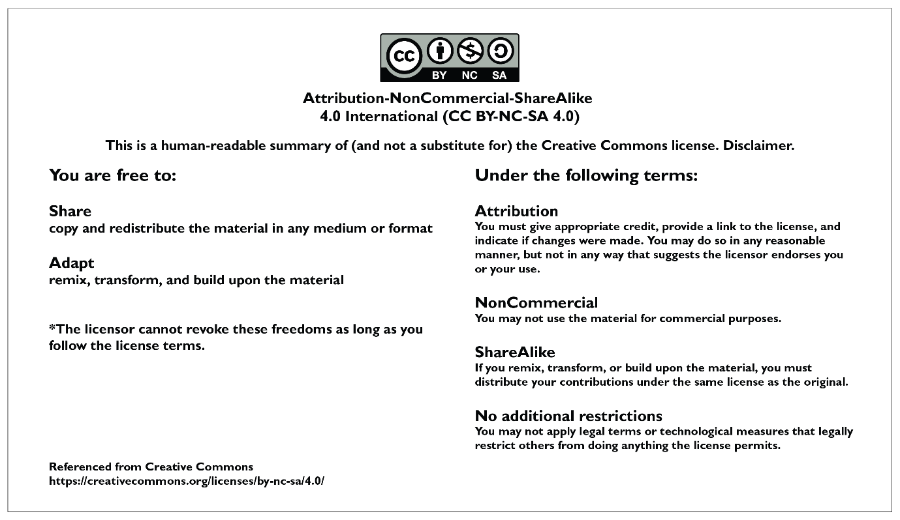

CONTENTS PAGE
PROJECT OVERVIEW 3
Preparing for the project 7
Preparing learners 7
The project 8
Lesson 1: What do we already know about space? 8
Lesson 2: Where do we want to explore? 11
Lesson 3: What’s our plan? Where are we going and how will we get there? 14
Lesson 4: Giving and receiving feedback 16
Lesson 5: Planning the ‘who’, ‘what’, and ‘how’. 18
Lesson 6: Making maps and building spaceships. 20
The Public Presentation 22
Annexures - useful tools for the project 23
Annexure 1: Exemplar Assessment rubric 23
Annexure 2: Exemplar Competency (Skills) Observation Checklist 25
Annexure 3: Example letter to parents and caregivers about Project-based Learning 26
Annexure 4: The Project Wall 27
Annexure 5: The Project Route Map 28
Annexure 6: Roles and responsibilities 29
Annexure 7: Teachers as scaffolders of learning 32
Annexure 8: Learner Self-reflection Tool 33
Annexure 9: Teacher S.P.E.C.I.A.L. Self-reflection Tool 34

PLEASE NOTE
This is an exemplar project, but we encourage you to make it your own. Please feel free to adapt it as necessary to ensure it is suitable and relevant to your learners in your classroom. Remember, the ultimate goal of this project is to engage your learners and foster their learning, so don't be afraid to put your own spin on it! The activities and assessments in these lessons are here to guide you on your Project-based Learning journey. Feel free to adapt the activities and assessment to suit your learners needs.

PROJECT OVERVIEW
 | Name of project: Space explorers: planning our first journey into space
Subject: Life Skills (Beginning knowledge) |  | Grade: 3 | Duration: 6 hours
Possible areas for integration with other subjects
Life Skills: Creative Arts
- Create in 2D: Design principles: conscious application and naming of contrast, proportion, emphasis and balance.
- Create in 3D: Craft from recycled materials.
Language development
Throughout this project learners will use language intensively, purposefully and authentically as they:
- interact and communicate with one another, ask and answer questions, discuss and make plans and decisions, read and interpret texts, make informal presentations and listen to presentations critically and provide constructive feedback.
Mathematics
Mathematics concepts relating to space and shape, quantity and measurement are applied when learners plan and construct their space route maps and build their spaceships.
CAPS content covered.  REMEMBER to always be aware of activities to promote Executive Functioning: Working memory, Inhibitory control and Self-regulation.  Learner talk, discussion, exploration, INQUIRY find-out”, problem solving, thinking and reasoning is of utmost importance.  Click here for the 2023/2024 ATPS |  | Weeks 9 and 10  SKILLS AND VALUES  - Understanding our world and beyond, what it is composed of.  - Find out – investigate, “research”.  KNOWLEDGE  Planet Earth and beyond  - Identify the planets, telescopes and space travel.  - Earth from space – what it looks like (land, sea, clouds).  - Stars and planets – what they are.  - Space travel – what it is.  - Satellites -what they are and what information we get.  - Observing the sky.
Driving question |  | As space explorers, what do we need to do to plan our first journey into space?
Project summary and objectives |  | For this project, learners imagine themselves as space explorers who are planning their first journey into space much like astronauts on a space mission. Like any journey, there must be planning and preparation. In order to do this and to answer the driving question, learners will:  - Remember and make visible what they already know about space (prior knowledge) and then work together to research and add to their knowledge.  - Use skills such as collaboration, communication, creative and conceptual thinking to:  - Make a democratic decision about the destination.  - Create a space route map of the journey they plan to take including the start, the destination, and at least three refuelling stops along the way.  - Plan, iterate and construct the spaceship that will transport them through space.  - Prepare to show off their maps and spaceships and explain all their learning and work involved at a public presentation.  - Learners are active and have a lot of autonomy in this project making it a rich and significant opportunity for learning. Learners get opportunities to practise a variety of Bloom’s cognitive skills including the higher order skills such as analysis, synthesis and evaluation. Learners are constantly active, in body and mind, as they discuss, listen, ask questions, solve problems, apply new knowledge, negotiate conflicts that may arise, plan, iterate, construct, present and most important of all – learn to love learning.
Entrepreneurial way-of- being skills developed in this project |  | Communication | Collaboration
 |  | Critical Thinking | Creative Thinking
Products |  | - A space route map showing the journey into space (2D).  - A spaceship that will transport the space explorer group to their destination (3D).
Public presentation |  | Projects will be presented by groups at a public presentation. Group members can explain knowledge they have learnt about space and their experience of the project. The public presentation could be, for example, held at a special event where caregivers and members of the community can join in the celebration. It is important that the projects are presented to a wider audience than just the learners and the teacher in the class.

PROJECT OVERVIEW
Activating the science of learning | This project:  Activates prior knowledge by encouraging all learners to remember (retrieve) what they already know about aspects of space and reflect on how they know what they know. Linking new knowledge to what is already known improves comprehension of new knowledge and tends to lead to better storage of knowledge in long-term memory.  Focuses learner attention and engagement on the learning as it stimulates their curiosity and imagination by casting them in the role of space explorers. In this role, learners have a high level of ‘voice and choice’ and get to make their own decisions about where they want to travel to and how they want to get there. When learners have this autonomy to follow their own interests, they are often more curious, engaged and attentive, all of which improve long-term retention of information and skills.  Results in ‘sticky learning’ learning that is memorable and lasting by contextualising their learning of space as a story/role play that includes planning and preparation ( both important real-life skills.) Learning becomes purposeful as learners need to use what they learn to solve problems and answer the driving question. This application of knowledge to an enjoyable and learning-rich project shifts knowledge from short-term to long-term memory making it ‘sticky’ and hard to forget.
Lesson summary  This is a 2-week project. The following activities are intended to guide learners to use their voice and choice to come up with a creative way of answering the driving question. | Lesson one: | In this lesson, learners:  - Launch into the project by taking an imaginary journey into space.  - Collaborate in a group to discuss what they know about various topics about space and make their knowledge visible by filling in a star map for display on the Project Wall.  - Reflect on what places in space they are curious about and would like to explore or visit on their journey into space.
 | Lesson two: | In this lesson, learners:  - Explore in more detail the topics they were introduced to in lesson 1 (i.e. The Sun, Space travel, The solar system, The night sky, The planets, The earth from space) and present their findings to the class.  - This new information will help them decide what they want to explore on their journey and what their final destination could be.
 | Lesson three: | In this lesson, learners:  - Decide where they are going in space.  - Brainstorm and plan a rough draft of the space route map to get there including the starting point, at least three stops along the way for refuelling and a final destination.  - Brainstorm and plan a rough draft of the spaceship that will get them there.
 | Lesson four: | In this lesson, learners:  - Present their ideas and rough drafts to the ‘Space Station Committee’ for feedback and iteration.
 | Lesson five: | In this lesson, learners:  Based on the iterated plans, the space explorer groups now:  - Use their iterated drafts to create detailed plans, sketches and designs for their space route maps and spaceships, and  - Develop a flow map of the plan of action, who will do what, when, and how to plan for lesson 5 when they start to make and build.
 | Lesson six: | In this lesson, learners  - Use the final plans, sketches and designs, and the roles and responsibilities flow map, to make their maps and build their spaceships.
Resources | - DBE Grade 3 Life Skills Rainbow Books pages 26 – 31  - Any other resources relating to the topic that you already have in stock.  - A range of found and recycled materials  - Examples of maps  - Examples of design plans
Entrepreneurship add-on possibilities | As an entrepreneurial opportunity, learners can host and sell tickets for space-themed events such as stargazing nights or space-themed movie nights. They could bake and sell star and moon -shaped biscuits and other space-themed refreshments.

Preparing for the project

Preparing learners
- Because there isn't much time for this project it's recommended that you plan the space explorer groups before launching the project so that learners are already sitting together and are starting to get to know each other.
- It’s recommended to explain the overview of the project i.e., that the learners are space travellers like astronauts who are going to work together in groups to plan their first journey into space. They will also make a space route map and spaceship..
- To create some excitement, each group could choose a name and learners can make little badges or name tags to identify their group.
- Effective group work is more manageable and more effective when each group member has a role and responsibility. Please see Annexure 6 for more detail on the types of roles that are useful for a project.

Preparing the classroom
- Before launching the project, you can create a Project Wall. This is very similar to a theme wall where you display and show resources, pictures, posters and objects about your new theme. The Project Wall takes this a step further in that it shows the driving question, journey of the project (Project Route Map found in Annexure 5). The project Wall can begin with a display of what learners already know about the topics and as the project progresses their displays become richer and richer which makes their learning progress visible. Keywords can be placed on the wall as can curious questions that learners ask that you want to revisit. As far as possible, get the learners to organise the wall and take ownership of what is displayed - after all it's their project and their learning. To learn more about Project Walls please see Annexure 4: The Project Wall.

Teacher preparation
- Read the project instructions. Make any changes or updates to the project to suit your learners needs.
- Read Teaching for Learning in a Fast Changing World. You can download it here: https://www.uj.ac.za/wp-content/uploads/2023/01/teaching-for-learning-in-a-fast-changing-world-e-version.pdf
- Do the Introduction to Project-based Learning course online https://learn.ecubed-dbe.org/courses/introduction-to-project-based-learning/
- Please see the additional notes on Collaborative Learning in Project-based Learning and Thinking Maps Resources for more information on these two topics.

Preparing parents and colleagues
- Inform parents and caregivers about your project. We have created a template that you can adapt, you can find this in Annexure 3.
- Tell your colleagues about your project and what to expect e.g., for example there will be lots of group work so your lessons might be a little bit noisier, but this is good, it means learners are engaged and paying attention.

Preparing for the Public Presentation
- The project ends with a Public Presentation where learners get to show off their projects. The date needs to be booked in advance as this is not a lesson. Public Presentations can be done at assembly, as an art exhibition at break, or at an event like a parents evening.

The project
Lesson 1: What do we already know about space? | Resources needed:  Project route map (Annexure 5)  Star-shaped thinking maps |  | Time required:  50 mins
Summary of the Lesson
In this lesson, learners will:
- Launch into the project by taking an imaginary journey into space.
- Collaborate in a group to discuss what they know about various topics about space and make their knowledge visible by filling in a star map for display on the Project Wall.
- Reflect on what places in space they are curious about and would like to explore or visit on their journey into space.
Objective
The purpose of this lesson is for learners to:
- Remember what they already know (prior knowledge) about the aspects of space listed in the CAPS.
- Practice collaborating and communicating as they discuss and pool prior knowledge about one aspect of space and present this knowledge on a star map.
- Reflect on the knowledge they have heard from their peers and identify what aspect of space they are most curious to explore or visit.

The purpose of this lesson is for teachers to:
- Informally evaluate learners’ prior knowledge about the topic and how well they can demonstrate their knowledge either through speaking and/or writing.
- Observe how learners are collaborating and communicating in their groups.
Before the lesson  - Learners should already be sitting in their space explorer groups as this is where they start imagining and planning their journey into space.  - Create 6 star-shaped maps on A4 paper/card. Write one of these topics into the middle of each star.  - The Sun  - Space travel  - The solar system  - The night sky  - The planets  - The earth from space  Lesson guidelines- what will learners and teachers do?  A. Launch the lesson  - Show learners the Project Route Map to get a sense of the ‘journey’ of the project, and you can build up their excitement. If you have a Public Presentation date booked, add the date to the final step of the project route.  - For fun, and to warm up their imaginations, you can play a game called, “I am a space explorer!” Learners can count down from 10 and then pretend to ‘launch’ themselves up into space and imagine all they can see as they travel through space. Allow learners a few minutes to explain and describe what they ‘saw’ in space with group members.  B. What we already know  - Each group is responsible for one star map. In groups, learners need to discuss and write WHAT they know about their topic into the star and HOW they learnt their knowledge into the rectangle.  C. Making our learning visible  - Each group nominates a presenter to present the information collected on the star maps. Allocate a time limit of 1 minute. Display these maps on the Project Wall.  D. Reflection: Looking back on our learning  - Use a reflection question such as the following to encourage learners to think back on lesson 1. Possible question: “As a space explorer, what part/s of space makes me the most curious. Where would I really love to explore and learn more about on our journey into space?”  - It’s useful to collect learners’ answers and display them on the Project Wall under the heading “What are we curious about? What part/s of space do we want to explore on our journey”? |  | How learning happens.  Prior knowledge  Learners’ prior knowledge about the topic of space is brought to mind and made visible through the star maps. This helps teachers assess informally how much the learners know and where the gaps are. This information helps to ensure that new learning connects and builds on what learners already understand.  S.P.E.C.I.A.L.  Learners are socially interactive as they discuss, share and document their current knowledge of space.  Reflection  Through the reflection question learners are encouraged to think about what aspect of space they are the most curious about and want to learn more about. This makes learning purposeful to learners which tends to increase motivation, engagement and attention thereby strengthening memory of what is learnt.  Remember that reflection leads to learning that is ‘sticky’ learning that lasts. So, don’t miss out the reflection activity.
Extended opportunities
- If there is time, give each group an opportunity to add what they know to each star map. This can be done in a different colour and must always be something new.
- Bridge learning from the classroom to the ‘real world’ by encouraging learners to try and find out more, from other friends and family members, about the part of space that makes them curious and that they would love to explore on their space journey.
Observations and facilitation - Assessment as Learning
As a teacher you already know that you play an essential role as a facilitator of learning. You know that rather than simply giving knowledge to learners, you create an environment in which your learners can explore, discover, and construct their own understanding of the subject matter. As a facilitator you will
- create an emotionally and psychologically safe learning environment so that learners feel safe to participate in the lesson,
- provide prompts when learners get stuck,
- provide constructive and timely feedback to learners,
- and make adjustments to your lesson based on what you observe (this is assessment as learning) so that learners can grow their understanding and grow their skills and competencies.

While learners are working on their tasks throughout this project your role as a facilitator is to observe, listen, and record the process of learning during the lesson. These observations are the foundation for the assessment of this project, so make a few notes, these will help you when you do the final assessment.
The first lesson focuses on launching the project and establishing what learners already know about the topic. While learners are collaborating in their groups, it’s important to actively observe and listen to what they are saying and how they are interacting with their peers. As you walk around the classroom, keep an eye out for the following indicators of learning:

- Learner participation: Is each group member getting a chance to participate?
You can monitor learner participation by observing their level of engagement during class discussions. It's important to note whether they are actively contributing to the conversation or whether they appear disengaged. If you notice that learners are not engaged, it's crucial to identify the cause and take appropriate action. It could be that they do not understand the content or instructions provided, or one learner could be dominating the discussion. To re-engage learners, you can use prompts such as:
- "Can you share your thoughts on what your classmate just said?" or
- "What do you think about what we just discussed?"
Such prompts can encourage learners to participate more actively, which enhances their learning experience. It's important to keep in mind that when learners are not engaged or paying attention, they are not learning.

2. Learner knowledge: What is learners’ current level of understanding of key words and concepts
Another crucial aspect to observe as learners' understanding of key concepts relating to the topic. You can assess this by observing if learners can describe or explain key words about the various topics on space. You can use prompts such as:
- “What planet do we live on?”
- “Can you explain the difference between the sun and the moon?”
- “When you look up into the sky at night, what do you see?”
- “Have you ever looked up at the sky and wondered what is out there?”
These prompts work as informal, continuous assessment and can help you gauge learners’ baseline comprehension of the topic. Re-asking these types of questions throughout the project will help monitor their progress.

For more ideas on prompts and scaffolding questions please see Annexure 6.

Teacher self-reflections
After every lesson it is important to reflect on how the lesson went so that you can make adjustments to the lesson or project. Check out annexure 9 for a whole range of different questions you could use to reflect on for this lesson. Note you do not need to reflect on all the questions, just select 1 or 2 that resonate with you. Your own self- reflection is important for a number of reasons: it is a crucial aspect of teacher professional development and enables you to learn from experience, grow as a teacher and continually improve your instructional effectiveness so that you can better support learners’ learning.

Lesson 2: Where do we want to explore? | Resources needed:  DBE Grade 3 Life Skills Rainbow Books pages 26 – 31  Any other resources relating to the topic |  | Time required:  50 mins
Summary of the Lesson
Like any journey or exploration, you need to find out more about what you could see along the way and get more ideas about where you want to go. In this lesson learners will:
- Explore in more detail the topics they were introduced to in lesson 1 (i.e., The Sun, Space travel, The solar system’ The night sky, The planets, The earth from space) and present key findings to the class.
- This new information will help them decide what they want to explore on their journey and what their final destination could be.

Objective
The purpose of this lesson is for learners to:
- Research new information about their specific topic.
- Take collective responsibility for all members of the group to understand the new information.
- Present their findings to the class and ‘teach’ their classmates more about their topic.
- Reflect on the knowledge they have heard from their peers and, as a group, narrow down a possible destination for their journey.

The purpose of this lesson is for teachers to:
- Informally evaluate learners’ ability to read and comprehend written paragraphs.
- Observe if learners are actively trying to understand by asking questions or are passively waiting for help.
- Observe how well learners support and help each other in the group and show patience and tolerance.

Before the lesson  Learners will be adding to their knowledge of the aspects of space they discussed in lesson 1. The DBE workbooks have some extra knowledge but please add any other resources that will be useful to enrich learners’ knowledge. Additional resources are listed at the end of this lesson.  Lesson guidelines- what will learners and teachers do?  - Reviewing  - Ask volunteers to explain what has been done/learnt so far in the project. They can use the Project Route Map to show progress and review what they wrote on the star maps.  B. Reading, learning and helping  - Each group will stay with the topic they brainstormed in Lesson 1 but in this lesson, they will deepen their own and others’ knowledge. As a group, they will be responsible for helping each other read and understand new information and will be responsible for ‘teaching’ the information to the class. Refer learners to their DBE Rainbow Workbook: Life Skills Grade 3 book 2, terms 3,4: pages 26 – 31 and any other available resources you have.  C. Presenting and teaching  - The groups can decide how they want to ‘teach’ the class, but it must include some writing/drawing as this will be added to the Project Wall. If they need some support, then a thinking frame such as the one below is useful to organise their knowledge.  We are here to teach you about….  Three (or more) facts we learnt…  One question we want to ask and learn more about…  Where we think we can find the answer to our question…  D. Conclusion  - Each group selects a presenter/s who ‘teaches’ the class more about the specific topic. This must be short and focussed.  E. Reflections  - Reflecting on what they have learnt, each group needs to start sharing ideas about where they want to go and what they want to explore on their journey into space and give reasons for their choices. |  | How learning happens.  S.P.E.C.I.A.L.  Learners are socially interactive. They are also active as they must take on responsibility for their own and other’s learning and understanding. Learners have autonomy as they can choose how they want to present what they have learnt.  In addition, asking learners to be ‘teachers’ taps into their motivation and sense of responsibility. Added to this, learners need a strong understanding of information to be able to ‘teach’ their peers.  Reflection  The reflection question further stimulates curiosity about what they want to explore in space. Ideas generated through reflection become part of the planning of the journey i.e., “Where do we want to go to and why do we want to go there?” Asking and answering their own questions and actively making their own choices increases active learning and learner autonomy.  Remember that reflection leads to learning that is ‘sticky’ learning that lasts. So, don’t miss out on the reflection activity.
Extended opportunities
- Once the presenters from the groups have finished ‘teaching’, learners in the class can ask questions to the presenter and her/his group. Classmates can also add in any other facts they know about the topics.
Observations and facilitation - Assessment as learning
As learners research, learn and plan how to present their new information, it's important to actively observe and listen to learners as they work together in groups. As you walk around the classroom, keep an eye out for several key indicators of learning, communication, and knowledge of the topic. These are just some examples of things to observe you might have your own list of observations to use.

- Learner communication skills
Objective: How well are learners communicating their ideas about the topic they are researching and the type of presentation their plan to use?
- Observe learners' active listening skills to determine if they are fully engaging with their peers during the interview process. Are they focused and attentive, or are they distracted or disengaged?
- Additionally, pay attention to their articulation skills. Are they speaking clearly and confidently, or are they mumbling or speaking too fast, or speaking too loudly or softly?
- Empathy is another key communication skill to observe as learners are responsible for the whole groups’ understanding of the new information. Are learners trying to understand how other people might be feeling? Are they showing empathy and consideration towards their peers?

If learners are struggling with any aspect of their communication skills, there are several strategies you can use to support them.
- One option is to model active listening yourself, showing the kinds of behaviours you expect from learners.
- You can also take the time to explain the guidelines for active listening or the interview process again, ensuring that all learners understand the expectations.
- It can be helpful to share and discuss the definitions of good communication. The Teacher's Guide to Competencies is an excellent resource for this purpose, providing information and guidance on the development of communication skills.

Remember, communication skills take time to develop, and learners will have many opportunities to practise and grow their abilities throughout the project. By actively observing and facilitating their progress, you can help them build important skills that will serve them well in the future.

Suggestions for facilitation and scaffolding
Although learners are responsible for their own and other’s learning, they still need you! It is essential to constantly facilitate and scaffold the quality of their learning. As a facilitator of learning you need to listen to WHAT learners are talking about so you can monitor if they are learning and to stop any incorrect learning immediately. Constant check-ins and questions of group members is invaluable for this.

Facilitation and scaffolding questions could be:
“How do we know what the earth looks like from space?”
“Why does so much of the earth look blue?”
“Can we fly to the sun?”
“What do people use to look at and learn about stars and planets?”
“Name three planets?”
“Explain what you can see in the night sky?”
“Can you tell me if earth is a planet or a star?”

For more ideas on prompts and scaffolding questions please see Annexure 5.

Further reading or information
https://www.kids-world-travel-guide.com/solar-system.html
• hps://www.youtube.com/watch?v=Qd6nLM2QlWw (Exploring Our Solar System: Planets and Space for Kids 11 mins 54)
• hps://www.nasa.gov/kidsclub/index.html (National Aeronautics and Space Administration – excellent resource for all things space)

Lesson 3: What’s our plan? Where are we going and how will we get there? | Resources needed:  Planning checklist  Exemplar assessment rubric |  | Time required:  50 mins
Summary of the Lesson
By now learners have more knowledge about space and have an idea of where they would like to go. Now it’s time to start planning their journey. As part of the plan, the groups will:
- Decide where they are going in space.
- Brainstorm and plan in rough the route or map to get there including the starting point, at least three stops along the way for refuelling and a final destination.
- Brainstorm and plan in rough the spaceship that will get them there and what they should pack in the spaceship.

Objective
The purpose of this lesson is for learners to:
- Collaborate and use critical and creative thinking and prior and new knowledge to make decisions and rough plans.

The purpose of this lesson is for teachers to:
- Observe how learners use their vocabulary of space (planets, telescopes, astronauts, etc) in their brainstorming and planning.
- Observe how learners manage decision-making in the group.

Before the lesson  Please write the following (or something similar) on the board.  Checklist: Planning our journey into space  - Group name:  - Vehicle description:  - Route map to show:  - Launch point,  - 3 different refuelling stops (E.g., a star, a planet and a moon) and a short written description of each stop  - the final destination and a short written reason for choosing the final destination.  - What else can we add to the map to show our knowledge of space?  Lesson guidelines- what will learners and teachers do?  A. Reviewing and reflecting  - Ask volunteers to explain what has been done/learnt so far in the project. They can use the Project Route Map to show progress. Reflecting on what may be on the Project Wall (i.e., star thinking maps and presentations from the previous lesson) will consolidate what has been learnt so far and function as a foundation for what is still to come.  B.Sharing the assessment rubric  - The groups are now moving into brainstorming the products. Ultimately these will be exhibited at a Public Presentation AND assessed. Show and explain the rubric to learners so they know exactly what is expected of them. Keep the rubric on display so the learners can keep checking that they are fulfilling the criteria. (Please see Annexure 1 for an exemplar assessment rubric which you can adapt to suit your objectives.)  C. Explaining the checklist  - Explain the checklist to learners i.e, this is an important part of planning and preparation for the journey.  D. Brainstorming and planning  - In groups, learners discuss and brainstorm ideas and to start to complete the checklist. There are no right or wrong answers. This is when creativity comes into play and learners can think of as many ideas as they want. This is an important part of the project (and an important part of many school tasks such as writing essays) so try not to rush the process. These plans will be finalised and presented for feedback in Lesson 4.  E. Conclusion  - You can link the concepts of brainstorming and planning to learners' lives by asking them when people need to plan and prepare in their school and everyday lives and why it is important. |  | How learning happens.  S.P.E.C.I.A.L.  This lesson is highly learner centred as they do most of the ‘doing’ and therefore also most of the learning.  Reviewing and reflecting  Learners are encouraged to constantly recall what they learnt in the past to use as foundation for what they will learn next. This creates layers of learning and helps learners build strong blocks of knowledge and concepts.  .  Remember that reflection leads to learning that is ‘sticky’ learning that lasts. So, don’t miss out on the reflection activity.
Observations and facilitation - Assessment as Learning
During this brainstorming and planning activity, it's important to actively observe and listen to learners as they work together in groups. As you walk around the classroom, keep an eye out for several key indicators of learning, including creative innovation, collaboration skills, communication, and critical thinking skills. Here are some suggestions of what you could observe:

  - Creative innovation: Observe learners’ range and type of ideas while they brainstorm and plan. Are they thinking out of the box, are their unique and interesting ideas or are they struggling to think creatively? If learners are struggling, prompt them by asking, “Have you ever thought of…”, “Imagine if…”, “What if…”
  - Critical thinking: Listen to learners’ critical thinking by asking, “Explain your choice for the refuelling stops?” or “What made you choose xxx for your final destination?”

For more ideas on prompts and scaffolding questions please see Annexure 5.

Lesson 4: Giving and receiving feedback | Resources needed:  Feedback protocol |  | Time required:  50 mins
Summary of the Lesson
By now learners have more knowledge about space and have an idea of where they would like to go. Now it’s time to start planning their journey. As part of the plan, the groups will:
- Finalise plans.
- They will also present their ideas and rough draft to the Space Station Committee for feedback and, if necessary, iteration.

Objective
The purpose of this lesson is for learners to:
- Finalise and present their plans for feedback.
- Evaluate other groups' plans and give feedback.
- Iterate plans.

The purpose of this lesson is for teachers to:
- Observe, or if needs be, teach how to give and receive feedback.
- Observe how well learners evaluate their feedback to decide what they need to iterate in their initial plan.

Before the lesson  Each group must have their checklists from lesson 3.  Lesson guidelines- what will learners and teachers do?  A. Reviewing  - Ask volunteers to explain what has been done/learnt so far in the project. They can use the Project Route Map and other products for previous lessons to track and show progress.  B.finalising the checklist  - In groups, learners can finalise their plans for the Star Route Map and the spaceship.  C.Giving and receiving feedback  - Explain to learners that every space exploration team and all astronauts must present their plans for inspection by a Space Station Committees to get a different point of view and make sure nothing important has been left out – because when you are out in space you are on your own so you need to be well prepared!  The Space Station Committee inspection can be organised as follows:  - Pair up two groups  - Each group has 1 – 2 minutes to present their plan.  - After the presentations they can ask questions, give feedback and comment on the plans.  - The feedback protocol below can be used to guide learners’ feedback and keep it constructive.  Feedback protocol  Please feel free to use your favourite feedback tools. This is just a suggestion of what learners could do.  Remember the three rules. Make sure your feedback is:  - Kind - think about how you give your feedback.  - Helpful - think about what you are sharing that is useful to the team.  - Specific - think about giving feedback that is very clear, simple and focuses on one thing.  Suggested feedback starter starters:  I really liked__________________ because….  - How could you _____________________________________  - Another way to do this is____________________________________  - Have you considered________________________________________  - I agree with_________________________________________________  D.Reflections  - Groups can reflect on and evaluate the feedback. Plans can be iterated and strengthened. |  | How learning happens.  S.P.E.C.I.A.L.  Iteration (I) comes into play in this lesson where learners get the chance to plan, give and get feedback. They also discover the power of iteration and can reflect on and think critically about the feedback and iterate their plan. The learning here is that we hardly ever get anything right the first time and it's natural to redo things so that each time we can learn more and improve.  Remember that reflection leads to learning that is ‘sticky’ learning that lasts. So, don’t miss out on the reflection activity.
Extended opportunities
- More feedback is always useful so if each group can get feedback from more than one other group – or other people including staff or family members.
Observations and facilitation - Assessment as Learning
During this feedback activity, it's important to actively observe and listen to learners as they work together in groups. As you walk around the classroom, keep an eye out for several key indicators of learning, including communication and critical thinking skills. Here are some suggestions of what you could observe:

- Giving feedback: Observe learners as they give feedback to their peers. Take note of the quality of their feedback, including whether it is specific, actionable, and relevant and shows respect and kindness. If learners get stuck, you could prompt them by saying “Can you give your peer a specific suggestion on how to improve their idea?
- Receiving feedback: Observe learners as they receive feedback from their peers. Take note of their reactions and whether they are open to receiving feedback. Prompt: "How did you feel when your peer gave you feedback on your idea? Was it helpful?"
  - Learner communication: how clear was the learner communication? Were they able to express their ideas logically? For example, when deciding how to iterate, was their final decision based on clearly expressed thoughts and ideas? Prompts: “Did everyone in the group have a say in the decision?” and “Can someone explain the decision about what to iterate?”
For more ideas on prompts and scaffolding questions please see Annexure 7.

Lesson 5: Planning the ‘who’, ‘what’, and ‘how’. | Resources needed:  Scrap paper  Examples of maps  Examples of design plans |  | Time required:  50 mins
Summary of the Lesson
Based on the iterated plans, the space explorer groups now:
- Create more detailed plans, sketches and designs for their space route maps and spaceships, and
- Develop a flow map of the plan of action, who will do what, when and how to plan for lesson 5 when they start to make and build.

Objective
The purpose of this lesson is for learners to:
- Apply and consolidate all the knowledge they have learnt and the feedback from peers to create a detailed plan of their route map through space and their spaceship.
- Develop an action plan to show who will do what, when and how.

The purpose of this lesson is for teachers to:
- Observe if learners are collaborating and sharing responsibility for the work.
- Evaluate the detail in the plans so see if prior learning and new learning is visible.
- Take note of how clearly and logically learners have constructed their plan of action.
Before the lesson  Lesson guidelines- what will learners and teachers do?  A. Reviewing  - Ask volunteers to explain what has been done/learnt so far in the project. They can use the Project Route Map to show progress. Learners will see that they are in the second-to-last step.  B. Introduction  - Explain to learners that this lesson is where they begin to see their planning come to life because they will be designing their route map through space and the spaceship. If possible, have some examples of simple maps and design sketches for learners to see.  C. Designing maps and spaceships  - Make sure each group has scrap paper and give them time to design and sketch out their projects. Learners must feel free to scribble, erase, cross out etc – this should not be a neat product. Try not to rush this process as it’s an important part of creative innovation.  - As there will be two products, learners can split into two groups with each group being responsible for one project – as far as possible allow each group to make this choice.  D. Planning roles and responsibilities’  - After the plans have been sketched out, learners could construct a flow map to set out a plan of action. This will be the foundation of lesson 5.  Space Route Map  Who will be making it?  What do they need?  Spaceship  What do they need?  Who will be making it?  E. Group check-in  - Each group member can check-in and say if they are happy  with their role/responsibility of if they have any questions or need  help. |  | How learning happens.  S.P.E.C.I.A.L.  This lesson incorporates all the principles of S.P.E.C.I.A.L. as learners work together to create designs of their choice.  Competencies  This lesson offers opportunities for learners to practice their collaboration, communication, creative and critical thinking.  Long-term memory  Learners actively use what they have learnt about space to design two products. Through the design process they will be using key vocabulary such as names of planets, stars, the sun, astronauts, space travel etc. Because learners are processing information deeply, there is an excellent chance it will become stored in long-term memory and not forgotten easily.
Observations and facilitation - Assessment as Learning
During this activity, it's important to actively observe and listen to learners as they work together in groups. As you walk around the classroom, keep an eye out for several key indicators of learning, including creative innovation, collaboration skills, communication, and critical thinking skills. Here are some suggestions of what you could observe:

- Incorporation of knowledge: Observe what is in the learners sketches and designs to check that they are incorporating appropriate and relevant knowledge about space and space travel. If you need to, prompt by asking, “Are there any planets on your map?” or “Can you think of anything else to add to the map to make it easier to follow?”

- Meta-learning (thinking) skills: Observe how learners break down their plan of action into smaller responsibilities, tasks and resource requirements. Is everyone included equitably and do all group members understand their role in the project? You can check in by asking each group member to explain their role to you. If you have a large class, focus only on groups that seem to be battling with their planning.

Lesson 6: Making maps and building spaceships. | Resources needed:  Found and recycled materials  Art supplies  Coloured crayons  Glue |  | Time required:  100 mins
Summary of the Lesson
Based on the more detailed plans, sketches and designs, and the roles and responsibilities flow map, the groups now pull everything together as they start to make their maps and build their spaceships.

Objective
The purpose of this lesson is for learners to:
- Construct their space maps and spaceships based on the designs and plans they collaborated to through the previous 5 lessons.

The purpose of this lesson is for teachers to:
- Observe if learners are collaborating and sharing responsibility for the construction and completion of the products.

Before the lesson  As far as possible, learners should be making their products at school, so all resources and materials need to be available.  Lesson guidelines- what will learners and teachers do?  - Reviewing  - Ask learners to explain what has been done/learnt so far in the project. They can use the project route map to show progress. This is the final step before the public presentation, so take some time and listen to learners’ experience of the project so far.  B. Set up and start  - In their groups learners set up their workspace, gather their materials and resources and start construction. It is recommended that learners complete this in class as observing the process is an invaluable source of information for you.  C. Next steps  - Depending on how close the public presentation date is, learners can take time to do final tweaks to their products.  - Learners will then present and explain their projects at the Public Presentation.  - During the presentation they will be assessed using the rubric.  - Once the presentation is over, it’s essential to do the last step which is the learner's self-reflection worksheet. (See annexure 8) |  | How learning happens.  S.P.E.C.I.A.L.  This lesson incorporates all the principles of S.P.E.C.I.A.L. as learners work together to make and build their products.  Competencies  This lesson offers opportunities for learners to practice their collaboration, communication, creative and critical thinking.  Reflection  The self-reflection sheet is an essential part of this project and is where most of the learning – including knowledge and skills is consolidated and moves to long-term memory.  Remember that reflection leads to learning that is ‘sticky’ learning that lasts. So, don’t miss out the reflection activity.
Observations and facilitation - Assessment as Learning
During this activity, it's important to actively observe and listen to learners as they work together in groups. As you walk around the classroom, keep an eye out for several key indicators of learning, including creative innovation, collaboration skills, communication, and critical thinking skills. Here are some suggestions of what you could observe:

  - Collaboration: Observe how the learners are fulfilling their roles and responsibilities. Are the groups functioning productively? Are they managing their own conflict and unexpected problems? Step in if it is clear they cannot solve the problem alone, but still try to scaffold their problem- solving skills with prompts such as, “Can you explain the problem here?”, “What help do you think you need?”, “What have you already done to manage the problem?”

  - Knowledge: While learners are busy making and building, walk around and ask individual learners questions about their product such as, “Explain the space route map to me”, “Why did you choose this refuelling station? “What planet have you included and what are the names of the other planets?” In this way you can evaluate how well learners have come to understand the knowledge about space.

For more ideas on prompts and scaffolding questions please see Annexure 7.

The Public Presentation | Resources needed  - This will depend on how learners want to display their products.
Summary of the lesson
At the end of the project, learners have the opportunity to present their work i.e. the space route maps and the spaceships. The purpose of a public presentation is to provide learners with an authentic audience to share their learning and achievements, and to receive feedback and recognition for their hard work. It also allows learners to practice important skills such as public speaking, communication, and presentation design.
Objective
The purpose of the public presentation is for learners to:
- Applying: Learners apply the knowledge gathered throughout the project to share their learnings and products.
- Learners get the opportunity to practice:
communication, critical thinking, collaboration, creative innovation and meta-learning as they work collaboratively to implement their plans for the Heritage Day Celebration.
End of project reflections  - Once the event is over, make sure you there is time to debrief the experience with the learners.  - Ask learners to complete the Learner Self-reflection Table (see annexure 8). You can decide what method to use to complete the reflection e.g. independently, in a group, in pairs. | How learning happens.  As learners work collaboratively (social interaction) to implement their ideas for their public presentations, they are actively engaged in the learning process (hands-on and minds on) which increases attention and engagement, which as we know leads to better learning outcomes.  This experiential approach (creating space route maps and spaceships) can create more vivid and lasting memories because it engages multiple senses and emotions, e.g. learners are not only sitting and listening - they are doing.  A public presentation is a nice place to observe the E - Enjoyment in S.P.E.C.I.A.L. Throughout the project learners would have had to persevere through challenges, they would have felt frustrations, they would have had to be resilient in overcoming challenges. The E for Enjoyment speaks to the joy that you feel once you have overcome your challenges.  Learners are actively making meaningful connections between their prior knowledge and new practical learning experiences as they deal with problems and find solutions, give and receive feedback, present their ideas and so on.  All of this leads to ‘sticky’ learning, learning that is memorable, lasting, and relevant to the learners.

Annexures - useful tools for the project

Annexure 1: Exemplar Assessment rubric
This is an exemplar assessment rubric. Please adapt to your objectives.
GRADE THREE ASSESSMENT RUBRIC
Space explorers: Planning our first journey into space
CRITERIA  How do we know that learners can do this? | 5  Mastering | 4  Advancing | 3  Developing | 2  Learning | 1  Starting | Insert your marks here
THE SPACE ROUTE MAP
Life Skills/ Beginning Knowledge: Knowledge of the stars and planets and space travel (CAPS content)
Do the route maps show a clear route that includes a starting point, three refuelling stops and a final destination? | The route is clearly marked with arrows or other route markers and includes all requirements - and more. The group has added in extra details that are not part of the journey such as more planets, a meteor shower or a satellite.  Learners have absorbed much of the knowledge about space and represented it clearly on the map. | The route is mapped and is clear to follow. All requirements have been included. The maps are well organised and show that the group has a good understanding of space. The group has delivered a strong product but it lacks some creative innovation and uniqueness. | The route is there but not all requirements have been included, for example a refuelling point may have been left out.  This may have been due to collaboration or communication challenges. Another iteration would have been beneficial for this project. | The map lacks many of the requirements and is disorganised.  This reflects that learners may have struggled with the process and need more scaffolding and support to develop their collaboration, communication etc skills. | The map does not represent anything meaningful and most of the requirements have been left off. Knowledge about space as well as growth of competencies is not evident.
Are there clear short written descriptions for the refuelling stops and a clear written reason for choosing the final destination? | All written information is included. WHile short, the descriptions are vivid and accurate. The reasoning for selecting the final destination is creative and interesting. This group has thrived through this PbL process. | All written information is included with concise and factual descriptions.  The reasoning for choosing the final destination is logical if not overly creative. | Learners have made an effort to write the descriptions and reasons but not enough research has been done and the content is limited/incorrect in places. | There are gaps and at least one piece of writing has been left out. The content of what is there is limited and shows no planning or editing. | Most of the writing has been left off. The group clearly had a battle with the process of this project and there may not have been enough allocation of roles and therefore responsibilities.
THE SPACESHIP
Life Skills/Visual Arts: Create in 3D: Create a utility product from recycled material.
Was the spaceship made entirely of recycled and found materials?  Was it well made and were the parts joined together securely?  Did learners use the resources available to them creatively? | The group has only used the required resources and been creative and innovative with how it has used the different materials. There is symbolic representation i.e. orange paper used to represent flames/heat.  The model is well proportioned and strong and will last.  A lot of care has been taken with the model and clearly learners have worked with a great sense of pride, purpose and enjoyment. | A good range of recycled materials has been used appropriately and learners have had some creative ideas around the construction and how to join the different parts. The project is well presented and looks appealing. More creative innovation would have taken this project to the next level. | Some appropriate choices of materials are evident, however learners could have done more to source a wider range of materials and used them more creatively. Learners have not been innovative around how to join the different parts and have relied, for example, only on glue which may have led to the construction not being that strong. | Learners appeared to have struggled to find different materials that are appropriate for their spaceships. This may have been due to poor planning and learners not fulfilling their roles and responsibilities. Due to this the spaceships lack creativity and innovative thinking. | Learners used only one or two materials making this spaceship unimaginative. Learners did not demonstrate much creativity when sourcing or using recycled materials and found objects for this project.
Comments/  feedback |  |  |  |  | Mark out of 5

Annexure 2: Exemplar Competency (Skills) Observation Checklist
How did the project help learners to grow their skills | Yes | No
Critical Thinking: is about asking questions to understand the world, it is also about trying to make sense of information, evaluating it and connecting it to other pieces of information.
- Did the learners grow their critical thinking through the project?
- Was there a difference from the start to the end of the project in the learners’ critical thinking skills?
- Did the learners ask questions?
- Did the learners find the relevant and appropriate information, evaluate, and analyse it and apply it to solve a problem?
- Did you notice a change in learners’ critical thinking skills?
COMMENTS: What did you notice

Creative Innovation: is the ability to come up with many different ideas and apply them to find realistic solutions to problems.
- Did the learners grow their creative innovation through the project?
- Was there a difference from the start to the end of the project in the learners’ critical thinking skills?
- Did the learners generate ideas and seek solutions?
- Did the learners transfer their knowledge of and experience about kindness to find solutions?
- Did you notice a change in learners’ creative innovation skills?
COMMENTS: What did you notice

Collaboration: when people work with each other to complete a task. It involves cooperation and teamwork and the sharing of ideas, knowledge, and skills to reach the same goal.
- Did the learners grow their ability to collaborate through the project?
- Was there a difference from the start to the end of the project in the learners’ collaboration?
- Did the learners show an ability to compromise, be considerate of each other, and be positive in a conflict situation?
- Did the learners leverage each other’s strengths? (Pool their collective resources in terms of strengths and knowledge)
- Were the learners willing to listen, empathise, and give and receive useful feedback to the team?
- Did you notice a change in learners' creative innovation skills?
COMMENTS: What did you notice

Communication: is all about sharing information, it is about what we say (verbal communication) and how we say it (non verbal communication).
- Did learners grow their ability to understand non-verbal cues such as tone of voice, body language through the project?
- Was there a difference from the start to the end of the project in how learners spoke (articulation) e.g. did they stop mumbling, talked at the right speed, used the right tone etc.
- Did you notice a change in learners ability to try and understand things from other people's perspective e.g. their empathy skills?
COMMENTS: What did you notice

Annexure 3: Example letter to parents and caregivers about Project-based Learning
This is just an example. Feel free to edit and adapt it to your needs.
Dear Parents and Caregivers,

We hope this letter finds you well. We want to share with you an exciting project that your child will be working on in school called "Celebrating our Rainbow Nation". This is a Project-based Learning project. You may have already heard a lot about Project-based Learning, but if not, Project-based Learning is a teaching method where learners learn by actively engaging in real-world and meaningful projects. Through this method, learners are given the opportunity to collaborate with their peers, conduct research, and apply their knowledge and skills to solve real-life problems.

There are many benefits to Project-based Learning. This method encourages creativity, critical thinking, and problem-solving skills. Learners also learn to communicate effectively, both with their peers and the community, and build personal connections with the subject content (CAPS), leading to deeper and more memorable learning experiences.

We are excited to inform you about our current project, "Celebrating our Rainbow Nation" where learners will be working collaboratively to plan and organise a special event that celebrates the diverse cultures and cuisines in South Africa on Heritage Day. Throughout the project, learners will be expected to communicate effectively and draw on their knowledge of different South African cultures and cuisines. Learners will be encouraged to use various thinking tools, to order, analyse, and evaluate information (data), as well as plan and sequence the necessary tasks to organise their event. In order for the project to be successful, learners will need to find ways to work collaboratively, communicate effectively, and share their knowledge with others. There are lots of ways you can support your child in their Project-based Learning journey that will not cost you anything. You can
Encourage your child to ask questions and take ownership of their learning. This can help them develop critical thinking skills and become more engaged in the project.
- Help your child find resources and materials related to the project topic. This can include books, articles, websites, or even just your own knowledge about the topic.
- Ask your child about their project and listen to their ideas. Show interest and enthusiasm for what they are learning, and offer positive feedback to encourage their progress.
- Help your child manage their time effectively by helping them to create a schedule or calendar with deadlines and milestones for the project.
- Attend any events or presentations related to the project and show support for your child and their classmates as they showcase their work.
We believe this project will promote attention and engagement among our learners, as they decide which foods, clothing, songs, and dances they wish to showcase at their event. We encourage you to support your child throughout this project and attend the event on Heritage Day to celebrate the country's cultural heritage.
Thank you for your ongoing support of our learners' education.

Sincerely,

[Your Name]
…………………………………………………………………………………………………………………………………………………………………………………………………………………………………………………………………………………………………………
This is to confirm that I __________________________________ parent/guardian of ___________________________________ have read this letter and I understand what the project is all about.

Annexure 4: The Project Wall

How to create your own Project Wall

Have you heard of a Project Wall? Or maybe you already have lots of Project Walls in your classroom. It's a physical space used in project-based learning to visually display the progress and development of a project. It's a central location where everyone can see and contribute to the organisation of ideas related to the project. If you're looking to create your own project wall, here are some ideas of what to include:
The driving question
- The project goals
- Assessment rubrics
- Tools that learners might use, like templates of thinking maps
- The steps of the project
- Reflection tools
- Pictures
- Examples of learners' work
- Questions that learners have

The Project Wall should be an evolving space that changes and grows as the project progresses, with new insights and ideas constantly being generated.

So, how does a Project Wall support learning? Here are a few ways:

- It provides a space for learners to engage with the project material and reflect on their progress.
- It makes learning visible, so learners know what they need to learn, how to learn it, and how to evaluate their own progress.
- It's a place to practice collaborative learning, as learners can decide together what to put on the wall.

Remember, a project wall is a great tool to help you organise and visualise your ideas, keep track of your progress, and learn collaboratively with your team.

Annexure 5: The Project Route Map
This is a project route map that learners can follow to help them understand the process of the project and where they are in the project. You can recreate this for the Project Wall. At the beginning of each lesson, ask some volunteers to review the lessons that have been covered and recall what they did and what they learnt.

About this project: Space Explorers: Planning for our first journey into space.

Part | What are we doing? | Status Tick this box after each lesson is completed.
1 | Discover what you already know about space and fill in a star map. (Lesson 1)
2 | Find out more about space by reading and looking at pictures and teach your classmates about what you have learnt. In your group decide where you want to travel to and explore in space. (Lesson 2)
3 | In groups, start to plan your space journey route map and the spaceship you will build to take you on your journey. (Lesson 3)
4 | Share your ideas for feedback and make changes if you need to. Lesson 4)
5 | Create more detailed plans, sketches and designs of your space route map and spaceship. (Lesson 5)
6 | Enjoy building your space route maps and spaceships. (Lesson 6)
 | Share your wonderful projects with lots of people at the Public Presentation.

Annexure 6: Roles and responsibilities
Here are some examples of roles and responsibilities. This can give you ideas about what roles would work in your class with your learners.
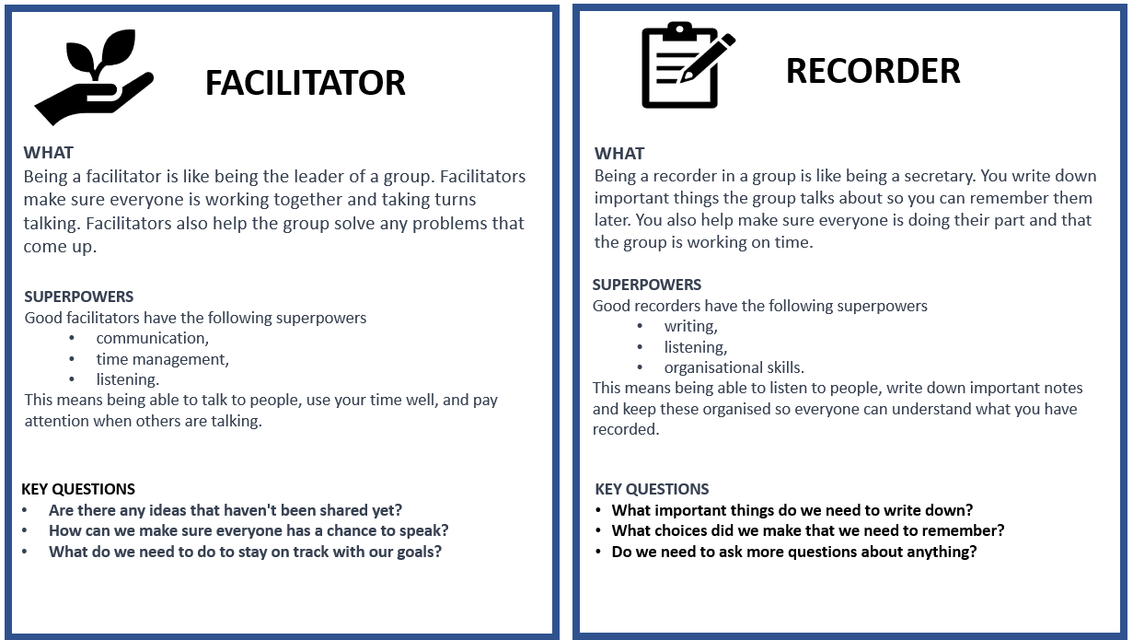
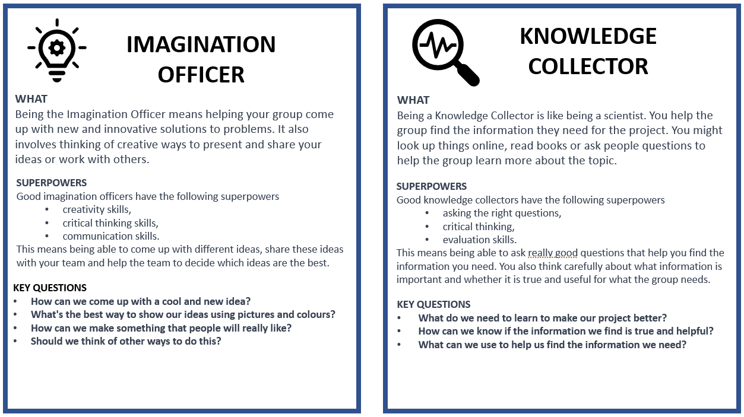

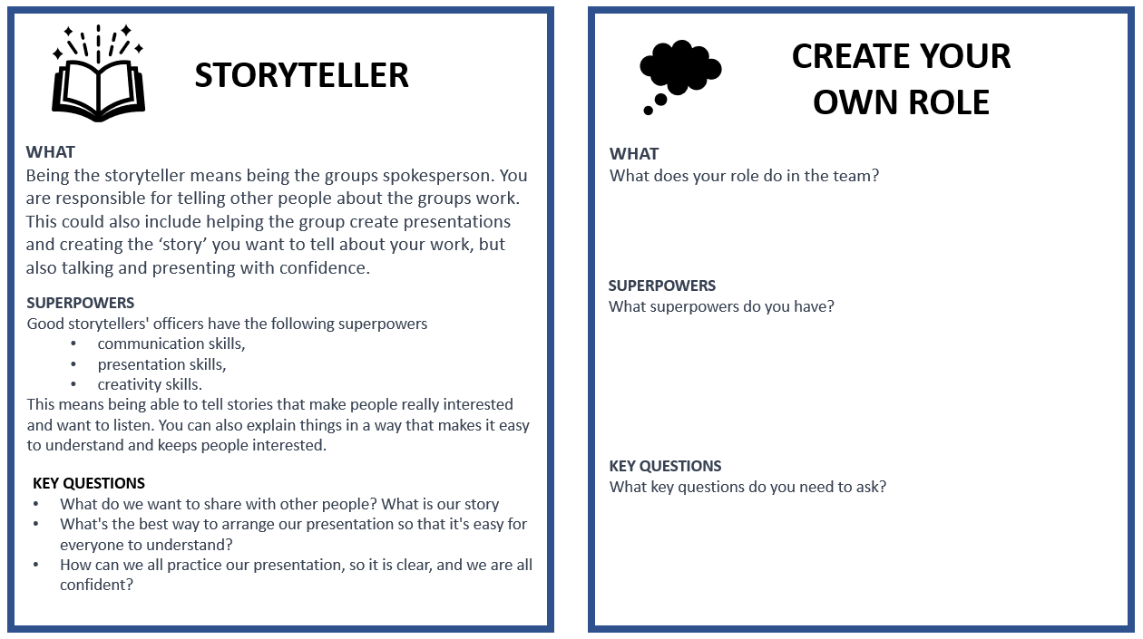

Annexure 7: Teachers as scaffolders of learning

Scaffolding learning is an instructional approach that is essential for Project-based Learning. When you scaffold learning you are providing support and guidance to learners as they engage with new or challenging material. The term "scaffolding" refers to the temporary support structures that construction workers use to help them reach high places while they build a building. In education, scaffolding means providing learners with the support they need to build their understanding of a topic or skill.
Scaffolding learning typically involves several steps.

First you assess the learners' prior knowledge and skills. What do learners already know about the topic and what gaps or misconceptions may need to be addressed.
- Provide support and guidance to help learners engage with the material and build their understanding. This support may take many forms, including modelling, feedback, prompts, and questions.
- As learners become more confident, gradually reduce the scaffolds.

Here are some examples of questions you can use in different circumstances to help scaffold your learners' learning.

Clarifying questions  Ask these types of questions to clarify learner understanding of a topic.  - Can you explain what you mean by that?  - Can you give me an example to illustrate your point? | Prompting questions  Ask these questions to help learners to think more deeply about a topic or idea.  - What other perspectives or points of view could we consider?  - How does this relate or link to what we've learned before?
Elaboration question  Ask these questions to encourage learners to expand on their ideas.  - Can you tell me more about that?  - Why do you think that is the case? | Strategy questions  Ask these questions to help learners develop problem-solving skills and strategies.  - What steps could we take to solve this problem?  - What information do we need to gather to answer this question?
Prediction questions  Ask these questions to help learners anticipate what might happen next.  - What do you think will happen if we try this?  - What do you expect to see when we conduct this experiment? | Clarification questions  Ask these clarification questions to help learners understand complex or abstract concepts.  - What do you think this term means?  - Can you give me an example of how this concept works in real life?
Reflection questions  Ask these questions to help learners to reflect on their learning  - What did you learn today?  - What was challenging about this activity, and how did you overcome those challenges? | Comparing and contrasting questions  Ask these questions to help learners understand similarities and differences between concepts or ideas.  - How is this similar to/different from what we learned before?  - What are the advantages and disadvantages of these two approaches?
Summarising questions  Ask these questions to help learners summarise key points or ideas.  - Can you tell me in your own words what we learned today?  - What are the most important takeaways from this reading? | Thinking questions: Ask these thinking questions to help learners reflect on their own learning processes and strategies.  - What strategies did you use to approach this task?  - How can you apply what you learned in this assignment to other contexts?

Annexure 8: Learner Self-reflection Tool
Each learner would benefit from thinking back on their experience of the project and answer these reflection questions. This can be done in written form or orally.

Let’s look back and learn: “We don’t learn from experience, we learn from reflecting on experience.” (John Dewey)
Knowledge of space
Share five new facts you learnt about space.
What is the most interesting new thing that you learnt about the planets?
Explain two main differences between Earth and the other planets.
Planning and building the roadmap and 3D model
What did you love the most about the project?
What did you find the most difficult about the project?
What was the biggest problem you had to overcome when building the maps and spaceships and how did you solve it?
What advice would you give to other learners who might do this project?
Working in a group
What was the best part of working in your group?
What do you think was the most important thing you did for your group?
What was the biggest problem you had to overcome when working in a group and how did you solve it?
Yourself
What did you do in the project that makes you feel proud of yourself?
The driving question
Can you answer the driving question which is: As space explorers, what do we need to do to plan our first journey into space?

Annexure 9: Teacher S.P.E.C.I.A.L. Self-reflection Tool

- Which teaching strategies were most effective in engaging the learners attention and promoting understanding? Are there other strategies that could be explored in future lessons?
- How did learners respond to the activities and tasks? Were they actively participating and demonstrating understanding? What adjustments could be made to enhance learner engagement and comprehension?
- Were there any misconceptions or misunderstandings that emerged during the lesson? How were they addressed, and how can they be prevented in future lessons?
- How effectively was feedback provided during the lesson? Were learners given opportunities to reflect on and improve their understanding?
- What opportunities were provided for learners to collaborate, problem-solve, and think critically? Can these opportunities be further developed in future lessons?
- What can be learned from this lesson to inform planning, instruction, and assessment for future lessons?

Prior Knowledge:  - How did I activate and build on the learners' prior knowledge during the lesson?  - Were there any gaps or misconceptions in learners' prior knowledge that needed to be addressed? How were they handled?  - How can I better connect new concepts to learners' existing knowledge in future lessons? | Curiosity:  - How did I encourage learners' curiosity and inquisitiveness during the lesson?  - Were there opportunities for learners to explore and investigate the subject matter on their own or with peers?  - How can I better incorporate inquiry-based learning and curiosity-driven activities in future lessons?
Social Interaction:  - How did I facilitate opportunities for social interaction and collaboration during the lesson?  - Were learners actively engaging with one another and sharing their ideas? How can I further promote this in future lessons?  - What role did peer feedback and discussion play in deepening learners' understanding of the material? | Iteration:  - Were learners provided with opportunities to practice, iterate, and refine their understanding and skills during the lesson?  - How effectively did I offer feedback and guidance to support learners' iterative learning process?  - How can I create more opportunities for practice and iteration in future lessons?
Purpose:  - Were the learning objectives clear and purposeful for the learners? Did they understand the relevance of the lesson to their lives and future learning?  - How did I connect the lesson content to real-world applications or contexts?  - What can I do to make the purpose of future lessons more explicit and meaningful for my students?  Enjoyment:  - How did I incorporate elements of enjoyment and fun into the lesson?  - Were learners actively enjoying the learning process? What can I do to further enhance their enjoyment in future lessons?  - How did the learning environment and classroom atmosphere contribute to learners' enjoyment and motivation? | Active Engagement:  - Were learners actively engaged in the learning process, both cognitively and behaviourally?  - Which activities or strategies were most successful in promoting active engagement and deep learning?  - How can I better design future lessons to foster active engagement and higher-order thinking?  Attention and Engagement:  - Which activities or strategies were most successful in capturing and maintaining learners' attention during the lesson?  - Were there any points during the lesson where learners seemed disengaged or distracted? How can I address these issues in the future?  - How can I modify the lesson to better sustain learners' attention and interest in the subject matter?
Learner Autonomy:
How did I promote learner autonomy and self-directed learning during the lesson?
Were learners given opportunities to make choices and take ownership of their learning?
How can I further support the development of learner autonomy and self-regulation in future lessons?

Find out more.

www.ecubed-dbe.org
https://learn.ecubed-dbe.org/

