Road safety: Learning and teaching the rules of the road.

Term three, Grade 2, Life Skills Project
Week 9
Playful learning to prepare teachers and learners to thrive in a changing world

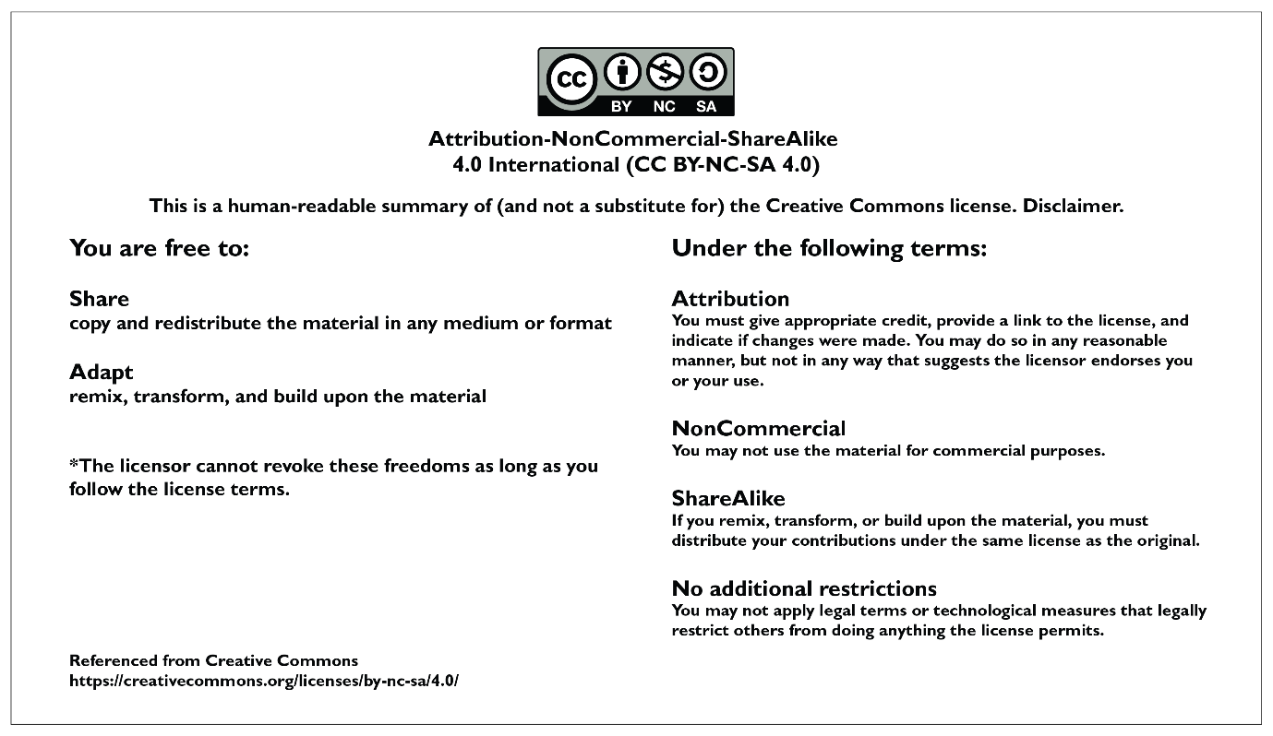

CONTENTS PAGE
PROJECT OVERVIEW 3
Preparing for the project 8
The project 9
Lesson 1: What do we know about the rules of the road? 9
Lesson 2: What more can we learn about road safety? 12
Lesson 3: Brainstorming the problem. 15
Lesson 4: Giving and receiving feedback. 17
Lesson 5: Finalising plans and starting to build! 21
The Public Presentation 23
Annexures - useful tools for the project 24
Annexure 1: EXEMPLAR ASSESSMENT RUBRIC 24
Annexure 2: Exemplar Competency (Skills) Observation Checklist 26
Annexure 3: Example letter to parents and caregivers about Project-based Learning 27
Annexure 4: The Project Wall 28
Annexure 5: The Project Route Map 28
Annexure 6: Roles and Responsibilities 29
Annexure 7: Teachers as scaffolders of learning 33
Annexure 8: Learner Self-reflection Tool 34
Annexure 9: Teacher S.P.E.C.I.A.L. Self-reflection Tool 35

PLEASE NOTE
This is an exemplar project, but we encourage you to make it your own. Please feel free to adapt it as necessary to ensure it is suitable and relevant to your learners in your classroom. Remember, the ultimate goal of this project is to engage your learners and foster their learning, so don't be afraid to put your own spin on it! The activities and assessments in these lessons are here to guide you on your Project-based Learning journey. Feel free to adapt the activities and assessment to suit your learners needs.

PROJECT OVERVIEW
 | Name of project: Road safety: learning and teaching the rule of the road
Subject: Life Skills (Personal and Social Well-being and Visual Arts) |  | Grade: 2 | Duration: 3 hours
Possible areas for integration with other subjects
Life Skills: Physical Education
- Locomotor: Walk forward crossing dominant leg over.
Language development
Throughout this project learners will use language intensively and authentically as they:
- interact and communicate with one another,
- ask and answer questions,
- discuss and make plans and decisions,
- read and interpret texts, make informal presentations
- listen to presentations critically and provide constructive feedback.
Due to the communication-rich nature of the process they go through, many aspects of language are practiced and developed.

Mathematics
Mathematics concepts relating to space and shape, quantity and measurement are applied when learners plan and construct their road/street maps and 3D models.

CAPS content covered.  REMEMBER to always be aware of activities to promote Executive Functioning: Working memory, Inhibitory control and Self-regulation.  Learner talk, discussion, exploration, INQUIRY find-out”, problem solving, thinking and reasoning is of utmost importance. |  | Week 9  Personal and social well-being  KNOWLEDGE  Road safety  • Recognising road signs and remaining safe  Road safety rules: for Pedestrians, Cyclists, Passengers  Creative Arts (Create in 3D)  Use recyclable materials and paper mâché to make useful objects: egg cups, containers, plant holders, etc. decorate using patterns; discuss geometric shapes and cool and warm colours, develop craft skills.  Click here for the 2023/2024 ATPS.
Driving question |  | How can we plan and build a road map and a 3D model of a road vehicle, a bicycle or a pedestrian to teach young learners about road safety?
Project summary and objectives |  | For this project, learners will take on the role of teachers as they create an interactive road map and 3D model of vehicle, a bicycle or a pedestrian as a tool for teaching younger learners about road safety.  - Learners need to draw on their prior knowledge and integrate new knowledge to answer the driving question.  - In groups, they use skills such as collaboration, communication, creative and conceptual thinking to:  - Make a democratic decision about which 3D model to make.  - Create a road map containing elements of road safety such as road signs and traffic lights to be used interactively with the 3D model.  - Draft a rough plan for feedback.  - Iterate the plan and create a plan of action including roles and responsibilities.  - Make the products for display and a Public Presentation.  - Learners are active and have a lot of autonomy in this project making it a rich learning experience. Learners get opportunities to practise a variety of Bloom’s cognitive skills including the higher order skills such as analysis, synthesis and evaluation. Learners are constantly active as they discuss, listen, ask questions, solve problems, apply new knowledge, negotiate conflicts that may arise, plan, iterate, construct, present and most important of all – learn to love learning.
Entrepreneurial way-of- being skills developed in this project |  | Communication | Collaboration
 |  | Critical Thinking | Creative Thinking
Products |  | A road map containing road signs.  A 3D model of either a road vehicle, a cyclist or a pedestrian.
Public presentation |  | Projects will be presented by groups at a public presentation. Group members can explain knowledge they have learnt about road safety, and how they made their road maps and 3D models. These projects are interactive and the public can test them out during the presentation. The public presentation could be, for example, held at a special event where caregivers and members of the community can join in the celebration. It is important that the projects are presented to a wider audience than just the learners and the teacher in the class. As the purpose of this project is for grade 2s to create a resource to teach grade r learners about road safety, a special teaching and learning session with grade 2s and grade r learners would be invaluable.

PROJECT OVERVIEW
Activating the science of learning | This project:  Activates prior knowledge by encouraging all learners to remember (retrieve) what they already know about aspects of road safety and reflect on how they know what they know. Linking new knowledge to what is already known improves comprehension of new knowledge and tends to lead to better storage of knowledge in long-term memory.  Focuses learner attention and engagement on the learning as it stimulates their curiosity and imagination by casting them in the role of teachers who will be learning more about road safety so that they can teach grade r learners how to follow road signs and stay safe on the roads. This creates an authentic purpose for the learning which tends to improve attention and engagement with the content. They also have a lot of voice and choice and get to make their own decisions about how to create their products. Having this autonomy to follow their own interests also leads to learners who are more engaged and attentive, which improves long-term retention of information and skills.  Results in ‘sticky learning’ learning that is memorable and lasting because it is purposeful, contains an authentic problem to solve, and includes many significant learning opportunities where learners can actively process new information in different ways. This all leads to information shifting from short-term to long-term memory making it ‘sticky’ and hard to forget.
Lesson summary | Lesson one: | In this lesson, learners will:  - Collaborate in a group to discuss what they know about road safety and use a circle map to document this prior knowledge and make it visible.  - Reflect on how they acquired their knowledge (how do they know what they know) which stimulates meta-thinking.  - Select a presenter to share what the group has discussed, with the rest of the class.
 | Lesson two: | In this lesson, learners will:  - Collaborate in their group to investigate and learn more about an aspect of road safety and update the circle maps from Lesson 1.  - Participate in a gallery walk to review the updated/enriched circle maps.
 | Lesson three: | In this lesson, learners will:  - Learn more about the problem and the call for help.  - Brainstorm ideas for their road/street maps and 3D models
 | Lesson four: | In this lesson, learners will:  - Develop a rough plan of their two products.  - Present their ideas and rough draft for feedback which is done as a role play.
 | Lesson five: | In this lesson, learners will:  - Apply their planning and use it to guide the building of their road maps and 3D models.
Resources | - DBE Life Skills grade 2, book 2, terms 3,4: pages 22-27.  - Any other resources relating to the topic that you already have in stock.  - A range of found and recycled materials.
Entrepreneurship add-on possibilities | Road Safety Education Kit: Learners can create a road safety education kit that includes an interactive road map and a 3D model of a vehicle, a bicycle, and a pedestrian. They can create these tools using recycled materials.  Road Safety Workshops: Learners could offer road safety workshops to younger learners in their community. They can use their road safety education kit to teach younger children about road safety rules, such as crossing the road safely, using pedestrian crossings, wearing a helmet while cycling, and obeying traffic signals.  Fundraising: Learners can use their road safety education kit and workshops as a fundraising opportunity. They can charge a fee for their workshops and donate the proceeds to a charity that supports road safety education.  Overall, this entrepreneurial opportunity can help learners develop important skills such as creativity, problem-solving, and communication while also promoting road safety education in their community.

Preparing for the project

Preparing learners
- This is a short (but powerful) project so preparation and planning is important. It's recommended that you plan the groups before starting the project so that learners are already sitting together and are starting to get to know each other.
- It’s recommended to explain the overview of the project i.e., that the learners are going to make a road map and model of a road vehicle, a bicycle or a pedestrian that grade r learners can use to learn about road safety.
- Effective group work is more manageable and more effective when each group member has a role and responsibility. Please see annexure 6 for more detail on the types of roles that are useful for a project.

Preparing the classroom
- Before launching the project, you can create a Project Wall. This is very similar to a theme wall where you display and show resources, pictures, posters and objects about your new theme. The Project Wall takes this a step further in that it shows the driving question, journey of the project (route map found in annexure 5). The project Wall can begin with a display of what learners already know about the topics and as the project progresses their displays become richer and richer which makes the growth of their learning visible. Keywords can be placed on the wall as can curious questions that learners ask that you want to revisit. As far as possible, get the learners to organise the wall and take ownership of what is displayed - after all it's their project and their learning. To learn more about Project Walls please see annexure 4.

Teacher preparation
- Read the project instructions. Make any changes or updates to the project to suit your learners needs.
- Read Teaching for Learning in a Fast Changing World. You can download it here: https://www.uj.ac.za/wp-content/uploads/2023/01/teaching-for-learning-in-a-fast-changing-world-e-version.pdf
- Do the Introduction to Project-based Learning course online https://learn.ecubed-dbe.org/courses/introduction-to-project-based-learning/
- Please see the additional notes on Collaborative Learning in Project-based Learning and Thinking Maps Resources for more information on these two topics.

Preparing parents and colleagues
- Inform parents and caregivers about your project. We have created a template that you can adapt, you can find this in annexure 3.
- Tell your colleagues about your project and what to expect e.g., for example there will be lots of group work so your lessons might be a little bit noisier, but this is good, it means learners are engaged and paying attention.

Preparing for the Public Presentation
- The project ends with a Public Presentation where learners get to show off their projects. The date needs to be booked in advance as this is not a lesson. Public Presentations can be done at assembly, as an art exhibition at break, or at an event like a parents evening. As the purpose of this project is for grade 2s to create a resource to teach grade r learners about road safety, a special teaching and learning session with grade 2s and grade r learners would be invaluable.

The project
Lesson 1: What do we know about the rules of the road? | Resources needed:  Project route map (Annexure 5)  Circle maps |  | Time required:  30 mins
Summary of the Lesson
In this lesson, learners will:
- Collaborate in a group to discuss what they know about road safety and use a circle map to document this prior knowledge and make it visible.
- Reflect on how they acquired their knowledge (how do they know what they know) which stimulates meta-thinking
- Select a presenter to share what the group has discussed, with the rest of the class.

Objective
The purpose of this lesson is for learners to:
- Remember what they already know (prior knowledge) and have experienced about road safety.
- Practice collaborating and communicating as they discuss what they know in their group.
- Develop meta-thinking by reflecting on how they know what they know.

The purpose of this lesson is for teachers to:
- Informally evaluate learners’ prior knowledge about the topic and how well they can demonstrate their knowledge either through speaking and/or writing.
- Observe how learners are collaborating and communicating in their groups.

Before the lesson  Prepare one circle map for each group. If you have many groups, then more than one group can work on a topic.  The following are the topics for the circle maps. Write these into the small middle circle.  - Road signs  - Rules for pedestrians  - Rules for cyclists  - Traffic lights  It is recommended that groups are organised before the project starts. As this project is all about road safety, groups may want to name themselves, for e.g., after different types of motor cars.  Lesson guidelines- what will learners and teachers do?  - Introduce the Project Route Map  - Show learners the Project Route Map so they get a sense of what they can expect. This also develops a sense of anticipation and curiosity about what is to come. (Please see annexure 5 for the Project Route Map)  - Leave the route map on the Project Wall as a lesson-by-lesson project guide – and for learners to revisit and review out of project time. This becomes an incidental learning resource/opportunity.  - We have a problem!  - Start the lesson with this (or a similar) problem:  “In assembly, the principal spoke to the Foundation Phase about the importance of road safety because there have been reports of learners breaking all sorts of rules and putting themselves in danger. The principal is particularly worried about the grade R learners who run across the road without looking. The principal wants to know if anyone can help educate the learners in that grade.”  - Explain to the class that you have volunteered them to help teach the younger learners all about road safety before there is an accident, and someone gets hurt.  - Then ask the following questions to facilitate deeper thinking and understanding of the problem.  - If grade R learners are in danger on the road, what rules are NOT followed? I.e., why are they in danger?  - Why do you think they are not following the rules of the road? What is the reason?  - Can we, as the grade 2s help them? If the answer is yes, what can we do?  C. Starting on our solution: What do we already know?  - Explain to learners that to be able to teach, you first need to learn about your topic, so if they want to teach and help grade r learners, they need to have a good understanding of road safety.  - Hand out the circle maps. Explain how to use them i.e., learners write what they know into the circle and where they learnt their knowledge into the rectangle.  - This is a ‘quick think’ so only give a few minutes and then get feedback.  - Give presenters a 1-minute time limit so feedback is kept short and focused.  - Learners may want to choose one or two writers to write ideas onto the circle maps and a presenter to do the feedback. These roles should change over the project so group members can experience different roles. (Please see Annexure 6: Roles and Responsibilities for more on roles and responsibilities)  - Collect the maps because they will be used in lesson 2.  D. Reflection: Looking back on our learning  - Because learners will be teaching other learners they need to reflect on their own level of knowledge. Challenge learners by asking them if what they know now (as shown on the circle maps) is enough, or do they need more knowledge about some of the topics? |  | How learning happens.  Prior knowledge  Learners’ prior knowledge about the topic of road safety is brought to mind and made visible through the circle maps. This helps teachers assess informally how much the learners know and where the gaps are. This information helps to ensure that new learning connects and builds on what learners already understand.  S.P.E.C.I.A.L.  Learners are socially interactive as they discuss, share and document their current knowledge and experience of road safety.  Reflection for meta-thinking  Learners reflect on how they know what they know i.e., where did they learn what they already know? This is an important step towards developing meta-thinking (thinking about thinking).  Questioning and critical thinking  Using inferential questions (Why? If so, How?) learners are challenged to think critically about their own knowledge and the problem located in the driving question. This level of processing deepens understanding and enhances memory.  Reflection for memory  Keeping the circle maps on display gives learners opportunities outside of project time to read, remember and think about road safety. This can deepen engagement with the topic which strengthens learning and memory.  Reflection for meta-thinking and critical thinking  Encouraging learners to consider how much they know and if this is enough to teach others develops meta-thinking and critical thinking as learners reflect honestly on their prior knowledge to evaluate if they have knowledge gaps that need filling.  Remember that reflection leads to learning that is ‘sticky’ learning that lasts. So, don’t miss out the reflection activity.
Extended opportunities
This project focuses on road safety. To start establishing the vocabulary around this theme start with a movement activity called, “Move like a motor car.” Ask learners to pretend to hold a steering wheel and:
- Drive straight.
- Turn your steering wheel to make a right turn.
- Turn your steering wheel to make a left turn.
- Lean backwards as we drive up a hill and lean forwards as we drive down a hill.
- While ‘driving straight’ press down on a pedal with your right foot and then your left foot.
- Look right, look left and look right again.
- Stop at the traffic light.
Please change and adapt to suit your context.
Observations and facilitation - Assessment as Learning
As a teacher you already know that you play an essential role as a facilitator of learning. You know that rather than simply giving knowledge to learners, you create an environment in which your learners can explore, discover, and construct their own understanding of the subject matter. As a facilitator you will
- create an emotionally and psychologically safe learning environment so that learners feel safe to participate in the lesson,
- provide prompts when learners get stuck,
- provide constructive and timely feedback to learners,
- and make adjustments to your lesson based on what you observe (this is assessment as learning) so that learners can grow their understanding and grow their skills and competencies.

While learners are working on their tasks throughout this project your role as a facilitator is to observe, listen, and record the process of learning during the lesson. These observations are the foundation for the assessment of this project, so make a few notes, these will help you when you do the final assessment.
The first lesson focuses on establishing what learners already know about the topic (prior knowledge). While learners are communicating in their groups, it’s important to actively observe and listen to what they are saying and how they are interacting with their peers. As you walk around the classroom, keep an eye out for the following indicators of learning:

Learner knowledge
This is a crucial aspect to observe as learners' understanding of key concepts relating to the topic. You can assess this by observing if learners can describe or explain key words and concepts about road safety.
- “What road signs do you see along the road on the way to school?”
- “Can you remember the colour of a stop sign?”
- “What do the different coloured lights on a traffic light mean?”
- “Are road safety rules only for people in cars?”

These prompts work as informal, continuous assessment and can help you gauge learners’ baseline comprehension of the topic. Re-asking these types of questions throughout the project will help monitor their progress.
For more ideas on prompts and scaffolding questions please see Annexure 7.

Teacher self-reflections
After every lesson it is important to reflect on how the lesson went so that you can make adjustments to the lesson or project. Check out annexure 9 for a whole range of different questions you could use to reflect on for this lesson. Note you do not need to reflect on all the questions, just select 1 or 2 that resonate with you. Your own self- reflection is important for a number of reasons: it is a crucial aspect of teacher professional development and enables you to learn from experience, grow as a teacher and continually improve your instructional effectiveness so that you can better support learners’ learning.

Lesson 2: What more can we learn about road safety? | Resources needed:  DBE Life Skills grade 2, book 2, terms 3,4: pages 22-27.  Any other resources relating to the topic |  | Time required:  30 mins
Summary of the Lesson
In this lesson, learners will:
- Collaborate in their groups to investigate and learn more about one aspect of road safety and update the circle maps from Lesson 1.
- Participate in a gallery walk to review the updated/enriched circle maps.
Objective
The purpose of this lesson is for learners to:
- Review and recall what they did in lesson 1 and connect this knowledge to new knowledge gained in lesson 2.
- Research new information about their specific topic and add it to a circle map.
- Display the updated circle maps for a gallery walk.

The purpose of this lesson is for teachers to:
- Check how well learners recall information and activities from lesson 1.
- Listen to the level of language used by learners to discuss their topic.
- Observe if learners can evaluate what new information should go onto the circle maps.
- Monitor collaboration and interaction in the group.

Before the lesson  - Learners will be expanding their knowledge of road safety by adding to the circle maps from lesson 1, so these need to be available.  - The DBE workbooks have some extra knowledge but please add any other resources that will be useful to enrich learners’ knowledge.  Lesson guidelines- what will learners and teachers do?  - Reviewing  - Ask volunteers to explain what has been done/learnt so far in the project. They can use the Project Route Map to show progress. This will also help learners reflect on what they have learnt and what they have done which is a good strategy for shifting new knowledge into long-term memory.  - Looking, learning and sharing  - Refer learners to their DBE Life Skills grade 2, book 2, terms 3,4: pages 22 -27.  - Hand the circle maps back to the groups but shuffle them around so each group gets a new map and new topic.  - In their groups, learners need to read the information in the workbook (or other resources) and ADD new information to their map. This must be done in a different colour. (As far as possible, encourage learners to take responsibility for helping all group members read and understand the new information.)  - Learners can choose different writers for this lesson. (Please see annexure 6 for more on roles and responsibilities.)  Presenting and teaching  - Display these enriched circle maps as an exhibition and encourage learners to do a gallery walk where they take some time to look at, read and think about all the information they can see in the circle maps.  Conclusion and reflection  - After the gallery walk and to stimulate reflection, revisit the question from the first reflection which was, “Do you think you know enough about road safety to teach the grade r learners?” to see if learners have changed their original answers based on how much the circle maps have changed. |  | How learning happens.  S.P.E.C.I.A.L.  Learners are socially interactive. They also work with purpose as there is a real-life reason for engaging with the content. A strong sense of purpose tends to increase attention and engagement which are essential for learning.  Reflection  The conclusion and reflection encourage learners to reconsider a belief they held about their knowledge about road safety and evaluate whether the belief holds true or if they need to iterate their thinking.  This level of critical thinking is an excellent strategy for shifting knowledge into long-term memory.  Remember that reflection leads to learning that is ‘sticky’ learning that lasts. So, don’t miss out the reflection activity.
Extended opportunities
Take the learning home by encouraging learners to ‘teach’ the new information they learnt to their parents/siblings or friends.
Observations and facilitation - Assessment as learning
As learners read, learn and enrich their circle maps, it's important to actively observe and listen to learners as they work together in groups. As you walk around the classroom, keep an eye out for several key indicators of learning, communication, and knowledge of the topic. These are just some examples of things to observe you might have your own list of observations to use.

Learner communication skills
  - Observe learners' active listening skills to determine if they are fully engaging with their peers during the group discussion process. Are they focused and attentive, or are they distracted or disengaged?
  - Additionally, pay attention to their articulation skills. Are they speaking clearly and confidently, or are they mumbling or speaking too fast, or speaking too loudly or softly?
Empathy is another key communication skill to observe while learners read and comprehend the new information and assist their peers who may be struggling and needing help. Are learners trying to understand how other people might be feeling? Are they showing empathy and consideration towards their peers? Are they showing tolerance and patience?

If learners are struggling with any aspect of their communication skills, there are several strategies you can use to support them.
- One option is to model active listening yourself, showing the kinds of behaviours you expect from learners.
- It can be helpful to share and discuss the definitions of good communication. The Teacher's Guide to Competencies is an excellent resource for this purpose, providing information and guidance on the development of communication skills.

Remember, communication skills take time to develop, and learners will have many opportunities to practise and grow their abilities throughout the project. By actively observing and facilitating their progress, you can help them build important skills that will serve them well in the future.

Suggestions for facilitation and scaffolding
Although learners are responsible for their own and other’s learning, they still need you! It is essential to constantly facilitate and scaffold the quality of their learning. As a facilitator of learning you need to listen to WHAT learners are talking about so you can monitor if they are learning and to stop any incorrect learning immediately. Constant check-ins and questions of group members is invaluable for this.

Facilitation and scaffolding questions could be:
“Tell me about two road signs you pass everyday to school?”
“Does our school have a scholar patrol?”
“If a traffic light is green, who must go, a driver or a passenger?”
“What do we call people who help direct traffic?”
“ Do any road signs confuse you?”
For more ideas on prompts and scaffolding questions please see Annexure 7.

Lesson 3: Brainstorming the problem. | Resources needed:  Assessment rubric  Examples of roadmaps  Bubble maps |  | Time required:  40 mins
Summary of the Lesson
In this lesson, learners will:
- Learn more about the problem and the call for help.
- Learn more about the assessment rubric
- Brainstorm ideas for their roadmaps and 3D models.

Objective
The purpose of this lesson is for learners to:
- Collaborate and use critical and creative thinking and prior and new knowledge to brainstorm ideas and capture these on a bubble map.
- Communicate these ideas so others can understand.
- Respect other learners’ opinions and points of view.

The purpose of this lesson is for teachers to:
- Observe learners’ ability to brainstorm and generate creative ideas.
- Listen to how well learners communicate these ideas.
- Observe how respectful learners are of others’ ideas.
- Observe if the brainstorming activity is fair and everyone has a chance to participate.

Before the lesson  Be prepared to explain how to use a bubble map if you choose to use one.  Lesson guidelines- what will learners and teachers do?  - Reviewing  - Ask volunteers to explain what has been done/learnt so far in the project. They can use the Project Route Map and, for example, the circle maps to show progress.  B. Learning more about the problem  - Explain to learners that so far in the project they have learnt new information and are better prepared to start teaching grade r learners about road safety – BUT there are some guidelines they need to think about when planning their roadmaps and 3D models. These are: grade r learners don’t learn well through just listening so you can’t tell them the rules. They also don’t learn well by just looking so making posters or pictures won’t be enough. Young children learn best by doing and touching so and using things, so your products must be usable. They do not have to be big, they do not have to be very neat and beautiful, but a grade R learner should be able to use them to learn about road safety.  - Tell learners: In your groups, you will now start to brainstorm, plan and make a model of a roadmap with at least 3 examples of road signs and a traffic light (i.e., all the rules) and a model of a car, a bus, a bicycle or a pedestrian who can be moved around the map according to the rules of the road. The last piece of the problem is that you can only use found or recycled materials.  - Be sure to put these project guidelines on the Project Wall.  C. Sharing the assessment rubric  - The groups are now moving into brainstorming the products. Ultimately these will be exhibited at a Public Presentation AND assessed. Show and explain the rubric to learners so they know exactly what is expected of them. (Please see annexure 1 for an exemplar assessment rubric.)  D. Brainstorming  - In their groups, learners need to decide how to approach this project. To begin with they can brainstorm as many creative and unique ideas as possible. The groups can use a bubble map to keep ideas visible. At this stage all ideas can be considered – no idea can be too wild or weird!  D. Conclude and reflect  - Sometimes the best ideas don’t happen in the moment. The project can pause here which will give everyone more time to imagine, think, investigate and research the possibilities for the project. |  | How learning happens.  S.P.E.C.I.A.L.  This lesson is highly learner centred. Learners have autonomy as they can decide what 3D model to build and how they want to make their roadmaps. When learners make their own decisions, they become more motivated and engaged with the process which improves learning and memory.  Competencies  Making their own decisions offers learning the opportunity to practise communication and collaboration skills. This also offers the opportunity for learners to learn how to respect differences, in this case different ideas and opinions about how to approach the project.
Extended opportunities
- A visit and talk from a traffic officer can be organised to inspire the learners. This person/people can also be invited to the Public Presentation.
- For homework, learners can start collecting recycled materials for their projects.
Observations and facilitation - Assessment as Learning
During this brainstorming, it's important to actively observe and listen to learners as they work together in groups. As you walk around the classroom, keep an eye out for several key indicators of learning, including creative innovation, collaboration skills, communication, and critical thinking skills. Here are some suggestions of what you could observe:

  - Creative innovation: Observe learners’ range and type of ideas while they brainstorm and plan. Are they thinking out of the box, are their unique and interesting ideas or are they struggling to think creatively? If learners are struggling, prompt them by asking, “Have you ever thought of…”, “Imagine if…”, “What if…”

  - Learner communication: how clear was the learner communication? Were they able to express their ideas clearly? For example, did group members express their thoughts and ideas clearly when brainstorming ideas for the road safety model? You can scaffold and prompt by asking: “Did everyone in the group add an idea?” and “Can someone explain some of the group’s thoughts for the project?”

  - Learner collaboration: were all learners involved and given a voice in the process? Prompt for this by asking a few learners in each group what idea they shared and to show it to you, for example in the bubble map.

For more ideas on prompts and scaffolding questions please see Annexure 7.

Lesson 4: Giving and receiving feedback. | Resources needed:  Feedback checklists |  | Time required:  40 mins
Summary of the Lesson
Learners will:
- Develop a rough plan of their two products.
- Present their ideas and rough draft for feedback which is done as a role play
Objective
The purpose of this lesson is for learners to:
- Collaborate and use critical and creative thinking and prior and new knowledge to make decisions and rough plans.
- Present their plans for feedback.
- Evaluate other groups’ plans and give feedback.
- Iterate plans.

The purpose of this lesson is for teachers to:
- Observe how learners manage decision-making in the group.
- Observe, or if needs be, teach how to give and receive feedback.
- Observe how well learners evaluate their feedback to decide if they need to iterate their initial plan.

Before the lesson  Please write the following (or something similar) on the board or make a copy for each group.  Planning guide What road signs will we use? What will it be made from? What tools do we need? (Scissors etc) Who will be responsible? (Names)  Planning the road map  What are we making (vehicle/bicycle/pedestrian) What will it be made from? What tools do we need? (Scissors etc) Who will be responsible? (Names)  Planning the 3D model  Lesson guidelines- what will learners and teachers do?  - Reviewing  - Ask volunteers to explain what has been done/learnt so far in the project. They can use the Project Route Map to show progress.  B. Explaining the checklist  - Explain the planning guide to learners i.e., this is an important part of planning and preparation for the project: the better the plan the better the build!  C. Completing the checklist  - In groups, learners start to make decisions and plans i.e., they move from brainstorming to focussing on planning. As soon as there are rough plans in place, groups can get some quick and early feedback to get different opinions about their project plans.  - It is essential to observe this process carefully and keep checking with the groups that their plans are reasonable and doable. This will safeguard against huge iterations or complete changes to the project plan at the last minute.  D. Giving and receiving feedback  - This feedback activity involves some roleplay and imagination. Explain to learners that they must present their plans for inspection by the local traffic officers (other groups will act out this role) who want to check that they have included everything for their project and that it makes sense. This is important because the grade r learners will be using them to learn about road safety.  The traffic officer inspection roleplay can be organised as follows:  - Pair up two groups  - Each group has 1 – 2 minutes to present their plan.  - After the presentations they can ask questions, give feedback and comment on the plans.  - The road safety project can be evaluated using a guide like the one below.  Road safety project checklist 1 Needs a rethink 2 Good 3 Great  Are there 3 examples of road signs?  Are all materials recycled or found?  Is the map sensible and not too complicated to make?  Has a 3D model been chosen?  Can the 3D model be moved around on the map?  Are all group members included?  Suggestions  E. Reflections  - Groups can reflect on and evaluate the feedback and consider what was useful that they will use and what they can ignore. They can iterate now or at the start in the next lesson.  - This gives learners more time to reflect on the plan and the feedback. It’s recommended that the planning guides are displayed on the Project Wall. There is a good chance that learners will return to these guides out of project time and start to make changes and iterations independently. |  | How learning happens.  S.P.E.C.I.A.L.  Learners are socially interactive. They are also active as they provide constructive feedback to their peers.  Reviewing and reflecting  Learners are encouraged to constantly recall what they learnt in the past to use as foundation for what they will learn next. This creates layers of learning and helps learners build strong blocks of knowledge and concepts.  Learners’ autonomy is evident as they make choices about what to iterate.  Iteration is an important part of this lesson as learners must reflect on and think critically about the value of the feedback they receive. Feedback should only be used if it will improve the plan.  Remember that reflection leads to learning that is ‘sticky’ learning that lasts. So, don’t miss out the reflection activity.
Extended opportunities
- Each group member has now got a project role and some responsibility. For homework, all learners need to collect any specific materials or tools they need to carry out their role and do their fair share of the work.
Observations and facilitation - Assessment as Learning
During this brainstorming and planning and feedback activity, it's important to actively observe and listen to learners as they work together in groups. As you walk around the classroom, keep an eye out for several key indicators of learning, including creative innovation, collaboration skills, communication, and critical thinking skills. Here are some suggestions of what you could observe:

Collaboration and decision making: Observe how learners are making plans and d decisions in a group. Is it fair or are a few learners taking over the process? Prompt by asking a few learners in each group if they could participate in the planning and if they could not, what was the barrier?

- Giving feedback: Observe learners as they give feedback to their peers. Take note of the quality of their feedback, including whether it is specific, actionable, and relevant and shows respect and kindness. If learners get stuck, you could prompt them by saying “Can you give your peer a specific suggestion on how to improve their idea?
- Receiving feedback: Observe learners as they receive feedback from their peers. Take note of their reactions and whether they are open to receiving feedback. Prompt: "How did you feel when your peer gave you feedback on your idea? Was it helpful?"
- Learner communication: how clear was the learner communication? Were they able to express their ideas clearly? For example, when deciding whether to iterate, was their final decision based on clearly expressed thoughts and ideas? Prompts: “Did everyone in the group have a say in the decision?” and “Can someone explain the decision about what to iterate.”
- Collaboration and decision making: Observe how learners are making plans and decisions in the group. Is it fair or are a few learners taking over the process? Prompt by asking a few learners in each group if they could participate in the planning and if they could not, what was the barrier?

For more ideas on prompts and scaffolding questions please see Annexure 7.

Lesson 5: Finalising plans and starting to build! | Resources needed:  Found and recycled materials  Art supplies  Coloured crayons  Glue |  | Time required:  40 mins
Summary of the Lesson
Based on the final plans, learners will start to apply their planning and use it to guide the building of the roadmaps and 3D models.

Objective
The purpose of this lesson is for learners to:
- Build their products based on the and plans they collaborated on through the previous lessons.

The purpose of this lesson is for teachers to:
- Observe if learners are collaborating and sharing responsibility for the construction and completion of the products.

Before the lesson  Have all resources and recycled materials available.  Lesson guidelines- what will learners and teachers do?  - Reviewing  - Ask learners to explain what has been done/learnt so far in the project. They can use the Project Route Map to show progress.  - Iteration check-in  - Give learners a few minutes to review their plans, and make changes if necessary.  - Set up and start  - In their groups learners now prepare to build. They need to set up their workspace, gather their materials and resources and start construction. It is recommended that learners complete this in class as observing the process is an invaluable source of information for you.  C. Next steps  - Depending on how close the public presentation date is, learners can take time to do final tweaks to their products.  - Learners will then present and explain their projects. During the presentation they will be assessed using a rubric.  - Once the presentation is over, it’s essential to do the last step which is the learner's self-reflection tool (See annexure 8) |  | How learning happens.  S.P.E.C.I.A.L.  This lesson incorporates all the principles of S.P.E.C.I.A.L. as learners work together to make and build their products.  Competencies  This lesson offers opportunities for learners to practise their collaboration, communication, creative and critical thinking.  Reflection  The self-reflection sheet is an essential part of this project and is where most of the learning – including knowledge and skills is consolidated and moves to long-term memory.  Remember that reflection leads to learning that is ‘sticky’ learning that lasts. So, don’t miss out the reflection activity.
Observations and facilitation - Assessment as Learning
During this activity, it's important to actively observe and listen to learners as they work together in groups. As you walk around the classroom, keep an eye out for several key indicators of learning, including creative innovation, collaboration skills, communication, and critical thinking skills. Here are some suggestions of what you could observe:

  - Collaboration: Observe how the learners are fulfilling their roles and responsibilities. Are the groups functioning productively? Are they managing their own conflict and unexpected problems? Step in if it is clear they cannot solve the problem alone, but still try to scaffold their problem solving skills with prompts such as, “Can you explain the problem here?”, “What help do you think you need?”, “What have you already done to manage the problem?”

  - Knowledge: While learners are busy making and building, walk around and ask individual learners questions about their product such as, “Tell me more about what that street sign means for drivers? Or “Show me the places on the map where pedestrians must stop and wait for cars to go past?”

For more ideas on prompts and scaffolding questions please see Annexure 7.

The Public Presentation | Resources needed:  - The completed projects and whatever is needed to display them effectively.
Summary of the lesson
At the end of the project, learners have the opportunity to present their work i.e., pet shelters to a wider public. The purpose of a public presentation is to provide learners with an authentic audience to share their learning and achievements, and to receive feedback and recognition for their hard work and to celebrate all that they have achieved. It also allows learners to practice important skills such as public speaking, communication, and presentation design.
Objective
The purpose of the public presentation is for learners to:
- Applying: Learners apply the knowledge gathered throughout the project to share their learnings and products.
communication, critical thinking, collaboration, creative innovation and meta-learning as they work collaboratively to implement their plans for the public presentation.
End of project reflections  - Once the event is over, make sure you there is time to debrief the experience with the learners.  - Ask learners to complete the Learner Self-reflection Table (see annexure 8). You can decide what method to use to complete the reflection e.g. independently, in a group, in pairs. | How learning happens.  As learners work collaboratively (social interaction) to implement their ideas for their public presentation they are actively engaged in the learning process (hands-on and minds on) which increases attention and engagement, which as we know leads to better learning outcomes.  This experiential approach (designing, making and presenting pet shelters) can create more vivid and lasting memories because it engages multiple senses and emotions, e.g., learners are not only sitting and listening - they are doing.  A public presentation is a nice place to observe the E - Enjoyment in S.P.E.C.I.A.L. Throughout the project learners would have had to persevere through challenges, they would have felt frustrations, they would have had to be resilient in overcoming challenges. The E for Enjoyment speaks to the joy that you feel once you have overcome your challenges.  Learners are actively making meaningful connections between their prior knowledge and new practical learning experiences as they deal with problems and find solutions, give and receive feedback, present their ideas and so on.  All of this leads to ‘sticky’ learning, learning that is memorable, lasting, and relevant to the learners.

Annexures - useful tools for the project

Annexure 1: EXEMPLAR ASSESSMENT RUBRIC
This is an exemplar assessment rubric. Please adapt to your objectives.

GRADE TWO ASSESSMENT RUBRIC
Road safety: Learning and teaching the rules of the road
CRITERIA  How do we know that learners can do this? | 5  Mastering | 4  Advancing | 3  Developing | 2  Learning | 1  Starting | Insert your marks here
Road safety
Models of road signs and a traffic light/ Knowledge of Road safety rules for pedestrians, cyclists and passengers
Practical Rubric (Models of Road signs and Traffic light)
5 marks
Does the project fulfil its purpose ie. is there a road map and a 3D model of for e.g., a car that can be used interactively as a tool that younger learners can learn from. | The project fulfils its purpose and more, It is rich in detail but still clear and easy to use. Groups have included a variety of road signs at appropriate places on the map. The 3D model is in proportions to the map and younger learners will love using and learning from it.  This group has represented this knowledge of road safety creatively and in a factually correct way. | The project fulfils its purpose and more, It is well organised and logical. Groups have included the required number of road signs/traffic lights. The 3D model is in proportion to the map, making the project interactive.  This group has represented this knowledge of road safety clearly and in a factually correct way. | The map features the required number of road signs. It is however somewhat unclear and needs some iteration to be fully usable as a teaching tool.  There is a 3D model but it doesn't quite fit the map which limits the interactive element. | There is a rough and poorly constructed road map with fewer than 3 road signs. The 3D model is out of proportion to the map and is difficult to use.  Poor planning and ineffective roles and responsibilities may have led to a project that does not yet fulfil its purpose. | This project cannot be used as a teaching resource. Road signs/traffic lights have been left off. No 3D model has been provided.
Were the products made entirely of recycled and found materials?  Was it well made and were the parts joined together securely?  Did learners use the resources available to them creatively? | The group has only used the required resources and been creative and innovative with how it has used the different materials.  The model is well proportioned and strong and will last so other learners will be able to use them to learn about road safety.  A lot of care has been taken with the model and clearly learners have worked with a great sense of pride, purpose and enjoyment. | A good range of recycled materials has been used appropriately and learners have had some creative ideas around the design of the map and construction of the 3D model. The project is well presented and looks appealing. More creative innovation would have taken this project to the next level. | Some appropriate choices of materials are evident, however learners could have done more to source a wider range of materials and used them more creatively. | Learners appeared to have struggled to find different materials that are appropriate for their projects. This may have been due to poor planning and learners not fulfilling their roles and responsibilities. Due to this the project lacks creativity and innovative thinking. | Learners used only one or two materials making the road map unimaginative. Learners did not demonstrate much creativity when sourcing or using recycled materials and found objects for this project.
 |  |  |  |  | 10/2 = 5 marks

Annexure 2: Exemplar Competency (Skills) Observation Checklist
How did the project help learners to grow their skills | Yes | No
Critical Thinking: is about asking questions to understand the world, it is also about trying to make sense of information, evaluating it and connecting it to other pieces of information.
- Did the learners grow their critical thinking through the project?
- Was there a difference from the start to the end of the project in the learners’ critical thinking skills?
- Did the learners ask questions?
- Did the learners find the relevant and appropriate information, evaluate, and analyse it and apply it to solve a problem?
- Did you notice a change in learners’ critical thinking skills?
COMMENTS: What did you notice

Creative Innovation: is the ability to come up with many different ideas and apply them to find realistic solutions to problems.
- Did the learners grow their creative innovation through the project?
- Was there a difference from the start to the end of the project in the learners’ critical thinking skills?
- Did the learners generate ideas and seek solutions?
- Did the learners transfer their knowledge of and experience about kindness to find solutions?
- Did you notice a change in learners’ creative innovation skills?
COMMENTS: What did you notice

Collaboration: when people work with each other to complete a task. It involves cooperation and teamwork and the sharing of ideas, knowledge, and skills to reach the same goal.
- Did the learners grow their ability to collaborate through the project?
- Was there a difference from the start to the end of the project in the learners’ collaboration?
- Did the learners show an ability to compromise, be considerate of each other, and be positive in a conflict situation?
- Did the learners leverage each other’s strengths? (Pool their collective resources in terms of strengths and knowledge)
- Were the learners willing to listen, empathise, and give and receive useful feedback to the team?
- Did you notice a change in learners' creative innovation skills?
COMMENTS: What did you notice

Communication: is all about sharing information, it is about what we say (verbal communication) and how we say it (non verbal communication).
- Did learners grow their ability to understand non-verbal cues such as tone of voice, body language through the project?
- Was there a different from the start to the end of the project in how learners spoke (articulation) e.g. did they stop mumbling, talked at the right speed, used the right tone etc.
- Did you notice a change in learners ability to try and understand things from other peoples perspective e.g. their empathy skills?
COMMENTS: What did you notice

Annexure 3: Example letter to parents and caregivers about Project-based Learning

This is just an example. Feel free to edit and adapt it to your needs.
Dear Parents and Caregivers,

We hope this letter finds you well. We want to share with you an exciting project that your child will be working on in school called "Celebrating our Rainbow Nation". This is a Project-based Learning project. You may have already heard alot about Project-based Learning, but if not, Project-based Learning is a teaching method where learners learn by actively engaging in real-world and meaningful projects. Through this method, learners are given the opportunity to collaborate with their peers, conduct research, and apply their knowledge and skills to solve real-life problems.

There are many benefits to Project-based Learning. This method encourages creativity, critical thinking, and problem-solving skills. Learners also learn to communicate effectively, both with their peers and the community, and build personal connections with the subject content (CAPS), leading to deeper and more memorable learning experiences.

We are excited to inform you about our current project, "Celebrating our Rainbow Nation" where learners will be working collaboratively to plan and organise a special event that celebrates the diverse cultures and cuisines in South Africa on Heritage Day. Throughout the project, learners will be expected to communicate effectively and draw on their knowledge of different South African cultures and cuisines. Learners will be encouraged to use various thinking tools, to order, analyse, and evaluate information (data), as well as plan and sequence the necessary tasks to organise their event. In order for the project to be successful, learners will need to find ways to work collaboratively, communicate effectively, and share their knowledge with others. There are lots of ways you can support your child in their Project-based Learning journey that will not cost you anything. You can
Encourage your child to ask questions and take ownership of their learning. This can help them develop critical thinking skills and become more engaged in the project.
- Help your child find resources and materials related to the project topic. This can include books, articles, websites, or even just your own knowledge about the topic.
- Ask your child about their project and listen to their ideas. Show interest and enthusiasm for what they are learning, and offer positive feedback to encourage their progress.
- Help your child manage their time effectively by helping them to create a schedule or calendar with deadlines and milestones for the project.
- Attend any events or presentations related to the project and show support for your child and their classmates as they showcase their work.

We believe this project will promote attention and engagement among our learners, as they decide which foods, clothing, songs, and dances they wish to showcase at their event. We encourage you to support your child throughout this project and attend the event on Heritage Day to celebrate the country's cultural heritage.

Thank you for your ongoing support of our learners' education.

Sincerely,

[Your Name]
…………………………………………………………………………………………………………………………………………………………………………………………………………………………………………………………………………………………………………
This is to confirm that I __________________________________ parent/guardian of ___________________________________ have read this letter and I understand what the project is all about.

Annexure 4: The Project Wall

How to create your own Project Wall

Have you heard of a Project Wall? Or maybe you already have lots of Project Walls in your classroom. It's a physical space used in project-based learning to visually display the progress and development of a project. It's a central location where everyone can see and contribute to the organisation of ideas related to the project. If you're looking to create your own project wall, here are some ideas of what to include:
- The driving question
- The project goals
- Assessment rubrics
- Tools that learners might use, like templates of thinking maps
- The steps of the project
- Reflection tools
- Pictures
- Examples of learners' work
- Questions that learners have

The Project Wall should be an evolving space that changes and grows as the project progresses, with new insights and ideas constantly being generated.

So, how does a Project Wall support learning? Here are a few ways:
- It provides a space for learners to engage with the project material and reflect on their progress.
- It makes learning visible, so learners know what they need to learn, how to learn it, and how to evaluate their own progress.
- It's a place to practice collaborative learning, as learners can decide together what to put on the wall.

Remember, a project wall is a great tool to help you organise and visualise your ideas, keep track of your progress, and learn collaboratively with your team.

Annexure 5: The Project Route Map

This is a project route map that learners can follow to help them understand the process of the project and where they are in the project. You can recreate this for the Project Wall. At the beginning of each lesson, ask some volunteers to review the lessons that have been covered and recall what they did and what they learnt.

About this project: Making road maps and 3D models

Part | What am I doing? | Status Tick this box after each lesson is completed.
1 | Discover what you already know about road safety and fill in a circle map. Lesson 1)
2 | Together with my group, learn more about different aspects of road safety. (Lesson 2)
3 | Answer the call to help and plan how we can improve younger learners' knowledge of road safety by making road maps and a 3D model that can be used on the map. But first, we need to brainstorm our ideas. (Lesson 3)
4 | Get feedback from our friends who can help us improve our maps and models. (Lesson 4)
5 | Build our interactive road maps and 3D models (Lesson 5)
6 | Show off our amazing projects at a public presentation.

Annexure 6: Roles and Responsibilities
Here are some examples of roles and responsibilities. Print a copy for each group and place one copy on the project wall.
Instructions: Choose a role that you would like to practice. Do not worry if you do not have the skills yet for the role, this is a great opportunity to practice different skills. By the end of the project, make sure you have tried more than one role so that you can practice and grow your skills.
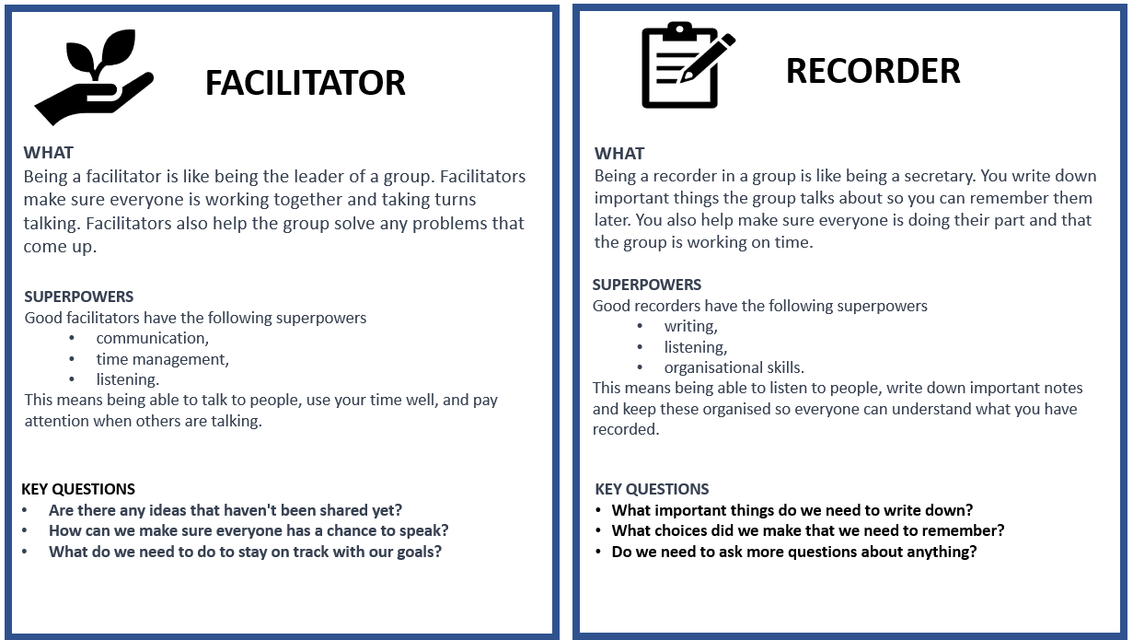
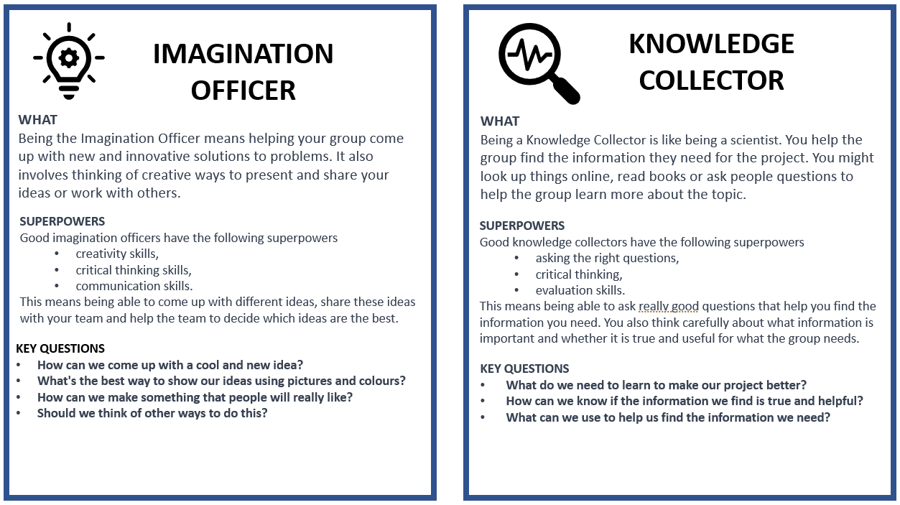

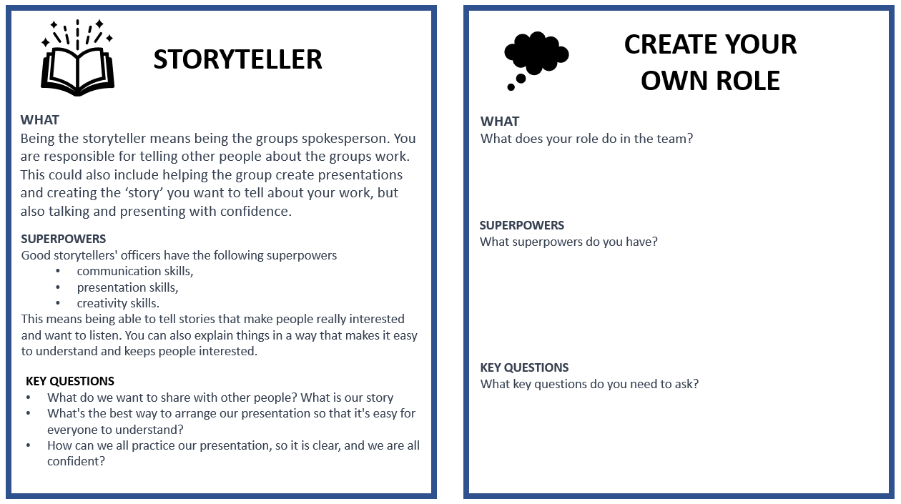

Annexure 7: Teachers as scaffolders of learning

Scaffolding learning is an instructional approach that is essential for Project-based Learning. When you scaffold learning you are providing support and guidance to learners as they engage with new or challenging material. The term "scaffolding" refers to the temporary support structures that construction workers use to help them reach high places while they build a building. In education, scaffolding means providing learners with the support they need to build their understanding of a topic or skill.
Scaffolding learning typically involves several steps.
First you assess the learners' prior knowledge and skills. What do learners already know about the topic and what gaps or misconceptions may need to be addressed.
- Provide support and guidance to help learners engage with the material and build their understanding. This support may take many forms, including modelling, feedback, prompts, and questions.
- As learners become more confident, gradually reduce the scaffolds.

Here are some examples of questions you can use in different circumstances to help scaffold your learners' learning.

Clarifying questions  Ask these types of questions to clarify learner understanding of a topic.  - Can you explain what you mean by that?  - Can you give me an example to illustrate your point? | Prompting questions  Ask these questions to help learners to think more deeply about a topic or idea.  - What other perspectives or points of view could we consider?  - How does this relate or link to what we've learned before?
Elaboration question  Ask these questions to encourage learners to expand on their ideas.  - Can you tell me more about that?  - Why do you think that is the case? | Strategy questions  Ask these questions to help learners develop problem-solving skills and strategies.  - What steps could we take to solve this problem?  - What information do we need to gather to answer this question?
Prediction questions  Ask these questions to help learners anticipate what might happen next.  - What do you think will happen if we try this?  - What do you expect to see when we conduct this experiment? | Clarification questions  Ask these clarification questions to help learners understand complex or abstract concepts.  - What do you think this term means?  - Can you give me an example of how this concept works in real life?
Reflection questions  Ask these questions to help learners to reflect on their learning  - What did you learn today?  - What was challenging about this activity, and how did you overcome those challenges? | Comparing and contrasting questions  Ask these questions to help learners understand similarities and differences between concepts or ideas.  - How is this similar to/different from what we learned before?  - What are the advantages and disadvantages of these two approaches?
Summarising questions  Ask these questions to help learners summarise key points or ideas.  - Can you tell me in your own words what we learned today?  - What are the most important takeaways from this reading? | Thinking questions:  Ask these thinking questions to help learners reflect on their own learning processes and strategies.  - What strategies did you use to approach this task?  - How can you apply what you learned in this assignment to other contexts?

Annexure 8: Learner Self-reflection Tool
Each learner would benefit from thinking back on their experience of the project and answer these reflection questions. This can be done in written form or orally.

Let’s look back and learn: “We don’t learn from experience, we learn from reflecting on experience.” (John Dewey)
Knowledge of road safety
Share five new facts you learnt about road safety.
What is the most interesting new thing that you learnt about road safety?
Planning and building the roadmap and 3D model
What did you love the most about the project?
What did you find the most difficult about the project?
What was the biggest problem you had to overcome when building the road maps and models and how did you solve it?
What advice would you give to other learners who might do this project?
Working in a group
What was the best part of working in your group?
What do you think was the most important thing you did for your group?
What was the biggest problem you had to overcome when working in a group and how did you solve it?
Yourself
What did you do in the project that makes you feel proud of yourself?
The driving question
Can you answer the driving question which is: How can we plan and build a road map and a 3D model of a road vehicle, a bicycle or a pedestrian to teach young learners about road safety?

Annexure 9: Teacher S.P.E.C.I.A.L. Self-reflection Tool

- Which teaching strategies were most effective in engaging the learners attention and promoting understanding? Are there other strategies that could be explored in future lessons?
- How did learners respond to the activities and tasks? Were they actively participating and demonstrating understanding? What adjustments could be made to enhance learner engagement and comprehension?
- Were there any misconceptions or misunderstandings that emerged during the lesson? How were they addressed, and how can they be prevented in future lessons?
- How effectively was feedback provided during the lesson? Were learners given opportunities to reflect on and improve their understanding?
- What opportunities were provided for learners to collaborate, problem-solve, and think critically? Can these opportunities be further developed in future lessons?
- What can be learned from this lesson to inform planning, instruction, and assessment for future lessons?

Prior Knowledge:  - How did I activate and build on the learners' prior knowledge during the lesson?  - Were there any gaps or misconceptions in learners' prior knowledge that needed to be addressed? How were they handled?  - How can I better connect new concepts to learners' existing knowledge in future lessons? | Curiosity:  - How did I encourage learners' curiosity and inquisitiveness during the lesson?  - Were there opportunities for learners to explore and investigate the subject matter on their own or with peers?  - How can I better incorporate inquiry-based learning and curiosity-driven activities in future lessons?
Social Interaction:  - How did I facilitate opportunities for social interaction and collaboration during the lesson?  - Were learners actively engaging with one another and sharing their ideas? How can I further promote this in future lessons?  - What role did peer feedback and discussion play in deepening learners' understanding of the material? | Iteration:  - Were learners provided with opportunities to practice, iterate, and refine their understanding and skills during the lesson?  - How effectively did I offer feedback and guidance to support learners' iterative learning process?  - How can I create more opportunities for practice and iteration in future lessons?
Purpose:  - Were the learning objectives clear and purposeful for the learners? Did they understand the relevance of the lesson to their lives and future learning?  - How did I connect the lesson content to real-world applications or contexts?  - What can I do to make the purpose of future lessons more explicit and meaningful for my students?  Enjoyment:  - How did I incorporate elements of enjoyment and fun into the lesson?  - Were learners actively enjoying the learning process? What can I do to further enhance their enjoyment in future lessons?  - How did the learning environment and classroom atmosphere contribute to learners' enjoyment and motivation? | Active Engagement:  - Were learners actively engaged in the learning process, both cognitively and behaviourally?  - Which activities or strategies were most successful in promoting active engagement and deep learning?  - How can I better design future lessons to foster active engagement and higher-order thinking?  Attention and Engagement:  - Which activities or strategies were most successful in capturing and maintaining learners' attention during the lesson?  - Were there any points during the lesson where learners seemed disengaged or distracted? How can I address these issues in the future?  - How can I modify the lesson to better sustain learners' attention and interest in the subject matter?
Learner Autonomy:
How did I promote learner autonomy and self-directed learning during the lesson?
Were learners given opportunities to make choices and take ownership of their learning?
How can I further support the development of learner autonomy and self-regulation in future lessons?

Find out more.

www.ecubed-dbe.org
https://learn.ecubed-dbe.org/

