PETS: Making pet shelters

Term three, Grade 1, Life Skills Project
Week 7

Playful learning to prepare teachers and learners to thrive in a changing world

CONTENTS PAGE
PROJECT OVERVIEW 3
Preparing for the project 7
The project 8
Lesson 1: What do we know about pets? 8
Lesson 2: We want to learn more about pets. 12
Lesson 3: Grade 1 to the rescue 15
Lesson 4: Giving and receiving feedback. 18
Lesson 5: It’s time to build! 20
The Public Presentation 22
Annexures - useful tools for the project 23
Annexure 1: EXEMPLAR ASSESSMENT RUBRIC 23
Annexure 2: Exemplar Competency (Skills) Observation Checklist 25
Annexure 3: Example letter to parents and caregivers about Project-based Learning 26
Annexure 4: The Project Wall 27
Annexure 5: The Project Route Map 28
Annexure 6: Roles and responsibilities 29
Annexure 7: Teachers as scaffolders of learning 32
Annexure 8: Learner Self-reflection Tool 33
Annexure 9: Teacher S.P.E.C.I.A.L. Self-reflection Tool 34

PLEASE NOTE
This is an exemplar project, but we encourage you to make it your own. Please feel free to adapt it as necessary to ensure it is suitable and relevant to your learners in your classroom. Remember, the ultimate goal of this project is to engage your learners and foster their learning, so don't be afraid to put your own spin on it! The activities and assessments in these lessons are here to guide you on your Project-based Learning journey. Feel free to adapt the activities and assessment to suit your learners needs.

PROJECT OVERVIEW
 | Name of project: Pets: making pet shelters
Subject: Life Skills (Personal and Social Well-being and Visual Arts ) |  | Grade: 1 | Duration: 3 hours
Possible areas for integration with other subjects
Life Skills: Physical Education
Locomotor: Walk forward crossing dominant leg over

Language development
Throughout this project learners will use language intensively and authentically as they:
- interact and communicate with one another,
- ask and answer questions,
- discuss and make plans and decisions,
- read and interpret texts and pictures,
- make informal presentations and listen to presentations critically and
- provide constructive feedback.
Due to the communication-rich nature of the process they go through, many aspects of language are practised and developed.

Mathematics
Mathematics concepts relating to space and shape, quantity and measurement are applied when learners plan and construct their pet shelters.
CAPS content covered.  REMEMBER to always be aware of activities to promote Executive Functioning: Working memory, Inhibitory control and Self-regulation.  Learner talk, discussion, exploration, INQUIRY find-out”, problem solving, thinking and reasoning is of utmost importance. |  | Week 7  Personal and social well-being  SKILLS AND VALUES  - Caring  - Function of animal welfare, work and contact details.  KNOWLEDGE  - Animals we can keep as pets.  - How to look after pets at home.  - Treating animals appropriately.  - Animal welfare.  Creative Arts (Create in 3D)  - Make models of imaginative creatures using clay, playdough or recyclable materials.  - Emphasise appropriate use of material and spatial awareness.  Click here for the 2023/2024 ATPS.
Driving question |  | How can we plan and build a pet shelter to keep a pet warm and safe?
Project summary and objectives |  | For this project, learners respond to a call to action which becomes the driving question. The scenario is as follows: There has been a disaster at the local animal shelter. There was a flood, and all the animal houses were damaged or destroyed. Now all the dogs and cats and donkeys and all the other animals are cold and miserable. The people at the animal shelter have asked for your help.“Can you please help us build new pet shelters so the animals can be safe and warm? Sadly, there is no money, so only recycled materials can be used.”  To help build their pet shelters:  - Learners need to draw on their prior knowledge and integrate new knowledge to respond to the driving question.  - In groups, they use skills such as collaboration, communication, creative and conceptual thinking to:  - Make a democratic decision about what pet shelter they want to build.  - Plan, get feedback and iterate the plan.  - Construct the pet shelter.  - Present their projects at a public presentation.  - Learners are active and have a lot of autonomy in this project making it a rich learning experience. Learners get opportunities to practise a variety of Bloom’s cognitive skills including the higher order skills such as analysis, synthesis and evaluation. Learners are constantly active as they discuss, listen, ask questions, solve problems, apply new knowledge, negotiate conflicts that may arise, plan, iterate, construct, present and most important of all – learn to love learning.
Entrepreneurial way-of- being skills developed in this project |  | Communication | Collaboration
 |  | Critical Thinking | Creative Thinking
Products |  | - A 3D pet shelter  - A model of a pet to live in the shelter (optional)
Public presentation |  | Projects will be presented by groups at a public presentation. Group members can explain knowledge they have learnt about pets, how to care for pets and how they made their pet shelter. The public presentation could be, for example, held at a special event where caregivers and members of the community can join in the celebration. It is important that the projects are presented to a wider audience than just the learners and the teacher in the class.

PROJECT OVERVIEW
Activating the science of learning | This project:  Activates prior knowledge by encouraging all learners to remember (retrieve) what they already know about pets and reflect on how they know what they know i.e. where did they learn this knowledge. This is an important process because linking new knowledge to what is already known improves comprehension of new knowledge and tends to lead to better storage of knowledge in long-term memory.  Focuses learner attention and engagement on the learning as it stimulates their curiosity and imagination by providing them with a purposeful call-to-action i.e., to help build new pet shelters for an animal welfare organisation. (Please note they will only build models of shelters). Throughout the project the learners have a lot of voice and choice and get to make their own decisions about the type of pet shelter they want to build. When learners have this autonomy to follow their own interests or choices, they are often more engaged and attentive, both of which improve long-term retention of information and skills.  Results in ‘sticky learning’ learning that is memorable and lasting as learners need to use their knowledge (old and new) to make decisions and choices that lead to plans for the final project. This application of knowledge and skill to a purposeful call-to-action means learners process information deeply and with enjoyment which in turns shifts knowledge from short-term to long-term memory making it ‘sticky’ and hard to forget.
Lesson summary | Lesson one: | In this lesson, learners will:  - Start the project with an animal movement warm-up activity.  - Collaborate in a group to discuss what they know about pets and choose a presenter to share what the group has discussed with the class.  - The teacher will write down facts on a circle map thus making learners’ knowledge visible.  - Meta-thinking (thinking about thinking) is stimulated as learners need to reflect on how they know what they know.
 | Lesson two: | In this lesson learner will:  - Collaborate in their group to investigate and learn more about one type of pet.  - Present what they have learnt with the class in the form of a role play.
 | Lesson three: | In this lesson, learners will:  - Listen to the call to action.  - Brainstorm what pet shelter they want to build, vote to decide and list (with support) what materials they will need.
 | Lesson four: | In this lesson, learners will:  - Present their ideas to their peers for feedback and iteration.
 | Lesson five: | In this lesson, learners will:  - Apply their planning and use it to guide the building of the pet shelter.
Resources | - DBE Grade 1 Life Skills Rainbow Books pages 10-13  - Any other resources relating to the topic that you already have in stock.  - A range of found and recycled materials  - Pictures of different pet shelters
Entrepreneurship add-on possibilities | As an entrepreneurial activity, learners can create and sell pet toys made from recycled materials to raise funds for building new pet shelters at the local animal shelter.  - Brainstorm ideas for creating pet toys using recycled materials, such as old socks, plastic bottles, and fabric scraps.  - Collect the necessary materials by asking for donations from family, friends, and neighbours.  - Learners wWork together to create fun and safe pet toys, such as sock tug toys, bottle treat dispensers, or fabric catnip toys.  - Set up a stand or table at a local community event, or school to sell the handmade pet toys. Learners can create eye-catching signs to attract customers and explain the cause.  - Keep track of the money raised from the toy sales, and once the project is complete, donate the funds to the local animal shelter to help build new pet shelters using recycled materials.  - This activity not only promotes creativity and teamwork but also teaches the importance of helping others, recycling, and raising funds for a good cause.

Preparing for the project

Preparing learners
- This is a short (but powerful) project so preparation and planning is important. It's recommended that you plan the groups before starting the project so that learners are already sitting together and are starting to get to know each other.
- It’s recommended to explain the overview of the project i.e., that learners are going to help an animal welfare organisation that was damaged by a flood and all the animal shelters have been damaged or destroyed. Learners will be responding to the call to action and coming to the rescue to build new (models of) shelters for all the different types of animals.
- Effective group work is more manageable and more effective when each group member has a role and responsibility. Please see annexure 6 for more detail on the types of roles that are useful for a project.

Preparing the classroom
- Before launching the project, you can create a Project Wall. This is very similar to a theme wall where you display and show resources, pictures, posters and objects about your new theme. The Project Wall takes this a step further in that it shows the driving question, journey of the project (route map found in annexure 5). The Project Wall can begin with a display of what learners already know about the topics and as the project progresses their displays become richer and richer which makes the growth of their learning visible. Keywords can be placed on the wall as can curious questions that learners ask that you want to revisit. As far as possible, get the learners to organise the wall and take ownership of what is displayed - after all it's their project and their learning. To learn more about Project Walls please see annexure 4.

Teacher preparation
- Read the project instructions. Make any changes or updates to the project to suit your learners needs.
- Read Teaching for Learning in a Fast-Changing World. You can download it here: https://www.uj.ac.za/wp-content/uploads/2023/01/teaching-for-learning-in-a-fast-changing-world-e-version.pdf
- Do the Introduction to Project-based Learning course online https://learn.ecubed-dbe.org/courses/introduction-to-project-based-learning/
- Please see the additional notes on Collaborative Learning in Project-based Learning and Thinking Maps Resources for more information on these two topics.

Preparing parents and colleagues
- Inform parents and caregivers about your project. We have created a template that you can adapt, you can find this in annexure 3.
- Tell your colleagues about your project and what to expect e.g., for example there will be lots of group work so your lessons might be a little bit noisier, but this is good, it means learners are engaged and paying attention.

Preparing for the Public Presentation
- The project ends with a Public Presentation where learners get to show off their projects. The date needs to be booked in advance as this is not a lesson. Public Presentations can be done at assembly, as an art exhibition at break, or at an event like a parents evening.

The project
Lesson 1: What do we know about pets? | Resources needed:  Project route map (Annexure 5)  Circle maps |  | Time required:  30 mins
Summary of the Lesson
In this lesson, learners will:
- Start the project with an animal movement warm-up activity.
- Collaborate in a group to discuss what they know about pets and choose a presenter to share what the group has discussed with the class.
- The teacher will write down facts on a circle map thus making their knowledge visible.
- Develop meta-thinking (thinking about thinking) as learners need to reflect on how they know what they know.
Objective
The purpose of this lesson is for learners to:
- Remember what they already know (prior knowledge) about pets.
- Practice collaborating and communicating as they discuss what they know in their group.
- Develop meta-thinking by reflecting on how they know what they know.

The purpose of this lesson is for teachers to:
- Informally evaluate learners’ prior knowledge about the topic and how well they can demonstrate their knowledge either through speaking and/or writing.
- Observe how learners are collaborating and communicating in their groups.
- Observe if learners can recall how/where/from whom they learnt what they know (meta-thinking).

Before the lesson  Draw a circle map on a big piece of paper and display it on the board.  Lesson guidelines- what will learners and teachers do?  - The project route map  - Show learners the Project Route Map so they get a sense of what they can expect. This is also an effective way to role model planning which is a useful skill for all learners to develop. (Please see Annexure 5: The Project Route Map for the Project Route Map.)  - Let's move!  - For some fun, encourage learners to do some body and brain warm-up movements. Take learners outside if possible and ask them to try to move like certain animals. They can:  ‘Walk’ on all fours slowly like tortoises or quickly like cheetahs.  Gallop like horses  Slither like snakes  Hop like rabbits  Swim like fish  Fly like birds  Crawl like crabs  Curl up and sleep like puppies  - Making our learning visible  - Encourage learners to spend a few minutes thinking about their pets and sharing their knowledge and personal experience of pets with group members. You can prompt their thinking with questions such as: “What animals can we NOT keep as pets?”, “How can we keep pets healthy?” and “How should we treat our pets?”  - Learners can select a presenter who calls out what learners shared in their group discussion. Write down what the presenters share in the middle circle of the Circle Map. (Please see annexure 6 for more on group Roles and Responsibilities.)  - As each presenter shares a fact, challenge the presenter and his/her group to answer HOW they know what they know? Fill this information into the rectangle (that surrounds the circle). This is an excellent way to start learners’ thinking about their thinking (meta-thinking).  D. Reflection: Looking back on our learning  - Place the circle map on the Project Wall. During the day/week learners will return to look at it which will stimulate reflection and memory. This is also a simple but effective incidental reading opportunity. |  | How learning happens.  Prior knowledge  Learners’ prior knowledge about the topic of pets is brought to mind and made visible through the circle maps. This helps teachers assess informally how much the learners already know and where the gaps are. This information helps to ensure that new learning connects and builds on what learners already understand.  S.P.E.C.I.A.L.  Learners are socially interactive as they discuss, share and document their current knowledge and experience of pets.  Reflection for meta-thinking  Learners reflect on how they know what they know i.e., where did they learn what they already know? This is an important step towards developing meta-thinking (thinking about thinking).  Reflection for memory  Keeping the circle maps on display gives learners opportunities outside of project time to read and remember and think about pets. This can deepen engagement with the topic and can strengthen learning and long-term memory.  Remember that reflection leads to learning that is ‘sticky’ learning that lasts. So, don’t miss out the reflection activity.
Extended opportunities
- Depending on the learners’ ability, each group could get a circle map and group members can fill it in using words and drawings. Learners can then present their circle maps to the class.
Observations and facilitation - Assessment as Learning
As a teacher you already know that you play an essential role as a facilitator of learning. You know that rather than simply giving knowledge to learners, you create an environment in which your learners can explore, discover, and construct their own understanding of the subject matter. As a facilitator you will
- create an emotionally and psychologically safe learning environment so that learners feel safe to participate in the lesson,
- provide prompts when learners get stuck,
- provide constructive and timely feedback to learners,
- and make adjustments to your lesson based on what you observe (this is assessment as learning) so that learners can grow their understanding and grow their skills and competencies.

While learners are working on their tasks throughout this project your role as a facilitator is to observe, listen, and record the process of learning during the lesson. These observations are the foundation for the assessment of this project, so make a few notes, these will help you when you do the final assessment.
The first lesson focuses on establishing what learners already know about the topic (prior knowledge). While learners are communicating in their groups, it’s important to actively observe and listen to what they are saying and how they are interacting with their peers. As you walk around the classroom, keep an eye out for the following indicators of learning:

Learner knowledge
This is a crucial aspect to observe as learners' understanding of key concepts relating to the topic. You can assess this by observing if learners can describe or explain key words and concepts about pets. Prompting questions can be:

- “Have you ever had a pet?”
- “Who do you know who has a pet?”
- “Can we keep a lion as a pet, if not why not?”
- “Do you think a pet needs clean water and food?”

These prompts work as informal, continuous assessment and can help you gauge learners’ baseline comprehension of the topic. Re-asking these types of questions throughout the project will help monitor their progress.

For more ideas on prompts and scaffolding questions please see Annexure 7.

Teacher self-reflections
After every lesson it is important to reflect on how the lesson went so that you can make adjustments to the lesson or project. Check out annexure 9 for a whole range of different questions you could use to reflect on for this lesson. Note you do not need to reflect on all the questions, just select 1 or 2 that resonate with you. Your own self- reflection is important for a number of reasons: it is a crucial aspect of teacher professional development and enables you to learn from experience, grow as a teacher and continually improve your instructional effectiveness so that you can better support learners’ learning.

Lesson 2: We want to learn more about pets. | Resources needed:  DBE Grade 2 Life Skills Rainbow Books pages 10-13  Any other resources relating to the topic |  | Time required:  30 mins
Summary of the Lesson
In this lesson, learners will:
- Collaborate in their group to investigate and learn more about one type of pet.
- Present what they have learnt with the class.
Objective
The purpose of this lesson is for learners to:
- Review and recall what they did in Lesson 1 so they can connect what they already know to new knowledge accessed in Lesson 2.
- Research new information about their specific topic.
- Present their findings to the class and ‘teach’ their classmates more about their topic.

The purpose of this lesson is for teachers to:
- Check how well learners recall information and activities from Lesson 1.
- Listen to the level of language used by learners to discuss their topic.
- Monitor collaboration and interaction in the group.
- Evaluate how clearly and effectively learners communicate new knowledge they learnt with the class.

Before the lesson  Learners will be adding to their knowledge of pets they discussed in lesson 1. The DBE workbooks have some extra knowledge but please add any other resources that will be useful to enrich learners’ knowledge.  Lesson guidelines- what will learners and teachers do?  - Reviewing  - Ask volunteers to explain what has been done/learnt so far in the project. They can use the Project Route Map to show progress. This will also help learners reflect on what they have learnt and what they have. This tends to consolidate learning and is a good strategy for shifting new knowledge into long-term memory.  - Looking, learning and sharing  - Refer learners to their DBE Life Skills grade 1, book 2, terms 3,4: pages 10 -13.  - Allocate each group 1 of the pets in the picture. If snakes and chameleons are more unusual then add in (or let learned choose) more common animals that are kept as pets.  - In their groups, learners need to share what they know about the care of that pet including aspects of pet care such as food, water, exercise, grooming, shelter, training, how to keep them safe and where to get help if they get sick or hurt.  - Presenting and teaching  - After the group discussions, one group member can feedback what was learnt in the group. If time is short, let them share two aspects of pet care.  - During the feedback you will see where there are knowledge gaps which is the perfect time to bring in new information about caring for pets.  - Conclusion and reflection  - Return to the circle map and ask learners what new knowledge they would like to add to the map. Anything new must be added in a different colour so learners can see how much more they have learnt. In this way they can see their knowledge expanding which is highly motivating. |  | How learning happens.  S.P.E.C.I.A.L.  Learners are socially interactive. They are also active as they must take on responsibility for their own and other’s learning and understanding. Learners have autonomy as they can choose how they want to present what they have learnt.  Reflection  The conclusion and reflection are a good way for learners to link prior knowledge to new knowledge which deepens comprehension and strengthens memory. Seeing knowledge grow is also highly motivating.  Remember that reflection leads to learning that is ‘sticky’ learning that lasts. So, don’t miss out the reflection activity.
Extended opportunities
- To boost the creativity element, challenge learners to present their information in different ways such as in a role play or interview where they act the parts of for e.g., pet owners and pets.
- Videoing their roleplays is a fun way to motivate learners and it gives you the opportunity to go back and watch what learners were doing. This is a rich source for observation and assessment.
- Take the learning home by encouraging learners to ask their parents/caregivers what they know about caring pets including the specific pet the learner explored in class.
Observations and facilitation - Assessment as learning
As they research, learn and present their new information, it's important to actively observe and listen to learners as they work together in groups. As you walk around the classroom, keep an eye out for several key indicators of learning, communication, and knowledge of the topic. These are just some examples of things to observe - you might have your own list of observations to use.

Learner communication skills
- Observe learners' active listening skills to determine if they are fully engaging with their peers during the group discussion process. Are they focused and attentive, or are they distracted or disengaged?
- Additionally, pay attention to their articulation skills. Are they speaking clearly and confidently, or are they mumbling or speaking too fast, or speaking too loudly or softly?

If learners are struggling with any aspect of their communication skills, there are several strategies you can use to support them.
- One option is to model active listening yourself, showing the kinds of behaviours you expect from learners.
- You can also take the time to explain the guidelines for active listening or the interview process again, ensuring that all learners understand the expectations.
- It can be helpful to share and discuss the definitions of good communication. The Teacher's Guide to Competencies is an excellent resource for this purpose, providing information and guidance on the development of communication skills.

Remember, communication skills take time to develop, and learners will have many opportunities to practise and grow their abilities throughout the project. By actively observing and facilitating their progress, you can help them build important skills that will serve them well in the future.

Suggestions for facilitation and scaffolding
Although learners are responsible for their own and other’s learning, they still need you! It is essential to constantly facilitate and scaffold the quality of their learning. As a facilitator of learning you need to listen to WHAT learners are talking about so you can monitor if they are learning and to stop any incorrect learning immediately. Constant check-ins and questions of group members is invaluable for this.

Facilitation and scaffolding questions relating to caring for pets could be:
“Should you give your pets a cold drink?”
“Do goats and dogs eat the same food?”
“Cats don't feel pain: True or false?”
“Can fish live in any type of water?”
“How often should a pet rabbit be fed?”
“What would you do if you saw someone kicking a dog?”
“ What would you do if your pet got sick?”

For more ideas on prompts and scaffolding questions please see Annexure 7.

Lesson 3: Grade 1 to the rescue | Resources needed:  Scrap paper to make lists |  | Time required:  30 mins
Summary of the Lesson
In this lesson, learners will:
- Listen to the call to action.
- Brainstorm what pet shelter they want to build, vote to decide and list (with support) what materials they will need.
Objective
The purpose of this lesson is for learners to:
- Collaborate and use critical and creative thinking and prior and new knowledge to make decisions and rough plans.
- Present their plans for feedback.
- Evaluate other groups’ plans and give feedback.
- Iterate plans.

The purpose of this lesson is for teachers to:
- Observe how learners manage decision-making in the group.
- Observe, or if needs be, teach how to give and receive feedback.

Before the lesson  No preparation necessary.  Lesson guidelines- what will learners and teachers do?  - Reviewing  - Ask volunteers to explain what has been done/learnt so far in the project. They can use the project route map to show progress. You can ask a few learners to share what they told their parents/caregivers about the project i.e., share what they did for homework.  - A call to action  - Share an imaginary scenario with learners. For example, you can say:  There has been a disaster at the local animal shelter. There was a flood, and all the animal houses were damaged or destroyed. Now all the dogs and cats and donkeys and all the other animals are cold and miserable.  The people at the animal shelter have asked for your help. “Can you please help us build new pet shelters so the animals can be safe and warm? Sadly, there is no money, so only recycled materials can be used.”  Please note: It's recommended that you share assessment rubric with learners at this stage so they know what is expected of them during the Public presentation. An exemplar rubric can be found in annexure 1.  - Brainstorming and planning how to help  - In their group learners need to decide what pet shelter they want to build. They can do this with a ‘hands-up’ vote. If learners struggle, then allocate each group a pet.  - Then learners brainstorm how they can build a shelter for the pet, what shape it could be, what colours to use and what materials it will be made of.  - Where possible, learners need to try and make a list of sorts – they could do little drawings and/or write simple words.  - Conclude  - Learners need to agree to the first draft of the planning. One group member needs to read/repeat what the group has decided on (This is like checking the minutes of a meeting). This gives learners a bit of time to reflect and do a ‘mental check’ to see if anything has been left out and if the plan makes sense.  - Reflection  - Encourage each learner to explain what they are doing for the project to a family member or friend outside of school. Rethinking, remembering and repeating what you have learnt and done really deepens learning. So, when a parent asks, “What did you do at school today?” the child can give a substantial answer. |  | How learning happens.  S.P.E.C.I.A.L.  This lesson is highly learner centred. Learners have autonomy as they can decide what pet shelter to build and plan how to build it.  Competencies  Making their own decisions offers learners the opportunity to practise communication and collaboration skills.
Extended opportunities
- Learners can also make models of the pet that lives in their pet shelter.
- A visit and talk from an animal welfare officer can be organised or a visit to a pet shelter if there is one in your area. This provides a great opportunity for learners to ask questions and learn more about pet care in an authentic way.
- This person/people can also be invited to the public presentation.
Observations and facilitation - Assessment as Learning
During this brainstorming, it's important to actively observe and listen to learners as they work together in groups. As you walk around the classroom, keep an eye out for several key indicators of learning, including creative innovation, collaboration skills, communication, and critical thinking skills. Here are some suggestions of what you could observe:

  - Creative innovation: Observe learners’ range and type of ideas while they brainstorm and plan. Are they thinking out of the box, are the ideas unique and interesting or are they struggling to think creatively? If learners are struggling, prompt them by asking, “Have you ever thought of…”, “Imagine if…”, “What if…”
  - Learner communication: how clear was the learner communication? Were they able to express their ideas clearly? For example, when did group members express their thoughts and ideas clearly when deciding on what pet shelter to build and how to build it? You can scaffold and prompt by asking: “Did everyone in the group have a say in the decision?”, “Can you explain what you will use to build your pet shelter?” “Why did you choose to build a…”

For more ideas on prompts and scaffolding questions please see Annexure 7.

Lesson 4: Giving and receiving feedback. | Resources needed:  Feedback checklists |  | Time required:  30 mins
Summary of the Lesson
Based on the brainstorming and rough planning done in lesson three, the group will present their ideas to their peers for feedback and iteration.
Objective
The purpose of this lesson is for learners to:
- Think critically and offer constructive feedback about other learners’ pet shelter plans.
- Listen to and evaluate feedback received and decide what to iterate and improve.

The purpose of this lesson is for teachers to:
- Observe learners' critical thinking as they evaluate one another’s plans.
- Observe the level of respect characterising the feedback interactions.
- Listen to learners’ discussions and reasoning when they are deciding what to iterate.

Before the lesson  Prepare feedback checklists.  Lesson guidelines- what will learners and teachers do?  - Reviewing  - Ask volunteers to explain what has been done/learnt so far in the project. They can use the project route map to show progress.  B. Using the checklist  - Explain to learners that they will take turns to pretend to be the animal welfare officers at the shelter who will use a checklist to check that the shelters planned are safe and warm and are suitable for the pets.  - Show learners the checklist. Read it and explain how it works.  C. Giving and receiving feedback  - Each group gets a turn to present/explain their ideas and plans for the pet shelter. The rest of the class, ‘the animal welfare officers’ use the checklist to guide their evaluation of the plans.  Animal welfare pet shelter checklist  Does the plan make sense or is it confusing?  Are they using only found and recycled materials?  Has the group explained how the shelter will be built?  Will the shelter hold together or fall apart?  Does the shelter seem safe for a pet to live in?  D.. Reflections  - Groups can reflect on and evaluate the feedback. Plans can be improved through iteration. |  | How learning happens.  S.P.E.C.I.A.L.  Learners are socially interactive. They are also active as they evaluate and provide constructive feedback to their peers.  Learners’ autonomy is evident as learners make choices about what to iterate.  Iteration is an important part of this lesson as learners must reflect on and think critically about the value of the feedback they receive and how they will use it.  Remember that reflection leads to learning that is ‘sticky’ learning that lasts. So, don’t miss out the reflection activity.
Extended opportunities
- More feedback is always useful so if each group can get feedback from more than one other group – or other people including staff or family members.
Observations and facilitation - Assessment as Learning
During this evaluation and feedback activity, it's important to actively observe and listen to learners as they evaluate each other’s shelter plans. As you walk around the classroom, keep an eye out for several key indicators of learning, including creative innovation, collaboration skills, communication, and critical thinking skills. Here are some suggestions of what you could observe:

- Giving feedback: Observe learners as they give feedback to their peers. Take note of the quality of their feedback, including whether it is specific, actionable, and relevant and shows respect and kindness. If learners get stuck, you could prompt them by saying “Can you give your peer a clear suggestion on how to improve their idea?
- Receiving feedback: Observe learners as they receive feedback from their peers. Take note of their reactions and whether they are open to receiving feedback. Prompt: "How did you feel when your peer gave you feedback on your idea? Was it helpful?"

Lesson 5: It’s time to build! | Resources needed:  Found and recycled materials  Art supplies  Coloured crayons  Glue |  | Time required:  40 mins
Summary of the Lesson
Based on the final plans, learners will start to apply their planning and use it to guide the building of the pet shelter (and the pet if they are making one).

Objective
The purpose of this lesson is for learners to:
- Build their pet shelter based on the and plans they collaborated on through the previous lessons.

The purpose of this lesson is for teachers to:
- Observe if learners are collaborating and sharing responsibility for the construction and completion of the pet shelter.
Before the lesson  Make sure building materials and resources that learners may need are available.  Lesson guidelines- what will learners and teachers do?  - Reviewing  - Ask learners to explain what has been done/learnt so far in the project. They can use the project route map to show progress. This is the final step before the public presentation, so take some time and listen to learners’ experience of the project so far. This is a recall opportunity. It’s important that no learning gets “left behind” and forgotten in the past.  - Set up and start  - In their groups learners set up their workspace, gather their materials and resources and start building their shelter. It is recommended that learners complete this in class as observing the process is an invaluable source of information for you.  C. Next steps  - Depending on how close the public presentation date is, learners can take time to do final tweaks to their products.  - Learners will then present and explain their projects (See rubric)  - During the presentation they will be assessed using the rubric.  - Once the presentation is over, it’s essential to do the last step which is the learner's self-reflection tool. (See annexure 8.) |  | How learning happens.  S.P.E.C.I.A.L.  This lesson incorporates all the principles of S.P.E.C.I.A.L. as learners work together to make and build their products.  Competencies  This lesson offers opportunities for learners to practise their collaboration, communication, creative and critical thinking.  Reflection  The self-reflection sheet is an essential part of this project and is where most of the learning – including knowledge and skills is consolidated and moves to long-term memory.  Remember that reflection leads to learning that is ‘sticky’ learning that lasts. So, don’t miss out the reflection activity.
Observations and facilitation - Assessment as Learning

During this activity, it's important to actively observe and listen to learners as they work together in groups to build their shelters. As you walk around the classroom, keep an eye out for several key indicators of learning, including creative innovation, collaboration skills, communication, and critical thinking skills. Here are some suggestions of what you could observe:

  - Collaboration: Observe how the learners are fulfilling their roles and responsibilities. Are the groups functioning productively? Are they managing their own conflict and unexpected problems? Step in if it is clear they cannot solve the problem alone, but still try to scaffold their problem-solving skills with prompts such as, “Can you explain the problem here?”, “What help do you think you need?”, “What have you already done to manage the problem?”

  - Knowledge: While learners are busy making and building, walk around and ask individual learners questions about their product such as, “Tell me more about the pet that will live in your shelter.” Or “Why do you think animals need shelters?”

For more ideas on prompts and scaffolding questions please see Annexure 7.

The Public Presentation | Resources needed:  - The completed projects and whatever is needed to display them effectively.
Summary of the lesson
At the end of the project, learners have the opportunity to present their work i.e., pet shelters to a wider public. The purpose of a public presentation is to provide learners with an authentic audience to share their learning and achievements, and to receive feedback and recognition for their hard work and to celebrate all that they have achieved. It also allows learners to practise important skills such as public speaking, communication, and presentation design.
Objective
The purpose of the public presentation is for learners to:
- Applying: Learners apply the knowledge gathered throughout the project to share their learnings and products.
communication, critical thinking, collaboration, creative innovation and meta-learning as they work collaboratively to implement their plans for the public presentation.
End of project reflections  - Once the event is over, make sure there is time to debrief the experience with the learners.  - Ask learners to complete the Learner Self-reflection Table (see annexure 8). You can decide what method to use to complete the reflection e.g., independently, in a group, in pairs. | How learning happens.  As learners work collaboratively (social interaction) to implement their ideas for their public presentation they are actively engaged in the learning process (hands-on and minds on) which increases attention and engagement, which as we know leads to better learning outcomes.  This experiential approach (designing, making and presenting pet shelters) can create more vivid and lasting memories because it engages multiple senses and emotions, e.g., learners are not only sitting and listening - they are doing.  A public presentation is a nice place to observe the E - Enjoyment in S.P.E.C.I.A.L. Throughout the project learners would have had to persevere through challenges, they would have felt frustrations, they would have had to be resilient in overcoming challenges. The E for Enjoyment speaks to the joy that you feel once you have overcome your challenges.  Learners are actively making meaningful connections between their prior knowledge and new practical learning experiences as they deal with problems and find solutions, give and receive feedback, present their ideas and so on.  All of this leads to ‘sticky’ learning, learning that is memorable, lasting, and relevant to the learners.

Annexures - useful tools for the project

Annexure 1: EXEMPLAR ASSESSMENT RUBRIC
This is an exemplar assessment rubric. Please adapt to your objectives.
GRADE ONE ASSESSMENT RUBRIC
Pets: building pet shelters
CRITERIA  What we are assessing | 5  Mastering | 4  Advancing | 3  Developing | 2  Learning | 1  Starting | Insert your marks here
Life Skills/Visual Arts
Activity: Makes models out of clay, playdough and recycled materials that resemble features of the real object.
5 marks
The pet shelter would serve its purpose to keep a pet warm and safe.  The model closely resembles a real pet shelter.  The model is well constructed and strong, and the dimensions are in proportion. | The model achieves its purpose very well. It is sturdy and strong. The pieces are securely joined. The proportions are excellent and the model closely resembles the real object indicating learners paid attention to details. If a real shelter was built according to the model a pet would be very warm and safe. This model has benefitted from excellent planning, communication and collaboration in the group. | The model achieves its purpose and would keep a pet safe and warm. It is well built. The parts are mostly in proportion and it comes quite close to resembling the real object. Overall this is a good project but needed a bit more creative innovation. | The model is adequate in achieving its purpose although there is room for improvement in terms of comfort and safety. Proportions are reasonable but the parts are not securely joined and it is not strong. Another iteration would have taken it to the next level. | The model would have been improved with better planning and more iteration. Although an effort was made to design a life-like model, it is out of proportion and poorly constructed. | The model does not achieve its purpose. It is incomplete or poorly made. Looks rushed with minimal planning and no iteration. A pet would not be safe or warm.
Learners have made creative use of resources available to them. | The group has been very creative with its choices of materials and how it has used them. For e.g., It has created patterns on cardboard to make it look like wood. The group also added extras like water bowls/blankets.  A lot of care has been taken with the model and clearly learners have worked with a great sense of pride, purpose and enjoyment. | A good range of materials has been used appropriately and learners have had some creative ideas around the construction and how to join the different parts. The project is well presented and looks appealing. More creative innovation would have taken this project to the next level. | Some appropriate choices of materials are evident, however learners could have done more to source a wider range of materials and used them more creatively. Learners have not been innovative around how to join the different parts and have relied, for example, only on glue which may have led to the construction not being that strong | Learners appeared to have struggled to find different materials that are appropriate for their pet shelters. This may have been due to poor planning and learners not fulfilling their roles and responsibilities. Due to this the shelters lack creativity and innovative thinking. | Learners used only one or two materials making this pet shelter unimaginative. Learners did not demonstrate much creativity when sourcing or using recycled materials and found objects for this project.
 |  |  |  |  | Mark out of 10/2

Annexure 2: Exemplar Competency (Skills) Observation Checklist
How did the project help learners to grow their skills | Yes | No
Critical Thinking: is about asking questions to understand the world, it is also about trying to make sense of information, evaluating it and connecting it to other pieces of information.
- Did the learners grow their critical thinking through the project?
- Was there a difference from the start to the end of the project in the learners’ critical thinking skills?
- Did the learners ask questions?
- Did the learners find the relevant and appropriate information, evaluate, and analyse it and apply it to solve a problem?
- Did you notice a change in learners’ critical thinking skills?

COMMENTS: What did you notice

Creative Innovation: is the ability to come up with many different ideas and apply them to find realistic solutions to problems.
- Did the learners grow their creative innovation through the project?
- Was there a difference from the start to the end of the project in the learners’ critical thinking skills?
- Did the learners generate ideas and seek solutions?
- Did the learners transfer their knowledge of and experience about kindness to find solutions?
- Did you notice a change in learners’ creative innovation skills?

COMMENTS: What did you notice

Collaboration: when people work with each other to complete a task. It involves cooperation and teamwork and the sharing of ideas, knowledge, and skills to reach the same goal.
- Did the learners grow their ability to collaborate through the project?
- Was there a difference from the start to the end of the project in the learners’ collaboration?
- Did the learners show an ability to compromise, be considerate of each other, and be positive in a conflict situation?
- Did the learners leverage each other’s strengths? (Pool their collective resources in terms of strengths and knowledge)
- Were the learners willing to listen, empathise, and give and receive useful feedback to the team?
- Did you notice a change in learners' creative innovation skills?
COMMENTS: What did you notice
Communication: is all about sharing information, it is about what we say (verbal communication) and how we say it (non verbal communication).
- Did learners grow their ability to understand non-verbal cues such as tone of voice, body language through the project?
- Was there a different from the start to the end of the project in how learners spoke (articulation) e.g. did they stop mumbling, talked at the right speed, used the right tone etc.
- Did you notice a change in learners ability to try and understand things from other peoples perspective e.g. their empathy skills?
COMMENTS: What did you notice

Annexure 3: Example letter to parents and caregivers about Project-based Learning
This is just an example. Feel free to edit and adapt it to your needs.

Dear Parents and Caregivers,

We hope this letter finds you well. We want to share with you an exciting project that your child will be working on in school called "Celebrating our Rainbow Nation". This is a Project-based Learning project. You may have already heard a lot about Project-based Learning, but if not, Project-based Learning is a teaching method where learners learn by actively engaging in real-world and meaningful projects. Through this method, learners are given the opportunity to collaborate with their peers, conduct research, and apply their knowledge and skills to solve real-life problems.

There are many benefits to Project-based Learning. This method encourages creativity, critical thinking, and problem-solving skills. Learners also learn to communicate effectively, both with their peers and the community, and build personal connections with the subject content (CAPS), leading to deeper and more memorable learning experiences.

We are excited to inform you about our current project, "Celebrating our Rainbow Nation" where learners will be working collaboratively to plan and organise a special event that celebrates the diverse cultures and cuisines in South Africa on Heritage Day. Throughout the project, learners will be expected to communicate effectively and draw on their knowledge of different South African cultures and cuisines. Learners will be encouraged to use various thinking tools, to order, analyse, and evaluate information (data), as well as plan and sequence the necessary tasks to organise their event. In order for the project to be successful, learners will need to find ways to work collaboratively, communicate effectively, and share their knowledge with others. There are lots of ways you can support your child in their Project-based Learning journey that will not cost you anything. You can
Encourage your child to ask questions and take ownership of their learning. This can help them develop critical thinking skills and become more engaged in the project.
- Help your child find resources and materials related to the project topic. This can include books, articles, websites, or even just your own knowledge about the topic.
- Ask your child about their project and listen to their ideas. Show interest and enthusiasm for what they are learning and offer positive feedback to encourage their progress.
- Help your child manage their time effectively by helping them to create a schedule or calendar with deadlines and milestones for the project.
- Attend any events or presentations related to the project and show support for your child and their classmates as they showcase their work.

We believe this project will promote attention and engagement among our learners, as they decide which foods, clothing, songs, and dances they wish to showcase at their event. We encourage you to support your child throughout this project and attend the event on Heritage Day to celebrate the country's cultural heritage.

Thank you for your ongoing support of our learners' education.

Sincerely,

[Your Name]

…………………………………………………………………………………………………………………………………………………………………………………………………………………………………………………………………………………………………………
This is to confirm that I __________________________________ parent/guardian of ___________________________________ have read this letter and I understand what the project is all about.

Annexure 4: The Project Wall

How to create your own Project Wall

Have you heard of a Project Wall? Or maybe you already have lots of Project Walls in your classroom. It's a physical space used in project-based learning to visually display the progress and development of a project. It's a central location where everyone can see and contribute to the organisation of ideas related to the project. If you're looking to create your own project wall, here are some ideas of what to include:

- The driving question
- The project goals
- Assessment rubrics
- Tools that learners might use, like templates of thinking maps
- The steps of the project
- Reflection tools
- Pictures
- Examples of learners' work
- Questions that learners have

The Project Wall should be an evolving space that changes and grows as the project progresses, with new insights and ideas constantly being generated.

So, how does a Project Wall support learning? Here are a few ways:

- It provides a space for learners to engage with the project material and reflect on their progress.
- It makes learning visible, so learners know what they need to learn, how to learn it, and how to evaluate their own progress.
- It's a place to practise collaborative learning, as learners can decide together what to put on the wall.

Remember, a project wall is a great tool to help you organise and visualise your ideas, keep track of your progress, and learn collaboratively with your team.

Annexure 5: The Project Route Map

This is a project route map that learners can follow to help them understand the process of the project and where they are in the project. You can recreate this for the Project Wall. At the beginning of each lesson, ask some volunteers to review the lessons that have been covered and recall what they did and what they learnt.

About this project: Making pet shelters

Part | What am I doing? | Status Tick this box after each lesson is completed.
1 | Discover what you already know about pets and help the teacher fill in a circle map. (Lesson 1)
2 | Together with my group, learn more about different pets and ‘teach’ this to our classmates. (Lesson 2)
3 | Answer the call to action and plan how we can help pets by building beautiful pet shelters. But first, we need to brainstorm our ideas. (lesson 3)
4 | Get feedback from our friends who can help us improve our pet shelter ideas. (Lesson 4)
5 | Build our beautiful pet shelter (Lesson 5)
6 | Show off our amazing projects at a public presentation.

Annexure 6: Roles and responsibilities
Here are some examples of roles and responsibilities. Print a copy for each group and place one copy on the project wall.
Instructions: Choose a role that you would like to practise. Do not worry if you do not have the skills yet for the role, this is a great opportunity to practise different skills. By the end of the project, make sure you have tried more than one role so that you can practise and grow your skills.
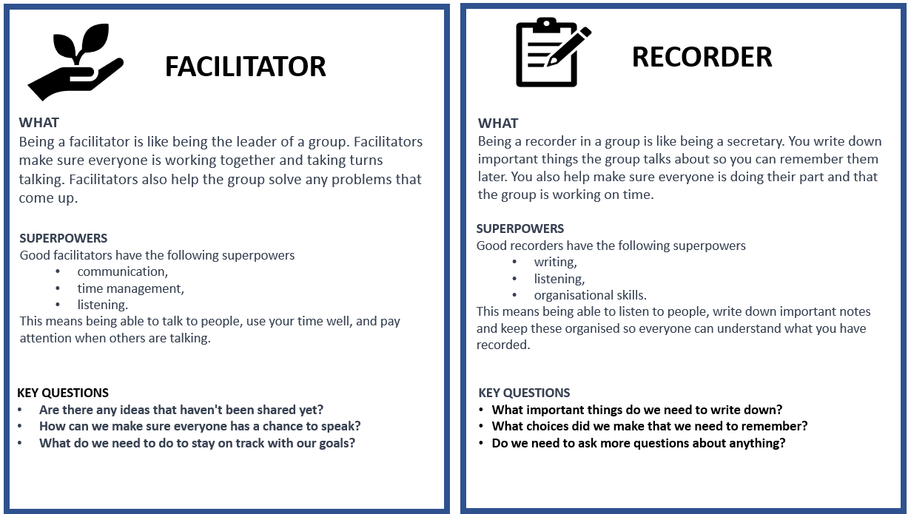
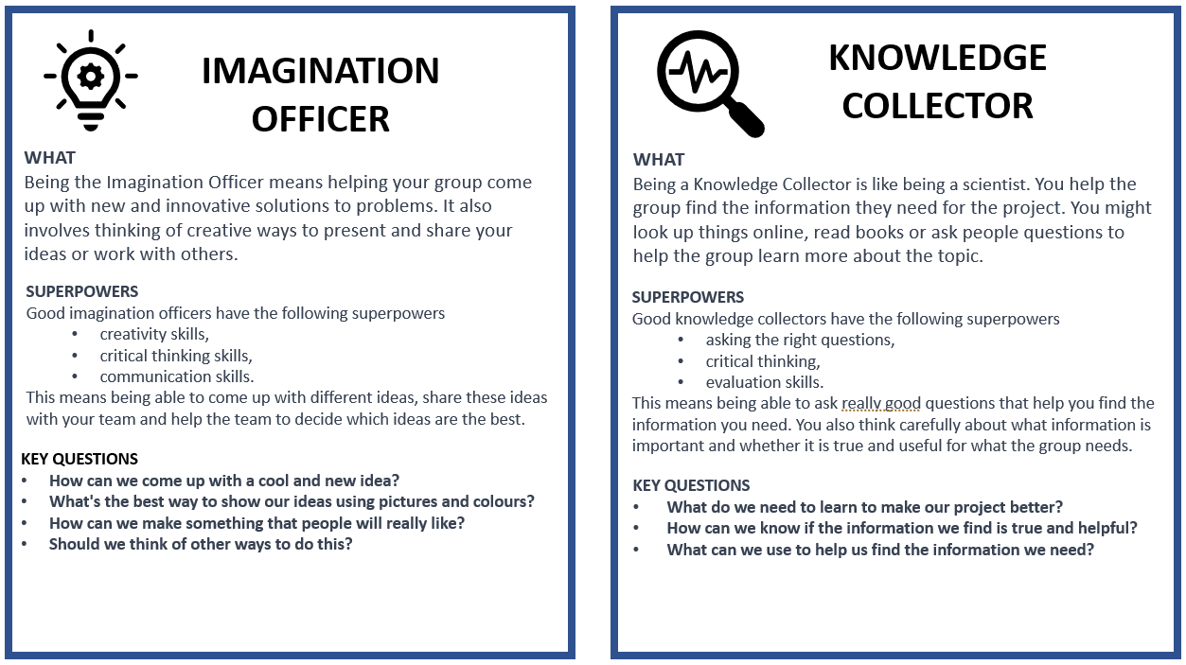

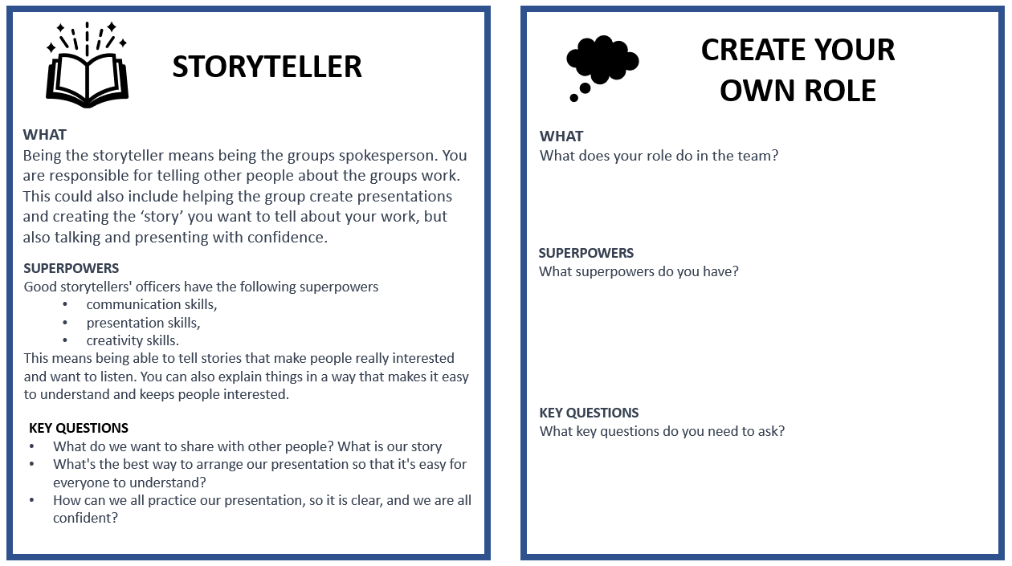

Annexure 7: Teachers as scaffolders of learning
Scaffolding learning is an instructional approach that is essential for Project-based Learning. When you scaffold learning you are providing support and guidance to learners as they engage with new or challenging material. The term "scaffolding" refers to the temporary support structures that construction workers use to help them reach high places while they build a building. In education, scaffolding means providing learners with the support they need to build their understanding of a topic or skill.
Scaffolding learning typically involves several steps.
First you assess the learners' prior knowledge and skills. What do learners already know about the topic and what gaps or misconceptions may need to be addressed.
- Provide support and guidance to help learners engage with the material and build their understanding. This support may take many forms, including modelling, feedback, prompts, and questions.
- As learners become more confident, gradually reduce the scaffolds.
Here are some examples of questions you can use in different circumstances to help scaffold your learners' learning.
Clarifying questions  Ask these types of questions to clarify learner understanding of a topic.  - Can you explain what you mean by that?  - Can you give me an example to illustrate your point? | Prompting questions  Ask these questions to help learners to think more deeply about a topic or idea.  - What other perspectives or points of view could we consider?  - How does this relate or link to what we've learned before?
Elaboration question  Ask these questions to encourage learners to expand on their ideas.  - Can you tell me more about that?  - Why do you think that is the case? | Strategy questions  Ask these questions to help learners develop problem-solving skills and strategies.  - What steps could we take to solve this problem?  - What information do we need to gather to answer this question?
Prediction questions  Ask these questions to help learners anticipate what might happen next.  - What do you think will happen if we try this?  - What do you expect to see when we conduct this experiment? | Clarification questions  Ask these clarification questions to help learners understand complex or abstract concepts.  - What do you think this term means?  - Can you give me an example of how this concept works in real life?
Reflection questions  Ask these questions to help learners to reflect on their learning  - What did you learn today?  - What was challenging about this activity, and how did you overcome those challenges? | Comparing and contrasting questions  Ask these questions to help learners understand similarities and differences between concepts or ideas.  - How is this similar to/different from what we learned before?  - What are the advantages and disadvantages of these two approaches?
Summarising questions  Ask these questions to help learners summarise key points or ideas.  - Can you tell me in your own words what we learned today?  - What are the most important takeaways from this reading? | Thinking questions:  Ask these thinking questions to help learners reflect on their own learning processes and strategies.  - What strategies did you use to approach this task?  - How can you apply what you learned in this assignment to other contexts?

Annexure 8: Learner Self-reflection Tool

Each learner would benefit from thinking back on their experience of the project and answer these reflection questions. This can be done in written form or orally.
Let’s look back and learn: “We don’t learn from experience, we learn from reflecting on experience.” (John Dewey)
Knowledge of pets and pet care
Share five new facts you learnt about pets.
What is the most interesting new thing that you learnt about caring for a pet ?
Planning and building the pet shelters
What did you love the most about the project?
What did you find the most difficult about the project?
What was the biggest problem you had to overcome when building the pet shelters and how did you solve it?
What advice would you give to other learners who might do this project?
Working in a group
What was the best part of working in your group?
What do you think was the most important thing you did for your group?
What was the biggest problem you had to overcome when working in a group and how did you solve it?
Yourself
What did you do in the project that makes you feel proud of yourself?
The driving question
Can you answer the driving question which is: How can we plan and build a pet shelter to keep a pet warm and safe?

Annexure 9: Teacher S.P.E.C.I.A.L. Self-reflection Tool

- Which teaching strategies were most effective in engaging the learners attention and promoting understanding? Are there other strategies that could be explored in future lessons?
- How did learners respond to the activities and tasks? Were they actively participating and demonstrating understanding? What adjustments could be made to enhance learner engagement and comprehension?
- Were there any misconceptions or misunderstandings that emerged during the lesson? How were they addressed, and how can they be prevented in future lessons?
- How effectively was feedback provided during the lesson? Were learners given opportunities to reflect on and improve their understanding?
- What opportunities were provided for learners to collaborate, problem-solve, and think critically? Can these opportunities be further developed in future lessons?
- What can be learned from this lesson to inform planning, instruction, and assessment for future lessons?

Prior Knowledge:  - How did I activate and build on the learners' prior knowledge during the lesson?  - Were there any gaps or misconceptions in learners' prior knowledge that needed to be addressed? How were they handled?  - How can I better connect new concepts to learners' existing knowledge in future lessons? | Curiosity:  - How did I encourage learners' curiosity and inquisitiveness during the lesson?  - Were there opportunities for learners to explore and investigate the subject matter on their own or with peers?  - How can I better incorporate inquiry-based learning and curiosity-driven activities in future lessons?
Social Interaction:  - How did I facilitate opportunities for social interaction and collaboration during the lesson?  - Were learners actively engaging with one another and sharing their ideas? How can I further promote this in future lessons?  - What role did peer feedback and discussion play in deepening learners' understanding of the material? | Iteration:  - Were learners provided with opportunities to practice, iterate, and refine their understanding and skills during the lesson?  - How effectively did I offer feedback and guidance to support learners' iterative learning process?  - How can I create more opportunities for practice and iteration in future lessons?
Purpose:  - Were the learning objectives clear and purposeful for the learners? Did they understand the relevance of the lesson to their lives and future learning?  - How did I connect the lesson content to real-world applications or contexts?  - What can I do to make the purpose of future lessons more explicit and meaningful for my students?  Enjoyment:  - How did I incorporate elements of enjoyment and fun into the lesson?  - Were learners actively enjoying the learning process? What can I do to further enhance their enjoyment in future lessons?  - How did the learning environment and classroom atmosphere contribute to learners' enjoyment and motivation? | Active Engagement:  - Were learners actively engaged in the learning process, both cognitively and behaviourally?  - Which activities or strategies were most successful in promoting active engagement and deep learning?  - How can I better design future lessons to foster active engagement and higher-order thinking?  Attention and Engagement:  - Which activities or strategies were most successful in capturing and maintaining learners' attention during the lesson?  - Were there any points during the lesson where learners seemed disengaged or distracted? How can I address these issues in the future?  - How can I modify the lesson to better sustain learners' attention and interest in the subject matter?
Learner Autonomy:
How did I promote learner autonomy and self-directed learning during the lesson?
Were learners given opportunities to make choices and take ownership of their learning?
How can I further support the development of learner autonomy and self-regulation in future lessons?

