2023 General Education Certificate

21st-Century Skills

Contents
Teacher Letter 3
Section 1: What is being measured? 4
Overview of 21st-Century Skills in Projects 5
Section 2: How to use the tools 6
Step 1: Observe skills in your lessons. 6
Step 2: Record a ‘score’ 8
Step 3: Subject teachers share their scores (template 2) with the class teacher. 9
Step 4: Inputting marks into SA SAMS 10
Observation tool templates 11

Teacher Letter

Dear Teacher
21st-Century Skills refer to key abilities that learners need to grow in order to succeed and thrive in today's fast-paced world. These skills include but are not limited to communication, creativity, collaboration, critical thinking, and metacognition.
These skills hold importance beyond just academic achievement. They play a crucial role in all spheres of life including education, employment, and entrepreneurship.
- Why should we measure these skills?
Given that South Africa's youth unemployment rate is at a high of 70%, it's more important than ever to provide learners with as many tools as possible for their future success. We know that 21st-Century Skills can be developed, and to do so, we need to identify and nurture these in learners. This guide has been created to help teachers begin observing these skills in their classrooms. Observing these skills is the first step in growing and then measuring these skills.
- How can we measure these skills?
During 2023, we focus on identifying and recognising these skills in learners and making both teachers and learners aware of the possibility of learning new skills (adding to) and/or developing existing (getting better at) skills.
The Skills Rubric is an easy tool to help teachers understand 21st-century competencies and to begin to recognise them in each learner. Teachers need to simply note down when they see these skills in their lessons. To help teachers navigate this rubric we suggest:
- Each teacher, across all 9 subjects, should familiarize themselves with the rubric (Figure 1).
- Remember that 21st-Century Skills can be observed during any activity, not just the integrated tasks.
There are four simple steps to follow:
The four steps to measuring 21st-Century Skills in the integrated projects.
- Step 1: Use Template 1: 21st-Century Skills Observation Tool, to note down whenever you see a learner demonstrating a skill outlined in figure one 21^{st-}century rubric.
- Step 2: After the project, use Template 2: Subject Teacher Capturing Template, to assign scores to the learners based on the observations made throughout the term.
- Step 3: Subject teachers should pass their completed Template 2s to the class teacher. The class teacher will use Template 3: Class Teacher Consolidation Tool, to compile all scores from different subjects into a single score for inputting into SA-SAMS.
- Step 4: The class teacher enters these scores into SA-SAMS.

Please note: These marks do not count toward promotion of any kind.
By becoming aware of the importance of developing 21st-Century Skills in our learners, we can better prepare them for the world that is forever changing.

Section 1: What is being measured?
While learners are working on this project, your role as a facilitator is to observe, listen, and record the process of their learning (21st-Century Skills) during the project.
The 21st-Century Skills rubric (figure 1) below provides you with clear definitions that enable you to start effectively observing these 21st-Century Skills in your lessons. The rubric also includes a scoring scale from 0 – not observed to 4 – always – the behaviour is consistent and present.
21st-century skill | Descriptor
Critical thinking  Critical thinkers ask questions, find the right information, and apply it to solve a problem | 1.1 Asking questions: The learner asks appropriate questions to find out more information.
 | 1.2 Evaluating ideas: The learner identifies which information was helpful to solve the problem.
 | 1.3 Identifying patterns: The learner uses tools (e.g., mind maps and diagrams) to help organise his/her information.
Communication  Communication is the process of sharing information, attitudes, and values. Both “what we say” (verbal communication) and “how we say it” (non-verbal communication) are important. | 2.1 Non-verbal communication: The learner recognises nonverbal cues such as tone of voice and expression.
 | 2.2 Articulation: The learner uses the correct language for the situation.
 | 2.3 Empathising: The learner tries to understand how others were feeling.
Creativity  Creative thinking is defined as the ability to come up with many different ideas and apply them to find realistic solutions to problems. There are two important aspects to creative thinking: Originality and usefulness | 3.1 Number of ideas: The learner comes up with many ideas.
 | 3.2 Range of ideas: The learner thinks of a range of different ideas.
 | 3.3 Feasibility of ideas: These ideas were realistically possible to implement as solutions to the problem.
Collaboration  Collaboration is when two or more people work together to solve a problem. Interdependence is achieved when group members share responsibility and pool their information and resources to develop a shared understanding of the problem and their solution to it. | 4.1 Negotiating roles and responsibilities: The learner negotiates and decides on the role he/she would play in the group.
 | 4.2 Pooling resources: The learner shares his/her own knowledge and experiences with the group to help strengthen the project.
 | 4.3 Engaging with roles and responsibilities: The learner completes and submit the required tasks for the group.
Metacognition Meta-learning is about being aware of how we think, what we know and how we know it. Metacognition helps us to reflect on our thinking, set goals, and monitor and evaluate our learning. | 5.1 Setting goals and planning: The learner set goals and make a plan during the project.
 | 5.2 Monitoring progress against plans: The learner monitors their progress against their plans
 | 5.3 Reflecting on planned work: The learner reflects on their project and or their prior knowledge.
Figure 1: 21st-Century Skills Rubric
Guidance is provided for each task by suggesting particular 21st-Century Skills you might focus on. These suggestions are located in the boxes entitled ‘21st-Century Skills to look out for.’ These suggestions are not exclusive; they're intended to simplify your observation process, so you do not need to try and observe everything all at once. Once the process becomes more familiar to you, you can begin to explore ways to observe additional or different skills. Below is a summary table of where you might observe the 21st-Century Skills throughout the project. The table also indicate some of the overlapping of the skills across the projects.

Overview of 21st-Century Skills in Projects
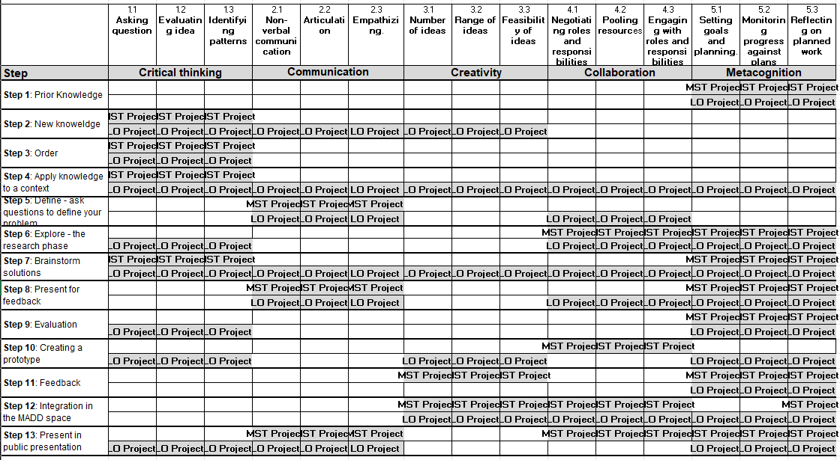
Figure 2: Overview of how the 21st-Century Skills have been integrated into the Integrated Project.
NOTE: this is a guideline, you might see other skills, or you might want to start observing skills outside of the project.

Section 2: How to use the tools.

Step 1: Observe skills in your lessons.

  - First, read a copy of the observation rubric (Figure 1) and familiarise yourself with the skill descriptors. Let's use 'critical thinking' as an example.
  - Every time you notice a learner asking questions (which shows critical thinking), jot it down in Template 1: 21st Century Skill Observation tool (example below). You can do this during or after the class.
  - This process is for gathering data throughout the term. All teachers will receive subject-specific templates (the example here is for Home Languages) on the skills that they should be able to observe in the different steps of the ICAT.
Make a mark when you observe a skill.
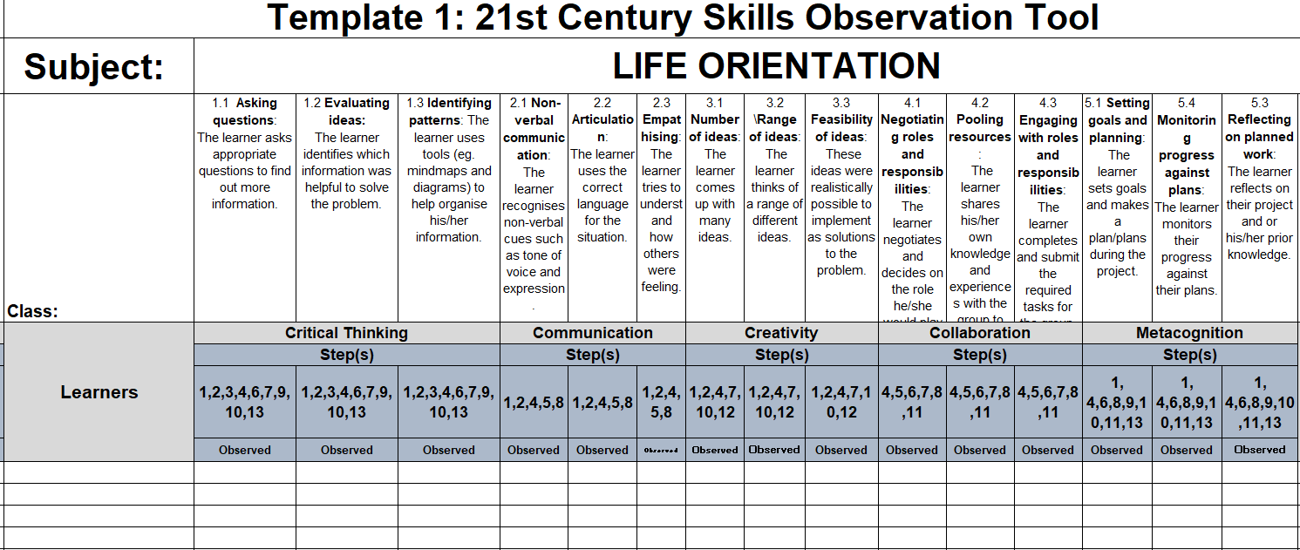
Template 1: 21st-Century Skills Observation Tool for Life Orientation (observing all 5 skills)

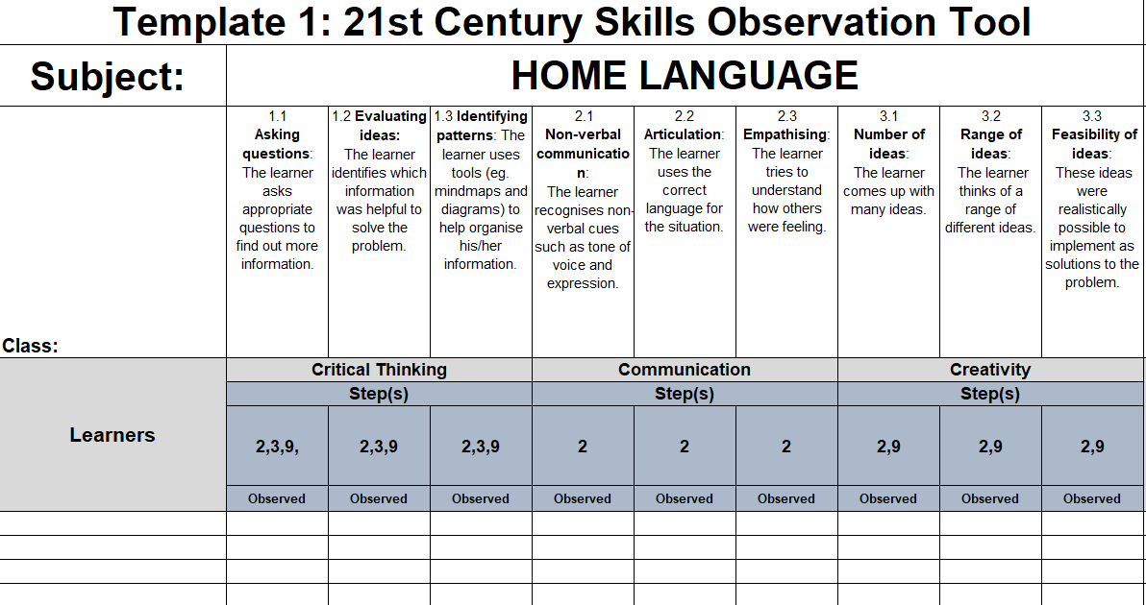
Template 1: 21st-Century Skills Observation Tool for Home Language (observing 3 skills)
Note: EMS and Life Orientation observe all 5 skills throughout the project.
Home Language, First Additional Language, Social Science, Natural Science, Technology, Maths, and Creative Arts observe 3 skills throughout the project.

Step 2: Record a ‘score’
  - Once the Integrated project is complete it is now time to assign a score.

  - Use the information you gathered during the term on Template 1: 21st Century Skill Observation tool to assign a score to each learner for each observed 21st-century sub-skill.
Use this scale to score each sub-skill:
Frequency | Never observed | Rarely Observed | Sometimes Observed | Often Observed | Always Observed
Description | The behaviour wasn't seen. | The behaviour occurs, but not often. | The behaviour occurs about half the time. | The behaviour happens most of the time. | The behaviour is consistent and regular.
Score | 0 | 1 | 2 | 3 | 4

  - Use Template 2: Subject teacher capturing template to record your scores. Note that each skill is made up of 3 sub-skills, the total of these sub-skills equates to a score for that skill.

  - The score represents the frequency of the observed skills, not the quality. Do not share these scores with the students as they are for your reference only.
This process is a long-term one. The rubric will adapt and grow over time to consider the quality of the skills. Therefore, please do not share these scores with the learners as they only indicate how often the skill was seen.
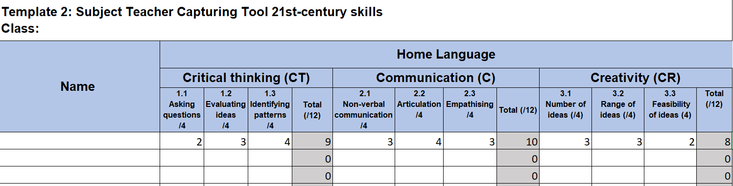
Template 2: Subject Teacher Capturing tool.

Step 3: Subject teachers share their scores (template 2) with the class teacher.
  - Subject teachers share their completed ‘Template 2: Subject Teacher Capturing Tool’ with the class teacher.
  - Class teachers input all the scores from all the subjects into one template, ‘Template 3: Class Teacher Consolidation Template.’ The purpose of this template is to ensure that the marks from all subjects are combined into one score that can be inputted into SA SAMS.
  - If you are completing this template on your computer in Excel the template will automatically convert the scores to a score out of 10. This is the score that then gets captured in SA-SAMS.
  - ‘Template 3: Class Teacher Consolidation Template’ is forwarded to the SA-SAMS capturing person who captures the scores out of 10 into SA-SAMS.
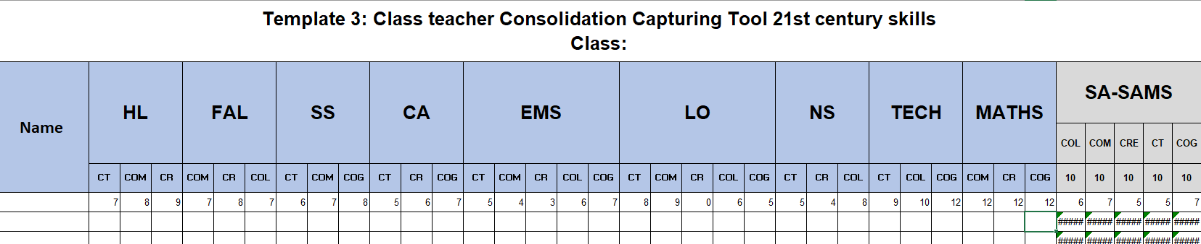
Template 3: Class teacher consolidation capturing template

Step 4: Inputting marks into SA SAMS

Below is a screenshot from SA-SAMS to illustrate the capturing of the 21st-Century Skills using the system.
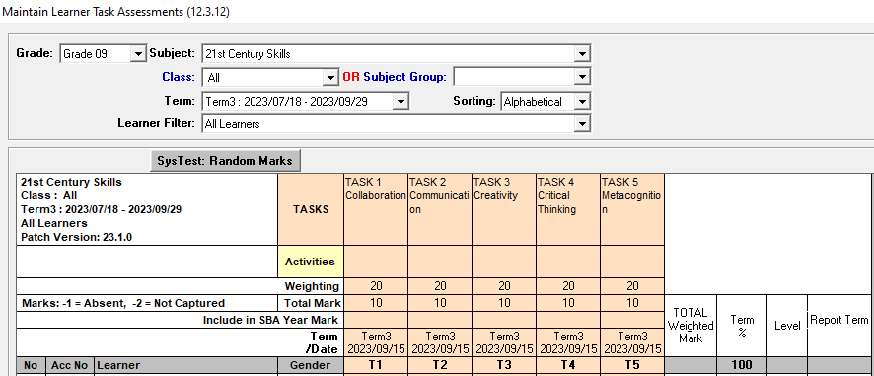

SA-SAMS export of 21st-Century Skills capturing.

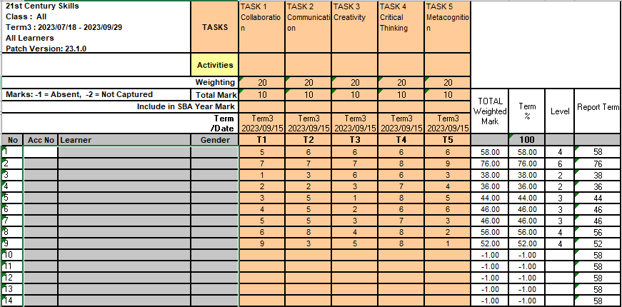

Observation tools
You can download all the templates from https://learn.ecubed-dbe.org/general-education-certificate/teachers-portal/
Home languages observation template
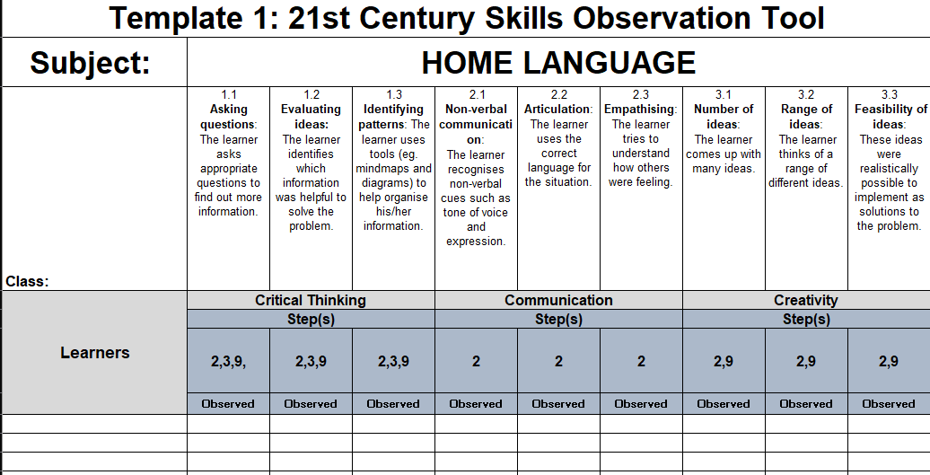
First Additional Language observation template
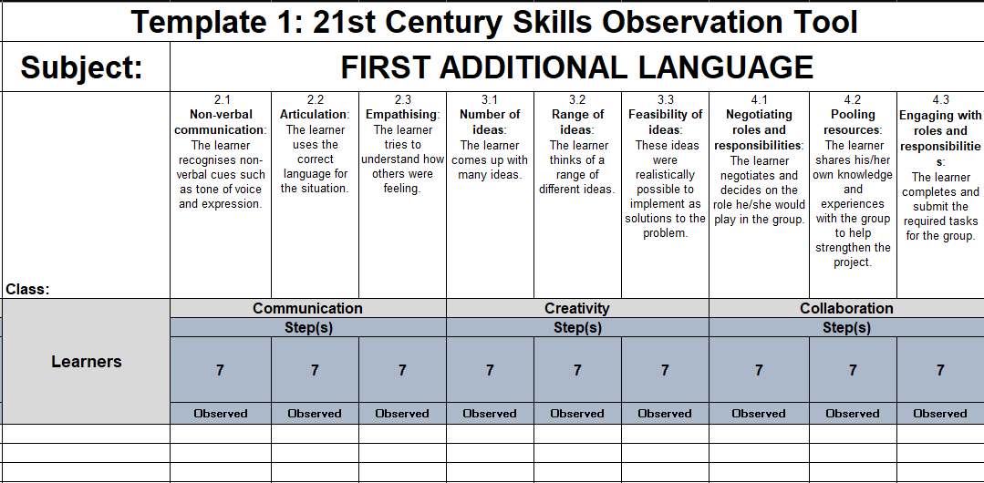
EMS observation template
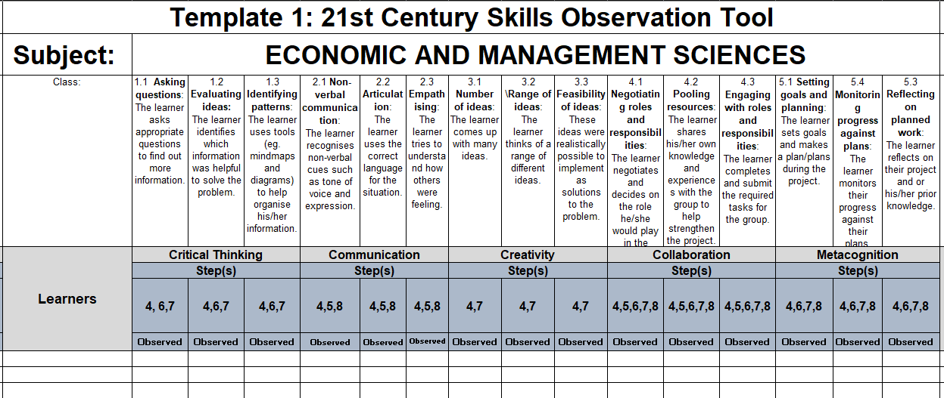

Life orientation observation template
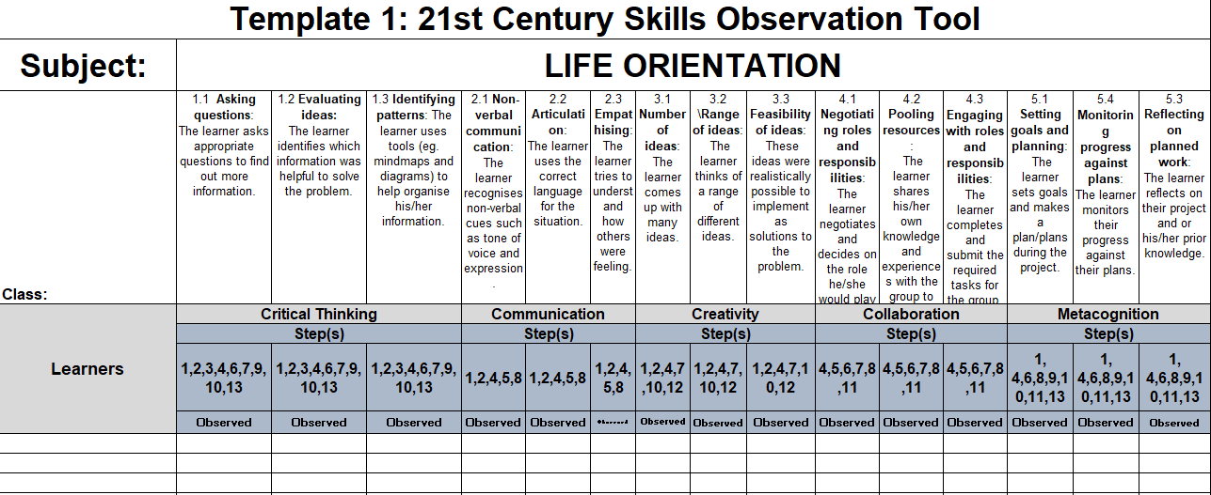

Social Science observation template
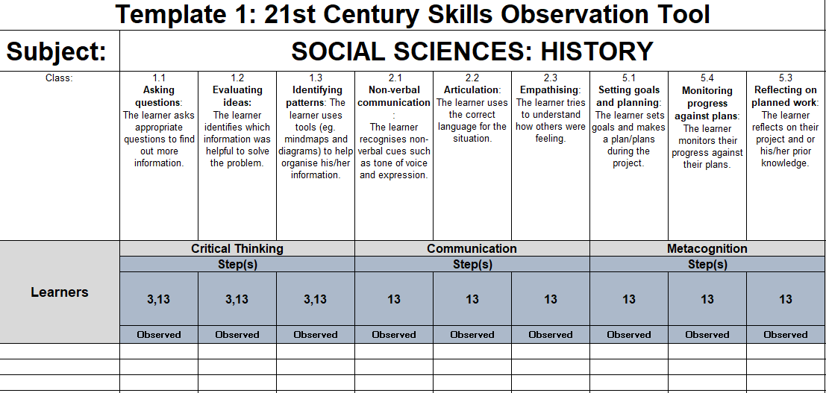
Creative Arts observation template
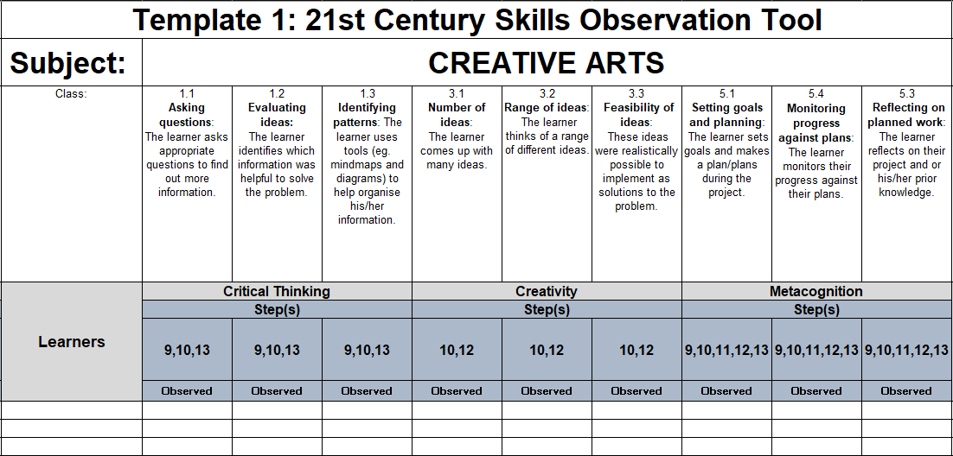

Technology observation template
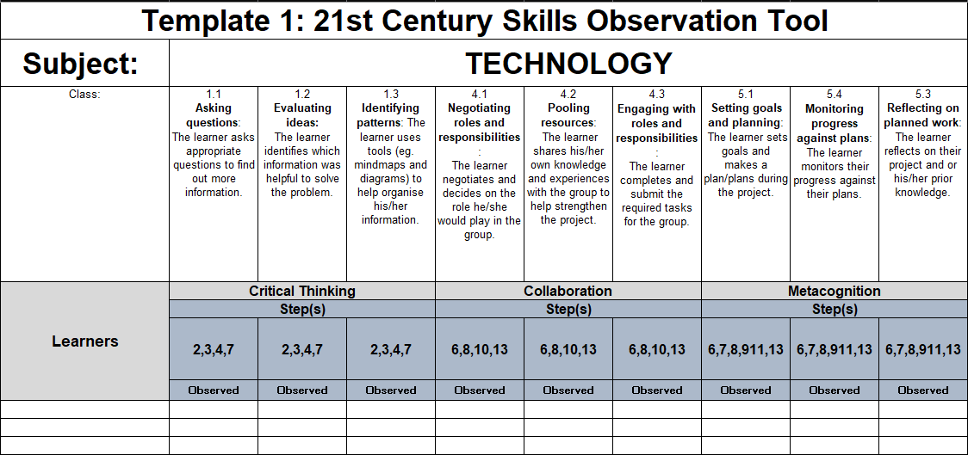
Natural Science observation template
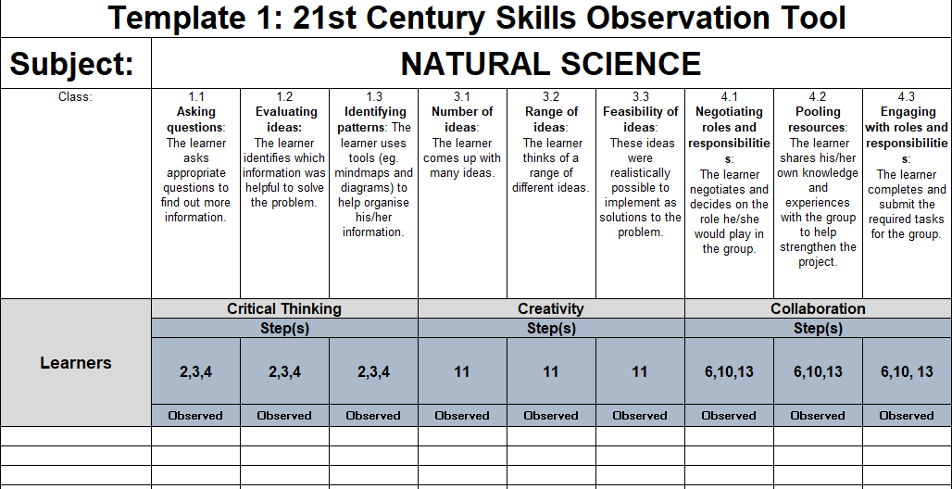
Maths observation template
